2022 Say on Pay & Proxy Results

Posted by Todd Sirras, Austin Vanbastelaer, and Justin Beck, Semler Brossy LLC, on Wednesday, July 6, 2022
Todd Sirras is a Managing Director, Justin Beck is a Consultant, and Austin Vanbastelaer is a Senior Consultant at Semler Brossy LLC. This post is based on a Semler Brossy memorandum by Mr. Sirras, Mr. Beck, Mr. Vanbastelaer, Alexandria Agee, Sarah Hartman, and Kyle McCarthy.

Breakdown of Say on Pay Vote Results
26 Russell 3000 companies (2.7%) failed Say on Pay thus far in 2022, 9 of which are in the S&P 400. 17 companies failed since our last report (bolded in the table later in this post). The failure rate has increased 80 basis points since our last report (1.9%).
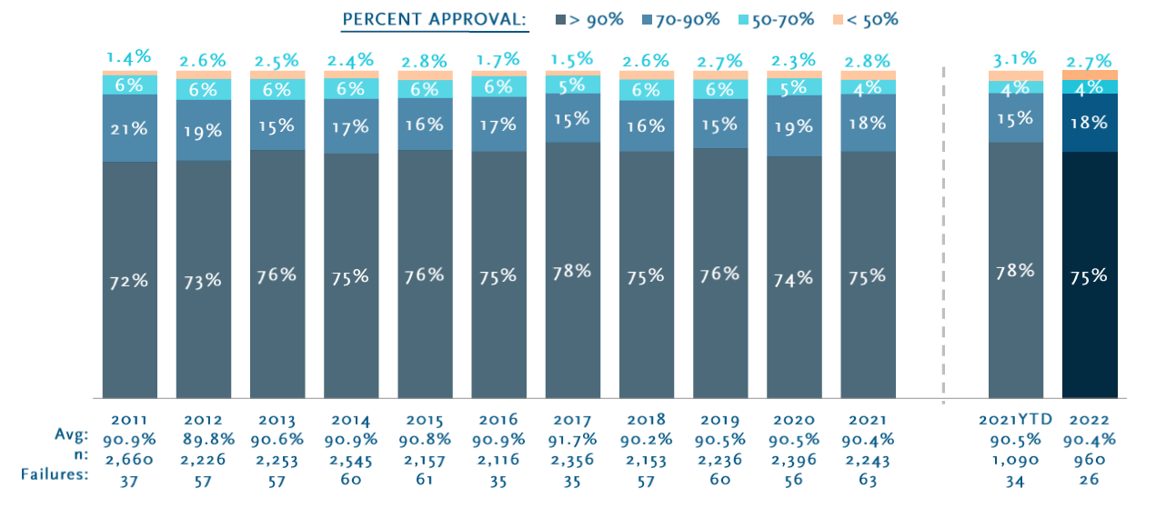

Say on Pay Observations
- The current Russell 3000 average vote result of 90.4% is similar to the index’s average vote at this time last year (90.4%); the current S&P 500 average vote result of 88.3% is below the index’s average at this time last year (89.6%), and is consistent with the year-end vote result in 2021.
- The 210-basis point spread between the current average vote results for the Russell 3000 and S&P 500 is equal to the spread at year-end in 2021; and wider than the 90-basis point spread at this time last year.
- The failure rates for the Russell 3000 and S&P 500 are lower than the failure rates at this time last year: the Russell 3000 is 40 basis points lower at 2.7% and the S&P 500 is 100 basis points lower at 3.4%.
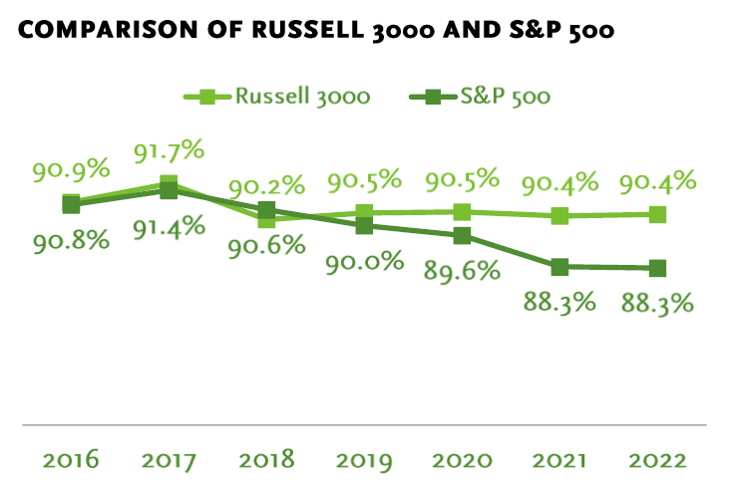
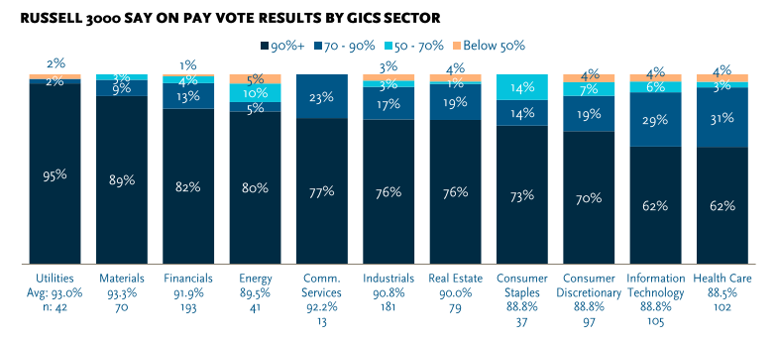

ISS Recommendation Rate Observations
- 10.0% of Russell 3000 and 10.8% of S&P 500 companies have received an ISS “Against” recommendation thus far in 2022.
- The Russell 3000 “Against” rate is 130 basis points lower than the rate observed last year, and the S&P 500 “Against” rate is 30 basis points lower.
- The average Say on Pay vote result for Russell 3000 and S&P 500 companies that received an ISS “Against” recommendation is 34 and 36 percentage points lower than for companies that received an ISS “For” recommendation, respectively.
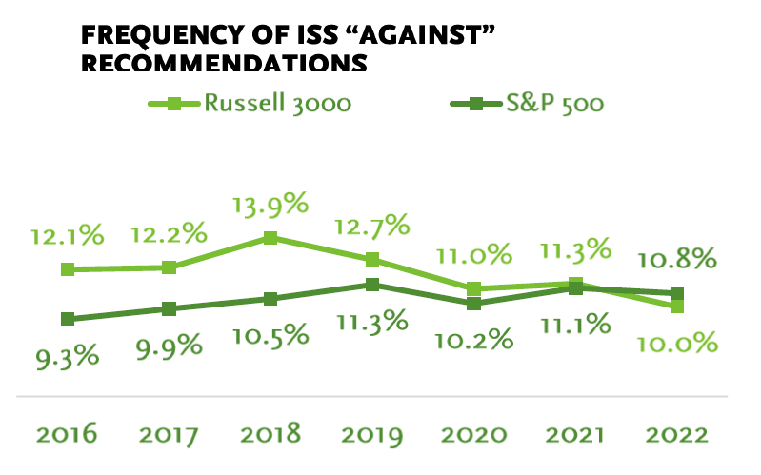
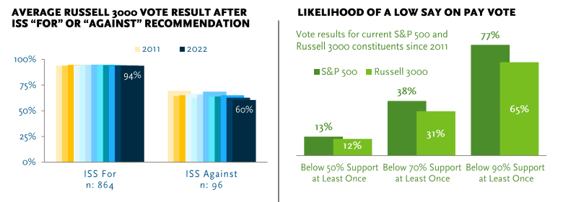
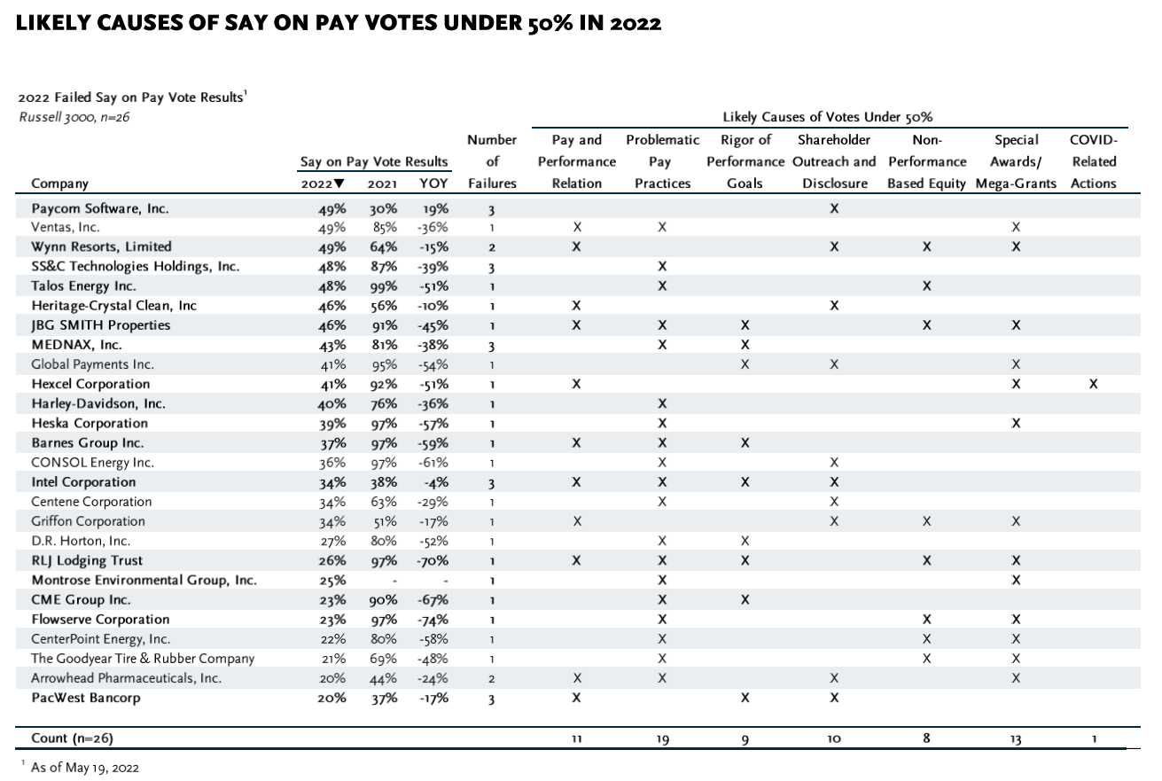
- Thus far in the 2022 proxy season, shareholders have voted on 80 social proposals and 25 environmental proposals
- Median vote support is 25% for social and 26% for environmental proposals, respectively.
- Six social proposals (10%) and three environmental proposals (18%) have received greater than 50% support thus far in 2022.
- When compared to the same period as last year, the rate of social and environmental proposals that received greater than 50% support has decreased by 11 percentage points and 20 percentage points, respectively.
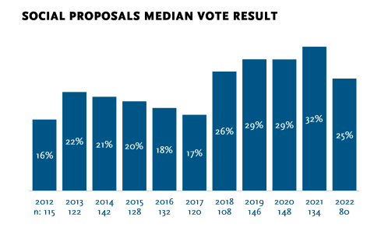
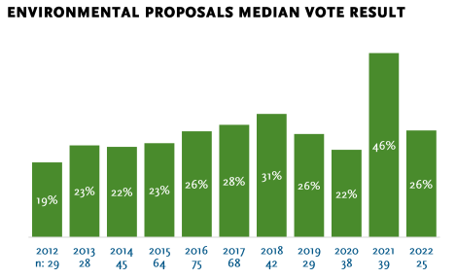

Spotlight: Waste Management
A shareholder submitted a proposal requesting that Waste Management oversee and report a third-party civil rights audit.
The proposal passed with 54% vote support.
- The proponent requested that the Company report on an independent audit analyzing the adverse impacts of business practices on the civil rights of its stakeholders.
- ISS recommend a vote “For” the proposal and noted it would allow shareholders to better understand how the company is managing related risks from gender and racial equity issues.
- The proponent stated that Covid-19 and recent racial justice movements have directed greater attention to gender and racial equity issues. They note that while the Company has stated they are proponents of diversity, equity, and inclusion, some of their policies and practices do not reflect this (i.e., lack of metrics attached to statement of increasing diversity representation by 2023).
- The Board stated that the Company plans to disclose two substantial ESG initiatives. They also noted that they engaged a consulting firm that conducted an ESG assessment and evaluated progress against goals. The Board argued that undertaking a civil rights audit may delay progress on the initiatives already underway.

Director Election Observations
- Average vote support for Director nominees of 95.3% thus far in 2022 is 20 basis points higher than the year-end support observed in 2021.
- Over the past five years, average Director election vote support at companies that received a Say on Pay vote below 50% in the prior year is six percentage points lower than at companies that received above 70% support.
- Average vote support for female Director nominees is 110 basis points higher than average support for male nominees, which is trending similar to previous years at this point in the season.
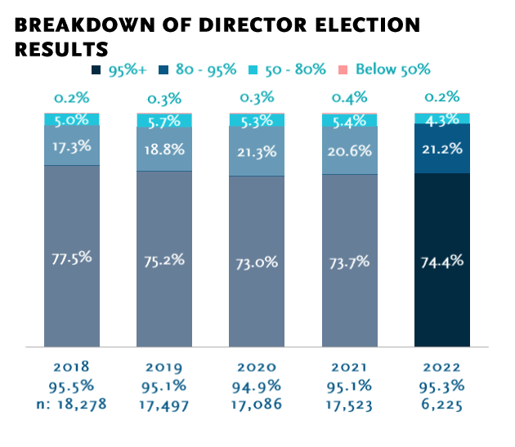
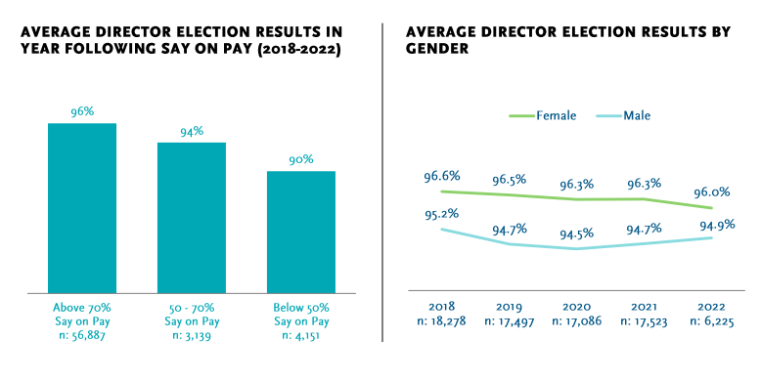
- Average vote support for equity proposals thus far in the proxy season (91.0%) is 60 basis points higher than the average vote support observed at this time last year (90.4%).
- No proposals have received vote support below 50% thus far in 2022.
- The correlation between vote support for equity plan proposals and Say on Pay has been weaker in 2022 than in previous years.
