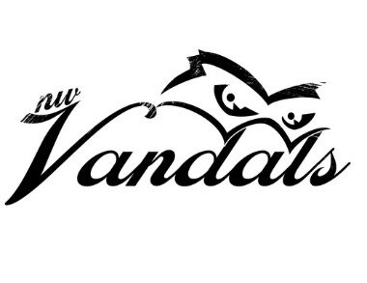

NW Vandals Standard Photo Release Form

I hereby give NW Vandals/NW Integrity Athletics permission to publish in print, electronic, or video format the likeness or image of my child(ren) to be used in publications, including the website and social media. I release all claims against NW Vandals/NW Integrity Athletics with respect to copyright ownership and publication including any claim for compensation related to use of the material. Please list all students participating in activities below:

ATHLETE NAME:

ATHLETE NAME:

ATHLETE NAME:

PARENT/LEGAL GUARDIAN NAME (print):

STREET ADDRESS:

CITY, STATE & ZIP:

SIGNATURE:

DATE:

* It is recommended that a release be obtained when photographing or videotaping a minor (under 18). Parent or guardian signatures are required; signatures of minors are not sufficient. When images are published, the organization will take cautionary steps to provide minimum identifying information and will not use specific street or mailing addresses, email addresses, or phone numbers. Signed release forms are not needed when subjects are in public places, such as ballparks or indoor facilities.