
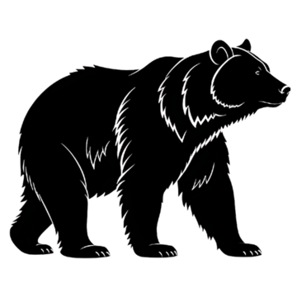
Wild Game Processing
Customer Name: ______________________________ Phone: ________________________
**Please check either of the following** Bear: _____ Venison: _____ Other: _____(Specify)
**10lb Minimum Per Product/Per Flavor**
Product List Total Trim Weight: _______lbs
Product/Ratio: | Flavor: (Please Check All That Apply) | Price/LB:
Hotdogs (10-10) | Original ____  Smokehouse ____ | $4.89
Summer Sausage (10-5) | Original SS ____  Garlic SS ____  Jalapeno/Cheddar SS ____ | $4.99
Snack Sticks (10-5) | Original ____  Garlic Cracked Pepper___  Old Grays Hot N Spicy____ Sweet Teriyaki ____  Sweet N Spicy ____  Honey BBQ ____ | $5.89
Ring Bolonga (10-5) | Big Kel's ____ | $4.99
Venison Bacon (10-10) | ____ | $4.99
Cheddarwurst (10-10) | ____ | $5.49
Bratwurst (10-10) | Original ____  Brew Crew Beer ____ | $4.89  $4.99
Ground Sausage (10-10) | Breakfast ____  Sweet Italian ____  Spicy Italian ____ | $3.99
Meatball Mix (10-6) | ____ | $4.89
Additional Add Ins
Product: | Price/LB:
Cheese (Cheddar, Swiss, Mozzarella, Gouda, Pepper Jack) | $6.00
Jalapeno Flakes | $10.50
Cranberries | $12.00
Pineapple | $8.00
Grinding
(**Please Check ALL That Apply**)
Grind Only: $1.00/LB _______ Beef Added: $5.75/LB_______ Pork Added: $2.99/LB______
Suet Added: $2.00LB______
Total Pork Trim Weight: ______lbs Total Beef Trim Weight:______lbs Total Suet:_______lbs
Total Final Weight:_________lbs

