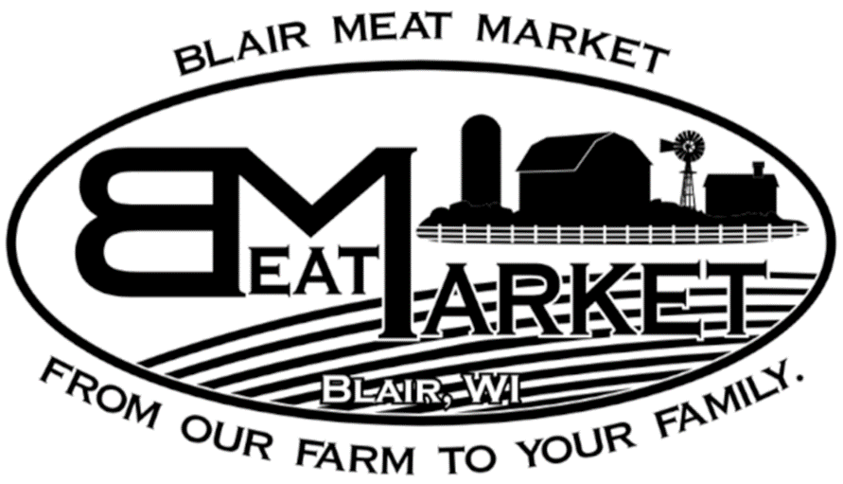**Name: Farmer:**

**Phone:**

**Beef Processing**

**Choose Size of Animal Receiving:** (please circle one):

Whole Half Quarter

**Steak Thickness:** (Average is 1’’)

**# Steaks per pack:** (Minimum of 2)

**Roast Size:** (Average is 2-3#)

|  |  |  |
| --- | --- | --- |
| **Cuts** | **“X” IF WANT** (everything else except organs go to burger) | **Comments** |
| **Heart** |  |  |
| **Tongue** |  |  |
| **Liver (1# packages)** |  |  |
| **Ox Tail** |  |  |
| **Soup Bones** |  |  |
| **Brisket (select whole or half)** |  |  |
| **Arm Roast** |  |  |
| **Chuck Roast** |  |  |
| **Short Ribs** |  |  |
| **Ribeye** |  |  |
| **Sirloin Tip Roast** |  |  |

**Quarter and Half Beef: (Choose 1 of the options): Whole Beef: (Choose 1 or 2 of the options):**

|  |  |  |
| --- | --- | --- |
| **Porterhouse & T-Bone** |  |  |
| **Filet & NY Strip** |  |  |

|  |  |  |
| --- | --- | --- |
| **Sirloin Steak** |  |  |

|  |  |  |
| --- | --- | --- |
| **Round Roast** |  |  |
| **Round Steak** |  |  |
| **Cube Steak (Extra Charge)** |  |  |
| **Stew Meat (1# packages) (Extra Charge)** |  |  |
| **Rump Roast** |  |  |
| **Ground Beef (2# packages)** |  |  |