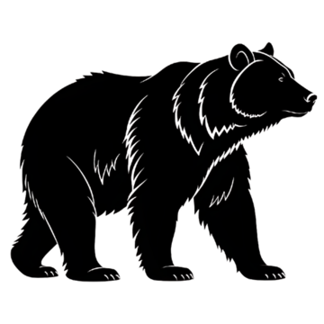*Wild Game Processing*

***Customer Name: ______________________________ Phone: ________________________***

***\*\*Please check either of the following** Bear: _____ Venison: _____ Other: _____(Specify)***

***\*\*10lb Minimum Per Product/Per Flavor\*\****

***Product List Total Trim Weight:*** *_______lbs*

|  |  |  |
| --- | --- | --- |
| ***Product/Ratio:*** | ***Flavor: (Please Check All That Apply)*** | ***Price/LB:*** |
| ***Hotdogs (10-10)*** | ***Original ____***  ***Smokehouse ____*** | ***$4.89*** |
| ***Summer Sausage (10-5)*** | ***Original SS ____***  ***Garlic SS ____***  ***Jalapeno/Cheddar SS ____*** | ***$4.99***  ***$5.29*** |
| ***Snack Sticks (10-5)*** | ***Original ____***  ***Garlic Cracked Pepper___***  ***Old Grays Hot N Spicy____ Sweet Teriyaki ____***  ***Sweet N Spicy ____***  ***Honey BBQ ____*** | ***$5.75*** |
| ***Ring Bolonga (10-5)*** | ***Big Kel's ____*** | ***$4.89*** |
| ***Venison Bacon (10-10)*** | ***____*** | ***$4.99*** |
| ***Cheddarwurst (10-10)*** | ***____*** | ***$5.49*** |
| ***Bratwurst (10-10)*** | ***Original ____***  ***Brew Crew Beer ____*** | ***$4.89***  ***$4.99*** |
| ***Meatball Mix (10-6)*** | ***____*** | ***$4.89*** |

***Additional Add Ins***

|  |  |
| --- | --- |
| ***Product:*** | ***Price/LB:*** |
| ***Cheese (Cheddar, Swiss, Mozzarella, Gouda, Pepper Jack)*** | ***$6.00*** |
| ***Jalapeno Flakes*** | **$10.50** |
| ***Cranberries*** | **$12.00** |
| ***Pineapple*** | **$8.00** |

***Grinding***

***(**Please Check ALL That Apply**)***

***Grind Only: $1.00/LB _______ Beef Added: $5.75/LB_______ Pork Added: $2.99/LB______***

***Suet Added: $2.00LB______***

***Total Pork Trim Weight:*** *______lbs* ***Total Beef Trim Weight****:______lbs* ***Total Suet:_______****lbs*

***Total Final Weight:_________****lbs*