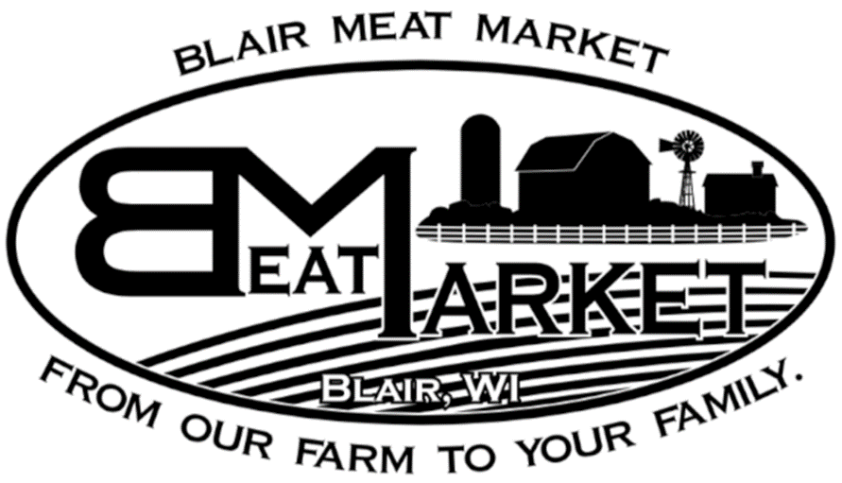
Name: Farmer:
Phone:

Beef Processing

Choose Size of Animal Receiving: (please circle one):

Whole Half Quarter

Steak Thickness: (Average is 1’’)
# Steaks per pack: (Minimum of 2)
Roast Size: (Average is 2-3#)

Cuts | “X” IF WANT (everything else except organs go to burger) | Comments
Heart
Tongue
Liver (1# packages)
Ox Tail
Soup Bones
Brisket (select whole or half)
Arm Roast
Chuck Roast
Short Ribs
Ribeye
Sirloin Tip Roast

Quarter and Half Beef: (Choose 1 of the options): Whole Beef: (Choose 1 or 2 of the options):
Porterhouse & T-Bone
Filet & NY Strip

Sirloin Steak

ROUND AREA: Quarter: 1 Option, Half: Two Options, Whole: Up to All Options
Round Roast
Round Steak
Cube Steak (Extra Charge)
Stew Meat (1# packages) (Extra Charge)
Fajita Meat (1# packages) (Extra Charge)
Rump Roast
Ground Beef (2#, 1.5#, 1# packages)

