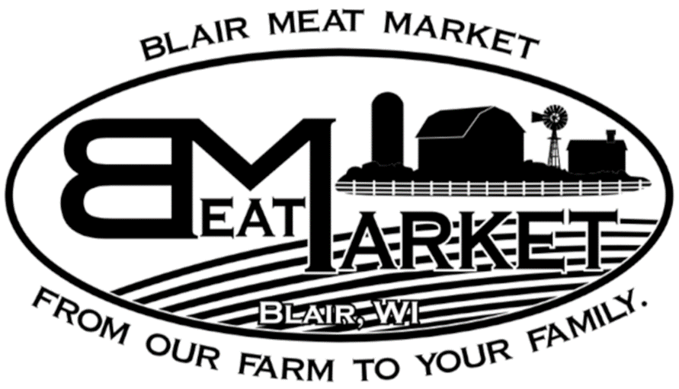**Name: Farmer:**

**Phone:**

**Pork Processing**

**Choose Size of Animal Receiving:** (please circle one):

Whole Half

**Steak Thickness:** (Average is ¾-1’’) **Chops Thickness:** (Average is 1”)

**# Steaks per pack:** (Minimum of 2) **# Chops per pack:** (Minimum of 2)

**Roast Size:** (Average is 2-3#)

|  |  |  |
| --- | --- | --- |
| **Cuts** | **“X” IF WANT** (everything else except organs go to trim) | **Comments** |
| **Heart** |  |  |
| **Tongue** |  |  |
| **Liver (1# packages)** |  |  |
| **Neck Bones** |  |  |
| **Fresh Hocks** |  |  |
| **Smoked Hocks (Extra Charge)** |  |  |
| **Shoulder Roast** |  |  |
| **Pork Steaks** |  |  |
| **Pork Chops** |  |  |
| **Spare Ribs** |  |  |

**Half Pig: Choose 1 option Whole Pig: Choose 2 options**

|  |  |  |
| --- | --- | --- |
| **Side Pork** |  |  |
| **Bacon (extra charge)** |  |  |

**Half Pig: Choose 1 Option Whole Pig: Choose 2 options**

|  |  |  |
| --- | --- | --- |
| **Fresh Ham** |  |  |
| **Smoked Ham (extra charge)** |  |  |
| **\*Cutting Options: Can be cut in quarter, half, whole, steaks** | | |

**Half Pig: Choose 1 option Whole Pig: Choose 2 options**

|  |  |  |
| --- | --- | --- |
| **Ground Pork (1# Packages) *No Seasoning** |  |  |
| **Ground Pork (1# Packages) *Seasoned (Extra Charge)** |  |  |