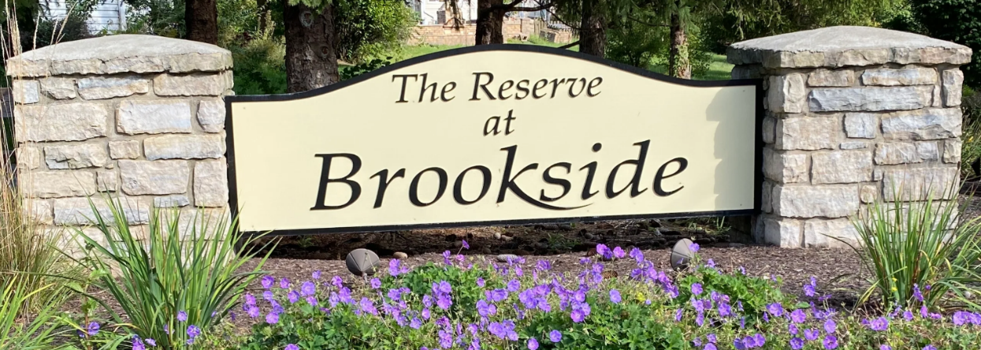
The Reserve at Brookside Newsletter
April 1, 2026

The Board hopes your 2025 has gone well as we continue 2026. We have several things we hope to alert you of: 1) we will engage further with all Homeowners throughout 2026 to elevate beauty standards that we believe are achievable and maintainable without undue burden, 2) a proposed ratification of one of the bylaws, and 3) a survey on how we can better serve you.
During the 2025 HOA meeting on November 18, we had an increased turnout relative to previous years and received further feedback from those homeowners. We reviewed the 2024 survey responses and compared them to the 2025 responses, but still require more responses to better gauge the Community’s interests. Areas that we believe would represent uniform beautification standards are highlighted below and are in-line with the bylaws as currently written and are in the “Property Upkeep” and “CCR Violations” sections below. Among other areas, we view these areas as those that increase the safety and presentation of the neighborhood without being overly burdensome or time consuming if sustained.
Additional information for homeowners: The city of Springboro mandates that residential sidewalks be cleared for ease of use for bus routes and general public utility. https://codelibrary.amlegal.com/codes/springboro/latest/springboro_oh/0-0-0-13537
Proposed bylaw change: Within the covenants there is a bylaw that stipulates that garbage cans should be “shielded from public view”. The HOA Board would like to amend the wording to be less ambiguous and to amend to reflect that garbage cans be “stored within the garage or along the side of the residence, behind the frontage of the house”. Is this change relevant to you?

How can we serve you better: The board has been in discussion about how to maintain steady communication with the residents and would like your feedback. We are weighing options that may curtail residents not being fully aware of events in the neighborhood. The board is here to serve the owners. A survey will be sent to all owners with e-mails on file. Would you prefer communications and dues to be electronic, or paper only? If you prefer electronic, make sure your e-mail is on file by entering the information into the survey (household name and street number/name).
Survey Link: https://www.surveymonkey.com/r/SB2G2QX
The 2026 HOA Board Members are:
Paul Hill, Sean Patrick, Nik Ilg, Benjamin Pierce, and Phillip Carr
A strong and active board is needed to protect property values for our neighborhood. This is accomplished by maintaining the common area (entrance to neighborhood), ensuring CCR’s are enforced and annual dues paid. A HOA board is required to make this happen.

Selling Your Property
If you are selling your property, have your realtor/title company contact J&J for property certification and current assessment of dues/fees. If you have questions about your HOA dues, fees balance, or property certification you may email or call J&J at office@jjtaxbusiness.com, 937-550-4219.
Property Upkeep
Please remember if your home is not up for sale, at any given time there are usually several other homes on the market. The appearance of any property in the neighborhood can positively or negatively change the value and perception of the neighborhood to prospective buyers.
Also, please note that the trees on your property that are between the sidewalk and road are the homeowner’s responsibility to maintain, trim, and remove when dead. Maintenance of the sidewalk on your property is also a homeowner responsibility.
Most commonly observed CCR violations for homeowners in The Reserve at Brookside:
- Not cutting and trimming grass regularly and keeping flower beds weed free.
- Trash cans are not being screened from public view and/or in driveway.
- Low-hanging tree limps over sidewalk.
- Not using a lamp post light from dusk to dawn. Some houses seem to no longer have a lamp post either; this is a safety issue to the neighborhood.
- Non-payment of annual dues. This year, all delinquent owners will be turned over to legal at their expense.

You can obtain the full CCR document by visiting the HOA website at www.reserveatbrookside.org.
2026 Budget
Annual dues go toward HOA expenses below. Dues for 2026 are $200.00 for each property and are due on March 1. We wish to bring to everyones’ attention increases in the accounting costs from previous years and utilities, which reinforces the need for everyone to be paying their HOA dues on time. Unpaid dues cause landscaping and maintenance to be decreased, and places a collections burden on the HOA and Accounting firm. All collections actions will be enforced.
Estimated Dues Collection | $15,200.00
Expenses
Miscellaneous | $541
Accounting | $2453
Insurance | $1554.00
Landscaping/Repairs & Maintenance | $8292
Utilities/Water | $1050
Total Expenses | $13,890

Important HOA Contact Information
- HOA Board members: Paul Hill (20 Churchill Ct), Sean Patrick (570 Arbor Hills Dr), Nik Ilg (25 Brighton Ct), Benjamin Pierce (25 Arbor Hills Dr), and Phillip Carr (55 Churchill Ct).
- HOA Board email: brooksidehoareserve@gmail.com Use this email address to communicate with the board or architectural committee
- HOA Internet site: https://reserveatbrookside.org You can find CCR’s on this website and other important HOA and community information
- HOA mailing address: The Reserve at Brookside, PO Box 771, Springboro, OH 45066
- HOA Bookkeeper: J&J Tax and Bookkeeping, 770 W. Central Ave, Springboro, OH 45066, office@jjtaxbusiness.com, 937-550-4219

