Our Year in Review from the Jersey Shore Schools Educational Foundation
Teacher Mini-Grant Program Funds Programs
During the current school year, the Foundation funded $6,895 for 4 innovative projects and programs proposed by our teachers within the district through our teacher mini-grant program.
The mini-grant program is designed to provide district teachers an opportunity to enhance their classroom activities for their students by providing materials that would not be available through the normal district budgetary process.
Each year teachers may apply for up to $2000 for special projects. These projects range from the arts to academics to STEM activities. During the current school year, these projects brought in a class set of ukuleles for the fifth grade students, a set of Ozobots for students in grades 2 – 5 at JSE, a composting bin for fifth graders at JSE and three 3-D printer kits for the networking, technology and art students at the high school.
Prior awards have created butterfly gardens at the elementary level, funded portions of seventh grade environmental field trips, purchased 3-D printers for the tech classes and provided materials for the community mural housed at the JS Community Swimming Pool.

Scholarships
More than $12,000 in scholarships were awarded in 2016 to assist students to further their education.
American Legion Post CTE Scholarships
Each year the American Legion Post 36 donates funds for scholarships for Consumer and Technical Education (CTE) students. To date the American Legion has donated $30,000 towards the funding of 15 students to further their education in any of the trades as well as nursing and other technical fields.
Gasperine Family STEM Scholarship
STEM is the integration of scientific principles with technology and the innovative application of engineering and math. The STEM Scholarship is funded by the Gasperine Family in honor of their commitment to the promotion of STEM careers. For the past two years, the family has donated $4000 to scholarships toward students to assist in their educational pursuits.
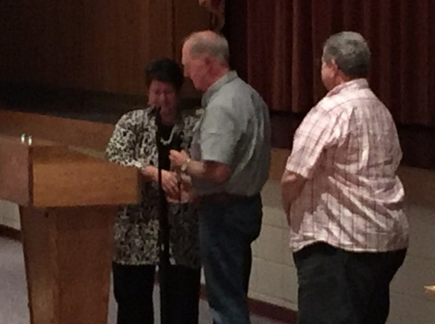
A big Thank You ! goes to the American Legion Post 36 and the Gasperine STEM for providing assistance to our students.

Foundation Gifts
Foundation gifts help to promote, enrich and enhance the academics currently in place in the JS District. These special gifts provided opportunities for students who would not normally be able to participate without the additional funds from the Foundation and ultimately you the donor.
Special events
A team of JS students are attending the VEX Robotic World competition in Tennessee. The Foundation assisted this unexpected and unplanned honor by contributing to their registration expenses.
AP Exams
Since the Foundation’s mission is to enhance and enrich academics, the students taking the AP exams can receive college credit for their hard work within academia. The Jersey Shore District offers AP classes in English, European History, American History, Calculus, Spanish, Chemistry, Statistics, Environmental Science, and Calculus BC. During the current school year, 46 students took at least one AP exam with the majority taking two or more exams. The Foundation believes that the cost of the exam should not exclude or discourage students from participating therefore the Foundation is contributing a portion of the cost of the exam for students taking two or more exams to ensure all students have an opportunity for the college credit.
FUNDING
EITC Funds
The Pennsylvania Educational Improvement Tax Credit (EITC) Program is administered through the PA Department of Community and Economic Development (DCED) under Act 48. The EITC program allows certain businesses tax credits for donations made to scholarship programs or educational improvement organizations that are on a list of approved and published organizations by DCED.
Thank you!
In December, Woodlands Bank donated EITC monies to the First Community Family Partnership (FCFP) for use by the District.
The Jersey Shore School Education Foundation has since filed to receive EITC funds directly from approved businesses and will identify appropriate programs to fund on behalf of the district.
Fundraisers
In April, the Foundation held their first ever My Mattress Fundraiser in the Jersey Shore Elementary gym. There were signs posted in many areas inviting all to the event. Throughout the day, many individuals stopped, browsed and some purchases were made. For the first time ever, this event netted $1050 for the JS Foundation. The next scheduled event will be April 7, 2018 for those who were not sure about a purchase this year.
In total, the Foundation has been actively seeking funds and projects to fund within the Jersey Shore Area School District. Remember that your donations to the Foundation are tax deductible! We welcome any support you or your group may offer.

