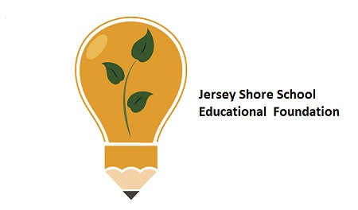
Jersey Shore Schools Education Foundation
End of Year Report

Teacher Mini-Grant Program Funds Programs
The mini-grant program provides district teachers an opportunity for materials to enhance classroom activities. Each year teachers may apply for up to $2000 for special projects. In the past, the activities range from the arts to academics to STEM activities.
During the current school year, the Foundation funded $7393.14 for 5 innovative projects and programs proposed by our teachers within the district through our teacher mini-grant program. Successful grants were awarded to Ms. Jen McKee for Lego mind-storms sets for STEM activities and a set of Ozobots for students in JSE and the middle school.
Mission Statement:
Engage and Extend Educational Experiences
Our mission is to engage partners to provide supplemental resource to extend learning opportunities beyond the conventional educational experience for students in the Jersey Shore Area Schools.

Vision Statement:
Assist JSASD to prepare students for the next step in life plan.
The Foundation is governed by our Board of Directors that represents the various area communities and towns and fosters the belief that community involvement in public education is essential to providing and sustaining the level of education that is expected in Jersey Shore Schools.

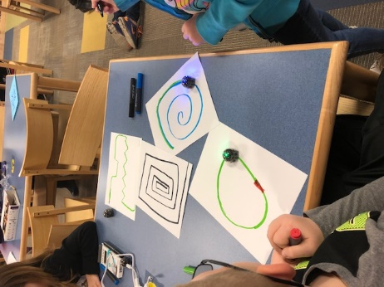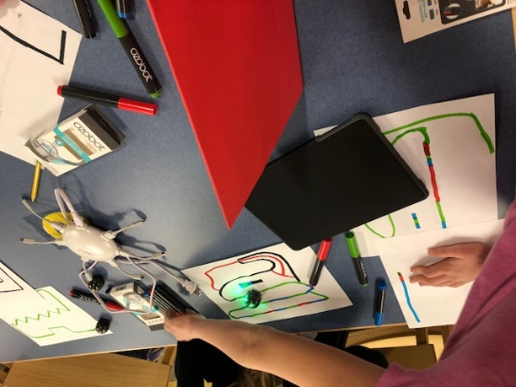
The fifth grade at JSE received funding for a community garden project to go with the composter from last year. At the middle school, history students traveled to the Boalsburg Museum to see the largest set of artifacts concerning Christopher Columbus.
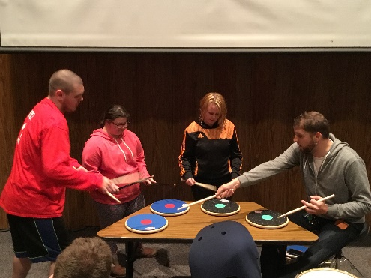
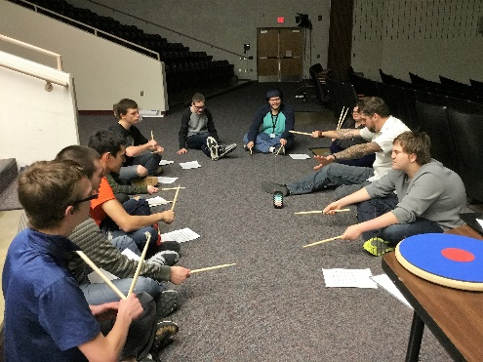
The life-skills students were visited by “Upbeat Outreach”, a drums program allowing students to get involved with drum beats and rhythms. Student comments included:
“We learned so many new things about drumming and important life lessons”.
“He taught us that anything worth doing takes practice and hard work. “ “Never give up!”
Scholarships Foundation Gifts

More than $12,000 in scholarships were awarded in 2017 to assist students to further their education with an additional $12,000 to be awarded in 2018.
American Legion Post CTE Scholarships
Each year the American Legion Post 36 donates funds for scholarships for Consumer and Technical Education (CTE) students. To date the American Legion has donated $40,000 towards the funding of 20 students to further their education in any of the trades as well as nursing and other technical fields.
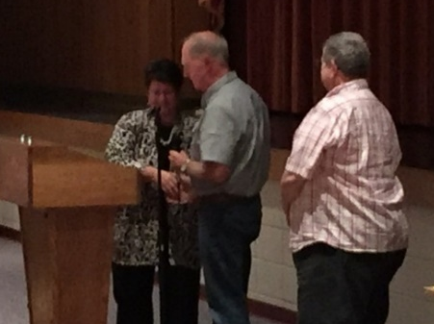
The recipients for 2018 are:
Victoria Bellomo – RIT for Engineering
Heidi Koch – Penn College –surgical technician
Luke Bischof – Juniata College - Computer Science
Jacob Jones – Penn College - HVAC
Ryan Stratton – RIT - Mechanical/Electrical Engineering

Gasperine Family STEM Scholarship
STEM is the integration of scientific principles with technology and the innovative application of engineering and math. The STEM Scholarship is funded by the Gasperine Family to honor their commitment to the promotion of STEM careers. For the past two years, the family has donated $4000 to scholarships toward students to assist in their educational pursuits.
The recipients for 2018 are:
Maddy Laubscher - Susquehanna University for Biology
Dylan Fox – PSU for Mechanical Engineering

A big Thank You ! goes to the American Legion Post 36 fund and the Gasperine Family STEM fund for these opportunities.

Foundation gifts help to promote, enrich and enhance the academics currently in place in the JS District. These special gifts provide opportunities for students who would not normally be able to participate without the additional funds from the Foundation.
Special events
A team of JS students are attending the VEX Robotic World competition in Tennessee. A restricted fund for TSA donations has been established to help fund the same competition in 2018.
AP Exams
Students taking AP classes and exams can receive college credit for their hard work in academia. The Jersey Shore District offers AP classes in English, European History, American History, Calculus, Spanish, Chemistry, Statistics, Environmental Science, and Calculus BC. During the 2016-2017 school year, 46 students took at least one AP exam with the majority taking two or more exams. Since the Foundation’s mission is to enhance and enrich academics, the Foundation believes that the cost of the exam should not exclude or discourage students from participating. The JSSEF is contributing a portion of the cost of the exam for students taking two or more exams to ensure all students have an opportunity to receive the appropriate college credit.
FUNDING
EITC Funds
The Pennsylvania Educational Improvement Tax Credit (EITC) Program is administered through the PA Department of Community and Economic Development (DCED) under Act 48. The EITC program allows certain businesses tax credits for donations made to scholarship programs or educational improvement organizations that are on a list of approved and published organizations by DCED.
The Jersey Shore Schools Education Foundation is now listed on the DCED list of approved EITC schools. The following programs have been approved and the Foundation may accept and use funds for the Elementary STEM center, Community Garden, Skills Quest, Field Trip to Boalsburg Museum and Butterfly Garden upkeep.
The teacher mini-grants for OZOBOTS and other STEM materials at the elementary level have been approved for the last two years and are a huge success. Students attend sessions at JSE before school to program ozobots and build structures with the materials in the STEM center at the library.
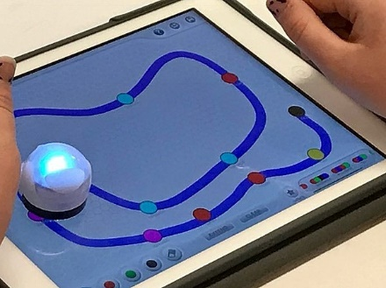
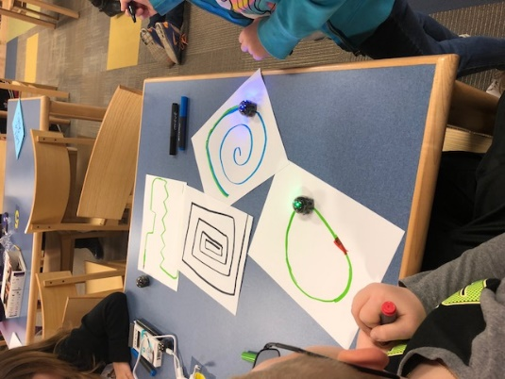

The Skills Quest is a program for which the Foundation is seeking funding. The funds would be used to place a John Deere excavator simulator in the Building and Maintenance Program to practice on before attempting the actual piece of equipment. The total cost is approximately $30K.

Field trips to local museums and government offices are currently an integral part of the history curriculum. The Foundation would like to see these experiences become a yearly activity to visit a courtroom for Crime and Law and the Business Law classes. The US history classes should visit the Boalsburg Museum where there is an extensive collection of Christopher Columbus artifacts.
The Butterfly Garden at JSE has been doing quite well. There have been some replantings of some species of flowers, and the garden has seen many classes release butterflies in the fall to the delight of the students.
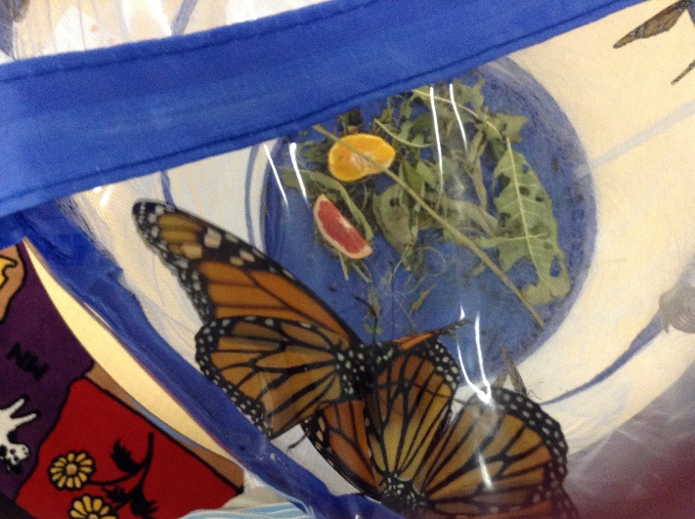
Fundraisers
The Foundation participated in the Raise the Region program again this year. Donations were up for the Foundation and we thank all who participated.
However, the Foundation relies primarily on the generosity of donations to fund our projects and programs.
Remember that your donations to the Foundation are tax deductible! We welcome any support you or your group may offer.

You Shop. Amazon Gives…to the Jersey Shore Schools Education Foundation
AmazonSmile offers the very same prices, products, and services you are familiar with on Amazon, but has an added bonus of supporting charitable organizations. Sign up is a one-time easy and quick process. Then every time you shop, a donation is made to the Foundation.
Restricted funds
There are established restricted fund accounts within the Jersey Shore Education Foundation to which individuals may contributions which are tax deductible. The current restricted funds accounts are:
American Legion Post 36 Scholarship – This fund provides 5 - $2000 scholarships for individuals to pursue Technical Education at universities and trade schools.
Gasperine STEM Scholarship – This fund provides 2 - $1000 scholarships for individuals pursuing a Science, Technical, Engineering and Math career.
TSA (Technology Student Association) – A program for technical education students that offer a variety of careers to explore from network design to engineering projects. This fund also includes the VEX Robotics teams that build robots and compete on the national level.
FBLA – (Future Business Leaders of America) – A national organization that provides opportunities for high school students to practice and hone business skills such as public speaking, Roberts Rules of Order and leadership as well as accounting and network design. The FBLA sends students to national competitions on a yearly basis.
General Scholarship Fund – A new fund that is under growth and development. This fund is designed to allow students to apply for funding to assist in further career pursuits in post-secondary education or to attend summer camps at the Middle School level.
Music/Drama – These funds are specifically used for the production of plays and musicals within the music and English department. This past year, funds were used to pay for royalties for the winter play.
Financial Statements
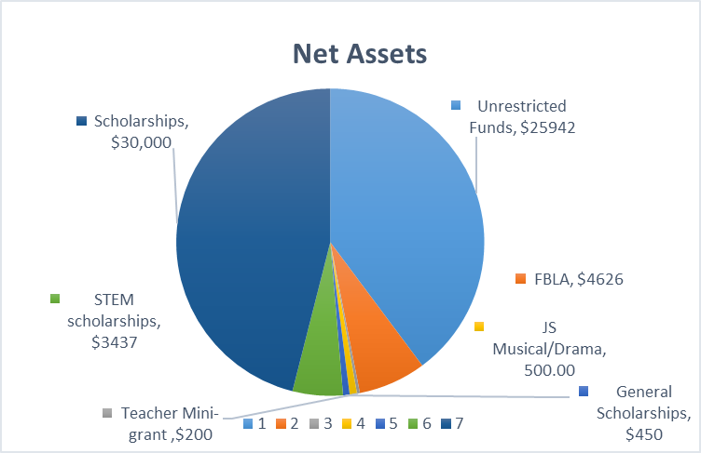
The Jersey Shore Schools Education Foundation is staffed by all volunteers, any expenses are kept to a bare minimum. All contributions are placed into appropriate funds as they are received.
Unrestricted funds are used to fund teacher mini-grants and to subsidize AP Exam fees for any student taking more than two tests.
Any incurred administrative expenses such as tax preparation and insurances also come from unrestricted funds.
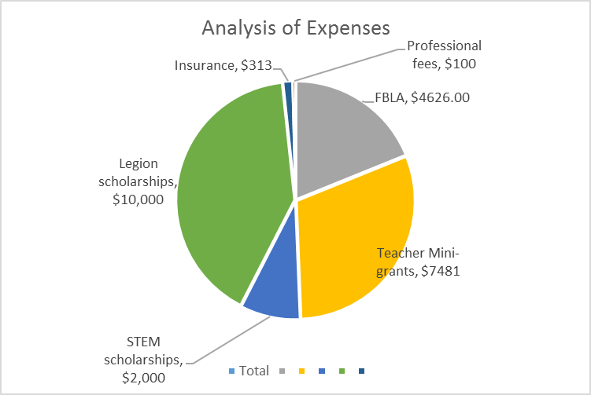

2017 – 2018 Foundation Donors
Many Thanks to all of our Foundation Donors during the 2017-2018 year.
Consider donating again last year so we can continue to do our work within the district.

JS Education Foundation is on Facebook!
Like us on Facebook

Jersey Shore High School Alumni
We have a group on the Jersey Shore Foundation page just for alumni. Check out the group to see what your fellow classmates are up to.

Our alumni are doing some amazing things!

