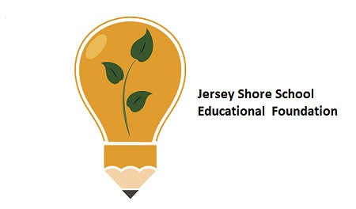

***Jersey Shore Schools Education Foundation***

***End of Year Report 2023***

Throughout the school year of 2022 – 2023, the Education Foundation impacted all of our students in the Jersey Shore School District. The Foundation would like to thank the administration and staff for their assistance in these accomplishments and hope to continue the positive relationship for the benefit of the students at Jersey Shore Schools.

**Mission Statement:**

**Engage and Extend Educational Experiences**

Our ***Mission***is to **engage** partners to **enrich** and **extend** learning opportunities beyond the conventional educational experience for students in the Jersey Shore Area Schools.

**Vision Statement:**

Our ***Vision*** is to assist the Jersey Shore Area School District to enrich educational and social opportunities for students.

The Foundation is governed by our Board of Directors that represents the various area communities and towns and fosters the belief that community involvement in public education is essential to providing and sustaining the level of education that is expected in Jersey Shore Schools.

**Teacher Mini-Grant Program Projects**

The mini-grant program provides district teachers an opportunity to purchase materials to enhance classroom activities. Each year teachers may apply for up to $2000 for special projects that benefit their students and classroom. In the past, these projects have ranged from the arts to academics to STEM activities.

During the 2022-2023 school year, the Foundation funded $61178.56 for innovative projects and programs proposed by our teachers within the district.

**Successful grants included:**

**\* Thinking Classroom Furniture ($1579.90)**

**Trading Places** was the name of the grant that placed stand-up desks, wiggle stools and surf desks in the classroom at the middle school. This project was intended to purchase flexible seating choices that will provide my students with options in the classroom to help them focus and become better thinkers to promote learning, as well as have more opportunities for collaboration and flexibility. A redesigned classroom has facilitated learning experiences and student-directed learning, increase levels of engagement, foster active learning, and support the learning goals of my students. Finally, the flexible workspace has reinforced the Jersey Shore School District mission to provide a supportive learning environment to help every student meet academic and social success. Student comments include:

"Mr. McCabe's seating makes our learning fun"

"I love that I can move in my seat while class is going on"

"It's great to be able to stand at a desk instead of sitting all the time"

"This is my favorite classroom to learn in"

**\*Jeff Klugh Rebecca Ball-Schaller for the Boalsburg Museum trip ($1169.96)**

The 8th grade students on this trip will get a first-hand experience that is unique to our region. The Columbus Chapel and Boal Museum are approximately an hour away (in Boalsburg) and have the largest collection of Columbus artifacts in North America. The eighth grade social studies curriculum analyzes Columbus and his interactions with native peoples extensively. This trip will allow the students to get a first-hand experience with historical artifacts.

**\*Trish Sweitzer for a water wall for the Trout in the Classroom Project ($4383)**

Trish Sweitzer and Stephanie Machmer both raise trout in their classrooms and then release them in Little Pine Creek in the Spring. With the funds from this year, they purchased a water wall which is a hydroponic system that will utilize the water from the fish tanks as nutrients to grow plants and then return the “clean” water back to the fish tanks. Funds for this project came primarily from the EITC grant from High, Inc.

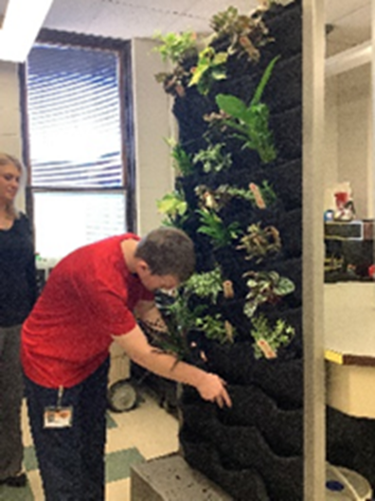 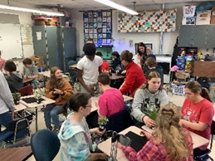

Classes raised trout in the classroom and released them into Little Pine Creek in May.

**\*Katie Wert for author visits for the elementary school. ($2000)**

**Artist / Author in Residence** provided an opportunity for Daniel Kirk to speak at the elementary schools concerning how he gets his ideas for books and the writing process. The students had opportunities to ask questions and interact with the author

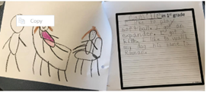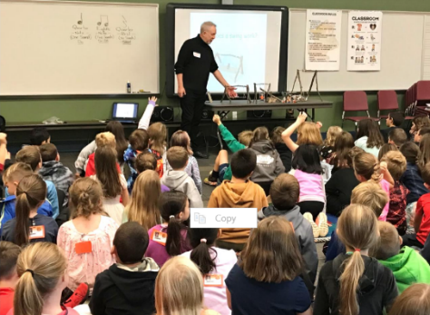

**\*Michelle Moore and Angela Haffley for a trip to LHU for a Biology Seminar ($288.80)**

Students were treated to a tour of the biology labs at LHU for a preview of what a college science curriculum could be like. A treat for sure to instill a love for STEM careers in the students.

**\*Tracey Silvis for a chemical demonstration for grades 7 and 8 ($200.00)**

There is no better way than hands-on to teach some science. However, allowing students to create fire and small explosions can be a hazard in the classroom. In the hands of a professional chemist, these things are not a problem. The whiz bangs of a great chemical demonstration will do more to spark a student’s interest in the sciences than any other. Just ask Bill Nye the science guy.

**\*Diane Mantek for an upgrade in the butterfly garden ($500)**

**The Butterfly Garden** at JSE needs an update and Mrs. Diane Mantek has undertaken a complete make over for plantings in the area. The garden has seen many classes release butterflies in the fall to the delight of all students.

**\*Mary Aungst for the Community Garden ($480.65)**

**The Community Garden** at JSE is now getting ready for its fourth year. Mrs. Mary Aungst has taken custody of the community garden at the elementary school with the help of students. They are planting and weeding and hoping for a plentiful crop during the summer.

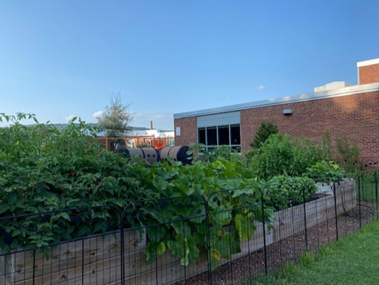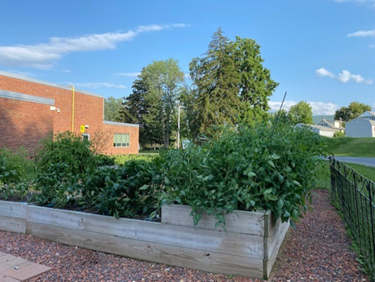

**\*Stephanie Machmer for Upbeat Outreach ($600.00)**

**The life-skills students were visited by “Upbeat Outreach”, a drums program allowing students to get involved with drum beats and rhythms. A new twist this year was a trip to a recording studio so the students could participate in a session. Student comments included:

“I love Mike’s positive attitude and want to be like him” – David Neufer.

“Thank you, Mike, for teaching us to always stay positive. “ – Jessica Clark

“I learned that I had to have patience to learn to drum.” – Caleb Leone

“I’m so glad we get to hit the drums with you.” – Heath Neufer You Tube video - [Upbeat Outreach Drumming 2022 - YouTube](https://www.youtube.com/watch?v=z9n4dfBw01E&t=5s)

**

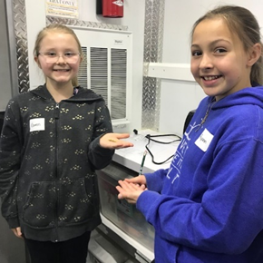Students love going into the PA Ag Science Van. They participated in hands on lessons concerning PA agriculture and learn how important science is to agricultural careers. The Foundation paid for the ag van to spend a week at all three elementary schools and an extra week at JSE.

**SIM Junior – High School -$35,921.00**

Sim Junior is an interactive pediatric simulator to meet training needs for CPR. All seniors must have a CPR training course as a graduation requirement. Students in the Health Sciences courses in preparation for entry into nursing programs will benefit from this equipment. An additional family set of mannikins were also purchased for use in the district.

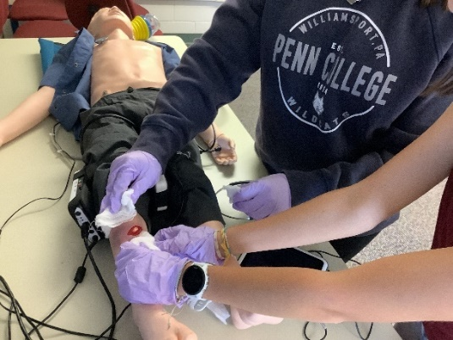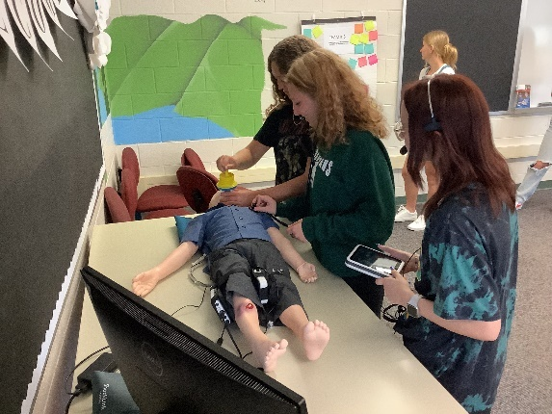

**Interplay Simulations ($8,000)**

Interplay Learning (Skill Mill) is a software program that is used to supplement the Building and Maintenance curriculum. The software program contains courses in HVAC, Solar Power, Electrical Systems, Plumbing, Maintenance, Safety, Residential Construction, and Appliance Troubleshooting. Each contains courses that are divided beginner, intermediate, and advanced levels and can be individually assigned according to students **A group of people in a room
**pathway. Students are assigned a course on their iPAD or Oculus. Each course contains knowledge checks and a final exam. Most courses are simulation based. Students must interact with the software completing simulations of real world experiences.

Students benefitted greatly by using the program. They were able to access different learning scenarios that we cannot provide in class due to space and budgeting constraints. This year, all Building and Maintenance students obtained the Advanced Level on their Nocti exam. I believe this was due to the implementation of this software program. This program prepares students for the US Department of Lab certification programs in OSHA and EPA 608 as well as skilled HVACR specialty exams for North American Technician Excellence (NATE) certifications.

**Anytime Grants**

The Anytime grant program is a success. This grant is designed to provide up to $2000 for unanticipated and/or time-sensitive opportunities that may present themselves over the course of the school year that may not be covered by district funds or teacher mini-grant funds. This year we provided for a chemical demonstration for the 7/8 science classes ($250) and a field trip to the Bio labs at LHU for the grade 8 students ($161.88).

**AP Exams**

The foundation will pay for any AP Exam that our students take. The cost of the tests last year was $85 per test and some of our students will take up to 4 AP Exams. That cost can prohibitive for some families. The foundation asks that a student pay the registration fee of $15 for each exam they wish to take and the foundation will pay the rest of the costs. This year the foundation paid $4497 in fees for our students to participate in the AP testing program. The foundation also paid for study materials requested by the instructor in preparation for the AP tests for the students.

**Scholarships**

Scholarships were awarded to 11 students during the June 2022 Senior Awards that amounted to $15,000 to further their education.

**American Legion Post 36 CTE Scholarships -5 @ $2K**

Each year the local American Legion Post donates funds for scholarships for Consumer and Technical Education (CTE) students and academic students. To date the American Legion has donated $60,000 towards the funding of Jersey Shore students to further their education in any of the trades as well as nursing and other technical fields.

The recipients for 2023 are:

**Kira Bierly – Nurse/Surgical Tech – PCT Charlie Frantz – Heavy Equipment Tech – PCT**

**Derek High – Civil Engineering – PCT Grace Lorson – Physical Therapy – PCT**

**Payton Wool – Welding / Metal Fabrication - PCT**

**American Legion Auxiliary Unit 36 – 2 @ $500**

This fund was donated by the Auxiliary Unit of the American Legion. It is specifically for individuals going into the medical professions and children of military veterans.

The recipients for 2023 are:

**Dylan Rhea - CPI Carter Stackhouse – Teaching / Psychology**

**Gasperine Family STEM Scholarship – 2 @ 1K**

STEM is the integration of scientific principles with technology and the innovative application of engineering and math. The STEM Scholarships are funded by the Gasperine Family to honor their commitment to the promotion of STEM careers. For the past six years, the family has donated $13,000 in scholarships to assist in their educational pursuits.

The recipients for 2023 are:

**Cassadi Dodd – RN Nursing – LHU Luke Springman – Polymer Engineering - PCT**

**Jersey Shore Ed Foundation Healthcare – 2 @ $1K**

Each year, faculty, staff, and administration of the JS school district donate funds into the scholarship program. There are now enough funds to begin to distribute these monies to JS graduates. The Foundation board and committee decided that more medical professionals are needed to meet the critical shortage of medical professionals as well as recent COVID pandemic.

This year’s recipients are:

**Nicholas Bellamo – Psychology Therapy - LHU Aliyah Neece –Exercise Science - LHU**

**Foundation Initiatives**

**FBLA** The JS Ed Foundation has supported FBLA in their various projects in the community. This year, approximately $1400 was donated to assist in the national registration payment for their trip to the National Conference and Competition.

**AP Exams ($4497.00)**

Students taking AP classes and exams can receive college credit for their hard work in academia. The Jersey Shore District offers AP classes in English, European History, American History, Calculus, Spanish, Chemistry, Statistics, Environmental Science, and Calculus BC. During the 202-2023 school year, over 40 students took at least one AP exam with the majority taking two or more exams. Since the Foundation’s mission is to enhance and enrich academics, the Foundation believes that the cost of the exam should not exclude or discourage students from taking these exams. The JSSEF is contributing a portion of the cost of the exam for students taking exams to ensure all students have an opportunity to receive the appropriate college credit.

**EITC Funds**

This year the Jersey Shore Education Foundation was the recipient of $60,475 in EITC funds primarily from Muncy Bank and Trust, Woodlands Bank, PPL Electric, UPMC, FCFP, High Company, C&N Bank, JSSB, and Weis Markets. The Pennsylvania Educational Improvement Tax Credit (EITC) Program is administered through the PA Department of Community and Economic Development (DCED) under Act 48. The EITC program allows certain businesses eligibility for tax credits in exchange for donations made to scholarship programs or educational improvement organizations that are based on a list of approved and published organizations by DCED.

The Jersey Shore Schools Education Foundation is listed on the DCED list of approved EITC schools. The following programs have been approved and the Foundation may accept and use funds for the Elementary STEM center, Community Garden, Skills Quest, Field Trip to Boalsburg Museum, Elementary STEAM lab, Health Sciences pathway, Mobile Ag Science Van, Artist/Authors in Residence, Trout in the Classroom, Enviroscape models, and Butterfly Garden upkeep among other programs/projects.

**Middle School and Elementary STEM classrooms** purchased materials through the EITC program. Specifically, the middle school spent over $6000 in materials for VEX robotics and support items. These funds came primarily through an EITC grant from PPL.

**Mannikins** EITC funds were primarily used to purchase a Sim Junior mannikin and two families of “Improved” mannikins that can be connected to iPads. It has already been determined that the students who learn CPR of the improved mannikins have a better quality of CPR. The iPads will show the number of compressions and if they are deep enough to be effective.

**Fundraisers**

Congratulations to the Senior Class was the theme for this year’s fundraiser. The Foundation purchased Senior Signs to be displayed in the yards of our graduating seniors. The signs were sold for $25 to allow our senior families to purchase one for their graduating senior. All fifty signs were sold!

**Become a Donating Member of the JS Ed Foundation**

The Foundation invites you to become a donor to be a hero to the students in the district. The generosity of our donors plays an integral role in funding our projects and programs.

Foundation gifts help to promote, enrich and enhance the academicscurrently in place in the JS District. These special gifts provide opportunities for students who would not normally be able to participate without the additional funds from the Foundation.

Remember that your donations to the Foundation are tax deductible! We welcome any support you or your group may offer.

**You Shop. Amazon Gives…to the Jersey Shore Schools Education Foundation**

**AmazonSmile** offers the very same prices, products, and services you are familiar with on Amazon, but has an added bonus. Amazon donates a percentage of your shopping total to supporting charitable organizations. Sign up is a one-time easy and quick process. Then every time you shop, a donation is made to the Foundation.

To date, the JS Ed Foundation has received over $600 in donations from Amazon Smile. Thank you to all who shop with AmazonSmile!

**Restricted Funds**

There are established restricted fund accounts within the Jersey Shore Education Foundation which individuals may make tax deductible contributions. The current restricted funds accounts are:

* **American Legion Post 36 Scholarship** – This fund provides 5 - $2000 scholarships for individuals to pursue Technical Education or academics at universities and trade schools.
* **American Legion Auxillary Unit 36 Scholarship –** this fund provides 2 - $500 scholarships for individuals to pursue a health care education at universities, trade schools, and programs.
* **Jersey Shore Schools Education Foundation Health Care Scholarships -**  This fund provides 2 - $1000 scholarships for students enrolled in a health care profession at any level of post-secondary education.
* **Gasperine STEM Scholarship** – This fund provides 2 - $1000 scholarships for individuals pursuing a Science, Technical, Engineering and Math career.
* **FBLA** – (Future Business Leaders of America) – A national organization that provides opportunities for high school students to practice and hone business skills such as public speaking, Roberts Rules of Order and leadership as well as accounting and network design. The FBLA sends students to national competitions on a yearly basis.
* **General Scholarship Fund** – A fund that is still growing and developing. This fund is designed to allow students to apply for funding to assist in further career pursuits in post-secondary education.
* **Music/Drama –** These funds are specifically used for production of plays and musicals within the music and English department.
* **Capital Funds Projects** Jersey Shore Education Foundation is partnering with the District to help raise funds for various school related capital projects. This fund and program is currently under development and will be included in our future plans to assist in new projects within the district.

**Next Year**

We are looking forward to next year to see what new projects and items which the Foundation may be able to contribute. I am sure there will be more ideas. If anyone on the board has any questions, concerns or ideas or would like to see any of our projects in action, please contact the Foundation through Dr. Ulmer or Mary Thomas (your JSASD board representative on the JSSEF board). Thank you for all your cooperation and assistance through the years.

**Financial Statements**

The Jersey Shore Schools Education Foundation (JSSEF) is staffed by all volunteers, any expenses are kept to a bare minimum. All contributions are placed into appropriate funds as they are received. The board’s funds are subjected to an independent audit annually.

Unrestricted funds are used to fund teacher mini-grants and to subsidize a myriad of projects such as the communication boards at JSE and the special swing at JSE. Administrative expenses such as tax preparation and insurances are also taken from the unrestricted funds.

EITC funding covers projects approved through Harrisburg that go above and beyond the scope of the regular curriculum. Examples of this funding are the AP Exam fees for any student taking tests, the PA Ag Van for the elementary schools and the Boalsburg trip at the middle school among other projects.

The Jersey Shore Schools Education Foundation 990 Form is posted on the Foundation’s website at [https://jsedFoundation.org/](https://jsedfoundation.org/).

The JSSEF wishes to extend a thank you to all who help to make our students’ educational experiences the very best that can be.