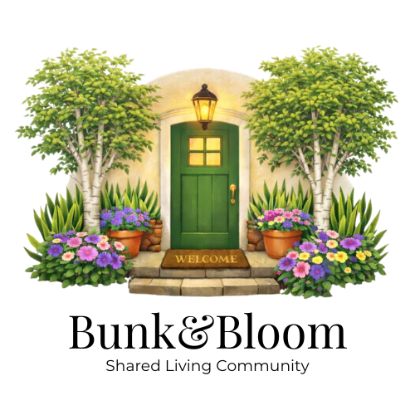

Member Application

Applicant Information
- Full Legal Name: ___________________________________________
- Preferred Name: ___________________________________________
- Date of Birth: _________________
- Phone Number: _______________________________
- Email Address: _______________________________
- Current Address: ______________________________
How did you hear about Bunk & Bloom? (check all that apply)
- ☐ Case Manager
- ☐ Friend / Family
- ☐ Social Media
- ☐ Google Search
- ☐ Website
- ☐ Other: ___________________________
Emergency Contact #1
- Name & Relationship: _________________________________
- Phone Number: ______________________________________
- Email Address: _______________________________________
Emergency Contact #2
- Name & Relationship: _________________________________
- Phone Number: ______________________________________
- Email Address: _______________________________________

Housing Information
- Desired Move-In Date: _____________________________________
- Preferred Room Type (Shared/Private): ________________________
- Anticipated Length of Stay: __________________________________
Eviction History
- Have you ever been evicted? ☐ Yes ☐ No
  - If yes, month & year of your most recent eviction: ____ / ____
Health & Safety Disclosure
- Are you leaving a residence that recently had any insect infestations (e.g., bed bugs, roaches)? ☐ Yes ☐ No
  - If yes, please explain:

Employment & Income
Current Employment Status: _______________________________

Employer #1
- Employer Name: ____________________________________
- Employer Address: __________________________________
- Manager/Supervisor Name: ___________________________
- Manager Email: _____________________________________
- Manager Phone: ____________________________________

Employer #2
- Employer Name: ____________________________________
- Employer Address: __________________________________
- Manager/Supervisor Name: ___________________________
- Manager Email: _____________________________________
- Manager Phone: ____________________________________

Income Sources
- Income Source #1 (e.g., employment, SSI, SSDI, pension): ____________________
  - Monthly Amount: $_______________
- Income Source #2: ____________________
  - Monthly Amount: $_______________
- Income Source #3: ____________________
  - Monthly Amount: $_______________
Total Monthly Income (all sources combined): $____________________

Independent Living Skills (check all that apply)
- ☐ Manages personal hygiene independently
- ☐ Manages medications independently
- ☐ Prepares own meals
- ☐ Cleans personal living space
- ☐ Manages appointments
- ☐ Manages finances/budgeting

Medical & Support Information
- Do you have any medical conditions staff should be aware of? ☐ Yes ☐ No
If yes, please explain:

Criminal Background History
- Are you currently on probation or parole? ☐ Yes ☐ No
- Have you ever been convicted of a felony? ☐ Yes ☐ No
If yes to either, please explain (charges, dates, and current status):

Community Living
- Have you ever been asked to leave a housing or community service program?
☐ Yes ☐ No
If yes, please explain:
- Describe how you typically handle conflict with others:

Applicant Acknowledgement
I certify that the information provided is true and complete to the best of my knowledge. I understand that Bunk & Bloom is an independent living home for adults and is not a medical, treatment, or assisted living facility.
Applicant Signature: ________________________________ Date: ____________

Fair Housing & Non-Discrimination Notice
Bunk & Bloom complies with the Wisconsin Open Housing Law and the Federal Fair Housing Act. We do not discriminate based on race, color, national origin, religion, sex, disability, familial status, marital status, sexual orientation, gender identity or expression, lawful source of income, age, ancestry, or any other protected class under applicable law. Reasonable accommodations may be requested.

Independent Living Readiness Questionnaire

This questionnaire helps determine whether Bunk & Bloom is a good fit for your needs and living style. Please answer honestly.
- Describe your typical daily routine:

- How do you manage stress, frustration, or conflict?

- How do you manage your medications and medical appointments?

- How do you handle cleaning and maintaining your personal space?

- Describe your experience living with others in a shared home:

- What kind of structure or boundaries help you be successful in housing?

- What support (if any) do you believe you need to live independently?

- Why are you interested in living at Bunk & Bloom?

