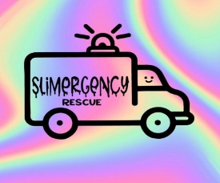SLiMeRGeNCY Rescue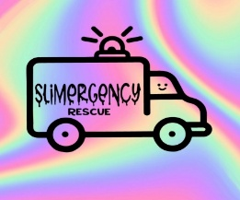
www.slimergencyrescue.com
slimergencyrecue@gmail.com

Name/Phone number/E-Mail _____________________________________________________

Who is this fun party for?
Name/s and Age/s: _____________________________________________________

Address of Party/Event _____________________________________________________

Date & Time of Party/Event _____________________________________________________

Age & Number of Participants _____________________________________________________

Party Theme _____________________________________________________

*VERY IMPORTANT - PLEASE NOTE* 3-5 days prior to your event, we will require a final headcount. You are responsible to pay for those listed participants. More can participate, and you will be charged according to your party package.
A $100 non-refundable deposit is due to hold your date. Balance is due on the day of the party and is non-refundable. We accept cash, Zelle (slimergencyrescue@gmail.com) Venmo (@slimergency-rescue) Credit Card with an additional 8% added. If your party is postponed due to sickness or emergency, you may reschedule within 30 days. If you do not reschedule within 30 days, your payment is forfeited. I have read the Slimergency Rescue party policies & agree to the terms & conditions. I agree that my $100 non-refundable deposit will be used to reserve a date for my party.

__________________________________ _________________________
Parent/guardian signature Date

