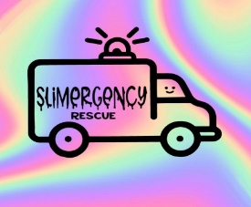SLiMeRGeNCY Rescue LLC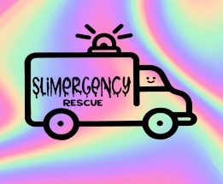
www.slimergencyrescue.com
slimergencyrecue@gmail.com
@slimergencyrescue
908-991-7767
CREATE-A-SLIME – Each participant will be introduced to up to 4 different 2oz sample slime textures that they get to take home. There will be many different choices of colors, scents & fun mix-ins as well. After a short presentation, each attendee will have a chance to customize their 2oz slimes. Then just like a buffet, they will come to the table/cart, pick their favorite charms, add-ins, premade slime base & continue to create their perfect 6oz slime to enjoy for months when taken care of properly.
*PLEASE NOTE* an additional $30 travel fee is added to requested events/parties that are 25 to 50 miles from Middlesex County NJ. Sites over 50 miles will be charged a fee of $50

1 1/2hr party - additional $75 per 30 minutes added to party time (2 1/2 hour max). If space allows, we bring our slime cart
- 30 min set up/20 min clean up not included in party time
- $450 for up to 15 participants
- $25 for each additional participant, up to 20 max with one attendant.
- Over 20 up to 30 attendees require an additional helper at $75
- 1 - 6 oz slime per participant with color/scents/mix-ins/charms included
- Birthday Boy/Girl can create 2 – 6oz slimes
- 3 Slime Base options – EX. floam , cloud, snow fizz, butter etc
- Multiple Color Options
- Scents - up to 5 choices (ex. Cotton candy, bubble gum, strawberry, etc)
- Mix-ins/Charms – foam balls, glitters, plastic straw beads etc.- we can accommodate most themes if given 2 WEEKS NOTICE
- Each participant will receive their own gift bag to hold their slime’s, care card and activator spray bottle
- Additional goodie bag items upon request - $3 additional per participant
SLIME FROM SCRATCH PARTY – Small group instruction - $35 per person with a minimum of 10 and a maximum of 15. This would include up to two hours of instruction, a goodie bag with activator and fun extras. 3-2oz customizable pre-made slimes included. We also make 2-6 oz different slimes from start to finish and if given two weeks notice, we can accommodate most themes.

POP-UP EVENTS WITH OUR SLIME CART – $125 non-refundable fee
with an additional $15-18 per person depending on size of slime/play dough.
2 hour time allotment. Additional charges for extended time. Minimum 12
$12-15 for play-doughs, $15-18 for slime, $18+ for a combo of both
Imagine an ice cream cart containing up to 5 premade slime/play dough bases with up to 7 additional add-on compartments for “toppings”, charms, add-ins (beads, “sprinkles”, fruits etc) Similar to CREATE-A-SLIME but we can customize the CART to a theme Ex. Ice cream, pizza, holidays, seasons and more!

CREATE-A-SLIME/SMALL GROUPS REQUIRE A $100 NON-REFUNDABLE DEPOSIT – we will apply your deposit to a rescheduled event if given at least 1 week notice, otherwise your deposit is fully non-refundable.

Please contact SlimergencyRescue@gmail.com directly for Schools, Brownies, Girl Scouts, Boy Scouts, party favors, sports team events & fundraising pricing

**FOR ALL SLIME EVENTS Additional slime bases of clear, jelly or icee, mix-ins, and character charms available upon request for an additional charge

***Please be advised we require enough space for our team to set up both a 6 ft & 4 ft folding table or our slime cart and a 6ft table.

****If for any reason slime gets on clothing, furniture, hair etc please have lemon juice/white vinegar or iodized salt handy to remove, works like a charm!

