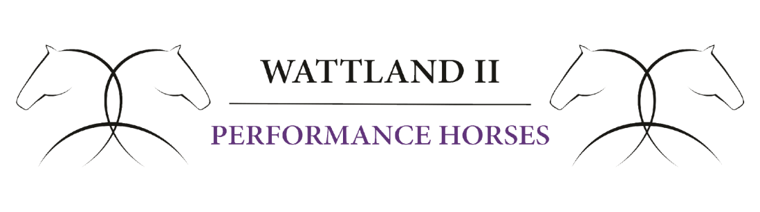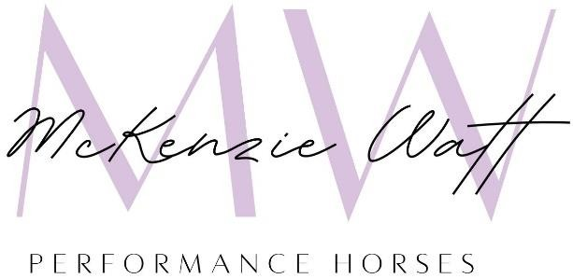

Riding Waiver and Release Form

Wattland II Inc. &
McKenzie Watt Performance Horses

6670 NW 82nd Terr,
Parkland FL 33076

Dawn Watt 954-520-5561 wattshowhorses@yahoo.com
McKenzie Watt-Talbott 954-914-8916

RELEASE, HOLD HARMLESS AND WAIVER OF LIABILITY

I, the undersigned for and exchange for participation in Equine Activities, including the permission to participate in any and all equestrian related activities and/or use of the property, facilities and services Wattland II Inc and all individual owners, landlord and agents of it, being permitted to be a lessee, spectator, rider, trainer, owner, groom, attendant, judge, minor chaperone, guest of a border/lessee, or any other equestrian or equestrian related activities including showing horses, taking lessons, jumping, walking or riding(all of the foregoing by way of example and not by way of limitation), the receipt and sufficiency whereof is all hereby acknowledged, do hereby agree and consent to the following:

RELEASE AND WAIVER FROM LIABILITY

In consideration of being permitted to participate in any capacity in activities within Wattland II Inc located at 6670 NW 82 Terr, Parkland FL 33067 and as set forth above, I, by execution of this General Release and Waiver of Liability, do hereby release McKenzie Watt Performance Horses & Wattland II Inc and all related affiliated corporations and individual property owners thereof, hereby RELEASE, WAIVE, DISCHARGE, AND COVENANT NOT TO SUE Wattland II for any and all damage, and any claims, including any claim of personal injury, death, or injury to or loss of personal property, whether arising from control or supervision of spectators, providing or failing to provide ambulance service, medical care, nursing care, paramedic care, basic life support care, emergency trauma care, advanced support care, first aid, emergency communication, emergency transportation, or design, maintenance or repair of any facility or anything or any other act caused by Owners Wattland I IncI or otherwise while I am in or upon premises Wattland II Inc. All personal property kept, placed or left on or about the premises of Wattland II Inc shall be at my sole risk as to los, theft, injury or damage and Wattland II Inc shall have no responsibility for such loss, theft, or damage, to any such personal property.

HOLD HARMLESS, Release

I hereby agree to INDEMNIFY AND SAVE AND HOLD HARMLESS McKenzie Watt performance Horses & Wattland II Inc, any Owners thereof, any sponsor, agent, landlord, their owners, their officers, their directors, members, affiliated organizations and any others acting on their behalf from any loss, liability, claims, rights for damages, costs or other expenses for any accident or injury’s which may occur to me, my animals or my adult guests including their minor children or legal wards at this activity and or event and location.

ASSUMPTION OF RISK

I hereby acknowledge and agree that horses, equine riding, hacking, cantering, galloping, jumping, and/or all other equestrian activities are dangerous and involve risk of serious injury and/or death and/or property damage and that the horses, equine, riding, hacking, cantering, galloping, jumping and/or all other equestrian activities are extremely dangerous and hazardous. I consciously and voluntarily assume all such risks, dangers and hazards inherent in these activities and assume the same risks for any invitees including, minor children or legal wards, I bring onto the Wattland II Inc property.

RULES

I agree to observe and obey all posted, written and oral rules and warnings and I further agree to follow any oral instructions or directions given by Wattland II Inc, its employees, representatives or agents of Wattland II Inc.

COSTS OF ENFORCEMENT

I agree to be liable for all of Wattland II Inc and all individual owners, landlord and agents of it, reasonable attorney’s fees and other costs resulting from my breach of any provision of the Release and Waiver. I further expressly agree that the foregoing release, waiver and indemnity provisions are intended to be as broad and inclusive as is permitted by law.

CHOICE OF LAW AND VENUE

I agree that this Release and Waiver shall be governed by and construed in accordance with the laws of the State of Florida. In the event any action, suit or proceeding is instituted as a result of any matter or thing affecting this Release and Waiver, the parties hereto hereby designate Broward County, Florida, as the proper jurisdiction and the venue in which same is to be instituted.

WARNING
CAUTION: HORSEBACK RIDING CAN BE DANGEROUS. RIDE AT YOUR OWN RISK.

Under Florida Law, an equine activity sponsor or equine professional is not liable for any injury or the death of, a participant in equine activities resulting from the inherent risks of equine activities. FLORIDA STATE STATUTE 773.04

If the below Participant/Guest is a minor, said minor must be accompanied by the parent or Legal guardian whose signature is on file for this Waiver/Release.
NOTE: This Waiver/Release form shall be valid for 1 (One) year from the date of signature and shall cover any and all events within that year.

Having read the preceding, I acknowledge my understanding of those risks set forth herein and knowingly agree to accept full responsibility for my exposure to such risks. I acknowledge a full and complete understanding of the limitations of liabilities and waiver of certain rights that I may have and granting of releases contained herein and knowingly consent thereto.

DATE:_____/_____/20____

Print Participant Name____________________________________ Date of Birth of Participant:_____________________

Address:__________________________________________________________________________________________

City,State,Zip:_____________________________________________________________________________________

Cell:_______________________________ Email Address:__________________________________________________

Emergency Contact:_______________________________________Phone:____________________________________

Signature____________________________________________
Participant / Legal Guardian

