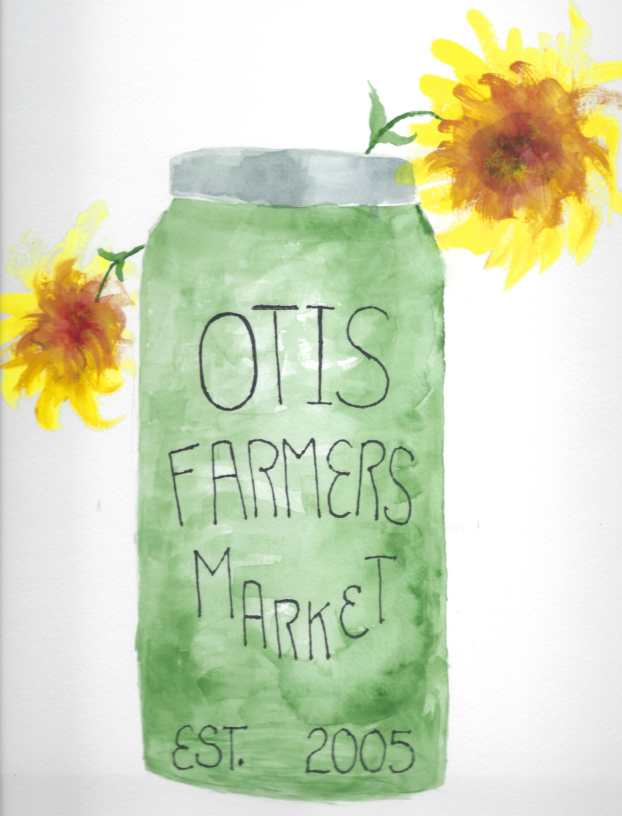

June 12th, 2024

Dear CSM Member~

Welcome back to our 11th CSM season at the Otis Farmers Market! Hard to believe we have been offering this for over a decade! Thanks to your support we can continue to offer it!

Just as we have done the past five years, the Gran-val Scoop will once again be offering ice cream as an add-on to your share, if you would like to subscribe. The cost added would be $12 a week for 2 pints ($120 total added to share) or $18 a week for 2 quarts ($180 total added to share). You would get to choose one flavor a week, and the other flavor is a surprise.

Below are a few guidelines to follow as well as questions for you to answer and get back to us in the stamped envelope.

*The CSM will run from **June 29th to August 31st** this year, which will give you 10 full Saturdays during our peak season. When you sign up for the CSM you are signing up for these dates, so please be sure that these dates work for you. There will be no substitute dates given. And please note that if you sign up for the 10 dates then you are expected to be a part of the CSM for 10 weeks. Withdrawing from the CSM before the 10 weeks are over is not an option.

*Pick up time is again between the hours of 10 am to 1 pm. Please note that if you do not pick up your share by 1 pm it will be diverted back amongst the market vendors (or given to an individual who could use it) and **no refund will be given**. If you are not able to pick up your share, please make arrangements for someone to do so for you. Also, keep in mind that if you are signing up for the special offer from the Gran-val Scoop, you will want to pick up your share sooner than later!

*Bringing your own bags for your share is totally fine, and a huge help. If you remember, please bring yours!

*If you or anyone in your family has any allergies to foods please be sure to clearly state what they are in your application so that those foods can be avoided in your share. The same goes with any restrictions you may have, such as vegetarian or gluten-free. We will make accommodations accordingly. Remember that your share will include baked goods, canned goods, eggs, meat, produce and soap. You will also be asked to provide any allergies to the ice cream that is being offered, such as to nuts. We will also be asking you which flavors you like and which you don’t, on the attached subscription sheet.

*Each week we strive to provide you with a variety of market goods. We do not want to give you the same thing week after week. Four years ago we created themes for the shares which went over very well! If you have any suggestions for themes, please share them! We love trying out different things! We try to include different aspects of the market to broaden your horizons on what is out there. At one point during the 10 weeks you will also receive what is called a Dry Goods Coupon, worth $5 at any of the craft vendors at market. You will have until the end of the market season to use this coupon.

*The level of shares available are as follows:

~ 1 person / Lone Farmer: $16 per week = **$160 share total**

*With ice cream sub. of 2 pints: $28 per wk/$120 = **$280 share total**

*With ice cream sub. of 2 quarts: $34 per wk/$180 = **$340 share total**

~ 2 people / Goose & Gander: $26 per week = **$260 share total**

*With ice cream sub. of 2 pints: $38 per wk = **$380 share total**

*With ice cream sub. of 2 quarts: $44 per wk = **$440 share total**

~ Family / Feed Herd Bag: $51 per week = **$510 share total**

*With ice cream sub. of 2 pints: $63 per wk = **$630 share total**

*With ice cream sub. of 2 quarts: $69 per wk = **$690 share total**

Payment for your share can be made in full or half prior to the peak season. We ask that you NOT pay week by week this year, as we need to plan ahead of time how many shares we will need for that week. If you are a “no show” it still leaves us with a share put aside for you that the vendors have to be paid for. Please keep in mind, that if you only pay a portion toward your share you will only receive that amount of shares and will not receive further shares until more money is received. Checks can be made out to **The Otis Farmers Market Inc.**

*If you have any problems or questions regarding your CSM share please feel free to contact the Market Manager, Jess Ripley at the following numbers:

Home: 413-357-9919

Cell: 413-233-7400 (can also text)

Email: [OtisFM1@ymail.com](mailto:OtisFM1@ymail.com)

We appreciate each and every one of you who has taken part in this, and those that have grown with these shares from year to year! We welcome all new comers to the CSM’s and hope that we exceed your expectations! We look forward to picking out the best of our market each week, and hope that we can open your eyes to new possibilities!

Yours in farming,

The Otis Farmers Market

***\*Please return this sheet in the stamped envelope\****

Name(s): ___________________________________________

Mailing Address: _____________________________________

_____________________________________

Phone #(s): ___________________ ______________________

Email Address: _______________________________________

Best Way to Contact you: _______________________________

**Please circle the share that you are signing up for:**

**Lone Farmer Goose & Gander Feed Herd Bag**

1. Are there any stipulations that you need us to know about, such as food allergies or food restrictions (gluten free or no meat)? Or simply list a food that you just detest and do NOT want to see in your weekly bag! Please explain: ___________________________________________________

______________________________________________________________________________________________________

1. Do you have a friend that is also signing up for a CSM share? If so please give their name: ________________________________

By signing up your friend you will receive special perk CSM benefits! So, be sure to tell us who it is!

1. Please circle your method of payment and write the amount that you are paying at this time: Please make check out to:

The Otis Farmers Market Inc.

**Check or Cash Amount Enclosed: $__________**

***\*Please return this sheet in the stamped envelope, ONLY if you wish to participate in the ice cream subscription\****

**~ The Granv-val Scoop Ice Cream Subscription ~**

*Each week you will receive either 2 pints or 2 quarts of ice cream in your CSM share, depending on what you sign up for. Two pints a week will add $10 a week, and 2 quarts a week will add $14 a week on to your share. One of those flavors of ice cream will be from the list below, the other flavor will be a surprise (but will go off of your suggestions as to what you like). Please list below any allergies you have (such as to nuts) or any flavors that you absolutely do NOT like. You may just end up with a new favorite flavor!

___________________________________________________________________________________________________________________________________________________________________________________________________

*Please number your ice cream choices from 1 to 10, in order of which flavor you would like each week. You may star other flavors that you wouldn’t mind receiving, in case there needs to be a substitute:

___ Chocolate

___ Dark Chocolate

___ Chocolate Peanut Butter Cup

___ Mint Chocolate Chip

___ Mocha Chip

___ Brownie Dough

___ Cookie Dough

___ Coffee

___ Coconut

___ Sweet Cream

___ Maple Cream

___ Maple Walnut

___ Almond Butter Crunch

___ Almond Joy

___ Peppermint Stick

___ Black Raspberry

___ Strawberry

*Please check off if you would like pints or quarts:

**_______ Pints _______ Quarts**