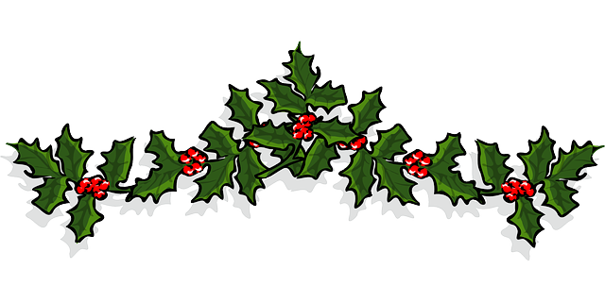

1ST, 2ND & 3RD PRIZES TO BE AWARDED!!!

# **BURNHAM BOROUGH’S**

# **4th ANNUAL CHRISTMAS**

# *RESIDENTIAL*

# DOOR DECORATING CONTEST

GET OUT YOUR HOLIDAY DECORATIONS.

**BE CREATIVE.**

**BE FESTIVE.**

MAKE YOUR DOOR THE BEST DRESSED DOOR IN THE NEIGHBORHOOD!

To enter, complete entry form and return it to

BURNHAM BOROUGH

200 FIRST AVE

BURNHAM, PA. 17009

**BY December 14**

JUDGING OF THE DOORS WILL BE HELD AT 5:30 PM DECEMBER 16, 2018

WINNERS WILL BE ANNOUNCED ON THE BOROUGHS WEBSITE BY DECEMBER 22, 2018

www.burnhamborough.net

*2018 ENTRY FORM*

NAME: _______________________________

PHONE: ______________________________

ADDRESS: ____________________________

____________________________