starters

Handhelds
(Includes One Side)

PC SIGNATURE BURGER* - $13
Fresh pattied burger topped with thick cut bacon, cheddar cheese, slow roasted tomatoes, and fried leeks
CHICKEN TENDERS - $12
Hand breaded chicken tenders served with your choice of sauce (Sauces on back of menu)
GRILLED CHEESE - $7
American Cheese between Texas Toast (add bacon $2, pulled pork or chicken bites $4 each)
PULLED PORK SANDWICH - $12
Brioche bun, roasted pulled pork, BBQ, and fried leeks
ALL ANGUS BEEF HOT DOG - $10
Choice of two toppings: Chili, PC Beer Cheese, Bacon, Tomato, Onion, Relish, Pickle (additional toppings $1 each)
HAMBURGER* - $10
Fresh pattied burger. (Add cheese $1 or bacon $2) Cheese: Swiss, American, Pepper Jack, and Cheddar
CUBAN SANDWICH - $13
Classic Cuban pulled pork, ham, mustard, mayo, pickle and swiss cheese
PC CLASSIC BLT - $11
Texas Toast, sliced tomatoes, thick cut bacon, romaine leaves, and mayo
CHICKEN PHILLY - $13
Cuban loaf, grilled chicken, onions, peppers, and PC beer cheese
PC GRINDER - $13
Cuban loaf, Fontanini’s Italian Sausage, marinara, onions, peppers, and mozzarella cheese
GRILLED CHICKEN - $13
Grilled chicken, garlic mayo, swiss cheese on a Brioche bun
CAJUN CHICKEN - $13
Grilled chicken, citrus mayo, pepper jack cheese on a Brioche bun

LOADED FRIES OR LOADED NACHOS - $10
Flat Fries or Tortilla Chips, shredded cheese, green onion, bacon bits and PC Beer Cheese on the side
PICKLE BALLS - $10
Our twist on fried pickles, with cream cheese, lightly breaded and served with PC Sriracha Aioli
CHEESE CURDS - $10
Lightly breaded white cheddar curd, served with PC Signature Sauce
BUFFALO CHICKEN BITES - $10
Lightly breaded bites tossed in buffalo sauce served with house made PC ranch
PC BEER CHEESE & PRETZELS - $10
Baked Pretzel loaves with our house made PC Beer Cheese made with Exile Ruthie Beer
BUFFALO CHICKEN DIP - $11
Buffalo Chicken, Bleu Cheese, and green onions, served with tortilla chips
STARTER SAMPLER PLATTER - $20
1 Full order of Cheese Curds
1 Full order of Chicken Bites
5 Pickle Balls
2 Pretzel Rolls
PC Signature Sauce
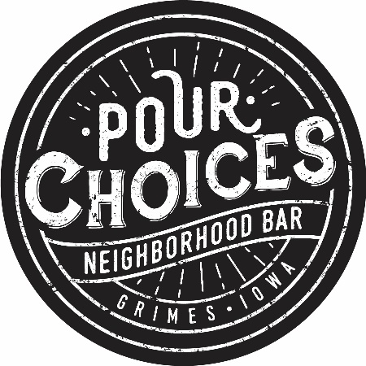
PC Beer Cheese
PC Ranch
PC Sriracha Aioli
(No Substitutions)

