SAUCES

MAINS
(Each entrée served with grilled Texas Toast)

BUFFALO SALAD - $13
Buffalo chicken bites, iceberg/romaine blend, Bleu cheese crumbles, diced tomato, diced cucumber, red onion, and choice of dressing
CHEF’S SALAD - $12
Iceberg/romaine blend with ham, hardboiled egg, bacon, tomato, onion, cucumber, and choice of dressing
CAVATELLI - $13
Fontanini’s Italian Sausage, pasta, marinara, diced tomato, mozzarella, and parmesan
MAC & CHEESE - $12
Add in-house made bacon - $2
Add pulled pork or Buffalo Chicken Bites - $4
Classic mac elbow noodles tossed with our house made cheese sauce, topped with shredded cheddar, and breadcrumbs
CAJUN CHICKEN PASTA - $13
Pasta, grilled diced chicken, asparagus, all tossed with an in-house made lightly spicy cream sauce

PC SIGNATURE SAUCE*
(Sweet Chili Garlic Style)
FRENCH
HONEY MUSTARD
PC RANCH*
ITALIAN
BBQ
PC BLEU CHEESE*
PC BEER CHEESE* ($1 Extra)
PC SRIRACHA AIOLI*
Made Fresh in-house*
Additional Sauce 25¢
SWEETS

PC BROWN BUTTER CAKE - $8
Topped with Vanilla Bean Ice Cream, choice of Caramel & Chocolate or mixed berries (Pecans Optional)
DRINKS $2

COKE MR. PIBB
DIET COKE MELLOW YELLOW
SPRITE
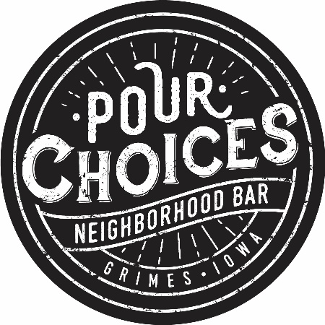
SPRITE ZERO
LEMONADE
ICED TEA
ORANGE JUICE
CRANBERRY JUICE
TONIC WATER
DIET TONIC WATER
SODA WATER
RED BULL
SF RED BULL
COFFEE
FLAT FRIES - $4
The latest twist on fries with a little bit of potato skin on them
SWEET POTATO FRIES - $4

CREAMY PESTO PASTA SALAD - $4
GRILLED ASPARAGUS - $4

SIDE SALAD - $5

SOUP OF THE DAY/CHILI - $3
sides

