This Press/Media Kit for children’s book author Tami Charles contains the following:

- High resolution author photo
- Bio
- Books (cover, synopsis)
- Awards, reviews, & recognition
- Media links
- Contact details

Photo—right click to save

Direct link here.

Bio:
Former teacher. Wannabe chef. Tami Charles writes picture books, middle grade, young adult, and nonfiction. Her middle grade debut novel, Like Vanessa, earned Top 10 spots on the Indies Introduce and Spring Kids' Next lists, three starred reviews, and a Junior Library Guild selection. Her recent titles include a picture book biography, Fearless Mary, humorous middle grade novel, Definitely Daphne, and forthcoming titles published by Sterling, Charlesbridge, Candlewick Press, and more. When Tami is not writing, she can be found presenting at schools both stateside and abroad.

Books

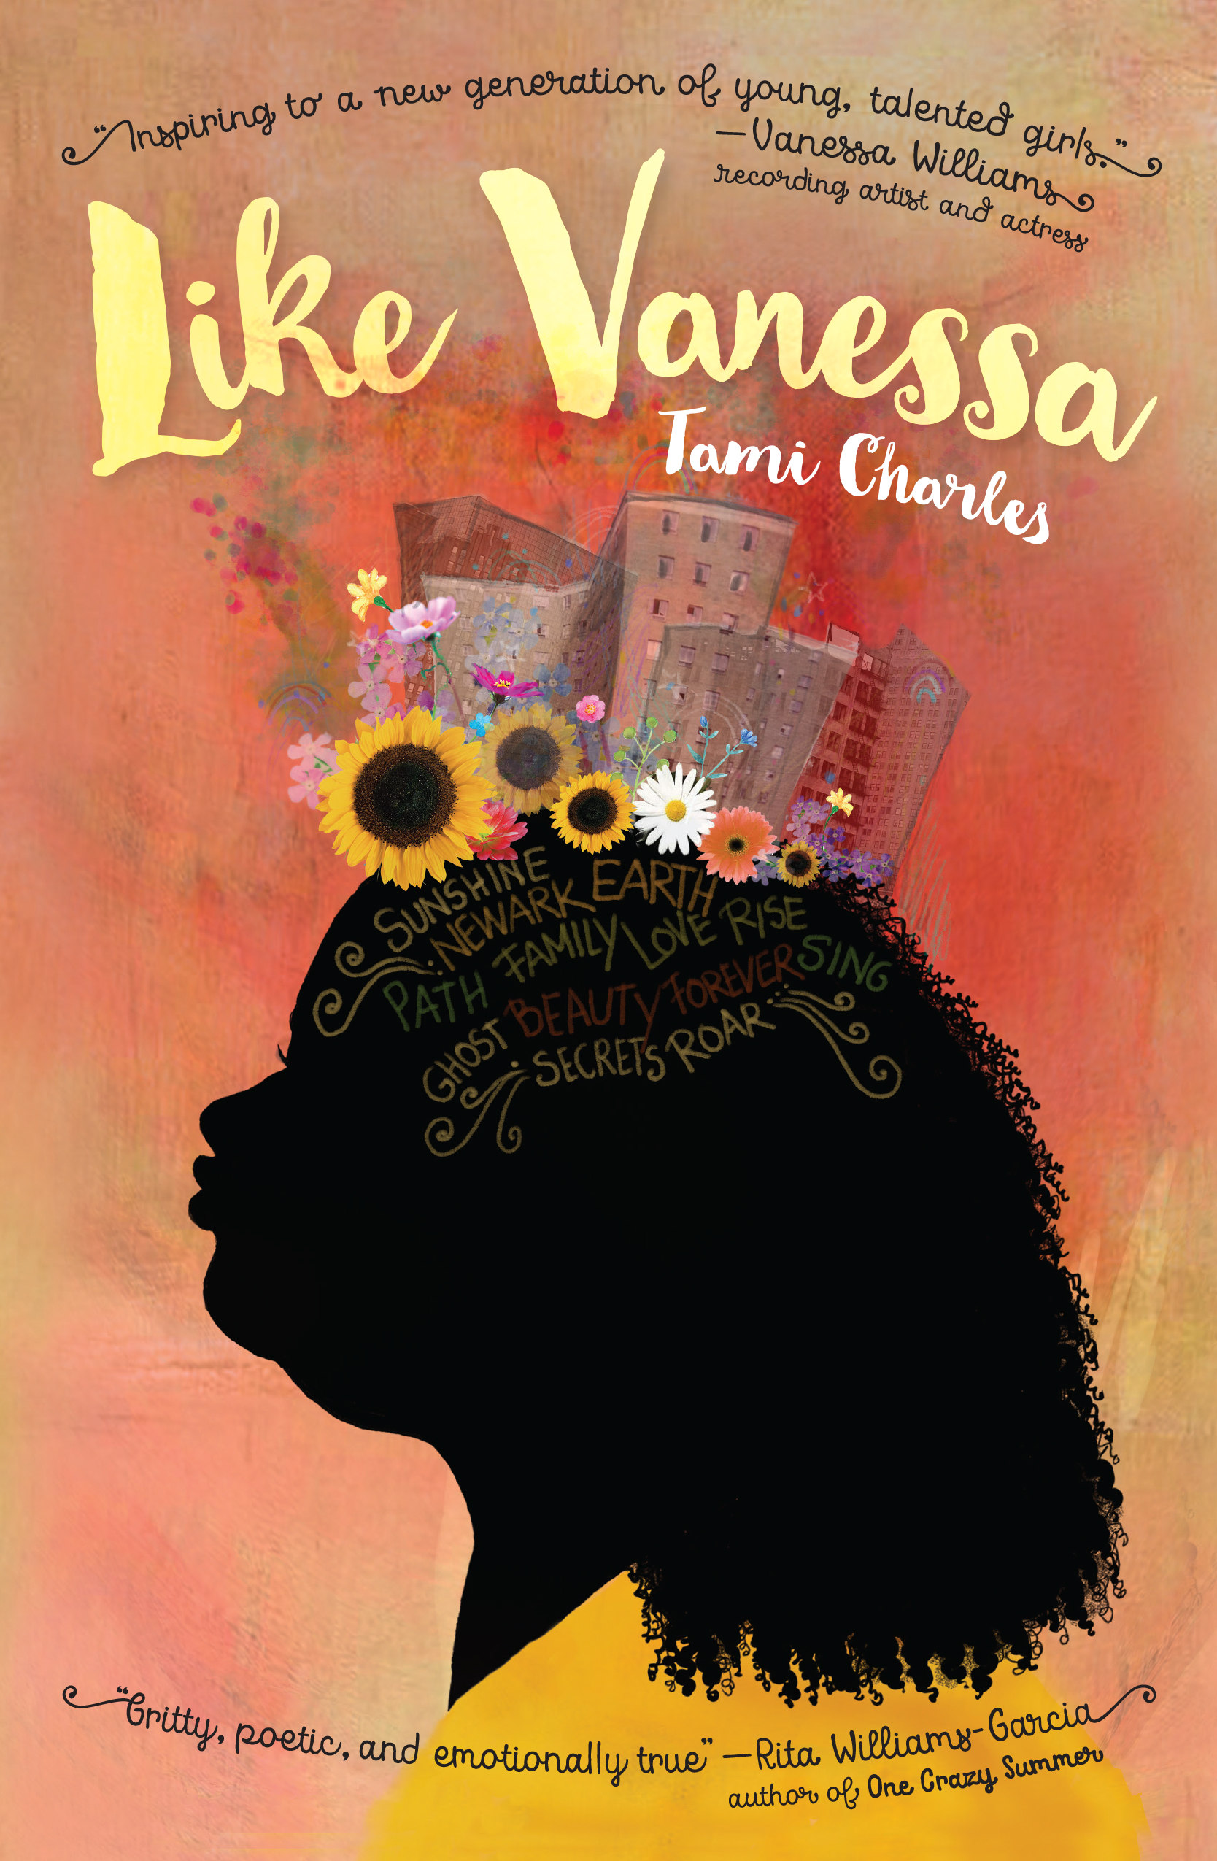 High resolution cover—right click to save
Direct link here.

Synopsis: In this semi-autobiographical debut novel, thirteen-year-old Vanessa Martin watches as the first black Miss America is crowned. It's 1983 in Newark, New Jersey, and Vanessa's life is a far cry from the glamorous Miss America stage. She struggles with family, friendships, racism, and self-confidence. When a new teacher at school coordinates a beauty pageant and asks Vanessa to enter, Vanessa decides there's no way. But with help from Pop Pop and her cousin TJ, Vanessa prepares for the challenge. Add in the neighborhood mean girl, a mysterious envelope addressed to Vanessa, and trying to make monthly ends meet, and eighth-grade is as stressful as it gets.

Awards, reviews, & recognition

"Charles evades the clichés and imbues Vanessa with an inner life that's so real and personal it's hard to deny the charm, heartbreak, and triumph of her story. . . . Superb."— Booklist STARRED REVIEW

"This debut is a treasure: a gift to every middle school girl who ever felt unpretty, unloved, and trapped by her circumstances."— Kirkus Reviews STARRED REVIEW

“An emotionally potent, engaging young adult story. . .” Foreword Reviews, STARRED REVIEW

"Inspiring to a new generation of young, talented girls." —Vanessa Williams, recording artist and actress

"Gritty, poetic, and emotionally true." —Rita Williams-Garcia, author of One Crazy Summer

2017 Indie's Introduce Winter/Spring 2018
2017 Kids' Indie Next Spring 2018
2017 SCBWI Book Launch Award
A 2018 Junior Library Guild Selection
Best New Books of 2018 List, First Book
Project Lit Top 10 Middle Grade List
We Need Diverse Books/ Goodreads "Must Reads" of 2018 List

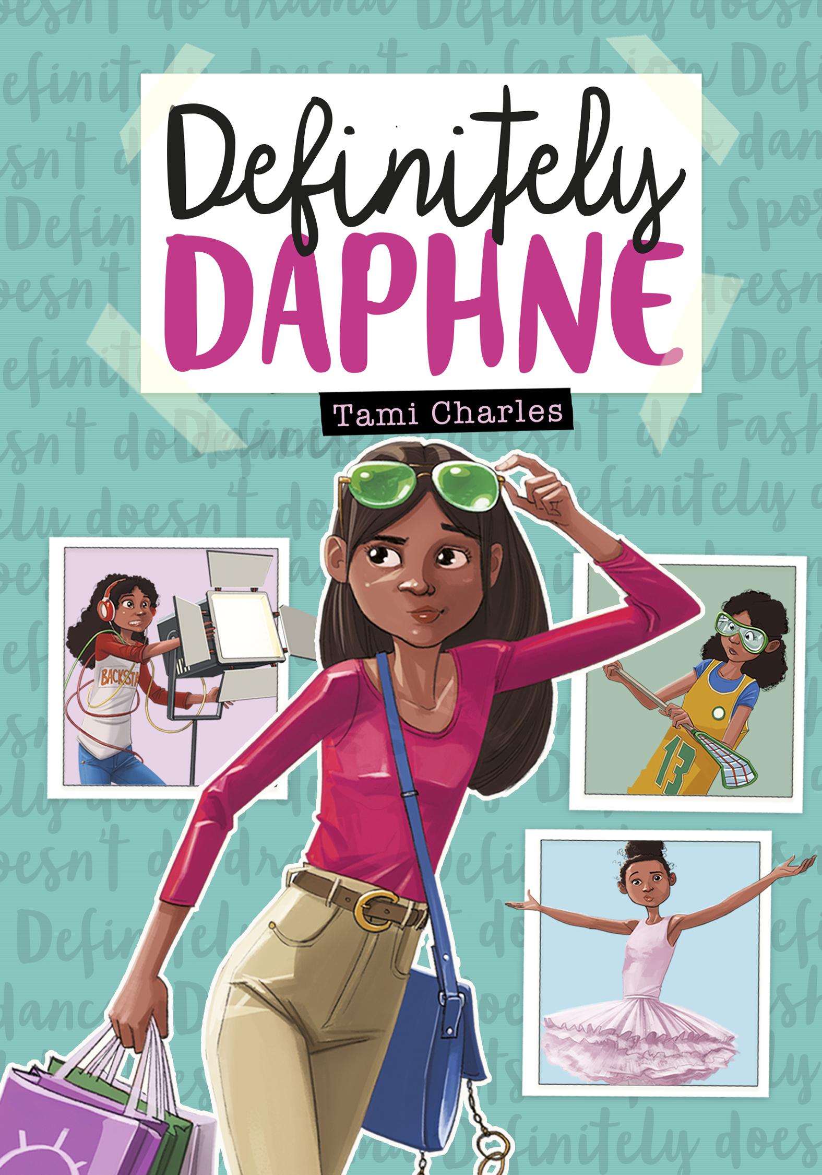 High resolution cover—right click to save
Direct link here.

Synopsis: In front of her followers, Daphne is a hilarious, on-the-rise vlog star. But at school Daphne is the ever-skeptical Annabelle Louis, seventh-grade super geek and perennial new kid. To cope with her mom's upcoming military assignment in Afghanistan and her start at a brand new middle school, Annabelle's parents send her to a therapist. Dr. Varma insists Annabelle try stepping out of her comfort zone, hoping it will give her the confidence to make friends, which she'll definitely need once Mom is gone. Luckily there is one part of the assignment Annabelle DOES enjoy--her vlog, Daphne Doesn't, in which she appears undercover and gives hilarious takes on activities she thinks are a waste of time. She is great at entertaining her online fans, yet her classmates don't know she exists. Can Annabelle keep up the double life forever?

Awards, reviews, & recognition
"Text-message transcripts and Annabelle's imaginary scripts enliven her narration. . . .it is refreshing to see diverse characters tackling the normal highs and lows of middle school life." - Kirkus Reviews

"Charles succeeds in capturing the particular brand of anxieties that accompany the middle school years: concerns about friends, relationships, and the influence of social media. Over the course of the novel, Annabelle gradually discovers that she can make friends by being herself rather than pretending to be someone else. Recommend for those who enjoy funny and fast-paced stories about school and friends." - School Library Journal

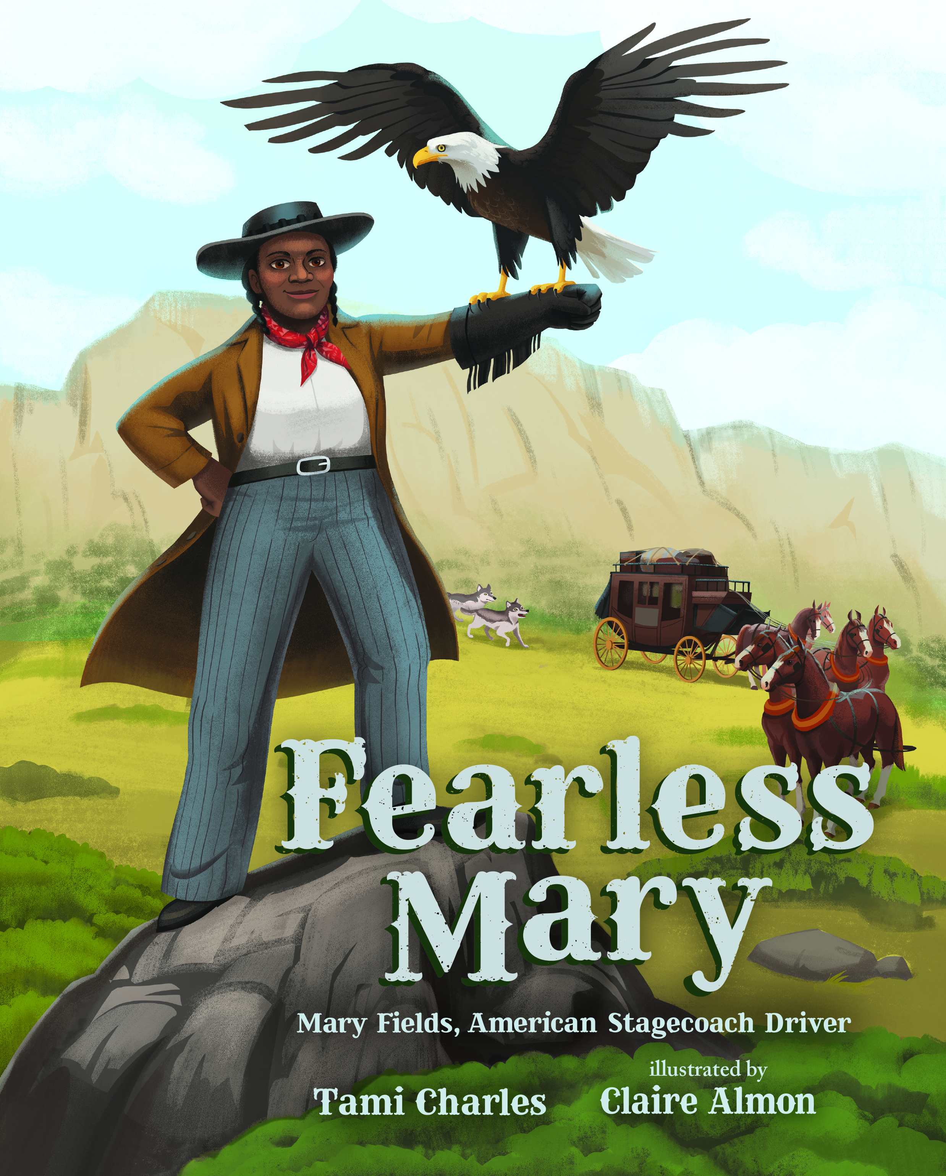 High resolution cover—right click to save
Direct link here.

Synopsis: A little-known but fascinating and larger-than-life character, Mary Fields is one of the unsung, trailblazing African American women who helped settle the American West. A former slave, Fields became the first African American woman stagecoach driver in 1895, when, in her 60s, she beat out all the cowboys applying for the job by being the fastest to hitch a team of six horses. She won the dangerous and challenging job, and for many years traveled the badlands with her pet eagle, protecting the mail from outlaws and wild animals, never losing a single horse or package. Fields helped pave the way for other women and people of color to become stagecoach drivers and postal workers.

Awards, reviews, & recognition

From the moment Mary rides into town, readers will be hooked….A wild ride through an impressive bit of history.- Kirkus Reviews

This picture-book biography reimagines Mary’s successful tryout against younger white cowboys to become the first African American female stagecoach driver in the country.
- Booklist

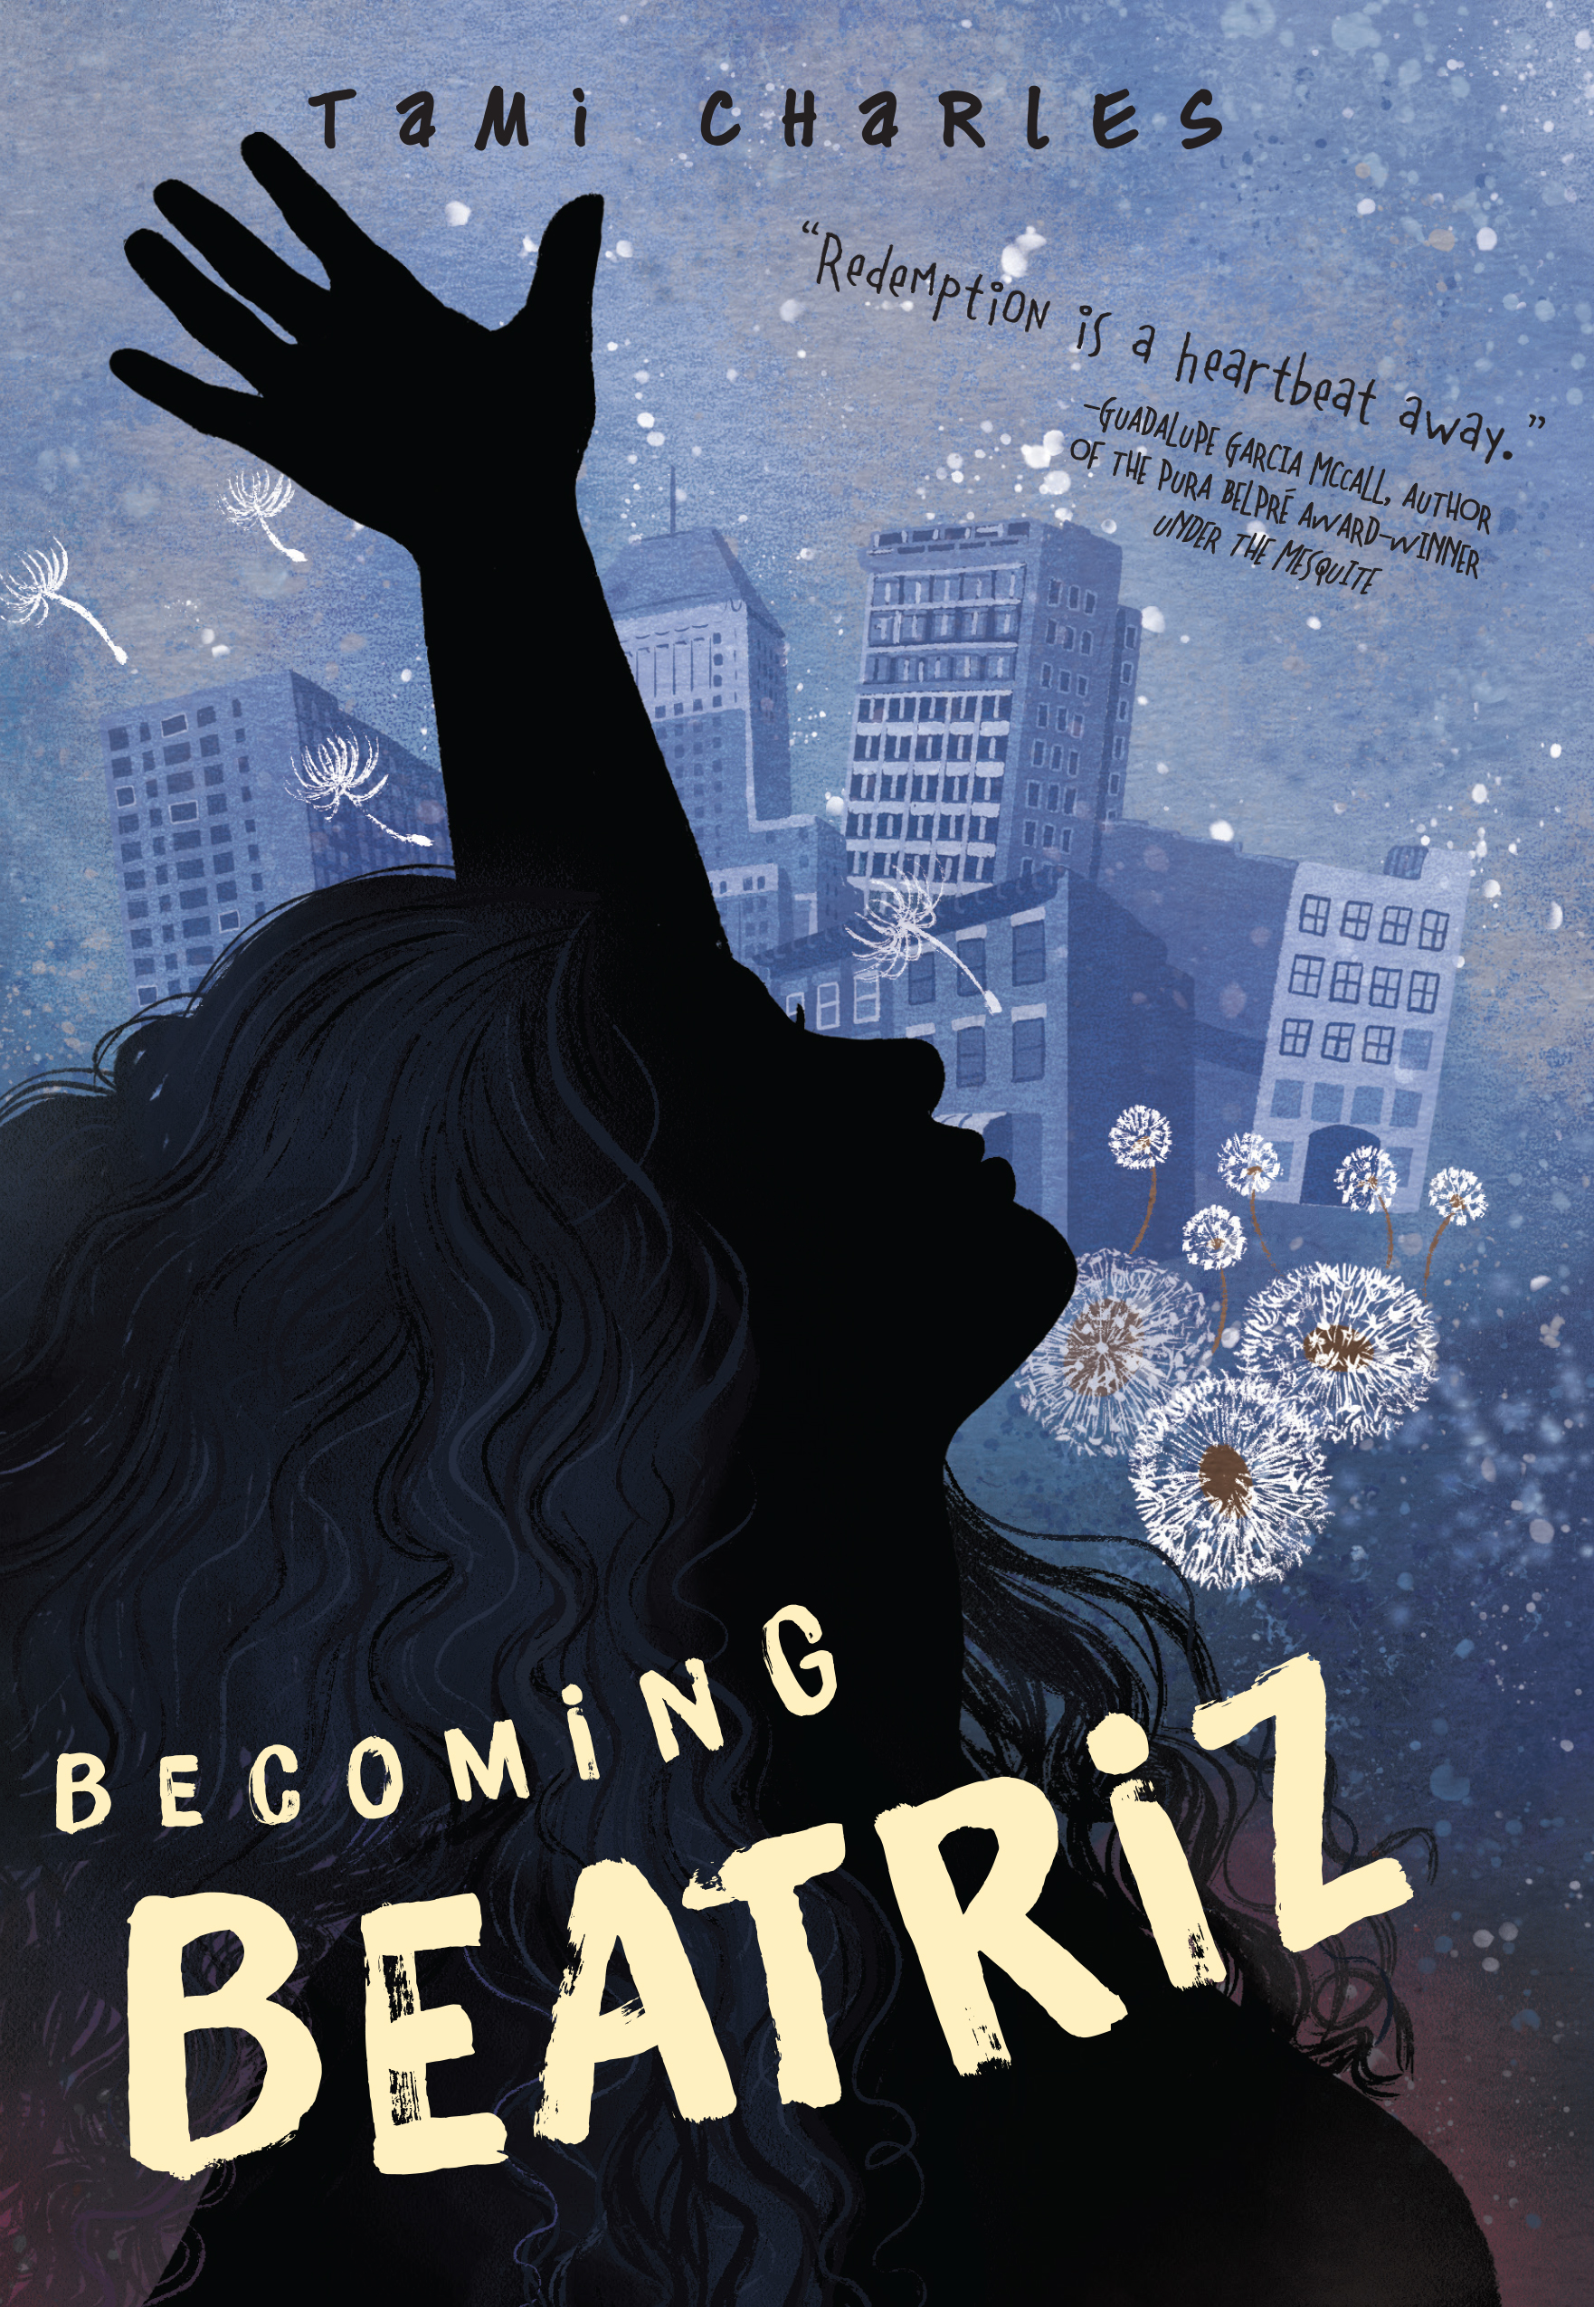 High resolution cover—right click to save

Direct link here.

Synopsis: Beatriz dreams of a life spent dancing–until tragedy on the day of her quinceañera changes everything.

Up until her fifteenth birthday, the most important thing in the world to Beatriz Mendez was her dream of becoming a professional dancer and getting herself and her family far from the gang life that defined their days–that and meeting her dance idol Debbie Allen on the set of her favorite TV show, Fame. But after the latest battle in a constant turf war leaves her gang leader brother, Junito, dead and her mother grieving, Beatriz has a new set of priorities. How is she supposed to feel the rhythm when her gang needs running, when her mami can’t brush her own teeth, and when the last thing she can remember of her old self is dancing with her brother, followed by running and gunshots? When the class brainiac reminds Beatriz of her love of the dance floor, her banished dreams sneak back in. Now the only question is: will the gang let her go?

Set in New Jersey in 1984, Beatriz’s story is a timeless one of a teenager’s navigation of romance, gang culture, and her own family’s difficult past. A companion novel to the much-lauded Like Vanessa.

To be published September 17, 2019.

Media links:

- Appearance on Good Morning America
- Charlesbridge Unplugged Podcast
- Publisher’s Weekly Podcast: A Conversation with Tami Charles
- Like Vanessa Book Trailer
- Definitely Daphne Book Trailer
- University High School, Author Visit
- Interview, Book Riot
- Interview, From the Mixed up Files
- Interview, YAYOMG!
- Interview, Medium.com
- Facebook Live Interview, Cardinal Rule Press
- Interview, KidLit 411
- 3 Questions with Tami Charles, Children’s Book Council
- Day 25: Tami Charles, Brown Bookshelf
- Storystorm Success
- Black Girls Nerds Review
- Indies Introduce Q & A
- Cover Reveal, Here Wee Read
- DIYMFA Podcast, Episode 210
- “Finding Your Squad,” Writer’s Digest
- Librarian Laura’s Review, Definitely Daphne
- Fearless Mary Review, Here Wee Read
- A Book & A Hug Review

Contact details

Author, Tami Charles

Email: tamicharles@gmail.com
Website: www.tamiwrites.com
Instagram: @tamiwrites
Twitter: @TamiWritesStuff
Skype: Tami Charles

Literary Agent, Lara Perkins
Email: laraaperkins@gmail.com

Booking Agent, Sarah Azibo, Booking Biz
Email: saraha@thebookingbiz.com

Publicists, Donna Spurlock & Mel Schuit
Charlesbridge Publishing
Titles: Like Vanessa, Becoming Beatriz
Email: mschuit@charlesbridge.com
Email: dspurlock@charlesbridge.com

Publicist, Tracie Schneider
Associate Marketing Manager, Laurel Symonds
Albert Whitman & Company
Title: Fearless Mary
Email: lsymonds@albertwhitman.com
Email: tschneider@albertwhitman.com

Marketing Director, Shannon Hoffmann
Capstone Publishing
Title: Definitely Daphne
Email: shoffmann@capstonepub.com

Publicist, Phoebe Kosman
Candlewick Press
Title(s): Freedom Soup, A Day with the Panye
Email: Phoebe.Kosman@candlewick.com

