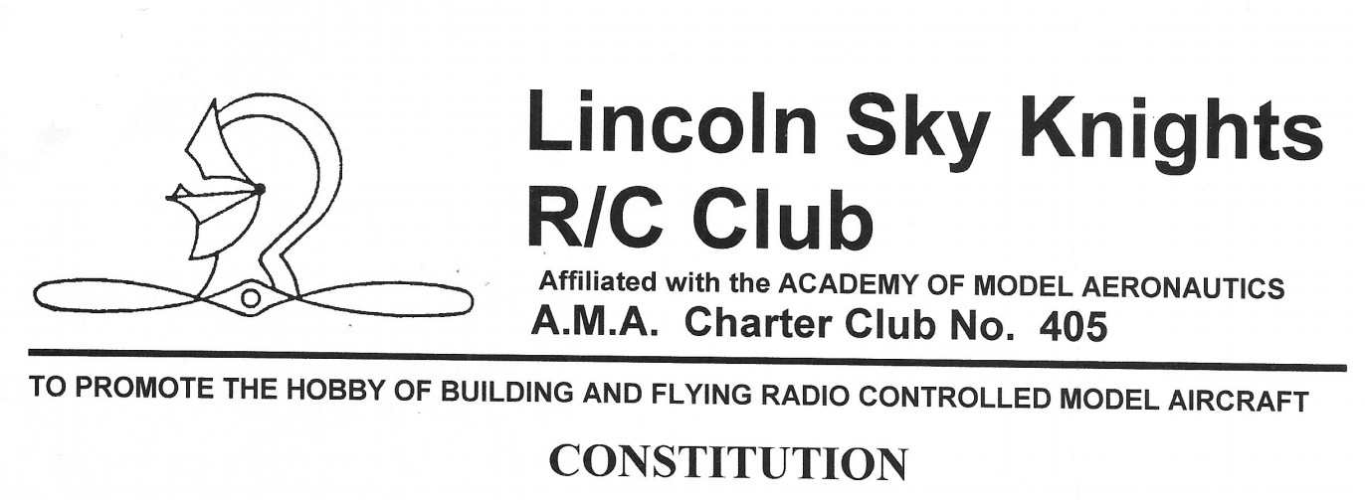
ARTICLE I - Name
The name of this organization shall be "Lincoln Sky Knights R/C Club”
Location: 1/4 Mile North of 134th and Waverly Road
Latitude: 40 deg 55' 53.44" N Longitude: 96 deg 32' 16.82” W
As decimal GPS: 40.931611, -96.538093
ARTICLE II - Purposes
This club will conduct business as a nonprofit organization that encourages and promotes all aspects of model aviation. The club will adhere to the rules and regulations of the Academy of Model Aeronautics (AMA), Federal Communications Commission (FCC), the State of Nebraska, and any local ordinances, as they pertain to the building and flying of Model Aircraft, small Unmanned Aircraft Systems (SUAS), Unmanned Aerial Vehicles (UAV), Remotely Piloted Aircraft, Multirotor (MR), and Drones.
ARTICLE III - Membership

Qualifications

Full Members
- Shall hold a current membership in the Academy of Model Aeronautics (AMA).
- Shall pay annual club dues.
- Shall be entitled to all club rights and privileges.

Restricted Members
- Shall have all club rights and privileges, except flying.
- Shall pay ½ the annual club dues, while retaining all voting rights.

Associate Members
- Shall be 19 years of age or under as of July 1st for the current fiscal year.
- Shall be a member of the AMA.
- Shall have all club rights and privileges, except voting.
- Shall pay club dues as outlined in the LSK “Application for Membership Form”.
- Pilots under 16 years of age must be supervised by a Full Member while flying or must get approval from the board after completing a skills and safety assessment.

Admission
- A prospective member shall be required to fill out, and submit, a “LSK Membership Application Form” along with proof of AMA Membership, to the club officers for consideration.
- A prospective member shall then present themselves, in person, at a regular club meeting for membership consideration. If a prospective member cannot attend a regular club meeting, two LSK members in good standing, may present the applicant's membership request to the club for consideration.
- A simple majority vote of the members present at the regular club meeting will confirm acceptance of a new member.
- A new member shall not be afforded the rights and privileges of membership until his or her club dues are certified as paid by the treasurer.
- A new member, who has paid their club dues, shall be given access to the current Constitution. Members are strongly encouraged to read and understand these Bylaws.
ARTICLE IV - Termination of Membership
- Any member may resign by filing a written resignation with the secretary.
- Allowing AMA license to expire (not applicable for "Restricted Members).
- Becoming delinquent in payment of club dues.
- Voluntarily contravening the purposes or rules of the club, after which, two thirds of the members present at the regular club meeting may vote the offending member out of the club.
ARTICLE V - Reinstatement of Membership
- Membership terminated by voluntary contravening, Article IV-4, may be reinstated by a vote of approval of two thirds of the members present at a regular club meeting.
- Membership terminated by lapsing of AMA membership shall be reinstated when a current AMA card is presented to the club officers.
- Membership terminated through non-payment of club dues shall be reinstated when all current dues are certified paid by the treasurer for the current fiscal year.

ARTICLE VI - Club Dues
- The club’s fiscal year shall run from January 1st to December 31st.
- Club Dues will be set at the October meeting for the upcoming year.
- Club Dues shall be due and payable during the month of January, of each year, or anytime sooner.
- Unpaid members, after of Jan 1st of the current fiscal year, are forbidden to fly until Club Dues are paid in full.
- All new members, potential new members and applicants for membership will be advised of their club financial obligation on the LSK membership application form. When accepted as members, new members will be assessed a pro-rated fee for their Club Dues, as set forth in the Application Form, based on the time of year the membership starts.
- Pro-rated Club Dues only apply to new memberships. All other members in default of payment will be assessed the full amount for the remainder of the year.
- Lifetime memberships (granted before July 1, 2005) shall be honored in accordance with terms in effect at the time such memberships were accepted
ARTICLE VII - Officers
- The Elected Officers of the club shall consist of President, Vice President/Contest Director, Secretary, Treasurer, and Safety Officer.
- The term of office shall be one calendar year beginning January 1st and ending December 31st.
- Revised 2015, removed term limits for all officers.
- The duties of the officers shall be:
  - President: The president shall preside at all meetings. The president shall have the power to establish committees. The president shall have the power to call special meetings provided all club members are notified in writing (e.g. email) no less than 5 days prior to the meeting. The purpose of a special meeting shall be stated in the notice and all discussion shall be limited to that topic. The president shall serve as Chairman of the Executive Committee.
  - Vice President/Contest Director: The Vice-President shall become a licensed contest director. He shall serve as the contest director for the annual club contest and be the point of contact for any of the club Fun Fly's and/or demonstrations. The Vice-President shall assume the duties of the President, in his absence. The Vice President shall serve as a member of the Executive Committee.
  - Secretary: The Secretary shall be responsible for maintaining an accurate record of all club business including keeping minutes of all meetings, renewing and updating the Club Charter, AMA Roster and any Insurance Certificates. The Secretary shall serve as a member of the Executive Committee
  - Treasurer: The Treasurer shall receive and have custody of all Funds and maintain an accurate record of all financial matters including a record of all club members. The Treasurer shall serve as a member of the Executive Committee.
  - Safety Officer: The Safety Officer promotes and encourages a climate of safety awareness within the club. He or she provides a communication between AMA and the club in matters related to safety. A safety audit of club facilities, equipment, and grounds to ensure everything is in good working order and safe for normal use by members and the public. This safety audit is recommended at least annually. He or she establishes a club emergency action plan to handle serious accidents/incidents and annually reviews emergency procedures with the club members.
- In the event of lateness for the presiding officers. The presiding chair shall be assumed by one of the duly elected in this order: (1) Vice President, (2) Treasurer, (3) Secretary; and for this meeting only or until the arrival of the presiding officer.
- Any Officer, for substantial cause, may be removed from office by a vote of two thirds of the members present at a regular club meeting.
ARTICLE VIII - Election of Officers
- Candidates for club officers shall be nominated at the October club meeting.
- An Election Committee of 3 members shall be elected by voice vote after nominations have been closed. Any voting member who is not a candidate or officer is eligible to serve on this committee. The Election Committee shall oversee the election and have custody of all ballots.
- Candidates for club officer shall be voted on at the November club meeting by secret ballot.
- Club Officers shall be elected by a majority of the members voting.
- New club officers shall be announced at the December club meeting or annual Christmas Party.
- If an Officer is removed from office, or resigns, candidates shall be nominated at the next regularly scheduled meeting, with voting to take place at the following months meeting. In the interim, the vacant position will be filled as stated in Article VII-5.
ARTICLE IX - Executive Committee
- The Executive Committee shall consist of the elected club officers and three club members elected at large during the first club meeting of the year.
- The responsibility of the Executive Committee shall be to devise and initiate such actions as may be necessary in the interim between regular club meetings; but such actions shall not be inconsistent with the objectives of the club.
- All Executive Committee actions will require a majority vote of the committee members.

ARTICLE X - Funds
- The Treasurer may, at his discretion, spend up to $100.00. Any amount spent over this sum must have prior approval of the Executive Committee or a majority of the members present at a regular meeting.
- The Executive Committee shall have the power to spend up to $250.00 at their discretion for routine club operating expenses and/or facility repairs. Any expenditure over $250.00 shall have the prior approval of the general membership. All disbursements approved by the Executive Committee shall be reported to the club during a regular club meeting.
- In the event of club dissolution, all properties shall be converted to cash, and all funds shall be donated to the “Academy of Model Aeronautics”.
ARTICLE XI - Meetings
- Regular meetings shall be called by the President on the first Friday of each month at 7:30PM.
- Parliamentary procedure shall be followed at all meetings.
- Ten percent (10%) of the voting membership shall constitute a quorum.
- A quorum must be present for the transaction of regular club business.
ARTICLE XII - Amendments
This constitution may be amended by a simple majority vote of the member's presents at a regular club meeting, following a written or email notice sent to all club member's, at least 3-weeks prior to the next regular club meeting, of the specific amendments to be made/changed, and the articles to be amended.

Revisions:
Date: August, 2005 Amended:
ARTICLE-VI 7 (uncertain of exact amending)
- Lifetime membership

Date: June, 2015 Amended:
ARTICLE VII-3
- Revised term limits

Date: April, 2018 Amended:
- ARTICLE II, III, IV, V, VI, VII, VII, VIII
- Added revision sheet for June 2018

Date: June, 2018 Amended:
- ARTICLE VI, VII, b. Revised Sheet Numbering

Date: August, 2021 Amended:
- Converted to MS Word format to enable future editing.
- ARTICLE I Name, added “Decimal GPS” line
- Typos and grammatical corrections, e.g. ARTICLE VIII 6 was changed from “In the event that an officer” to “If an Officer”.
- Published on our Website https://lincolnskyknights.com/ in two forms:
  - MS Word document (for future revisions)
  - PDF document for general viewing or printing.

