**Diggers Bus Tour: Saturday August 2, 2025**

Welcome to our 2025 Diggers bus tour! Our tour starts at a nearby garden in Golden Valley. Jean’s garden has been on the MN Arboretum tour and is on the MN Lily Society tour this year. It is a beautiful garden with a variety of plants and in the beginning of August the lilies and other perennials should be at their peak. Maybe some of her 150+ roses will even rebloom.

Next we head to Creekside Dahlias in Ham Lake. Kyle will give us a tour of his over 700 dahlias which includes 350 varieties! Kyle is a member of the MN Dahlia Society, shows dahlias and is a senior judge.

Our next stop is the Green Barn Garden Center in Isanti. They raise most of their annuals and perennials on site and also have fresh produce from their farm, garden gifts and décor.

After shopping we will have our lunch stop at Merlin’s Restaurant in Princeton, MN. This is a family restaurant with great homemade food.

Rusty Shovel Gardens in Milaca is our next stop. They offer beautiful, organically grown flowers for weddings and seasonal subscriptions. We will see how this fresh cut flower growing business has grown since it started 4 years ago in their own yard and those of neighbors.

Our last stop will be at a park shelter in Milaca where we will enjoy wine and snacks before heading back to Robbinsdale.

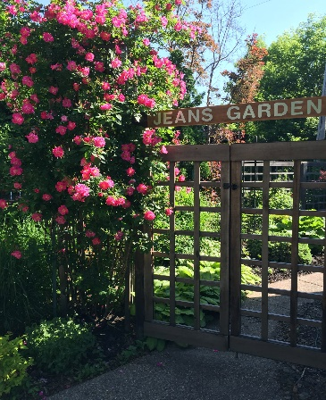   

Jean’s Garden Creekside Dahlias Rusty Shovel Gardens

**Details:** Saturday August 2, 2025, 8:45 am to 5:45 pm (estimate), The bus, a modern charter bus with air conditioning and a restroom, leaves from and returns to the Robin Center parking lot, 4072 Lakeland Ave N, Robbinsdale. This tour is open to the general public.

**Tickets:** $70 includes restaurant lunch, 2 bottles water, and the driver’s tip. Deadline to purchase is July 19th, 2025. The tour is rain or shine. No refunds given. Please join us!