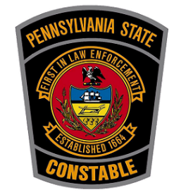
Constable Voters Guide – how to choose the right constable and why it’s important.

Pennsylvania State Constables referred to as “The Peoples Officer” are constitutionally elected law enforcement officers. They are the officers who protect your civil rights, maintain peace, and protect your community. They offer a wide variety of services statewide and work to make the community a peaceful and safe place for everyone.
Constables also ensure that offenders of the law are held accountable to pay their fines and execute warrants when issued by the court. This ensures that consequences are served so that it deters anyone from breaking the law or reoffending due to no consequences being enforced. It also helps ease the financial burden of prosecution by collecting fines that may go unpaid of constable were not enforcing this. Constables do not cost the taxpayers anything for this service.
Constables by law must be present at very election and keep the peace at the poles. They are charged with upholding your civil rights and making sure that everyone gets the right to vote and that no one is intimidated or hindered from doing so. Constables help maintain accountability for election integrity.
You should familiarize yourself with what a constable is and what they can do for the community prior to voting.

Who to Vote For?
You should make sure the candidate you are voting for is willing and able to do the job. They should be of upstanding and good moral character and not have any criminal background that could tarnish the office. The candidate should be able to tell you why they are running for the office, what they are willing to do as a constable, and how they plan to benefit the community if elected. Remember, this person is the potential officer that will represent your community and will be upholding and protecting your civil rights and will be responsible for keeping the peace and protecting your community at the local level. Make sure this person is someone you believe is willing to and capable of doing the job that you are electing them to do.

