The management and prevention of Suicide in The Primary Health Care setting:

P I Parkinson
MB ChB (Otago)
MRCP (UK)
FRNZCGP
PhD (Lond)
AANZPA (Practitioner and Educator)
NZAP

Introduction
For approximately 30 years I have been working this field. I have been utilizing what would be regarded as significantly different resources. However the results so far suggest that the current trend of unexplained suicide would virtually disappear if these resources were the norm in General Medical Practices throughout the country.

I, and my team have learned salient lessons during this time and these have led to careful selection and further fine tuning of the resources.

The basic purpose of this primary health care approach is to ensure that the patient is considered as a unique individual and from the moment that he or she presents they are made to feel very special. Furthermore they come to know that no one in the team will be phased by, or will pass judgment on their desire to die, and that they will have at least one other human being who will stand beside them throughout and beyond this crisis time of their life.

The working hypothesis is that depression and suicide are the outcomes of the prolonged subjective experience of un-recognition of the patient’s deeper inner experience.

I will present case studies to exemplify both the approaches and resources that we have used. The resources will be summarized later. I will conclude with proposals of how to proceed from here.

Case One

An Antique Dealer in his 50’s.

The focus of his appointment was his depressed mood.

I shared with him my interest in how down he was and I asked him to choose two objects on the desk, one to represent the value of life to him and the other the value death. I took an extra moment as he held each object. I asked him to hold the object and to immerse himself in the feeling that that particular object was to represent. I did this to ensure that each object held the depth and significance of his experience. Once this “warm up” period was completed, I asked him to place each object on the desk as close or as far away as he felt that each was to him at that moment.

He placed the death item quite close to himself. The life object he placed at a full arm’s distance from himself.

This quick and simple test alerted me to a significant level of suicide risk, requiring further attention.

Hence I left from behind my desk and invited him to sit beside me in one of the two chairs at the end of the consulting room. I did this in order for him to experience my support along side of him, and I carefully emulated his body language. This is a psycho-dramatic concept called doubling. It enables me (the double) to tune in with his experience and for him to experience a significant level of support.

I then asked him to carefully select an object to represent his spirit of death, paying attention the size, the colour, and the shape of the object. I then asked him to place in a way that reflected his experience.

He chose a darkly stained stool and placed it beside himself.

I then asked for him to do the same to represent the spirit of his life. At this request he became quite alive and went over to the doctor’s modern design swivel chair. He held the back of it in both hands. He then addressed me with the eloquence of well-educated antique enthusiast.

“This is a modern designed, purpose built chair. It is padded, sleek, and looks as though it will serve its purpose well…..UNTIL, like life, you come to sit in it, and it is damned uncomfortable!”

Whereupon he placed it outside the door and as he re-entered the room he closed the door behind him. I suggested for the purpose of our work, that he place it just inside the door, but that I respected his opinion that outside the door was the correct place for him. This he did.

He then, at my request, sat upon the death stool and addressed the chair that was his with the reasons why he, as the spirit of death, was so important to him. I entered the interaction by sitting in his chair and listened to Death’s statement:

“I offer you absolute peace, the end of all the pain and the confusion of life.”

I then asked him to sit in the chair of life and I sat on the stool of death and from there, as his spirit of death, I said to him as he took the role of “The Spirit of Life”:

“I am offering him peace and an end to the pain and confusion that he endures” to which the patient, as life, responded,

“How can you be so sure of that? Maybe he will have to face all that in his next lifetime. I as life really offer him the only hope. With me he really does have the chance to work it all out step by step.”

And as life he continued, addressing the stool of death: “You are just a fantasy, he can be sure of nothing through you!”

The dramatic interaction continued as we pursued the debate by exchanging between the roles of life, death and him self.

After 10 minutes I asked him if he was ready to readdress the positions of the chairs, whereupon I placed the life chair back outside the door where he had positioned it initially. In acknowledging that he was ready, he picked up the death stool and placed it about three paces from him saying as he did this:

“One day I will need you, but not now. I can’t get out of this life alive and you do have a role, but much later!”

He then went and retrieved the chair of life from the hall outside and placed it significantly closer to him than death, saying, “I choose you, and I accept that you are not easy. However I have my support here, referring to me, and I will work sincerely with you, referring to “Life”.”

Before leaving I insisted that he make the Goulding and Goulding promise to stay alive till the next time that we meet.

As he repeated:

“I promise that I will not take my own life either on purpose or through an act of carelessness.”

I checked that his tone of voice and his facial and body expressions were congruent, which they were.

I then said that, if need be, he could and must phone me if he were in any doubt about his promise to stay alive.

In subsequent consultations we repeated the two-chair assessment, and Gouldings’ promise, as we, step by step, worked through issues that needed to be addressed.

At the first session I assisted him to use the client operated assessment software that I have personally designed and had programmed. After this first session he took home a disk to install the program on his own computer and he emailed me the results of his home self-evaluations

He chose to work with me alone and his social atom (whanau) score indicated that his relationship with me was, for some time, his main support in life. It was for this reason that I chose to keep our one to one relationship going rather than suggest referral.

Clinical value of the different resources:
- The initial desktop suicide test alerted me to suicidal risk.
- “Doubling” is a technique designed and taught by Dr Jacob Moreno. It consists of sitting or standing alongside the patient, usually a little behind, and emulating their body language. Doubling acknowledges that body language works both ways, viz; his body expressed how he feels, and if I emulate that body language I will begin to achieve within myself, an experience similar to his. I can enquire from him if I am correct. Doubling provides and instant and sizable experience of support and relief from isolation.
- The two-chair life/death vignette gave him instant recognition and that I accepted totally his preference to die. This removed any sense of isolation that he experienced in his suicidal contemplations. He also picked up that I cared, and that I was both un-phased and competent, to accept and work with his current state of being.
- The Goulding and Goulding wish to stay alive promise is a well-tested tool only for short-term usage. If there is not congruency of expression where the words match voice tone and body and facial language then one must assume a conflict of expression and encourage more complete expression until the promise is made with congruency.
- The client operated software (below) provided essential short and long term progress data:

The life/death ratio is a software client operated version of the rapid desktop suicide risk procedure. The graph demonstrates the degree of the initial suicide risk (-4 on the graph) and the success of the first primary health care intervention, described above (Moving to +2 by the end of the session).

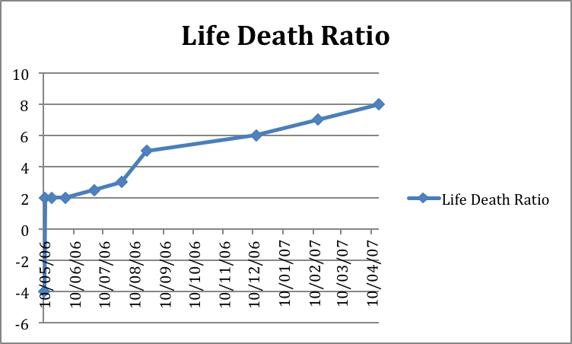

The social atom, or whanau score is another psycho-dramatic concept of Dr J. L. Moreno. Dr Jacob Moreno described the social atom as the smallest social system, namely that which surrounds one individual.

Moreno states that oneself is the nucleus of one’s own social atom and one’s significant other persons and organizations are the electrons etc. The distance between the significant other and the nucleus (self) represents the strength of the bond, and the valency (+ or -) indicates the desirability of the “other” The software version of this assessment guides the patient to place their significant others around themselves at appropriate distances and to give each the positive or negative valency. The computer sums the distances and valency and graphs the sequential scores.

Note that the suicidal state is reflected in a perceived negativity of the whanau or social atom score below.

Note also that the early rapid rise in this score that relates to the initial interview.

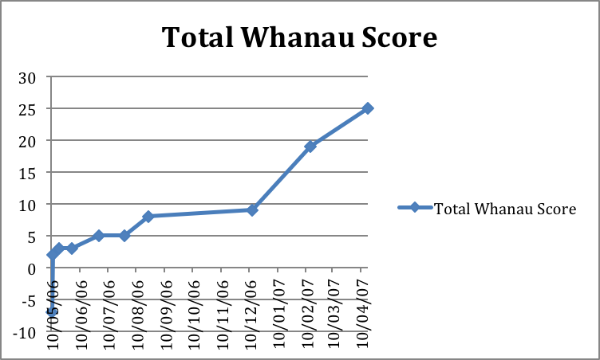

The social atom/whanau scoring software asks the patient to differentiate between the scores of their own friends and associates from members of their professional support team. This is graphed thus:

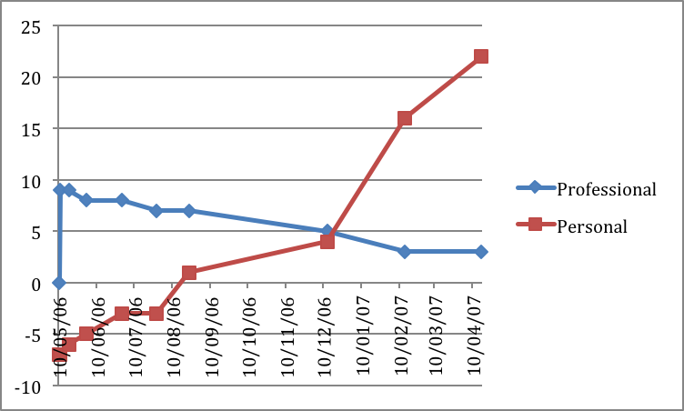

This graph clearly demonstrates that the positivity of the whanau score is, for the initial 5 months, dependent on the professional connection with myself. Honouring the importance of the primary health care professional relationship is essential during this time. The graph strongly suggests that withdrawal of support or referral during this phase could and probably would precipitate another suicidal crisis.

Case two:

is an 18 year-old motorcycle enthusiast.

He had simply come to the drop in centre for a cuppa. When he arrived I was out there sharing coffee with the practice nurse.

He joined in our conversation that soon focused on the death by suicide of a friend of his. The nurse asked if he too was considering suicide. He made no verbal statement but nodded his head as a sign of guarded affirmation. There were children’s toys nearby and I asked him to select one of these for life and one for death. The warm-up process and execution of the test described above ensued, and the toy representing death was the one he positioned nearer to himself. However, in contrast to case 1, when repositioning time arrived, the toy representing death stayed closer to him than the one representing life.

I explained to him that his life was his responsibility and that I fully respected that his wish to be dead exceeded his wish to be alive. However I pointed out to him that I was, by law, not permitted to let him go if he was a risk to himself. I checked with the nurse that we could arrange for 45 minutes together with him in about half an hour’s time. I said to him:

“We can use this time so that you can explore in depth your preference to die, are you prepared to hang round and do this.” To which he nodded, so I said:

“If there is any risk that you might leave in the meanwhile would you be prepared to give me the keys to your bike?”

He gave me his keys. I then said that he could chat to others here and see if there were one or two who might like to join him in his session.

The Session

There were four attending the session; the patient, the nurse and one auxiliary (volunteer) that he had chosen, and myself.

I explained to him that this was an opportunity whereby he could experience his own suicide even more fully that actually doing it, and that, by the time that he came to the end, that he still had the option of life.

I asked him to set up the scene of his proposed death.

He moved the examination plinth out into the room. This represented a large truck driving down the highway. He used a chair, sitting on it back to front, as his motorcycle and he smashed into the front of the truck at high speed. This was re-enacted with him standing beside me.

“See, easy, and it’s all over!”

So I asked him to sit up on the plinth and be the truck driver. After he experienced that, he proceeded to take the roles of the police attending the scene and later, the ambulance staff that took his body to the mortuary.

In the mortuary scene I requested that he take the roles of his mother, his farther and sister whom he stated would be identifying the body. While in his mother’s role he began to gag and wretch on seeing the mangled body on the couch. The auxiliary took over from him in the mother’s role. He returned to lie down on the plinth as the body. As the auxiliary re-enacted the mother retching he “came alive” and sat up, looked straight at her and said:

“Now you know what it feels like to be your son!”

And he continued:

“You have put me down in front of my friends, you shame me by saying that I am nothing like my sister and in front of her. You are ashamed of me, and you never wanted to have a boy in the first place. Now you know what it feels like!”

Further significant inter-actions followed before we explored the relationship with his girlfriend. This was indeed supportive.

Following this drama of his suicide, we repeated the life/death two chair process and the ”life” chair was placed significantly closer.

We concluded with a Gouldings’ promise of life and further appointments were made to which he invited the auxiliary. The Auxiliary and the patient left together for coffee.

Social atom scoring and subsequent sessions showed that his world was improving with the notable exception of his relationship with his mother. He had requested that she too came to a session but she had refused.

Crisis point.

Three months after the initial consultation he called me to say that he was intending to take his life. I went straight to his flat to find that he had called the auxiliary as well.

It was after midnight and he had returned from his sister’s wedding. He had rigged up a pipe from the exhaust of his girlfriend’s car to take the fumes into through the passenger’s window.

By the time that we arrived his girlfriend was up and she had called his parents. She, the girlfriend, was angry and said, referring to his mother:

‘She needs to see the effects of her vicious tongue!”

The girlfriend reported that, in front of the guests at his sister’s wedding that day, she had again made public derogatory remarks and put him down, and this, she claimed, precipitated the crisis.

I spent time together with the patient, the girlfriend and the auxiliary. They held and nurtured him and shared their love and caring with him.

When the mother arrived I interviewed her outside the house. I shared with her his real wish to die, and invited her to be part of the team that would give him the experience that life was worth living. As we sat outside in the street light she looked at me and said:

‘Best if I don’t see him now, but can I have an appointment with you by myself tomorrow?” I agreed.

The mother’s insights:
In this session the next day, she told me about not wanting a son and her inexplicable hostility towards him. I handed her a cushion to hold and requested that she warm up to holding him as an infant. Once this had happened I enquired:

“Where does this take you?” to which she responded:

“To my own childhood, to being physically and emotionally abused by my own farther! He was an animal!”

In subsequent sessions she proceeded to repair the damage of those childhood experiences.

I asked her permission to share with her son that she was embarking on repairing this part of her life. She agreed.

During the same time the patient himself utilized the group work that was an integral part of our practice, to express his indignation towards his mother’s mistreatment of him. These sessions served to reset his adrenal axis and to unload stored and out of date resentment. These were done within the spontaneity theatre and without the mother being present.

Eventually she was ready to have a facilitated meeting with him, where she apologized, and wept as she declared her love and commitment to him. Having expressed his outrage in the sessions that we did, he was ready for the meeting and was ready to embrace her and commence a new beginning to their relationship.

The long-term outcome was more than satisfactory.

In addition to the advantages mentioned in the first case presentation reflects further advantages.

- The use of community support that further lessens his isolation.
- The value of the drop in centre for he may never have even mentioned his suicidal intentions outside of this setting.
- The importance of formalizing the invitation to call if he were intending to commit suicide.
- The diagnostic value of the “suicide” drama.
- The advantage of doing this work in the primary health care setting where the practitioner has direct access to significant others in the patient’s life.

Case three

E, a 48 year-old single woman, phones another member of her surrogate whanau with the statement:

“ I am going to kill my two cats tonight so that they wont see me kill myself.”

I was thus called to an emergency meeting of the surrogate whanau.

At the meeting general concern was being discussed as to the time commitment needed for her caring and the conflict that would be created in their own homes. There was no doubt in any of their minds that she needed 24 hour care and that they were the best ones to give it to her.

C., a 40 year-old epileptic psychopath, sat silently. Two years before he had been referred to the practice by the Chief District Court Judge, Justice R Kearney. He was a repeat offender, his conviction always relating to knocking police constables unconscious. The patient, E had been, to C, an invaluable auxiliary in clarifying and healing the transference between police officers in the present time slot, and C’s Uncle, in the distant past time slot, who had had repeatedly homosexually raped C from the age of 7 through to 15.

Bob was a solo parent of a family of 5. C had been assisting in the care of these children for some months. Bob, who also valued E’s contribution to his development said: “I really want to go and stay with her, but I can’t leave my children. “

In response to this C said:
“I am the only one in the group with the time, but I’ve never been any use to anyone!”

“Crap!” responded Bob “I could have never managed the kids by myself. You’ve been fabulous!”

“Don’t bullsh** me, you’re just saying that to make me feel better!” responded C

Bob looked at me, and I said: “repeat it!” In fact he repeated it 3 more times before C began to believe him. As it sank in C stood and announced:

“It’s over my dead body that she kills herself. I’m going now!”

He spent two weeks living there at E’s home. This supporting role was backed up by the intermittent attendance of other members of the surrogate whanau. I, and my team, kept a vigilant oversight.

Clinical value of the different resources:

- The surrogate whanau was vital to both the detection and the successful outcome.
- The process was not only valuable but was key in repairing C’s self image and self-confidence.

Summary of the approaches and resources used in this pilot study.

These include the following factors and innovations;

- A working hypothesis that depression and suicide are the outcome of a prolonged subjective experience of un-recognition of their subjective experience of life.
- The word recognition is regarded as having ones inner experience acknowledged and honoured. Recognition in this context is not to be confused with accolade which is praise and approval for having done or performed something well. Whether the deed or performance concurs with the subject’s inner desire is immaterial when accolade is exhibited.
- The initial and ongoing personal connections between the patient and members of the primary health care team are regarded as crucial.
- Referral that fails to acknowledge the above relationships can precipitate a suicidal crisis.
- The Goulding and Gouldings’ “Promise to stay alive” (described in detail later) as a short-term safety tool.
- The use of “action methods”. This can be the utilization of figurines on the desk, chairs or cushions in the consulting room, or spontaneity actors (auxiliaries) in therapeutic spontaneity theatre.
- The specific work on the psycho-dramatic approach to suicide by Dr Rex Hunton and the late Wayne Scot.
- Group work, the focus of which can either be centred on the client’s specific needs, or it may be a general group where the theme of the groups emerges from those present, and bonding and friendship emerges.
- The immense value of doubling in providing a sense of support and mirroring to provide the experience of recognition.
- The surrogate whanau. These are small community groups that emanate from the “groups” mentioned above (8), and who support one another. Members each surrogate whanau meet and support one another in day-to day life, and the skills used to support one another differ from their families of origin. The new skills emerge as they embark on the training that is provided as part of the practice. Trainers include both practice members and/or professional trainers from out of town or from overseas.
- A drop in/cuppa tea centre as part of the Primary Heal Care unit.
- A suite of client operated software that records their status on presentation and their ongoing progress.
- A highly trained and aware practice team.

Summary

I have presented three cases that demonstrate the potential of certain methods that I have either trained in or developed. From a 13-year primary health care experience there were three suicides, but these were all referrals and did not involve themselves in the above stated processes.

It is my belief that if and when these abilities are present and used in primary health care and combined with specific education programs that the incidence of suicide should fall to virtually zero.

I have shown how the software serves as both a screening tool and also a follow up method.

