True Israelites

According to the Heavenly Father and His word, the true Israelites are so-called blacks and the indigenous people from the Americas (North, Central, South and the Caribbean), and our brethren scattered throughout the four corners of the earth, in every country: Jeremiah 23:7-8. To reiterate, not just the United States (Modern Egypt) where we serve hard captivity and oppression, but throughout the earth where we remain punished for our sins/breaking the commandments: IJohn 3:4, Deuteronomy 28:15, Amos 3:1-2, Jeremiah 16:10-11).

Baruch 2:30 For I knew that they would not hear me, because it is a STIFFNECKED PEOPLE: but in the land of their captivities THEY SHALL remember themselves.
:31 And shall know that I am the Lord their God: for I WILL GIVE them an heart, and ears to hear:
:32 And they shall praise me in the land of THEIR CAPTIVITY, and think upon my name,
:33 And RETURN FROM their stiff neck, and from their wicked deeds: for they shall remember the way of their fathers, which sinned before the Lord.
(We are the true Israelites, ALTHOUGH America and the world DENIES the truth, as it is written: Hosea 1:10-11! True Israelites are in captivity WHEREVER we are, and afflicted: Deuteronomy 28:15. The so-called jews in the land of Israel which rule America and the earth: Job 9:24, falsely claiming and declaring they are Jews and Israelites are deceitful LIARS: IJohn 2:22. The world and EVERY Christian falsely claims so-called jews are the real Jews, which is PERFECTLY contrary to the word of truth: Jeremiah 16:19, Deuteronomy 33:29, IICorinthians 4:3-4, Matthew 11:25!)

Deuteronomy 28:33 The fruit of thy land, and all thy labours, shall A NATION which thou knowest not eat up; and thou shalt BE ONLY oppressed and crushed alway:
(Although all nations are subjected to America’s and Edom’s tyranny and control, the true Israelites are powerless, poor, and cruelly oppressed by Edom (“a nation”) as well as all OTHER NATIONS. Even in countries which are supposed to be our homelands such as Puerto Rico, Dominican Republic, Cuba, Jamaica, Haiti, Mexico, Brazil, Peru, Colombia, Panama, Costa Rica, Nicaragua, Belize, El Salvador, etc.)

Even the Japanese that were nuclear bombed and imprisoned during World War II were given many reparations, supported and allowed to rebuild, and Hong Kong was “returned” to the Chinese, etc. But because we Israelites sinned against the LORD, His sword against our unrepentant nation by the wicked: Psalms 17:13, Amos 1:11, Obadiah 1:10, has been sore and relentless. Not only were we completely decimated and destroyed centuries ago, but the Conquistadors and Pilgrims REMAINED among our enslaved survivors, and CONTINUED their evil and DAILY oppression to this day, October 26, 2013!

IIEsdras 6:57 And now, O Lord, behold, these heathen, which have ever been reputed as nothing, have BEGUN TO BE lords over us, and TO DEVOUR us.
:58 But WE THY PEOPLE, whom thou hast called thy firstborn, thy only begotten, and thy fervent lover, ARE GIVEN INTO their hands.
:59 If the world now be made for our sakes, why do we NOT POSSESS an inheritance WITH the world? HOW LONG shall this endure? [Luke 21:24 “until the times of the gentiles be fulfilled”]
(We are Israelites because we fulfill ALL the scriptures pertaining to Israelites! So-called jews, and other liars claim to be saints or “spiritual Israelites”, but DO NOT fulfill the Israelites’ curses and prophecies.)

Deuteronomy 28:43 The stranger that is within thee shall get up ABOVE THEE very high; and thou shalt come down VERY LOW.
:44 He SHALL LEND to thee, and thou SHALT NOT lend to him: he shall be the head, and THOU SHALT BE the tail.
(We are the poorest nation on the earth, surpassed and below every other nation, even those emigrating to our lands, or also newly come to America, that are not our people. NO NATION speaks up for NOR defends us, but scorns us or fights for animals rights or endangered animals and our endangered children: Zechariah 11:5, Zephaniah 2:1, Isaiah 11:11-12, Psalms 83:3-8. Even the other nations of the earth flocking to America have their own lands and own rulers to return to, and own economy, but not us true Israelites. Where can us former slaves go, Israel? California? If we hate our lives in Jamaica or Mexico, where can we go to escape our iron furnace: Deuteronomy 28:65-66???

Leviticus 26:17 And I will set my face against you, and ye shall be slain before your enemies: they THAT HATE you SHALL REIGN over you; and ye shall flee when none pursueth you.
(Matthew 9:36 But when he saw the multitudes, he was moved with compassion on them, because THEY FAINTED, and were SCATTERED ABROAD, as sheep having NO shepherd.)

Nations have hope and power in their world, or their own economic areas and niches (jewelry, clothing, technology, Persian rugs, “mediation and spirituality”, etc.) and their actual economic power in this world that belongs to Caesar (Edom) and them! Our ONLY hope though, as it is prophesied, is the LORD in truth and being washed by His Spirit, NOT religious baptisms (Israelite nor Christian), this world or lies:
Jeremiah 17:13 O LORD, THE HOPE OF ISRAEL, all that forsake thee shall BE ASHAMED, and they that depart from me shall be written in the earth, because they have forsaken the LORD, the fountain of living waters.

Luke 21:24 And they shall fall by the edge of the sword, and shall be led away CAPTIVE into all nations: and Jerusalem shall be trodden down of the Gentiles, UNTIL THE TIMES OF the Gentiles be fulfilled.
(Christ prophesied about the true Israelites’ slavery and final scattering in the Last Days, while the nations of the earth would be in their glory and even have our holy land to do with it how they pleased, UNTIL their time to rule is ended: Daniel 7:9, John 16:20-22.)

After our documented fall in 70 A.D. by the hand of Edom/Romans: Luke 19:43-44, Daniel 9:26, Luke 21:24, etc., we would be scattered in their lands as oppressed slaves, never recovering our own homeland of Israel, not even now during these last days, and definitely NOT as the United Nations complex in New York FALSELY CLAIMS by engraving of Isaiah 2:4 on its outer walls; when America, NOT the LORD, deceitfully established false imposter Jews in the land of Israel officially in 1948.
Their deceit is exposed by attempting to actually use the bible to support their intentional trickery, them being in the land, and all the war clearly shows this scriptures NOT being fulfilled, NOR them being Jews:
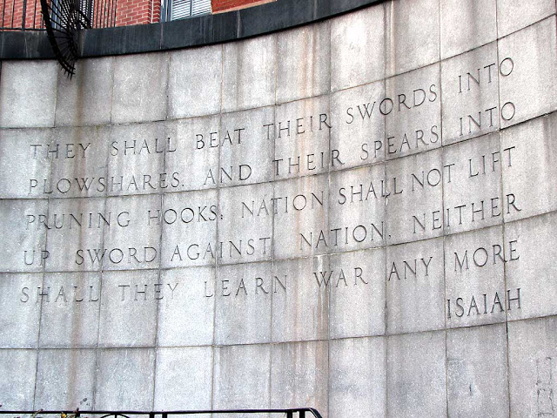

True Israel however, ARE JOINED to the LORD, His word and prophecies. But, so-called jews REJECT Christ and the word/tenach/bible, and instead trust in their world, power, promoting of sin for more money, their wealth and thorough absolute world dominion, etc. As it is written, the actual Israelites continue to trust in the LORD, but do so by man, or tradition of Israelite men, and WITHOUT knowledge and Truth/Christ:
Romans 10:1 Brethren, my heart's desire and prayer to God for Israel is, that they might be saved.
:2 For I bear them record that they HAVE A ZEAL of God, BUT NOT ACCORDING to knowledge.
:3 For they BEING IGNORANT of God's righteousness, and going about to establish THEIR OWN righteousness, have NOT SUBMITTED themselves unto the righteousness of God.
(We must NOT continue to try to serve the Heavenly Father our own way: Proverbs 3:5-7, such as Christianity, joining an Israelite group, Islam, combining different beliefs, doing our own thing, etc.)

We link to the entire bible, our spirit LINKS TO the Heavenly Father’s Spirit: Isaiah 59:20-21, Romans 8:16, IICorinthians 13:8. No matter where we are scattered or how we look today after being mingled, lost and outcast:

Romans 8:16 The Spirit itself beareth witness with our spirit, that WE ARE the children of God:
(Baruch 4:37 Lo, thy sons come, whom thou sentest away, they come gathered together from the east to the west BY THE WORD OF the Holy One, rejoicing in the glory of God.)

Jeremiah 5:4 Therefore I said, Surely these ARE POOR; they ARE FOOLISH: for they KNOW NOT the way of the LORD, NOR the judgment of their God.
(Because we still disobey the word, we are poor, disadvantaged, powerless not only against the “white man” (Edom), but all people, and are a prey even to WICKED of our own people: Zechariah 11:5, Jeremiah 5:26-31. The one victim that cannot fight back nor defend ourselves in any way Psalms 83:3-8,

Jeremiah 50:33 Thus saith the LORD of hosts; The children of Israel and the children of Judah were oppressed TOGETHER: AND ALL that took them captives held them fast; they refused to let them go.
OPPRESSED TOGETHER, and continue to be an easy prey as a lost and destroyed nation: Philippians 2:15!
(Unlike ancient Babylonian captivity circa 609 B.C. – 539 B.C. where only 3 tribes in Israel (Judah, Benjamin, Levi) went into captivity, our captivity in modern Babylon (America) in these last days has all 12 tribes in bondage, and all nations pick at our bones and exploit us!)

IIEsdras 13:39 And whereas thou sawest that he gathered another peaceable multitude unto him;
:40 Those are the TEN TRIBES, which were carried away prisoners OUT OF their own land in the time of Osea the king, whom Salmanasar the king of Assyria led away captive, and he carried them over the waters, and so came they into another land.
(IIKings 17:23-24)
:41 But they took this counsel among themselves, that they WOULD LEAVE the multitude of the heathen, and go forth into a further country, WHERE NEVER MANKIND DWELT,
:42 That they might there keep their statutes, which they never kept in their own land.
:43 And they entered into Euphrates by the narrow places of the river.
:44 For the most High then shewed signs for them, and held still the flood, till they were passed over.
:45 For through that country there was A GREAT WAY TO GO, namely, of a year and a half: and the same region IS CALLED Arsareth.
(Arsareth: the Americas)
:46 Then dwelt they there UNTIL THE LATTER TIME; and now when they shall begin to come,
(The indigenous people of the Americas including the Caribbean, are Israelites, although many false theories and LIES such as us migrating as Asians via the “Bering Straits” to America are deceitfully taught and pushed in universities or christianity! We come from Israel originally, NOT Africa nor Asia, and our deliverance from this hard bondage is coming: Micah 4:10, Isaiah 14:1-3, Matthew 24:30-31, Amos 9:8-12, Isaiah 2:1-4, Joel 3:1-2, Jeremiah 16:14-15, etc.)

John 17:17 Sanctify them through thy truth: THY WORD is truth.
(To find out the truth, our history, how to improve our lives, as well as how to teach and help our nation, we must seek the bible, and STAY IN the bible: IITimothy 2:15, John 5:39, Isaiah 34:16, Ecclesiastes 12:12-13, Isaiah 8:20, etc.)

Zechariah 1:6 But MY WORDS and MY STATUTES, which I commanded my servants the prophets, did they not TAKE HOLD of your fathers? and they returned and said, Like as the LORD of hosts thought to do unto us, according to our ways, and according to our doings, so hath he dealt with us.
(Exactly as the LORD said in the bible, is what we have suffered! That is truth, NOT religion nor opinion!)

Hosea 6:5 Therefore have I hewed them by the prophets; I have slain them BY THE WORDS of my mouth: and thy judgments are as the light that goeth forth.
(The righteous word and judgments given to our nation, are light/truth and our life; or will continue to be what causes our punishments, death and suffering: Luke 13:1-5, Amos 3:1-2, Proverbs 13:13, etc.)
Jeremiah 15:3 And I will appoint over them four kinds, saith the LORD: the sword to slay, and THE DOGS to tear, and the fowls of the heaven, and the beasts of the earth, to devour and destroy.
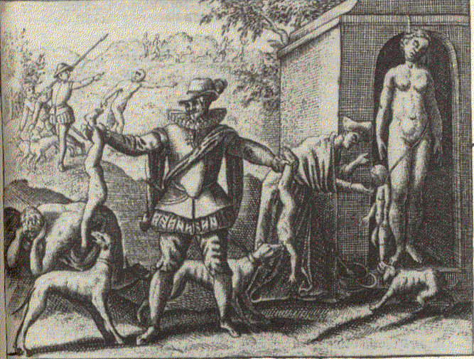

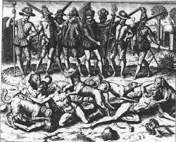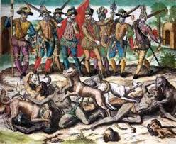

[Many of our Israelite brothers do not yet see or understand “Hispanics” are our brothers: Lamentations 4:16, Isaiah 11:13, Deuteronomy 28:54, nor do most Hispanics see so-called blacks and indigenous americans as their BLOOD brothers. But thankfully, the word of TRUTH, its prophecies and punishments which afflict us are irrefutable, and confirm we are the Israelites and children of the Most High!]

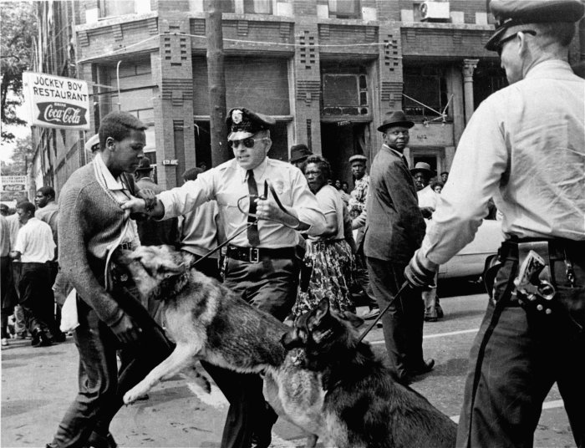

Daniel 9:12 And he hath CONFIRMED HIS WORDS, which he spake against us, and against our judges that judged us, by bringing UPON US a great evil: for under the whole heaven HATH NOT BEEN DONE as hath been done UPON JERUSALEM.
(The Israelite sufferings, which are worse than any other nation’s tribulations, IDENTIFY and VERIFY whom the true Israelites are upon earth today, regardless of this world’s or Christian lies:
Deuteronomy 28:45 Moreover all these curses SHALL COME upon thee, and shall pursue thee, and OVERTAKE thee, till thou be destroyed; BECAUSE thou hearkenedst not unto the voice of the LORD thy God, to keep his commandments and his statutes which he commanded thee:
:46 And they shall be upon thee FOR A SIGN and for a wonder, and UPON THY SEED for ever.)

Daniel 9:13 As it is WRITTEN in the law of Moses, all THIS EVIL is come upon us: yet made we NOT our prayer before the LORD our God, that we might turn from our iniquities, and UNDERSTAND thy truth.

Deuteronomy 30:1 And it shall come to pass, when all these things are come upon thee, the blessing AND THE CURSE, which I have set before thee, and thou shalt CALL THEM TO MIND AMONG all the nations, whither the LORD thy God hath driven thee, [Baruch 2:30-32]
:2 And SHALT RETURN unto the LORD thy God, and SHALT OBEY his voice according to all that I command thee this day, thou and thy children, with all thine heart, and with all thy soul;
:3 That then the LORD thy God WILL TURN THY CAPTIVITY, and HAVE COMPASSION upon thee, and will return and GATHER THEE from all the nations, whither the LORD thy God hath scattered thee.

Deuteronomy 4:30 WHEN THOU ART in tribulation, and all these things are come upon thee, EVEN IN THE LATTER DAYS, if thou turn to the LORD thy God, and shalt be obedient unto his voice;
:31 (For the LORD thy God is a merciful God;) he WILL NOT forsake thee, NEITHER destroy thee, NOR FORGET the covenant of thy fathers which he sware unto them.

REPENTANCE is the key for us, not economic revolution, RAILING against Caucasians (Esau) on corners, complaining, being a thug, focusing on education or money, or pleading for “equal rights” to the same shameless nation used to punish us for OUR SINS: Baruch 4:15, Deuteronomy 28:47-48, Leviticus 26:17.

Leviticus 26:40 If they SHALL CONFESS their iniquity, and the iniquity of their fathers, with THEIR TRESPASS which they trespassed against me, and that also they have walked contrary unto me;
:41 And that I also have walked contrary unto them, and have brought them into the land of their enemies; if then their uncircumcised hearts BE HUMBLED, and THEY THEN ACCEPT of the punishment of their iniquity:
:42 Then will I REMEMBER my covenant with Jacob, and also my covenant with Isaac, and also my covenant with Abraham will I remember; and I will remember the land.
(True repentance! NOT continuing in lies like Christianity, Islam, Israelite fables, and any other sins!)

IKings 8:46 IF THEY SIN against thee, (for there is no man that sinneth not,) and thou be angry with them, AND DELIVER THEM to the enemy, so that they carry them away captives unto the land of the enemy, FAR or near;
:47 YET IF THEY SHALL bethink themselves in the land whither they were carried captives, and repent, and make supplication unto thee in the land of them that carried them captives, saying, We have sinned, and have done perversely, we have committed wickedness;
:48 And so return unto thee with all THEIR HEART, and with all their soul, IN THE LAND of their enemies, which led them away captive, and PRAY UNTO THEE TOWARD their land, which thou gavest unto their fathers, the city which thou hast chosen, and the house which I have built for thy name:
:49 Then HEAR THOU their prayer and their supplication in heaven thy dwelling place, AND MAINTAIN their cause,
:50 And FORGIVE THY PEOPLE that have sinned against thee, and all their transgressions wherein they have transgressed against thee, and give them compassion BEFORE THEM WHO carried them captive, that they may have compassion on them:
(Our “survival” and little mercies like being allowed to sit in the front of the bus or less blatant and overt vile treatments today in America, ARE BECAUSE of the LORD: Malachi 3:6, NOT man!)

As we see, all the way back to Moses over 3,400 years ago, or centuries later through Solomon, the LORD foretold of OUR CAPTIVITY, suffering, and grievous oppression throughout our history for our sins and disobedience to His word. Therefore we must truly repent to the LORD, NOT by religion, churches or continuing to do “our best” (Isaiah 55:6-9).

We are the true Israelites, and we MUST return to the LORD! Not only as Israelites, but we MUST worship Him in spirit and truth!!!!!!! It is the only way: John 14:6.

John 4:22 Ye worship ye know not what: we know what we worship: for salvation is of the Jews.
:23 But the hour cometh, and now is, when the true worshippers shall worship the Father in spirit and in truth: for the Father seeketh such to worship him.
:24 God is a Spirit: and they that worship him must worship him in spirit and in truth.
(We must HUMBLY learn and obey the word by the Holy Spirit/Christ in truth: John 14:16-18, in order for us to properly worship the LORD. As we see, although we have always had a “zeal” for the LORD, we have suffered from curses and punishments because of not worshipping Him ACCORDING to the bible/knowledge. In these last days NOW, we MUST worship through the Holy Spirit/Christ in truth, and we will understand truth: Daniel 9:13, and no longer remain cursed and destroyed: Acts 1:6, Matthew 19:27-29, Daniel 2:44, Isaiah 11:11-12, Matthew 11:12, Jeremiah 23:7-8, Isaiah 45:17, etc., etc., etc.)

Concerning those people that the world and its religions recognize as Israelites and call jews (so-called jews, “jewish people”) they are NOT the true jews/Israelites: Ezekiel 35:5,10-15. Their global control, annexing the land of Israel, world domination, and the world’s lies INDISPUTABLY and DECISIVELY negates any possibility of them being the true Israelites. But, suffering and fulfilling the prophecies concerning Israelites exactly according to the word of truth clearly identifies the actual Israelites/Jews.

Humbly repent and diligently search the word of truth beloved brethren, NOT continuously to men, false doctrines, churches or groups teaching the bible according to precepts of men!
Mark 1:15 And saying, The time is fulfilled, and the kingdom of God is at hand: REPENT YE, and BELIEVE THE GOSPEL.

All glory, honor and praises to our Holy and Eternal Heavenly Father, and our Salvation and Redeemer Jesus Christ.
1611 king james version bible; www.thetruththebible.com

