Colombia, Repent

Brothers and sisters, REPENT! Judgment Day is real. Look at the constant judgments and punishments God has brought to Colombia. These are not coincidences, bad luck, or mother nature! Obviously if Catholicism pleased God and was how to serve Him, He would not afflict Colombia with constant judgment, poverty, and despair:
Proverbs 28:13 He that covereth his sins shall not prosper: but whoso confesseth and forsaketh them shall have mercy.
But because lies and darkness continue to blind the whole earth, especially Colombia: Isaiah 60:1-2, IJohn 5:19, most of the people continue to follow this world's lies, wicked idolatries [Catholicism, Easter, Christmas, Christianity, etc.], and false ways to worship God. Including countless other evils because they are disguised and widely accepted. The Word/Bible only, which is also the true Jesus Christ, IS OUR LIFE [Deuteronomy 8:3, Psalms 40:7, John 6:63, etc.] NOT religions, NOT our own ways, nor doing what we think is best.
Redeem the time now, by using our last opportunity to REPENT and STOP THE SINS [breaking the commandments in the Bible: IJohn 3:4, Proverbs 13:13] that are being chosen with suffering, INSTEAD of what God says and commands us in the Bible:
IIPeter 3:9 The Lord is not slack concerning his promise, as some men count slackness; but is longsuffering to us-ward, not willing that any should perish, but that all should come to repentance.
:10 But the day of the Lord will come as a thief in the night; in the which the heavens shall pass away with a great noise, and the elements shall melt with fervent heat, the earth also and the works that are therein shall be burned up.

Luke 21:34 And take heed to yourselves, lest at any time your hearts be overcharged with surfeiting, and drunkenness, and cares of this life, and so that day come upon you unawares.
[surfeiting = indulging in sin completely: Proverbs 27:20;
drunkenness = totally consumed with idolatry: Deuteronomy 29:19]
:35 For as a snare shall it come on all them that dwell on the face of the whole earth.

2017
The southern city of Mocoa was engulfed on April 1, by a huge landslide of mud, rocks and gushing waters that swept away homes and cars and killed hundreds of people and left hundreds injured.
Luke 13:5 I tell you, Nay: but, except ye repent, ye shall all likewise perish.
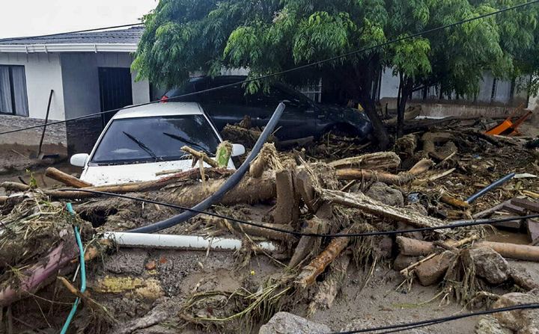
Landslides caused by heavy rain have killed dozens of people in the city of Manizales, in central Colombia on April 19.
Jeremiah 10:11 Thus shall ye say unto them, The gods that have not made the heavens and the earth, even they shall perish from the earth, and from under these heavens.
:12 He hath made the earth by his power, he hath established the world by his wisdom, and hath stretched out the heavens by his discretion.
:13 When he uttereth his voice, there is a multitude of WATERS in the heavens, and he causeth the vapours to ascend from the ends of the earth; he maketh LIGHTNINGS with RAIN, and bringeth forth the WIND out of his treasures.
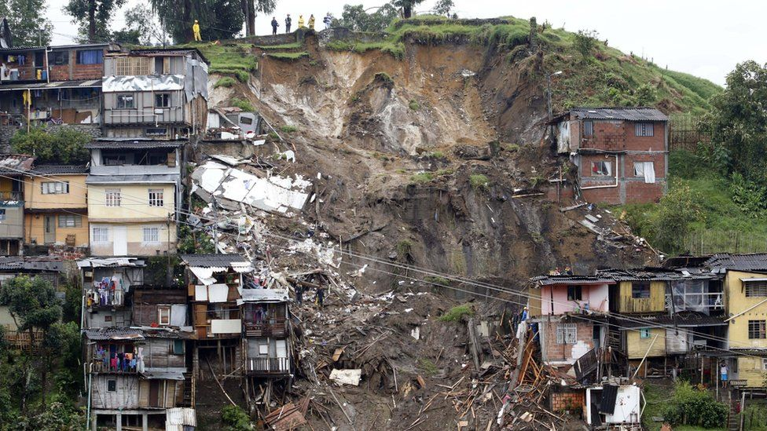

2019
In Antioquia Department, wide areas of Caucasia Municipality were flooded after heavy rain from around May 27.
On 21 November, many Colombians, estimated between hundreds of thousands and over 1 million, protested throughout the country, with the government responding by deploying hundreds of thousands troops. The Colombian government also closed all of its borders.

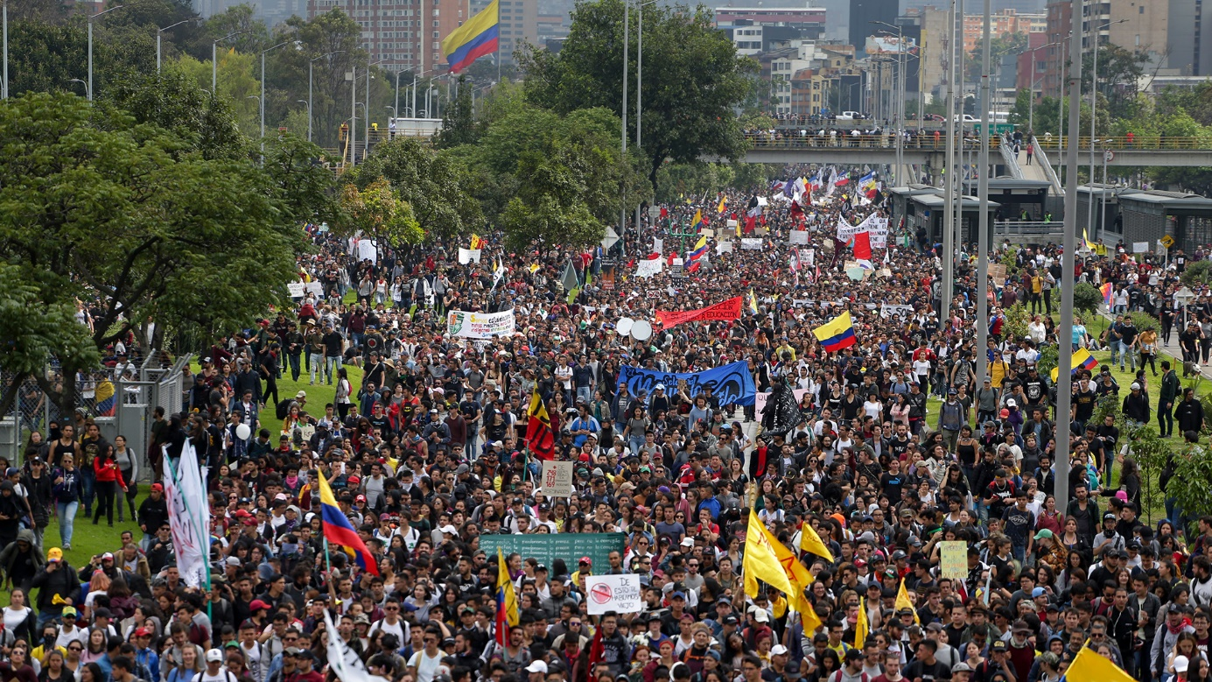

IIEsdras 9:2 Then shalt thou understand, that it is the very same time, wherein the Highest will begin to visit the world which he made.
:3 Therefore when there shall be seen earthquakes and UPROARS of the people in the world:
Paired with a national strike, the protesters in Colombia come from all backgrounds, and that they are protesting because of a general displeasure with government actions across a range of issues, triggered to action by rumors of pension cuts.
The protesters demands range from more money for public education, higher wages and more job stability to subsidised pensions, a better healthcare system and the implementation of the peace accords.
Thousands of protesters continued the following weeks throughout Colombia.
Several people died in the clashes, hundreds of civilians and hundreds members of the security forces were injured.
Matthew 24:21 For then shall be great tribulation, such as was not since the beginning of the world to this time, no, nor ever shall be.
2020
Dozens of people have died in floods and landslides in the departments of Santander and Caldas in Colombia after heavy rain on February 26. Hundreds of people were displaced.

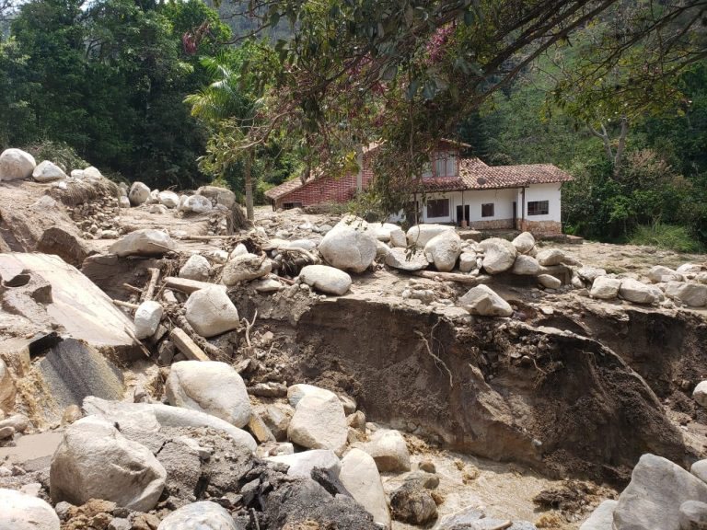
Isaiah 29:6 Thou shalt be visited of the LORD of hosts with thunder, and with earthquake, and great noise, with STORM and tempest, and the flame of devouring fire.
2021
Colombia's main states of Antioquia, Valle del Cauca, Narino, Huila and Cundinamarca are the most affected parts of the country by the rainfall. Dozens of people have died in floods caused by excessive rains. And dozens of people were inured, on March 25.
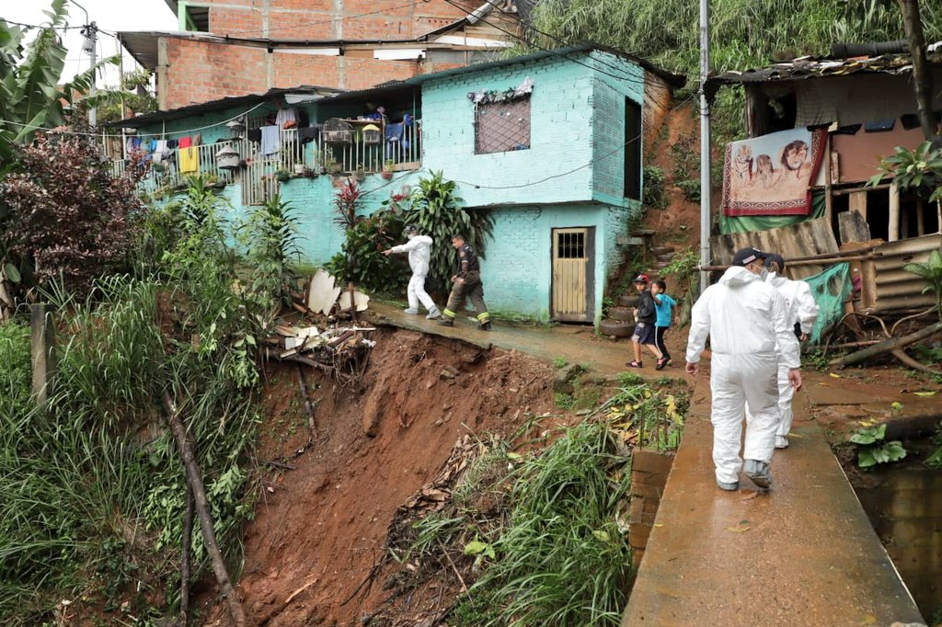
Isaiah 29:6 Thou shalt be visited of the LORD of hosts with thunder, and with earthquake, and great noise, with STORM and tempest, and the flame of devouring fire.
Tens of thousands affected by floods and landslides for weeks in May.
Significant flooding was reported in La Virginia municipality of Risaralda Department, Meta Department, Puerto Lleras, Cabuyaro, Puerto López, El Castillo, Fuente De Oro, Lloró municipality of Chocó Department, Viterbo municipality in Caldas, Orocué in Casanare Department, San José Del Guaviare in Guaviare Department, La Montañita in Caquetá Department, La Pintada in Antioquia Department.
Several people have died and several were injured. Around 8 houses were destroyed and thousands damaged.

Protesters take to the streets for fourth week (May) demanding government action on poverty, police violence, and other issues.
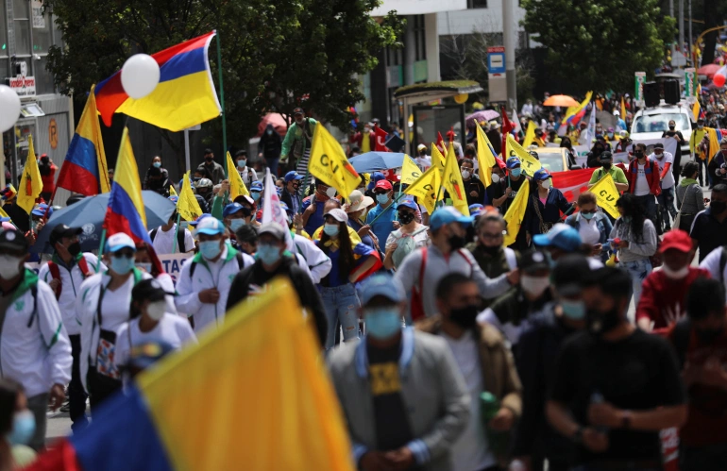
Daniel 12:1 And at that time shall Michael stand up, the great prince which standeth for the children of thy people: and there shall be a TIME OF TROUBLE, such as never was since there was a nation even to that same time: and at that time thy people shall be delivered, every one that shall be found written in the book.
The protests have been marked by violence, dozens have been killed during clashes with the police.
The protests began last month after right-wing Colombian President Ivan Duque’s government introduced a tax reform that critics said would disproportionately harm the working and middle classes, already hard-hit by the COVID-19 pandemic.

Colombia has seen a surge in coronavirus cases over the last few weeks, while deaths from COVID-19 have also reached an all-time high in the past week, with estimated more than 400 people dying each day from the virus.
With a population of over 51 million, Colombia has Latin America's third-highest coronavirus death toll after Brazil and Mexico. Colombia has registered nearly 2.8 million coronavirus infections and more than a estimated 71,000 deaths, according to a running tally by US-based Johns Hopkins University.
Matthew 24:3 And as he sat upon the mount of Olives, the disciples came unto him privately, saying, Tell us, when shall these things be? and what shall be the sign of thy coming, and of the end of the world?
:7 For nation shall rise against nation, and kingdom against kingdom: and there shall be famines, and PESTILENCES, and earthquakes, in divers places.
By repenting truly [obeying the LORD’S commandments in the Bible], the LORD will protect His children, the true Israelites which include so-called Colombians. While His judgments, pestilences and punishments will continue in Colombia and in the earth, the LORD will protect those that abide in Him and His Word [the true Jesus Christ]:
Psalms 91:1 He that dwelleth in the secret place of the most High shall abide under the shadow of the Almighty.
:2 I will say of the LORD, He is my refuge and my fortress: my God; in him will I trust.

:6 Nor for the pestilence that walketh in darkness; nor for the destruction that wasteth at noonday.
:7 A thousand shall fall at thy side, and ten thousand at thy right hand; but it shall not come nigh thee.
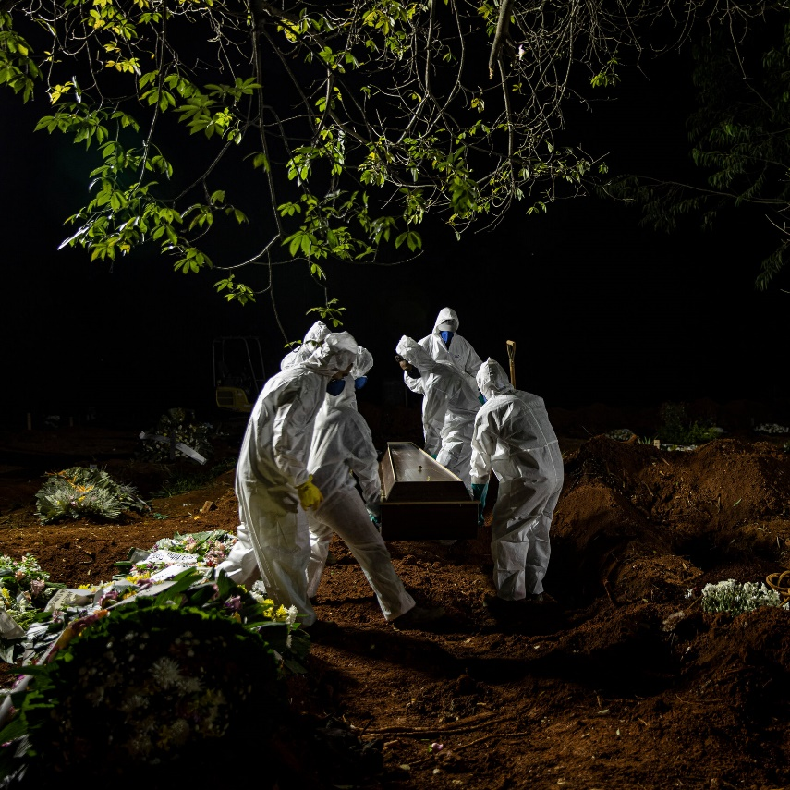

All honor glory and praises to our Almighty and Eternal Heavenly Father, through His Word our Life and King Jesus Christ.

1611 king james version bible/1769 king james version bible; www.thetruththebible.com

