Guatemala, Repent

Guatemalan brothers and sisters, REPENT! Judgment Day is real. Look at the constant judgments and punishments God has brought to Guatemala. These are not coincidences, bad luck, or mother nature! Obviously if Catholicism and religion pleased God and was how to serve Him, (or practicing witchcraft/voodoo), He would not afflict Guatemala with constant judgment, poverty, and despair:
Proverbs 28:13 He that covereth his sins shall not prosper: but whoso confesseth and forsaketh them shall have mercy.
But because lies and darkness continue to blind the whole earth, especially Guatemala: Isaiah 60:1-2, IJohn 5:19, most of the people continue to follow this world's lies, wicked idolatries [Catholicism, Easter, Christmas, Christianity, etc.], and false ways to worship God. Including countless other evils because they are disguised and widely accepted. The Word/Bible only, which is also the true Jesus Christ, IS OUR LIFE [Deuteronomy 8:3, Psalms 40:7, John 6:63, etc.] NOT religions, NOT our own ways, nor doing what we think is best.
Redeem the time now, by using our last opportunity to REPENT and STOP THE SINS [breaking the commandments in the Bible: IJohn 3:4, Proverbs 13:13] that are being chosen with suffering, INSTEAD of what God says and commands us in the Bible:

IIPeter 3:9 The Lord is not slack concerning his promise, as some men count slackness; but is longsuffering to us-ward, not willing that any should perish, but that all should come to repentance.
:10 But the day of the Lord will come as a thief in the night; in the which the heavens shall pass away with a great noise, and the elements shall melt with fervent heat, the earth also and the works that are therein shall be burned up.

Luke 21:34 And take heed to yourselves, lest at any time your hearts be overcharged with surfeiting, and drunkenness, and cares of this life, and so that day come upon you unawares.
[surfeiting = indulging in sin completely: Proverbs 27:20;
drunkenness = totally consumed with idolatry: Deuteronomy 29:19]
:35 For as a snare shall it come on all them that dwell on the face of the whole earth.
:36 Watch ye therefore, and pray always, that ye may be accounted worthy to escape all these things that shall come to pass, and to stand before the Son of man.

2020
Between November 3rd and November 17th 2020, landslides and flooding have affected hundreds of thousands of people, caused by blasphemously called hurricane Eta and Iota. Guatemala reporting the deaths of dozens of people.
Matthew 24:3 And as he sat upon the mount of Olives, the disciples came unto him privately, saying, Tell us, when shall these things be? and what shall be the sign of thy coming, and of the end of the world?
:7 For nation shall rise against nation, and kingdom against kingdom: and there shall be famines, and PESTILENCES, and earthquakes, in divers places.
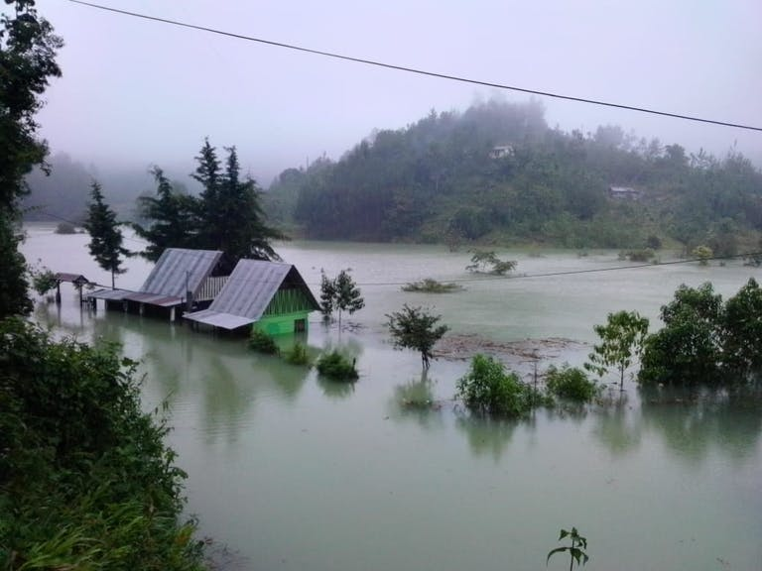
By repenting truly [obeying the LORD’S commandments in the Bible], the LORD will protect His children, the true Israelites which include so-called Guatemalans. While His judgments, pestilences and punishments will continue in Honduras and in the earth, the LORD will protect those that abide in Him and His Word [the true Jesus Christ]:
Psalms 91:1 He that dwelleth in the secret place of the most High shall abide under the shadow of the Almighty.
:2 I will say of the LORD, He is my refuge and my fortress: my God; in him will I trust.

:6 Nor for the pestilence that walketh in darkness; nor for the destruction that wasteth at noonday.
:7 A thousand shall fall at thy side, and ten thousand at thy right hand; but it shall not come nigh thee.

Jeremiah 10:11 Thus shall ye say unto them, The gods that have not made the heavens and the earth, even they shall perish from the earth, and from under these heavens.
:12 He hath made the earth by his power, he hath established the world by his wisdom, and hath stretched out the heavens by his discretion.

:13 When he uttereth his voice, there is a multitude of WATERS in the heavens, and he causeth the vapours to ascend from the ends of the earth; he maketh LIGHTNINGS with RAIN, and bringeth forth the WIND out of his treasures.
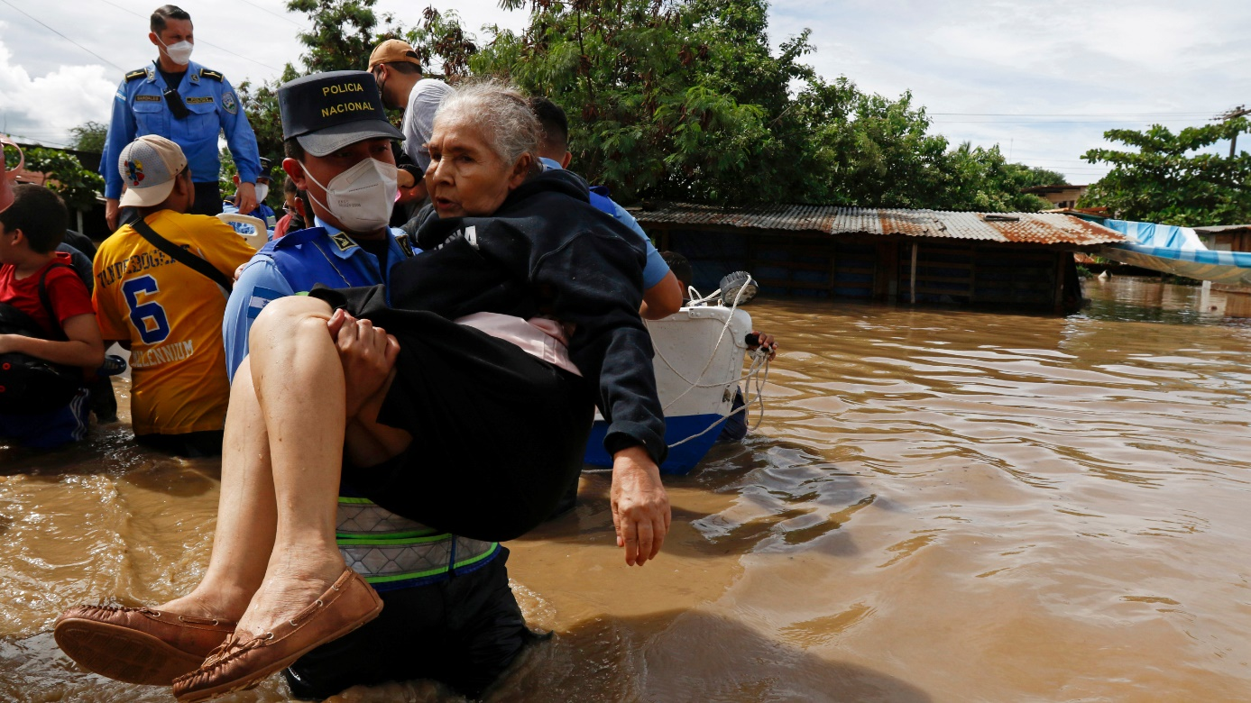
Isaiah 29:6 Thou shalt be visited of the LORD of hosts with thunder, and with earthquake, and great noise, with STORM and TEMPEST, and the flame of devouring fire.
2020 - 2021
Guatemala has hundreds of thousands reported cases with thousands of deaths due to Covid19:

Psalms 91:1 He that dwelleth in the secret place of the most High shall abide under the shadow of the Almighty.
:2 I will say of the LORD, He is my refuge and my fortress: my God; in him will I trust.

:6 Nor for the PESTILENCE that walketh in darkness; nor for the destruction that wasteth at noonday.
:7 A thousand shall fall at thy side, and ten thousand at thy right hand; but it shall not come nigh thee.
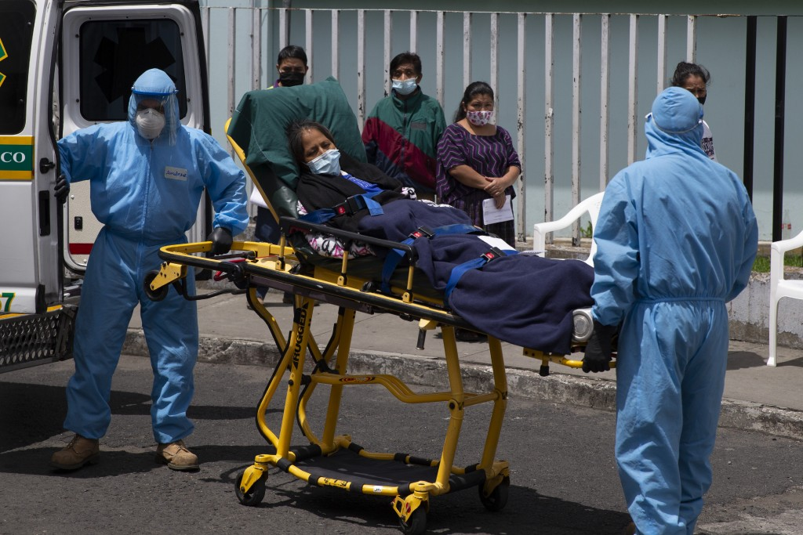
Unidentified graves of Covid19 casualties in Guatemala.
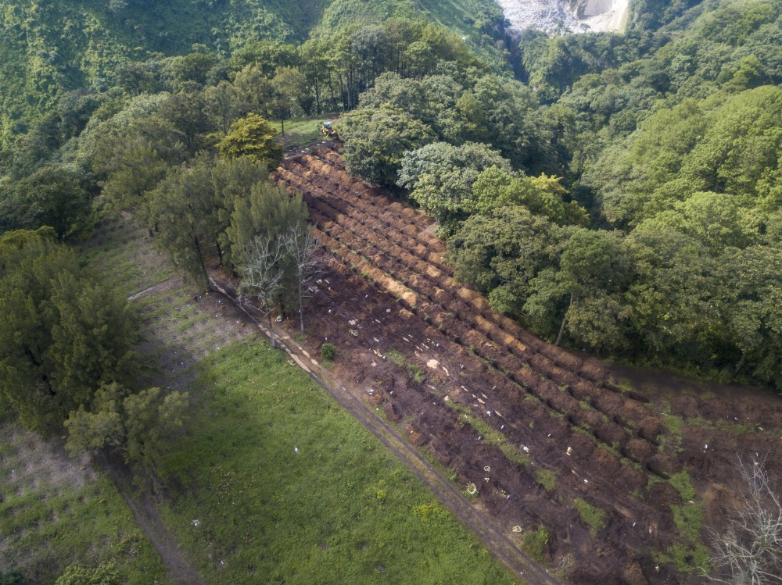

2021
On January 17, 2021, migrant caravans occurred in Guatemala.
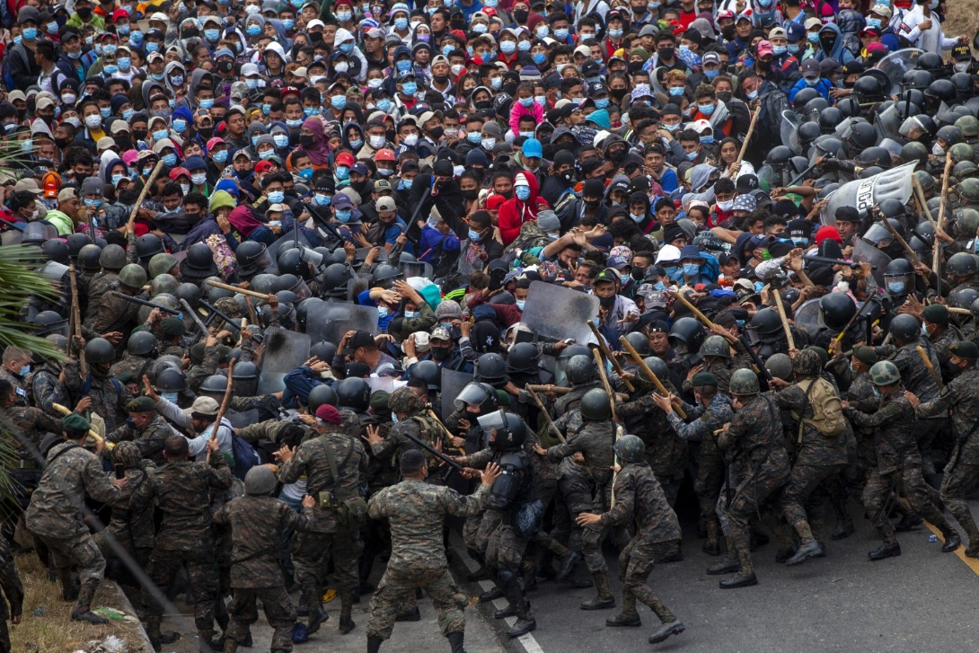

The Atlantic Council’s Latin America Center said climate change, the effect of the pandemic, poverty, corruption, and insecurity in Central America will continue to drive mass migration to the US.

They also indicated the lack of “sustained and inclusive economic opportunities” in the Northern Triangle region were among the main drivers of unauthorized migration.
So-called Guatemalans seek to cross the Mexican border to America [Babylon the Great], instead of seeking the Heavenly Father through His Word Jesus Christ [LORD of hosts]. Do you believe in God?:

Isaiah 9:13 For the people turneth not unto him that smiteth them, neither do they seek the LORD of hosts.
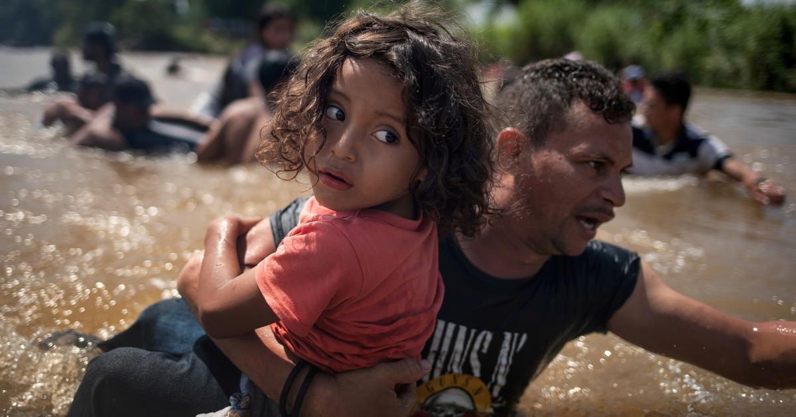

On January 17, 2021, Guatemalan soldiers and police attacked Honduran migrants near Chiquimula, Guatemala. INSTEAD OF SEEKING TO HELP their brothers with whom they are separated by a border established by their enemies [Conquistadors, Americans/Puritans]:

IJohn 3:15 Whosoever hateth his brother is a murderer: and ye know that no murderer hath eternal life abiding in him.
:16 Hereby perceive we the love of God, because he laid down his life for us: and we ought to lay down our lives for the brethren.
:17 But whoso hath this world's good, and seeth his brother have need, and shutteth up his bowels of compassion from him, how dwelleth the love of God in him?
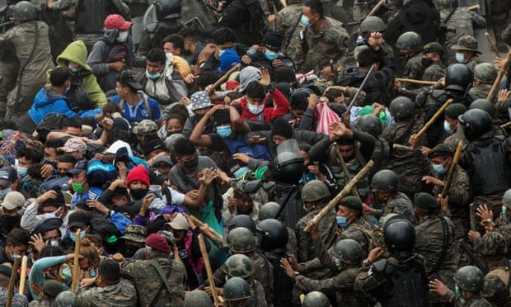

Daniel 12:1 And at that time shall Michael stand up, the great prince which standeth for the children of thy people: and there shall be a TIME OF TROUBLE, such as never was since there was a nation even to that same time: and at that time thy people shall be delivered, every one that shall be found written in the book.
“We have no work. We can’t go back,” one migrant insisted. “Back home we’re dying of hunger.”
TRAPPED in tribulation in Central America, the Caribbean and South America. Cannot go back, cannot go forward and are not wanted by their brothers [not even bordering countries such as Guatemala] nor by our enemies, exactly as our other scattered brethren are unwanted:
Zephaniah 2:1 Gather yourselves together, yea, gather together, O nation not desired;
(it is time for us to gather together as the Bible commands us to do, and says we will: Genesis 49:10, Isaiah 11:10-12, Baruch 4:37, etc.)

2021
On July 29, 2021, tens of thousands of Guatemalans took to the street to demand the resignation of the country’s president and attorney general due to the administration’s lack of willingness to address corruption.
Proverbs 29:2 When the righteous are in authority, the people rejoice: but when the wicked beareth rule, the people MOURN.
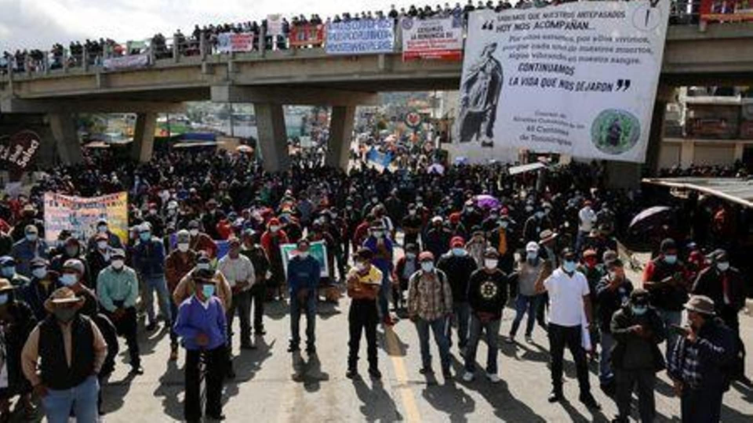
Isaiah 9:13 For the people turneth not unto him that smiteth them, neither do they seek the LORD of hosts.
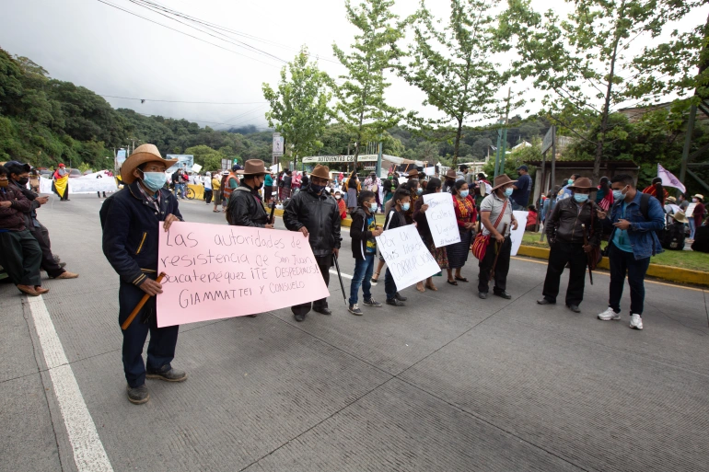
IITimothy 3:1 This know also, that in the last days PERILOUS TIMES shall come.
(perilous = exposed to imminent danger, extremely unsafe)

Repent my beloved brethren, we are in the Last Days:
Luke 13:5 I tell you, Nay: but, except ye repent, ye shall all likewise perish.

All honor glory and praises to our Almighty and Eternal Heavenly Father, and His Word our Life and King Jesus Christ.

1611 king james version bible/1769 king james version bible; www.thetruththebible.com;
Sagrada Biblia 1602 – Cipriano de Valera version; www.laverdadlabiblia.com

