POLICE BRUTALITY

Romans 13:1 Let every soul be subject unto the higher powers. For there is no power but of God: the powers that be are ordained of God.

:2 Whosoever therefore resisteth the power, resisteth the ordinance of God: and they that resist shall receive to themselves damnation.

3 For rulers are not a terror to good works, but to the evil. Wilt thou then not be afraid of the power? do that which is good, and thou shalt have praise of the same:

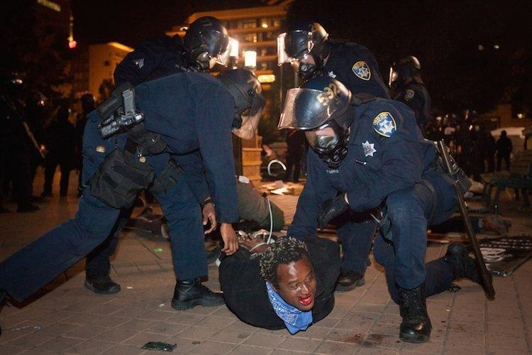

:4 For he is the minister of God to thee for good. But if thou do that which is evil, be afraid; for he beareth not the sword in vain: for he is the minister of God, a revenger to execute wrath upon him that doeth evil.
[When we OBEY our Almighty Creator and Father’s Word, we will not suffer violence from the police, not EVEN racist policemen. BECAUSE God controls all things, including racist policemen.]

There are several things occurring at the same time, (1) we’re being punished for our sins by God our Heavenly Father; (2) lies and injustice by our enemies ruling/reigning over us; (3) constantly sinning and therefore our enemies that rule us, are used AND CONTROLLED by the LORD to punish us; one of the Almighty Father’s many tools of judgment and punishment against us His sons and daughters of Israel.
Israel/Jews = so-called blacks and so-called Indians of the Americas, Caribbean, and our scattered brethren.
When our people continue daily in sins: such as idolatries, not teaching, discipling and raising our children, disrespecting your man as a woman, dishonoring father and mother, being criminally minded, hating your own people, etc., etc., etc., etc., etc., etc., etc., then the Heavenly Father chastises us fiercely. As it is written:
Deuteronomy 8:5 Thou shalt also consider in thine heart, that, as a man chasteneth his son, so the LORD thy God chasteneth thee.
[Hebrews 12:5 And ye have forgotten the exhortation which speaketh unto you as unto children, My son, despise not thou the chastening of the Lord, nor faint when thou art rebuked of him:

:6 For whom the Lord loveth he chasteneth, and scourgeth every son whom he receiveth.]

Aside from illnesses, chronic sickness, death, spirits/demons afflicting our minds, poverty, hurricanes and earthquakes, etc., God also allows AND MOVES the so-called white man to afflict us, who inherently hates us. Therefore, the racism, violent oppression and injustice is unending and perfect in its cruelty:
Luke 13:3 I tell you, Nay: but, except ye repent, ye shall all likewise perish.
Deuteronomy 28:29 And thou shalt grope at noonday, as the blind gropeth in darkness, and thou shalt not prosper in thy ways: and thou shalt be only oppressed and spoiled evermore, and no man shall save thee.
[This is one of many precepts and curses in the bible that make it very clear and very specific, that we continually suffer as we do, for the breaking of the commandments in the Bible.]
Leviticus 26:15 And if ye shall despise my statutes, or if your soul abhor my judgments, so that ye will not do all my commandments, but that ye break my covenant:

:17 And I will set my face against you, and ye shall be slain before your enemies: they that hate you shall reign over you; and ye shall flee when none pursueth you.
THEY THAT HATE YOU SHALL RULE/REIGN OVER YOU:
Deuteronomy 28:47 Because thou servedst not the LORD thy God with joyfulness, and with gladness of heart, for the abundance of all things;

:48 Therefore shalt thou serve thine enemies which the LORD shall send against thee, in hunger, and in thirst, and in nakedness, and in want of all things: and he shall put a yoke of iron upon thy neck, until he have destroyed thee.
“THEREFORE SHALT THOU SERVE THINE ENEMIES WHICH THE LORD SHALL SEND AGAINST THEE…” 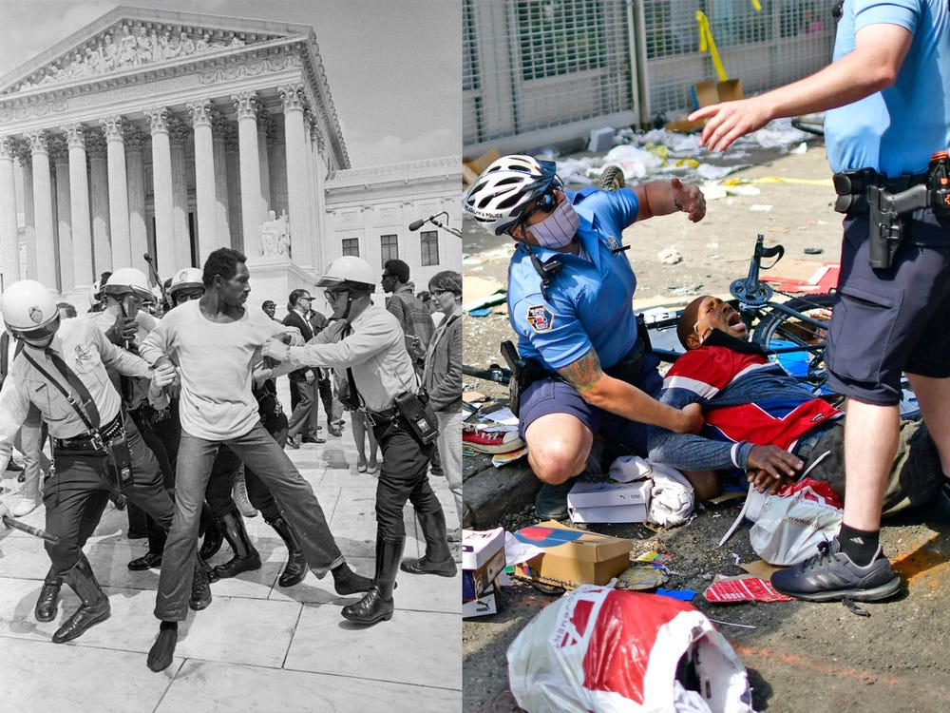
LIES and Violent INJUSTICE:
Deuteronomy 33:29 Happy art thou, O Israel: who is like unto thee, O people saved by the LORD, the shield of thy help, and who is the sword of thy excellency! and thine enemies shall be found liars unto thee; and thou shalt tread upon their high places
[Liars, lying to justify murder, violence, perverting the force of the law, and incessant brutality.]
THESE INJUSTICES are a result of us sinning BEFORE the police bring God’s chastening by their hand. And the House of hard Bondage for us, as it is written, NOT the land of the free!

Ecclesiasticus 20:25 A thief is better than a man that is accustomed to lie: but they both shall have destruction to heritage.
[obviously whether an individual, or the nation of Edom, destruction awaits thieves and liars, regardless of their deceitful ways of making themselves the victim or the noble hero while bringing death.]

Aside from continual and great blasphemies, making idols of Heavenly Father and Jesus Christ and using their lying image to represent God [The Heavenly Father, His Son Jesus Christ]: IIThessalonians 2:3-4, Jeremiah 16:19, etc., Edomites/the so-called white man also continue to use all of their power to afflict the sons of the LORD in their hand. HOWEVER, by us breaking the Heavenly Father’s commandments and man’s laws, many of our people will continue to feel the LORD’s wrath, and the frustrations of captivity and oppression [punishments for sin], racial profiling, and NO justice, etc.:
Leviticus 26:37 And they shall fall one upon another, as it were before a sword, when none pursueth: and ye shall have no power to stand before your enemies.
[NO power, even with a black chief of police, black governor, or black mayor!]
:38 And ye shall perish among the heathen, and the land of your enemies shall eat you up.
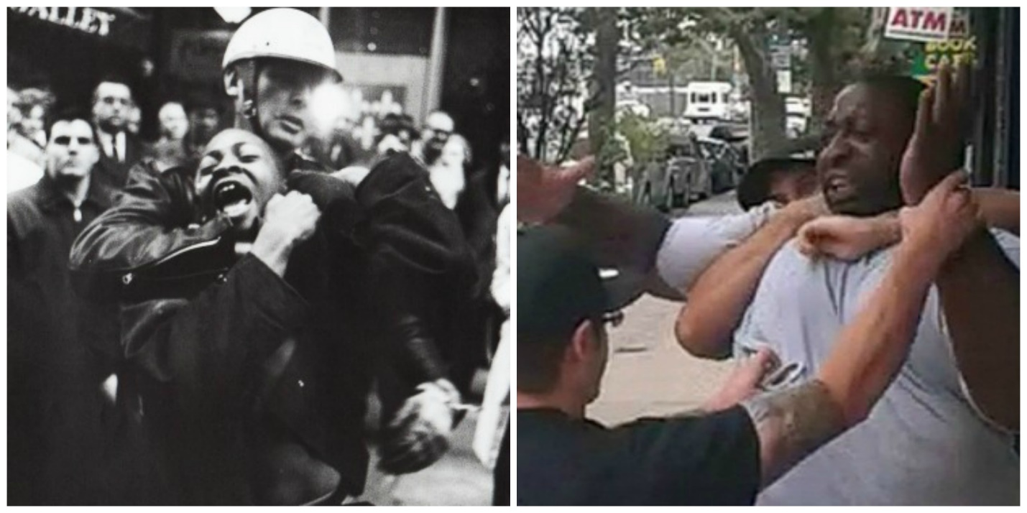
MANY TOOLS of wrath and punishment we suffer from the LORD for our sins:
Psalms 17:13 Arise, O LORD, disappoint him, cast him down: deliver my soul from the wicked, which is thy sword:
Although police keep law and order, when WE AS the LORD’S children sin against our Father the Eternal Most High, we activate and bring about the curses and punishments in the Bible which are written:
Deuteronomy 28:32 Thy sons and thy daughters shall be given unto another people, and thine eyes shall look, and fail with longing for them all the day long: and there shall be no might in thine hand.
[WE STILL have NO might/power in our hand to fight against our enemies, NOT even in our own communities/ghettos. Including today while we’re still in slavery, even if not in prison, or in shackles!]
Jeremiah 31:10 Hear the word of the LORD, O ye nations, and declare it in the isles afar off, and say, He that scattered Israel will gather him, and keep him, as a shepherd doth his flock.

:11 For the LORD hath redeemed Jacob, and ransomed him from the hand of him that was stronger than he.
[We ARE not going escape, nor do anything in this iron furnace and house of bondage (Babylon the Great), until we truly repent and our Biblical Lord Jesus Christ liberates us, period.]

Jeremiah 50:33 Thus saith the LORD of hosts; The children of Israel and the children of Judah were oppressed together: and all that took them captives held them fast; they refused to let them go.
In these last days before Judgment Day, there is no relief or getting out of racist oppression until we change/repent, as individuals and as a righteous remnant. AS indicated in Romans 13:4, our oppressors in power and with God-given authority (Job 9:24, Luke 4:5-8, etc.) will not brutalize us when we do well [obey the Most High] or even if we are confronted by a racist policeman’s harassment.

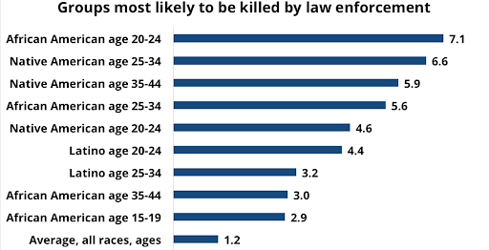 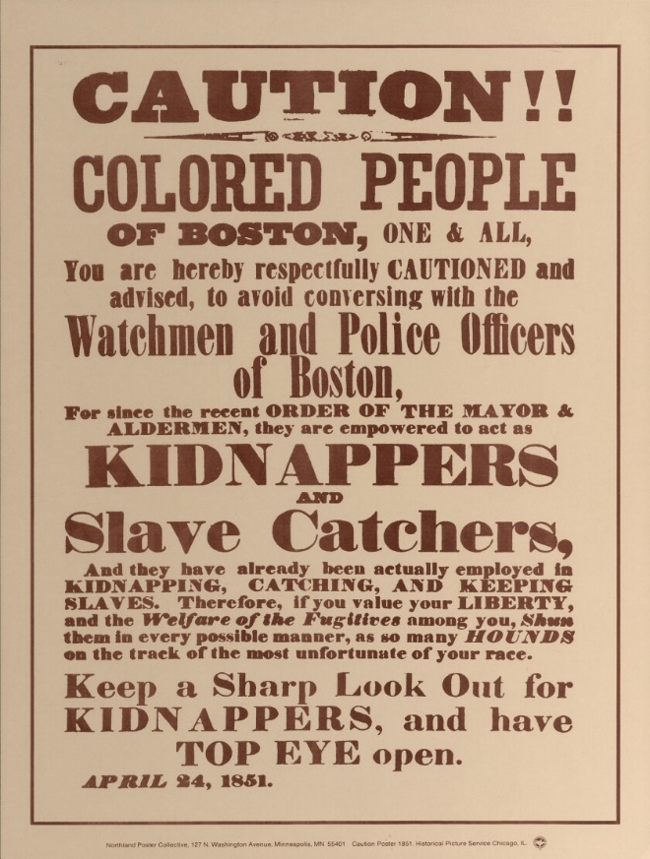Rate of law enforcement killings, per million population per year, 1999-2011.
Source: Centers for Disease Control and Prevention, National Center for Health Statistics.
[Babylon the Great/America has all 12 tribes [so-called indigenous people, and so-called blacks] in relentless oppression, one of many distinctions biblically between ancient Babylon [600B.C.], and America/modern Babylon. Intentional affliction, and other bonus exploitations such as real estate values always low where we live, and constant appreciating property values where we do not live, etc.]
As liars, the so-called white man purposely does not keep PUBLIC records too accurately which detail murders or crimes by officers. Which allow racist police officers or murderers to constantly escape justice or get employment in other cities, counties, or states. HOWEVER, rage filled murderers are always excellent at fulfilling the LORD’S bidding and judgment against the sinners of our people.

Isaiah 51:20 Thy sons have fainted, they lie at the head of all the streets, as a wild bull in a net: they
are full of the fury of the LORD, the rebuke of thy God.
Repent my dear brothers and sisters. What you do not realize, is by sinning ALL day every day, when you encounter the police the LORD has sent for you for judgment, YOU WILL NOT escape! Even though at the moment you may have been innocent, or guilty of no crime, or had the most minor of infractions such as a tail light not working, or being accused falsely of jay-walking, etc., which DOES NOT have a sentence of death, broken bones or permanent physical damage.
THEREFORE repent, and stop the senseless marching and protesting to our enemies to bring justice: Isaiah 9:13. Because for centuries they have undeniably proven their justice is “just us” not for us true Israelites that God says are their enemies [by their hand] and whom they have perpetual hatred for:
Amos 1:11 Thus saith the LORD; For three transgressions of Edom, and for four, I will not turn away the punishment thereof; because he did pursue his brother with the sword, and did cast off all pity, and his anger did tear perpetually, and he kept his wrath for ever:
[Ezekiel 35:5 Because thou hast had a perpetual hatred, and hast shed the blood of the children of Israel by the force of the sword in the time of their calamity, in the time that their iniquity had an end:

:6 Therefore, as I live, saith the Lord GOD, I will prepare thee unto blood, and blood shall pursue thee: sith thou hast not hated blood, even blood shall pursue thee.
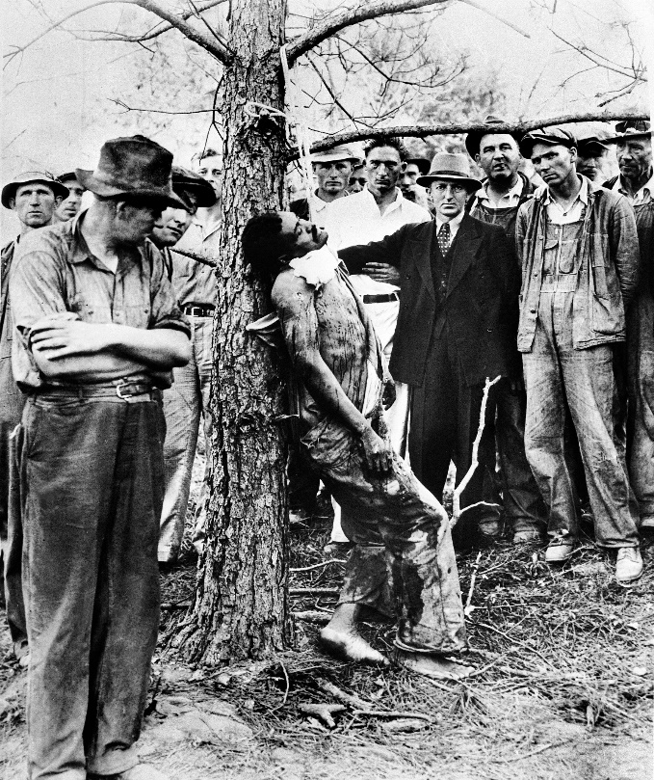Perpetual [unending] hatred, as it is written. (Armaud Arbery’s lynching, left photo)

Think of how much bloodshed, atrocities and violence to men peaceful towards them, as well as to women and children, if starting with Colombus in 1492. Judgment is coming, as it is written above.]

Isaiah 9:13 For the people turneth not unto him that smiteth them, neither do they seek the LORD of hosts.
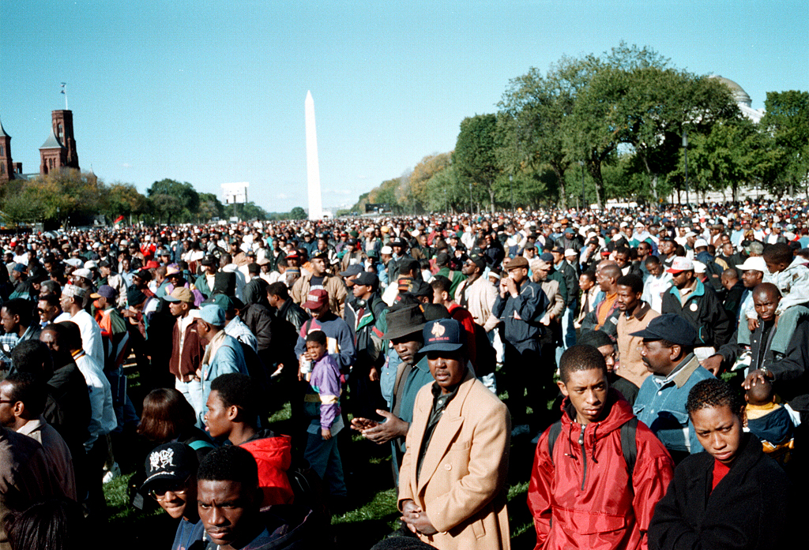

[October 16, 1995…million man march, headed by Louis Farrakhan. Seek the LORD of hosts, the biblical Jesus Christ (The Bible). SEEK, Hear the Word/Bible and do the word, not seek our oppressor the so-called white man, Not seek Crhsitianity, Islam or any religion; nor seek man, nor liars and dumb dogs. Again, Christ is our ONLY way, and without Him we will do nothing (John 15:3-8)!]

REPENT:
Luke 13:5 I tell you, Nay: but, except ye repent, ye shall all likewise perish.
All honor, truth, glory and praises to our Almighty and Eternal Heavenly Father, through His Word and our King Jesus Christ.

1611 king james version bible/1769 king james version bible; www.thetruththebible.com

