Puerto Rico, Repent
Boricua and Taino brothers and sisters, REPENT! Judgment Day is real. Look at the constant judgments and punishments God has brought to Puerto Rico. These are not coincidences, bad luck, or mother nature! Obviously if Catholicism pleased God and was how to serve Him, or worshipping Yemaya, He would not afflict Puerto Rico with constant judgment, poverty, and despair:
Proverbs 28:13 He that covereth his sins shall not prosper: but whoso confesseth and forsaketh them shall have mercy.
But because lies and darkness continue to blind the whole earth, especially Puerto Rico: Isaiah 60:1-2, IJohn 5:19, most of the people continue to follow this world's lies, wicked idolatries [Catholicism, Easter, Christmas, Christianity, etc.], and false ways to worship God. Including countless other evils because they are disguised and widely accepted. The Word/Bible only, which is also the true Jesus Christ, IS OUR LIFE [Deuteronomy 8:3, Psalms 40:7, John 6:63, etc.] NOT religions, NOT our own ways, nor doing what we think is best.
Redeem the time now, by using our last opportunity to REPENT and STOP THE SINS [breaking the commandments in the Bible: IJohn 3:4, Proverbs 13:13] that are being chosen with suffering, INSTEAD of what God says and commands us in the Bible:
IIPeter 3:9 The Lord is not slack concerning his promise, as some men count slackness; but is longsuffering to us-ward, not willing that any should perish, but that all should come to repentance.
:10 But the day of the Lord will come as a thief in the night; in the which the heavens shall pass away with a great noise, and the elements shall melt with fervent heat, the earth also and the works that are therein shall be burned up.
Luke 21:34 And take heed to yourselves, lest at any time your hearts be overcharged with surfeiting, and drunkenness, and cares of this life, and so that day come upon you unawares.
[surfeiting = indulging in sin completely: Proverbs 27:20;
drunkenness = totally consumed with idolatry: Deuteronomy 29:19]
:35 For as a snare shall it come on all them that dwell on the face of the whole earth.

2017
On May 3, Puerto Rico files for bankruptcy. It is the largest municipal bankruptcy in US history.
Deuteronomy 28:43 The stranger that is within thee shall get up above thee very high; and thou shalt come down very low.
:44 He shall lend to thee, and thou shalt not lend to him: he shall be the head, and thou shalt be the tail.
American citizens, but NOT cared for by those that hate you and whom you hve to beg for assistance. America test nuclear weapons in Puerto Rico, in Vieques and other areas, with no consequences. They put 17 year old under-aged so-called Puerto-Ricans on the front lines of their invading armies to die, with no consequences. But instead of truly seeking to God that put us in our enemies’ hands, you still seek to America: Isaiah 9:13. By following christianity and other idolatries, and continually breaking Gods commandments, we become poorer and seek even more aid, as it is written:
Jeremiah 5:9 Shall I not visit for these things? saith the LORD: and shall not my soul be avenged on such a nation as this?
On September 7, 2017, the Most High’s Judgment, a Hurricane blasphemously called Irma hit Puerto Rico Category 5 storm with 185 mph winds. About a million people were without power and nearly 50,000 also were without water.
Irma caused $65 billion in damages:
Deuteronomy 8:5 Thou shalt also consider in thine heart, that, as a man chasteneth his son, so the LORD thy God chasteneth thee.
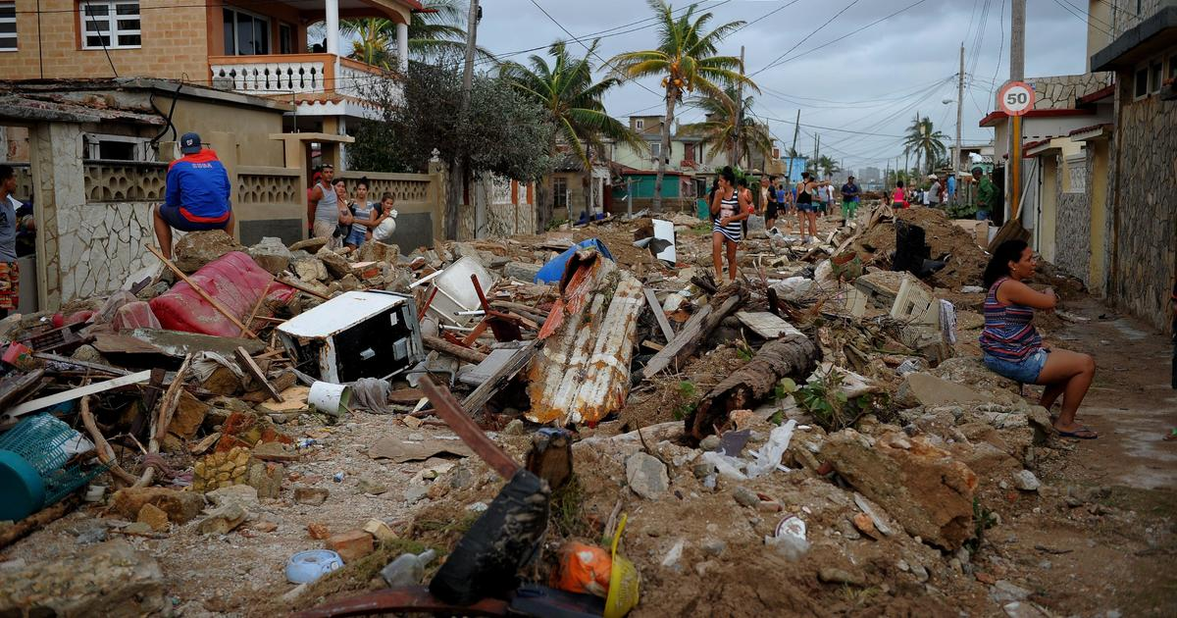
Isaiah 29:6 Thou shalt be visited of the LORD of hosts with thunder, and with earthquake, and great noise, with STORM and TEMPEST, and the flame of devouring fire.
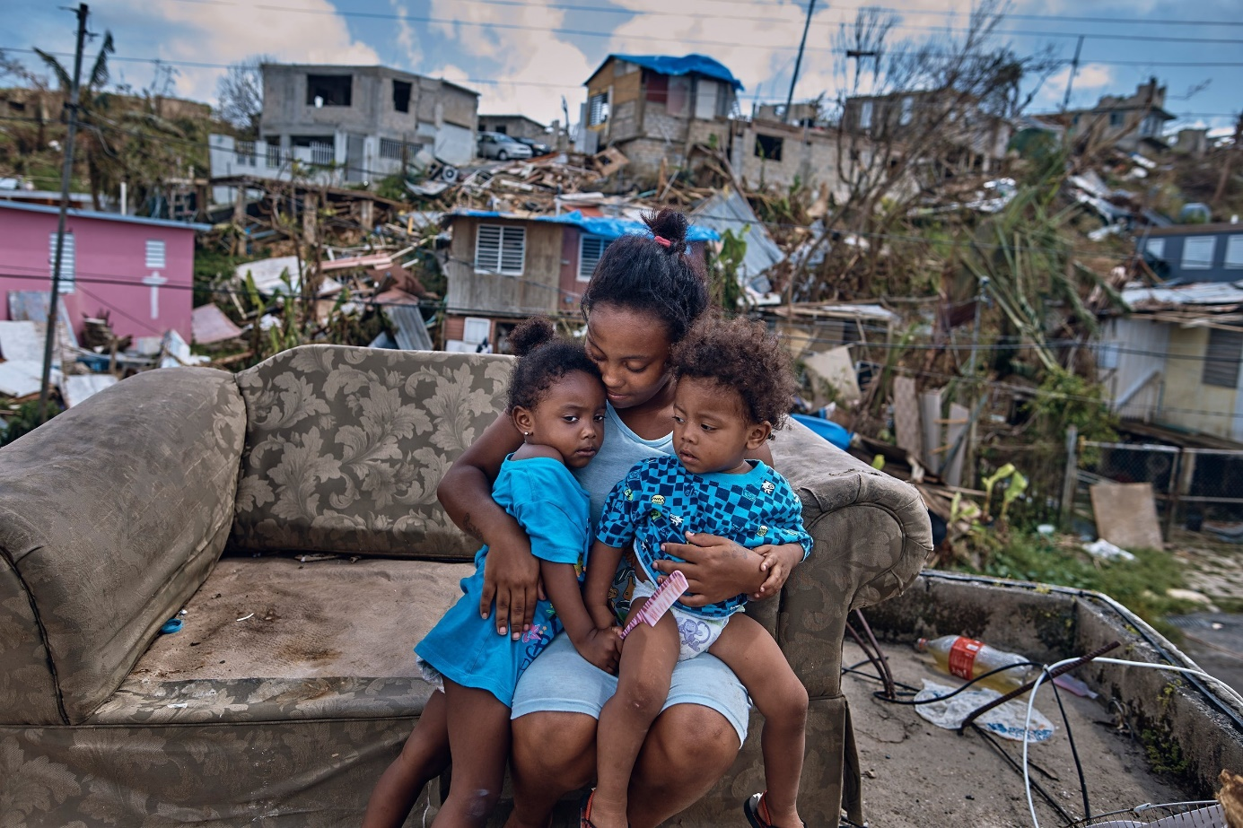
On September 20, the Most High’s Judgment Hurricane blasphemously called Maria made landfall near Yabucoa, Puerto Rico as a Category 4 hurricane. The electrical power was heavily affected, with an island-wide power outage.
Thousands of people were killed, many of them due to delayed medical care.
Maria caused $90 billion in damage in Puerto Rico. And it resulted in the longest blackout in US history, 328 days for power to be restored to all areas in the island:
Jermiah 5:22 Fear ye not me? saith the LORD: will ye not tremble at my presence, which have placed the sand for the bound of the sea by a perpetual decree, that it cannot pass it: and though the waves thereof toss themselves, yet can they not prevail; though they roar, yet can they not pass over it?

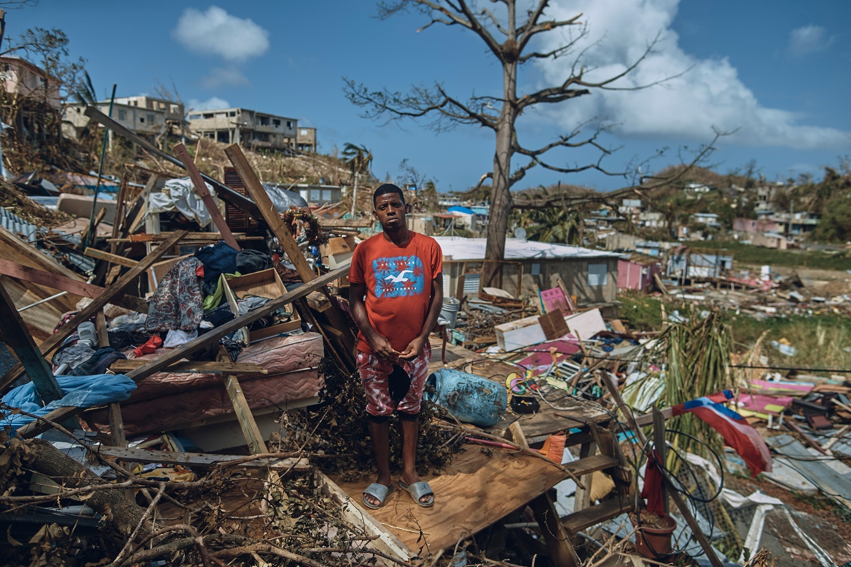

2019
On July 25, Governor Ricardo Rossello resigns after 12 days of protests by hundreds of thousands of people, announcing he would step down on August 2.
The protests have made history: Not only were they the largest ever seen on the island, but it's also the first time a governor has been pushed out of office without an election.
IIEsdras 9:2 Then shalt thou understand, that it is the very same time, wherein the Highest will begin to visit the world which he made.
:3 Therefore when there shall be seen earthquakes and UPROARS of the people in the world:
Matthew 24:21 For then shall be great tribulation, such as was not since the beginning of the world to this time, no, nor ever shall be.

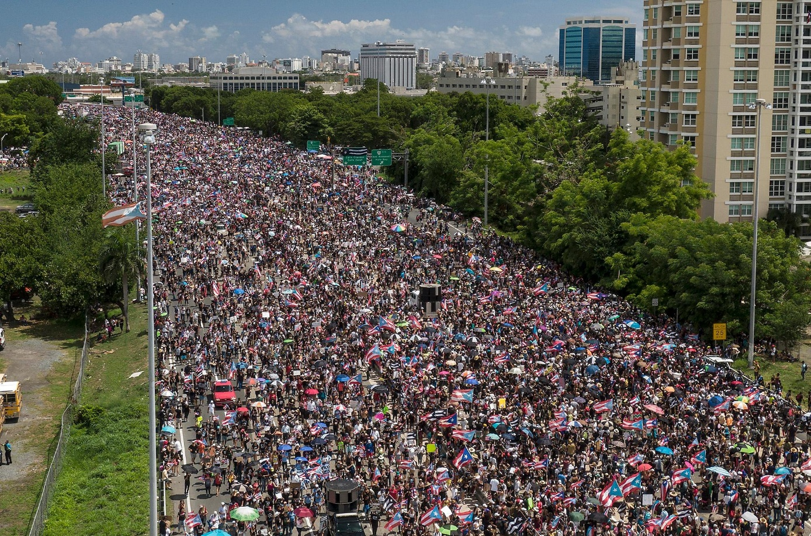

2020
On January 6, a 5.8-magnitude quake hits the island, causing power outages and severely damaging several homes and structures.
On January 7, a 6.4-magnitude quake hits the island, the strongest in a series of earthquakes starting on December 28th, and the most powerful to strike the island in 102 years.
The quake killed and injured several people and caused an island-wide power outage as well as structural damage to homes, schools, roads and bridges, especially in the southwestern part of the island.
The island is still recovering from the devastation of 2017's Hurricane Maria, which killed thousands of people and destroyed a significant amount of infrastructure.
IIEsdras 9:2 Then shalt thou understand, that it is the very same time, wherein the Highest will begin to VISIT the world which he made.
:3 Therefore when there shall be seen EARTHQUAKES and uproars of the people in the world:
Isaiah 29:6 Thou shalt be visited of the LORD of hosts with thunder, and with EARTHQUAKE, and great noise, with storm and tempest, and the flame of devouring fire.
Luke 21:11 And great EARTHQUAKES shall be in divers places, and famines, and PESTILENCES; and fearful sights and great signs shall there be from heaven.
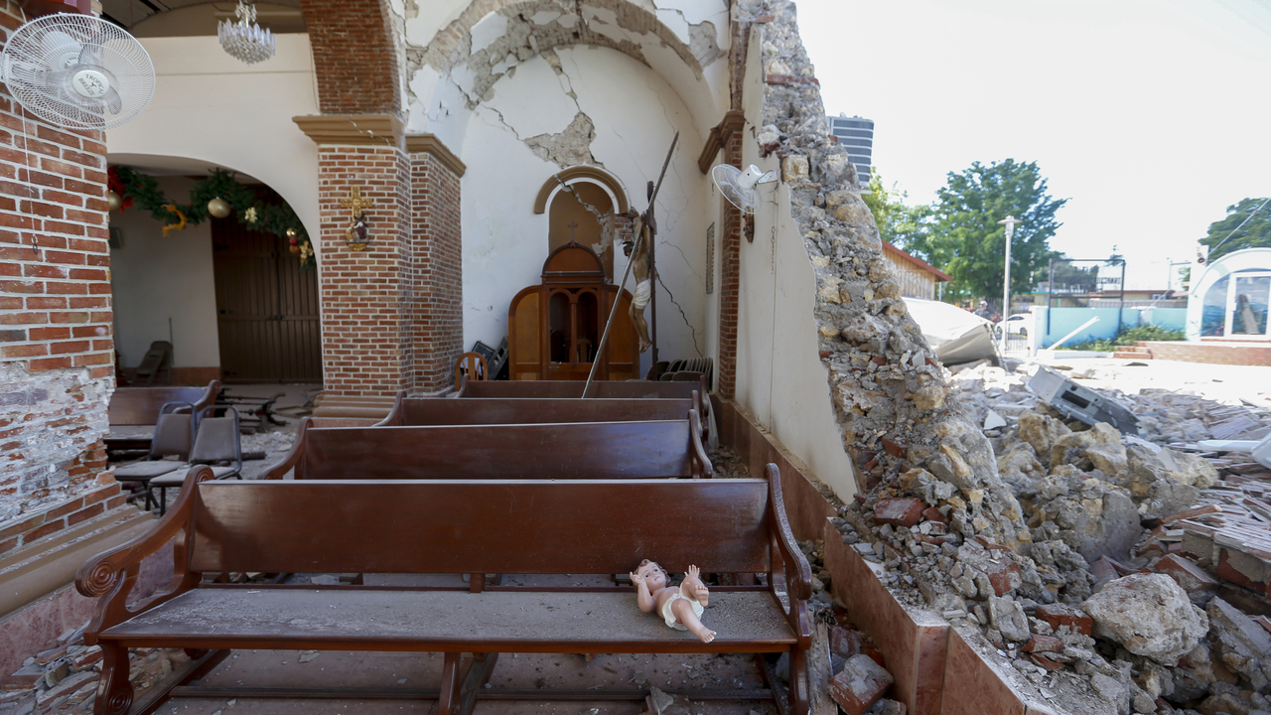

2021
New variants of Covid-19 started spreading across the U.S. territory of Puerto Rico.
Now, a spike in cases and hospitalizations has put medical experts at odds with the government, which is struggling to protect people's health while also trying to prevent an economic implosion on an island battered by hurricanes, earthquakes and a prolonged financial crisis.
Matthew 24:3 And as he sat upon the mount of Olives, the disciples came unto him privately, saying, Tell us, when shall these things be? and what shall be the sign of thy coming, and of the end of the world?
:7 For nation shall rise against nation, and kingdom against kingdom: and there shall be famines, and PESTILENCES, and earthquakes, in divers places.
By repenting truly [obeying the LORD’S commandments in the Bible], the LORD will protect His children, the true Israelites which include so-called Puerto Ricans. While His judgments, pestilences and punishments will continue in Puerto Rico and in the earth, the LORD will protect those that abide in Him and His Word [the true Jesus Christ]:
Psalms 91:1 He that dwelleth in the secret place of the most High shall abide under the shadow of the Almighty.
:2 I will say of the LORD, He is my refuge and my fortress: my God; in him will I trust.

:6 Nor for the pestilence that walketh in darkness; nor for the destruction that wasteth at noonday.
:7 A thousand shall fall at thy side, and ten thousand at thy right hand; but it shall not come nigh thee.
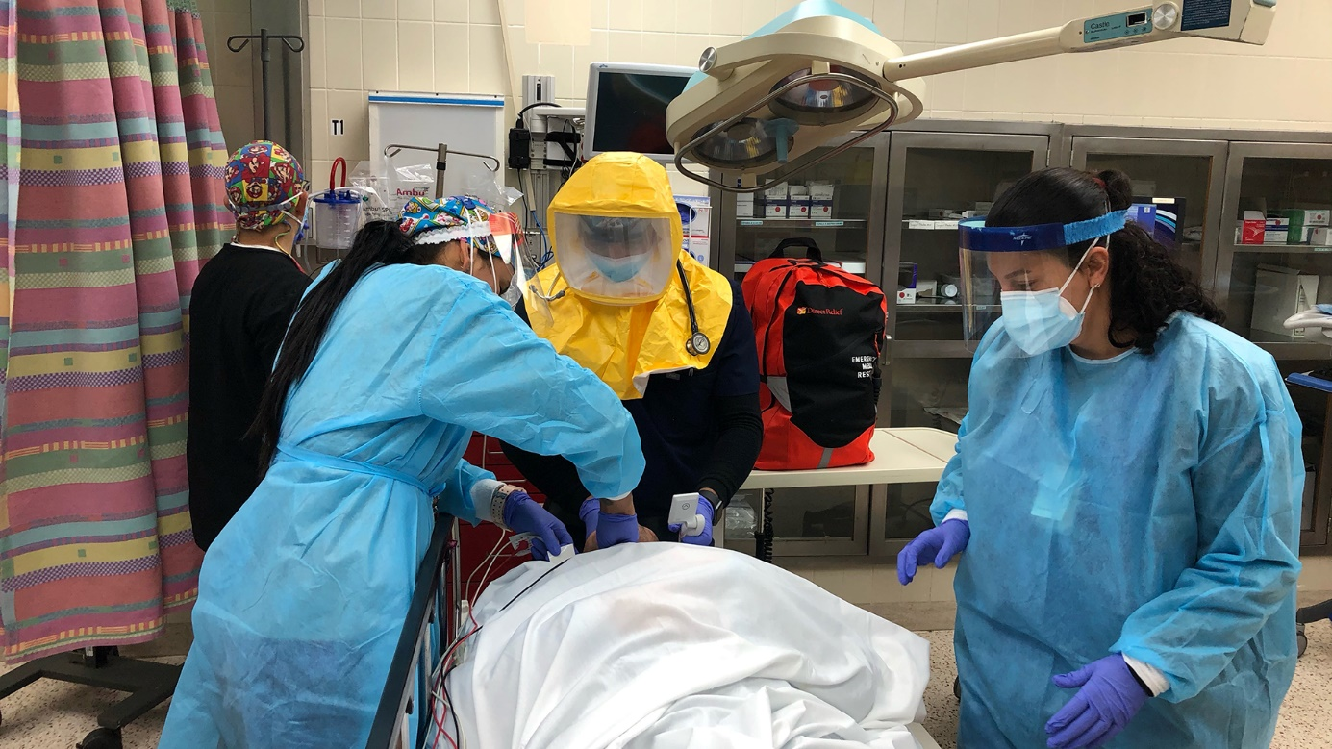

Outcry/Uproars of the people of Borinquen [PR] due to women being victims of violence and murder.

Hundreds of Puerto Ricans shut down San Juan’s Teodoro Moscoso Bridge in the evening of May 2nd, gathered to denounce the archipelago’s epidemic of gender-based violence.

This year several more women have been murdered. Last year there was about 60 women. Reports estimate a woman is murdered in Puerto Rico every seven days, with the rates increasing:
IITimothy 3:1 This know also, that in the last days PERILOUS TIMES shall come.
(perilous = exposed to imminent danger, extremely unsafe)
Repent my beloved brethren, we are in the Last Days:
Luke 13:5 I tell you, Nay: but, except ye repent, ye shall all likewise perish.

All honor glory and praises to our Almighty and Eternal Heavenly Father, and His Word our Life and King Jesus Christ.
1611 king james version bible/1769 king james version bible; www.thetruththebible.com

