UFO’s ARE Identified in the Bible

U.F.O.’S are vehicles or chariots/clouds used by the angels of heaven, in the past during biblical times [where no weather balloons nor any other air born vehicles could FALSELY claim identity], and today:

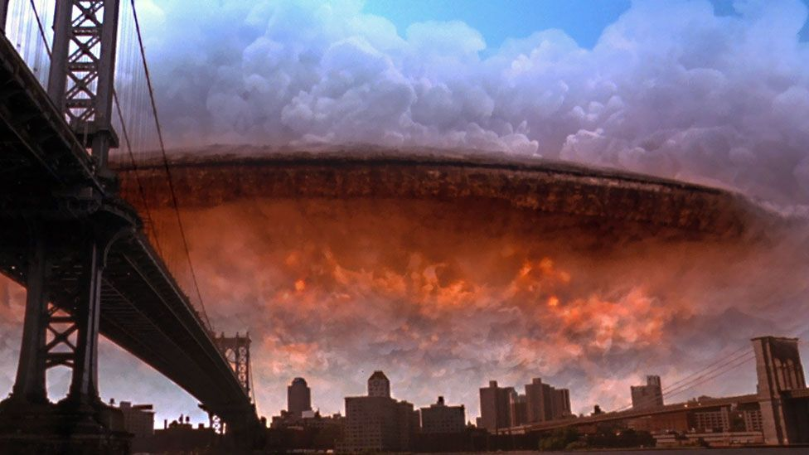
[an image from the movie Judgment Day. The so-called white man knows the Bible (Matthew 4:1-10).]
Ezekiel 1:4 And I looked, and, behold, a whirlwind came out of the north, a great cloud, and a fire infolding itself, and a brightness was about it, and out of the midst thereof as the colour of amber, out of the midst of the fire.

:5 Also out of the midst thereof came the likeness of four living creatures. And this was their appearance; they had the likeness of a man.

:6 And every one had four faces, and every one had four wings.

:7 And their feet were straight feet; and the sole of their feet was like the sole of a calf's foot: and they sparkled like the colour of burnished brass.
2Kings 2:11 And it came to pass, as they still went on, and talked, that, behold, there appeared a chariot of fire, and horses of fire, and parted them both asunder; and Elijah went up by a whirlwind into heaven.

:12 And Elisha saw it, and he cried, My father, my father, the chariot of Israel, and the horsemen thereof. And he saw him no more: and he took hold of his own clothes, and rent them in two pieces.
Psalms 68:17 The chariots of God are twenty thousand, even thousands of angels: the Lord is among them, as in Sinai, in the holy place. [The Biblical Jesus Christ on Judgment Day]

:18 Thou hast ascended on high, thou hast led captivity captive: thou hast received gifts for men; yea, for the rebellious also, that the LORD God might dwell among them.
[The Biblical Christ being born upon the earth in 1A.D., and being murdered on the Passover in 34A.D., rising from the dead three days later because he overcame sin by being sinless; and was soon after taken up by a cloud/chariot and presented by angels to the Most High: Acts 1:9-11, Daniel 7:13-14.]
Acts 1:9 And when he had spoken these things, while they beheld, he was taken up; and a cloud received him out of their sight.

:10 And while they looked stedfastly toward heaven as he went up, behold, two men stood by them in white apparel;

:11 Which also said, Ye men of Galilee, why stand ye gazing up into heaven? this same Jesus, which is taken up from you into heaven, shall so come in like manner as ye have seen him go into heaven.

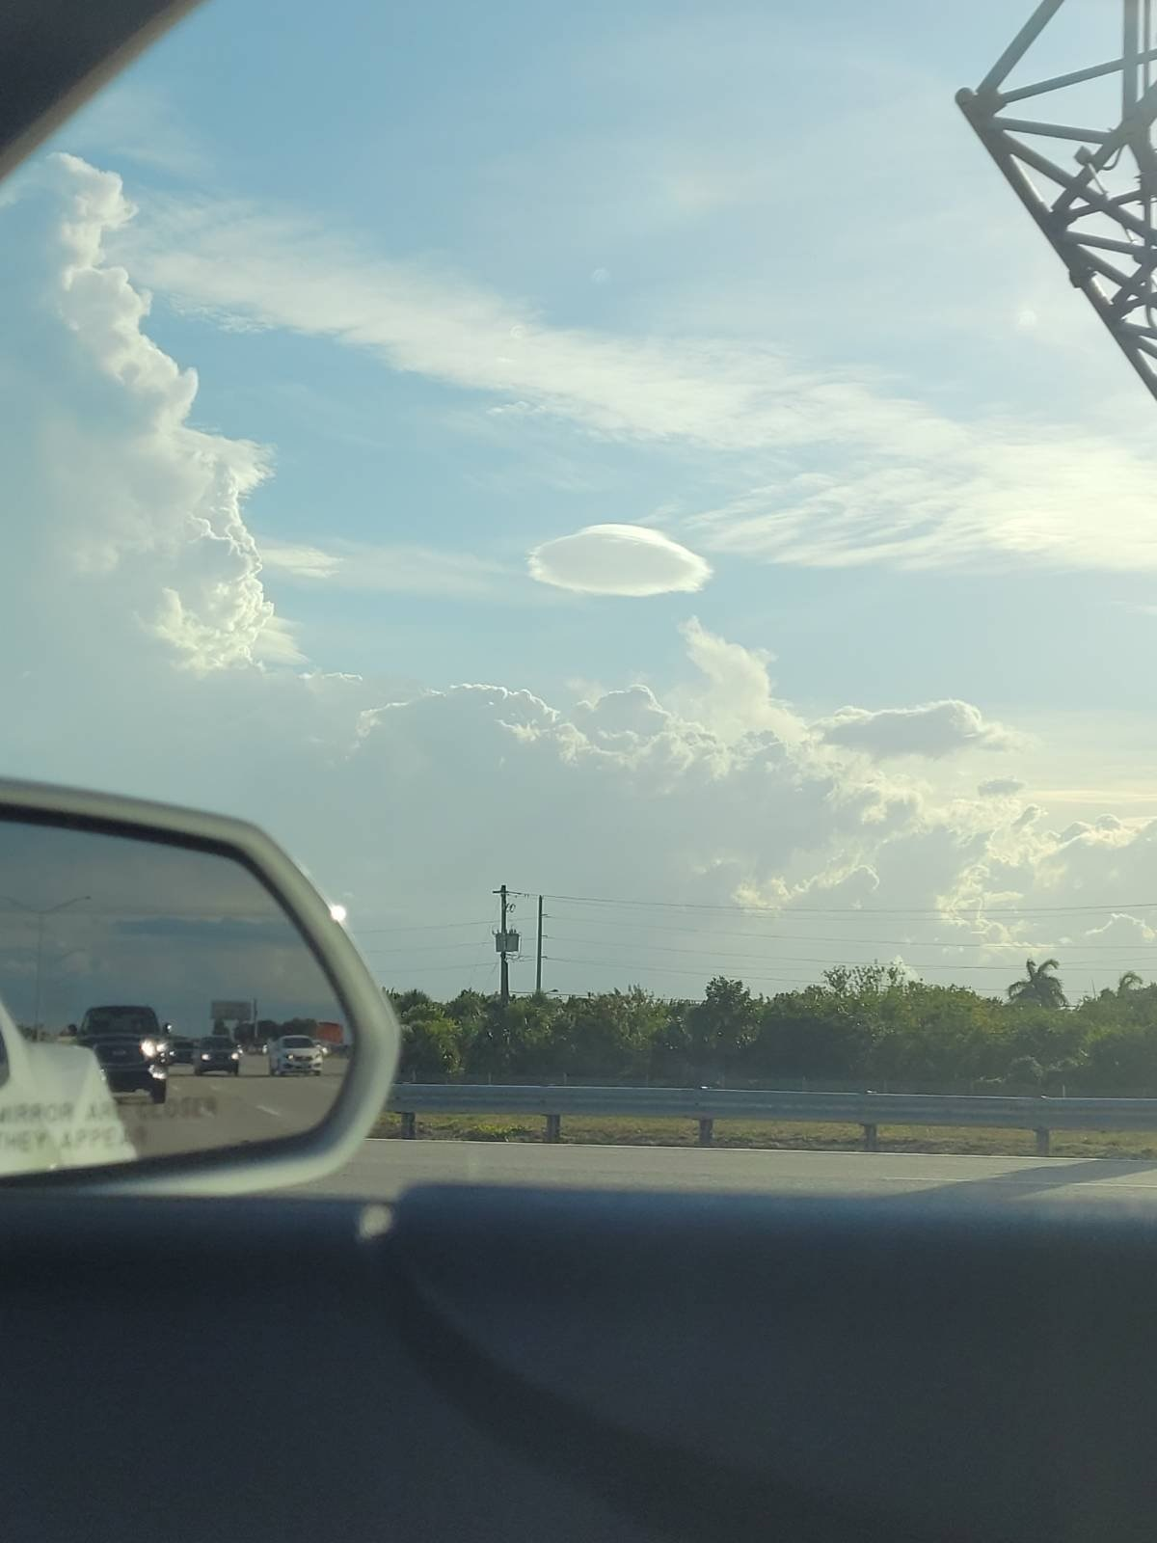
[Daniel 7:13 I saw in the night visions, and, behold, one like the Son of man came with the clouds of heaven, and came to the Ancient of days, and they brought him near before him.

:14 And there was given him dominion, and glory, and a kingdom, that all people, nations, and languages, should serve him: his dominion is an everlasting dominion, which shall not pass away, and his kingdom that which shall not be destroyed.
[Christ prophesied as the son of man to be brought to ASCEND to the heavens He descended from: Proverbs 30:9, Micah 5:2, Psalms 68:18, etc.]
IThessalonians 4:16 For the Lord himself shall descend from heaven with a shout, with the voice of the archangel, and with the trump of God: and the dead in Christ shall rise first:

:17 Then we which are alive and remain shall be caught up together with them in the clouds, to meet the Lord in the air: and so shall we ever be with the Lord.
:18 Wherefore comfort one another with these words.
Isaiah 60:8 Who are these that fly as a cloud, and as the doves to their windows?
[The bible shows us clearly, that not all clouds are regular clouds, but some are chariots with windows.]
Zechariah 5:1 Then I turned, and lifted up mine eyes, and looked, and behold a flying roll.

:2 And he said unto me, What seest thou? And I answered, I see a flying roll; the length thereof is twenty cubits, and the breadth thereof ten cubits.
3 Then said he unto me, This is the curse that goeth forth over the face of the whole earth: for every one that stealeth shall be cut off as on this side according to it; and every one that sweareth shall be cut off as on that side according to it.

:4 I will bring it forth, saith the LORD of hosts, and it shall enter into the house of the thief, and into the house of him that sweareth falsely by my name: and it shall remain in the midst of his house, and shall consume it with the timber thereof and the stones thereof.
[chariots of heaven, UFO’s are NOT a terror to us, nor alien life forms, nor something to fear!]
Isaiah 66:15 For, behold, the LORD will come with fire, and with his chariots like a whirlwind, to render his anger with fury, and his rebuke with flames of fire.

:16 For by fire and by his sword will the LORD plead with all flesh: and the slain of the LORD shall be many.
Revelation 19:11 And I saw heaven opened, and behold a white horse; and he that sat upon him was called Faithful and True, and in righteousness he doth judge and make war.
:19 And I saw the beast, and the kings of the earth, and their armies, gathered together to make war against him that sat on the horse, and against his army.
[On judgment day, Babylon the great/America and the nations will fight against Christ, as it is written.]
IIEsdras 13:32 And the time shall be when these things shall come to pass, and the signs shall happen which I shewed thee before, and then shall my Son be declared, whom thou sawest as a man ascending.

:33 And when all the people hear his voice, every man shall in their own land leave the battle they have one against another.

:34 And an innumerable multitude shall be gathered together, as thou sawest them, willing to come, and to overcome him by fighting.
All honor, glory and appreciation to our Almighty Heavenly Father through His Word our King Jesus Christ.
1611 king james version bible; www.thetruththebible.com

