**Venezuela, Repent**

Venezuelan brothers and sisters, REPENT! Judgment Day is real. Look at the constant judgments and punishments God has brought to Venezuela. These are not coincidences, bad luck, or mother nature! Obviously if Catholicism pleased God and was how to serve Him, or practicing witchcraft in its many forms, He would not afflict Venezuela with constant judgment, poverty, and despair:

**Proverbs 28:13 He that covereth his sins shall not prosper: but whoso confesseth and forsaketh them shall have mercy.**But because lies and darkness continue to blind the whole earth, especially Venezuela: **Isaiah 60:1-2**, **IJohn 5:19**, most of the people continue to follow this world's lies, wicked idolatries [Catholicism, Easter, Christmas, Christianity, etc.], and false ways to worship God. Including countless other evils because they are disguised and widely accepted. The Word/Bible only, which is also the true Jesus Christ, IS OUR LIFE [**Deuteronomy 8:3**, **Psalms 40:7**, **John 6:63**, etc.] NOT religions, NOT our own ways, nor doing what we think is best.

Redeem the time now, by using our last opportunity to REPENT and STOP THE SINS [breaking the commandments in the Bible: **IJohn 3:4**, **Proverbs 13:13**] that are being chosen with suffering, INSTEAD of what God says and commands us in the Bible:

**IIPeter 3:9 The Lord is not slack concerning his promise, as some men count slackness; but is longsuffering to us-ward, not willing that any should perish, but that all should come to repentance.**

**:10 But the day of the Lord will come as a thief in the night; in the which the heavens shall pass away with a great noise, and the elements shall melt with fervent heat, the earth also and the works that are therein shall be burned up.**

**Luke 21:34 And take heed to yourselves, lest at any time your hearts be overcharged with surfeiting, and drunkenness, and cares of this life, and so that day come upon you unawares.**

[surfeiting = indulging in sin completely: **Proverbs 27:20**;

drunkenness = totally consumed with idolatry: **Deuteronomy 29:19**]

**:35 For as a snare shall it come on all them that dwell on the face of the whole earth.**

On March 5, 2013, after a 14-year rule, Venezuelan President Hugo Chavez died of cancer. He was succeeded by Vice President Nicolas Maduro. Since then, the oil-rich but cash-poor South American country has been in a political and economic crisis.

Since then there have been constant upheavals, protests and upoars of the people.

**IIEsdras 9:2 Then shalt thou understand, that it is the very same time, wherein the Highest will begin to visit the world which he made.**

**:3 Therefore when there shall be seen earthquakes and UPROARS of the people in the world:**

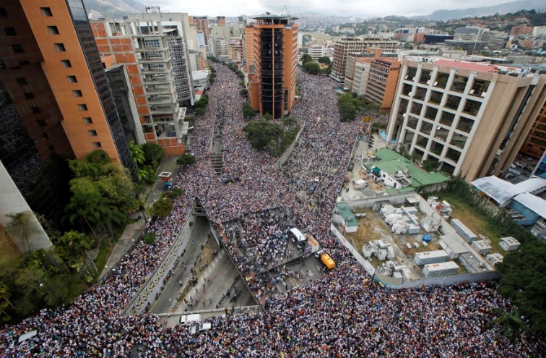

**Daniel 12:1 And at that time shall Michael stand up, the great prince which standeth for the children of thy people: and there shall be a TIME OF TROUBLE, such as never was since there was a nation even to that same time: and at that time thy people shall be delivered, every one that shall be found written in the book.**

The grave political crisis also consist out of corruption in the government, Venezuelan currency being nearly worthless, health system being in shambles, and ever-rising unemployment.

**Proverbs 29:2 When the righteous are in authority, the people rejoice: but when the wicked beareth rule, the people mourn.**

Venezuelans are slowly starving to death, living in poverty, many have died as result of famine. Food and basic medicine are inaccessible for the majority of our brethren in Venezuela.

**Luke 21:11 And great earthquakes shall be in divers places, and FAMINES, and pestilences; and fearful sights and great signs shall there be from heaven.**

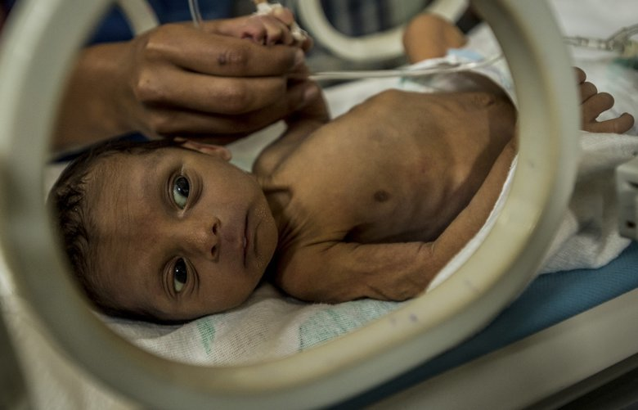

1 of every 3 Venezuelans is facing hunger, and are being deservedly punished and afflicted by the LORD, and need to turn to the Heavenly Father through Christ [LORD of hosts] in our affliction instead of seeking to catholicism, christianity, witchcraft or any other religion:

**Isaiah 9:13 For the people turneth NOT unto him that smiteth them, neither do they seek the LORD of hosts.**

**Matthew 24:21 For then shall be great TRIBULATION, such as was not since the beginning of the world to this time, no, nor ever shall be.**

**Job 5:19 He shall deliver thee in six troubles: yea, in seven there shall no evil touch thee.**

**:20 In FAMINE he shall redeem thee from death: and in war from the power of the sword.**

**:21 Thou shalt be hid from the scourge of the tongue: neither shalt thou be afraid of destruction when it cometh.**

**:22 At destruction and FAMINE thou shalt laugh: neither shalt thou be afraid of the beasts of the earth.**

**:23 For thou shalt be in league with the stones of the field: and the beasts of the field shall be at peace with thee.**

Venezuela has some of the highest murder rates on earth.

In the meantime a mass exodus has taken place, more than 5 million have left the country. Clashes erupted between Venezuelan military and Colombian armed groups on the Venezuelan side of the border.

**IIEsdras 15:4 For all the unfaithful shall die in their unfaithfulness.**

**:5 Behold, saith the Lord, I will bring plagues upon the world; the sword, famine, death, and destruction.**

**:6 For wickedness hath exceedingly polluted the whole earth, and their hurtful works are fulfilled.**

**Psalms 91:1 He that dwelleth in the secret place of the most High shall abide under the shadow of the Almighty.**

**:2 I will say of the LORD, He is my refuge and my fortress: my God; in him will I trust.**

**:6 Nor for the PESTILENCE that walketh in darkness; nor for the destruction that wasteth at noonday.**

**:7 A thousand shall fall at thy side, and ten thousand at thy right hand; but it shall not come nigh thee.**

Once considered a rich oil-producing country, Venezuela is confronting a rapidly increasing COVID-19 epidemic that adds to a complex humanitarian crisis that has been affecting the country since 2016.

The health-care system has collapsed and is incapable of responding to the ever-increasing number of patients who require hospitalization.

Health-care personnel, including doctors, nurses, and other health staff, have been substantially affected by the epidemic, leading to the highest mortality rates reported in the Americas.

**Matthew 24:3 And as he sat upon the mount of Olives, the disciples came unto him privately, saying, Tell us, when shall these things be? and what shall be the sign of thy coming, and of the end of the world?**

**:7 For nation shall rise against nation, and kingdom against kingdom: and there shall be famines, and PESTILENCES, and earthquakes, in divers places.**

**IITimothy 3:1 This know also, that in the last days PERILOUS TIMES shall come.**

(perilous = exposed to imminent danger, extremely unsafe)

Repent my beloved brethren, we are in the Last Days:

**Luke 13:5 I tell you, Nay: but, except ye repent, ye shall all likewise perish.**

All honor glory and praises to our Almighty and Eternal Heavenly Father, and His Word our Life and King Jesus Christ.

1611 king james version bible/1769 king james version bible; <www.thetruththebible.com>;

Sagrada Biblia 1602 – Cipriano de Valera version; www.laverdadlabiblia.com