SERVICE PROVIDER CHOICE AND REFERRAL FORM
NAME: | ADDRESS: | PHONE:
DATE OF BIRTH: | SSN: | MEDICAID #:
TIER: | MCO: | MCO COORDINATOR:
GUARDIAN: | GUARDIAN ADDRESS: | GUARDIAN PHONE:

SERVICE CHOICES: Write in the name of the providing agency or agencies for the authorized services. (Subject to authorization from MCO)

IT IS MY CHOICE TO RECEIVE SUPPORTS THROUGH: Home and Community Based Services Institutional/ICF Based

TARGETED CASE MANAGEMENT: | CURRENT PROVIDER: | NEW PROVIDER: | NOT INTERESTED:
DAY SERVICES: | CURRENT PROVIDER: | NEW PROVIDER: | NOT INTERESTED:
RESIDENTIAL SERVICES: | CURRENT PROVIDER: | NEW PROVIDER: | NOT INTERESTED:
SUPPORTED EMPLOYMENT: | CURRENT PROVIDER: | NEW PROVIDER: | NOT INTERESTED:
FINANCIAL MANAGEMENT SERVICES (Self-Direct): | CURRENT PROVIDER: | NEW PROVIDER: | NOT INTERESTED:
SUPPORTIVE HOME CARE: (Agency-Direct): | CURRENT PROVIDER: | NEW PROVIDER: | NOT INTERESTED:
ENHANCED CARE SERVICES: | CURRENT PROVIDER: | NEW PROVIDER: | NOT INTERESTED:
OVERNIGHT RESPITE: | CURRENT PROVIDER: | NEW PROVIDER: | NOT INTERESTED:
WELLNESS MONITORING: | CURRENT PROVIDER: | NEW PROVIDER: | NOT INTERESTED:
SPECIALIZED MEDICAL CARE (Nursing): | CURRENT PROVIDER: | NEW PROVIDER: | NOT INTERESTED:
MEDICAL ALERT RENTAL: | CURRENT PROVIDER: | NEW PROVIDER: | NOT INTERESTED:
CHILDREN’S RESIDENTIAL (Voluntary Foster Care): | CURRENT PROVIDER: | NEW PROVIDER: | NOT INTERESTED:

- I have reviewed the CDDO Options Counseling and choice form with the CDDO. YES NO
- I have reviewed the CDDO Rights-Responsibilities Brochure with the CDDO. YES NO
- I have reviewed the CDDO Appeal and Grievance Process with the CDDO. YES NO

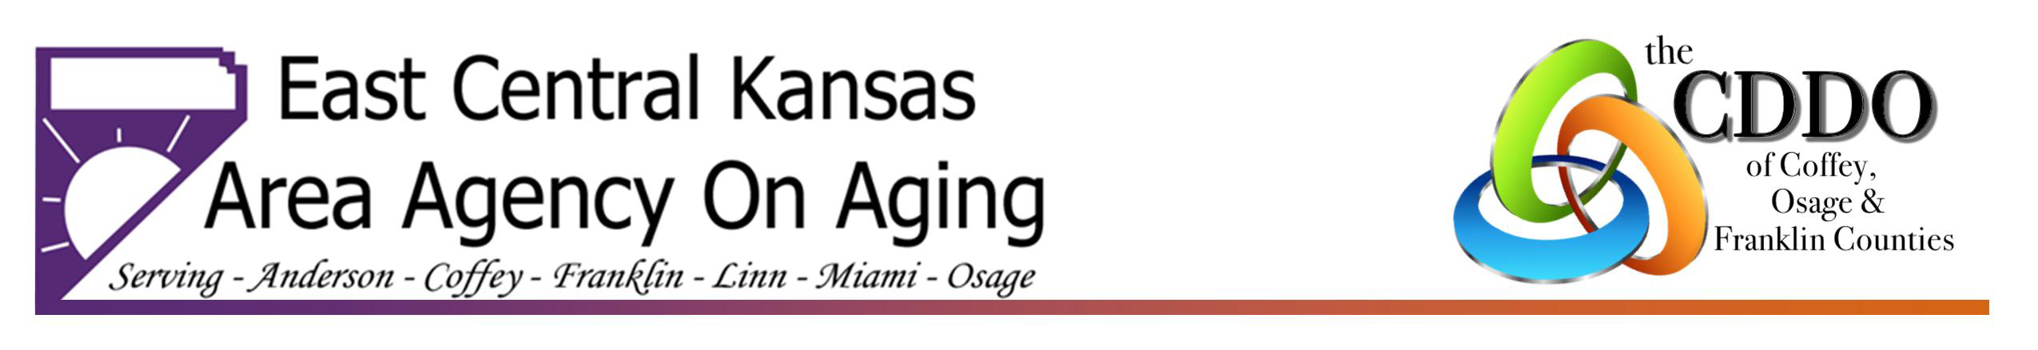
Individual’s Signature/Date: ________________________________________________________________________________
117 South Main - Ottawa, Ks 66067 ● (785) 242-7200 ● (800) 633-5621 ● www.eckaaa.org

Guardian/Designated Representative Signature/Date: ___________________________________________________________
ECK CDDO Signature/Date: _________________________________________________________________________________

Rev. 10.29.2019 Changes Made to Providers: YES NO

