Instructions to Configure
Firefox for PIV Authentication
Using ActivClient

NOTE: These instructions only apply to NASA\ACES Computers with ActivClient installed.
Launch Firefox
Open the Firefox Menu by clicking the three-line icon in the upper right hand corner of the Firefox Browser.
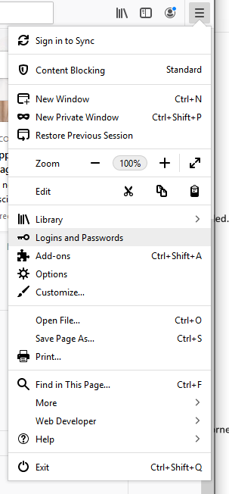
And then select the Options icon.
On the left side if the page select Privacy & Security

Scroll to the bottom of the page and select the Security Devices Button.

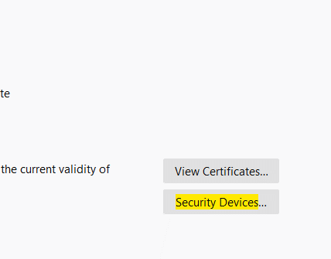

*Or if Security Devices is not located select the Search option at the top right and search Security Devices
In the Device Manager window click the load button.
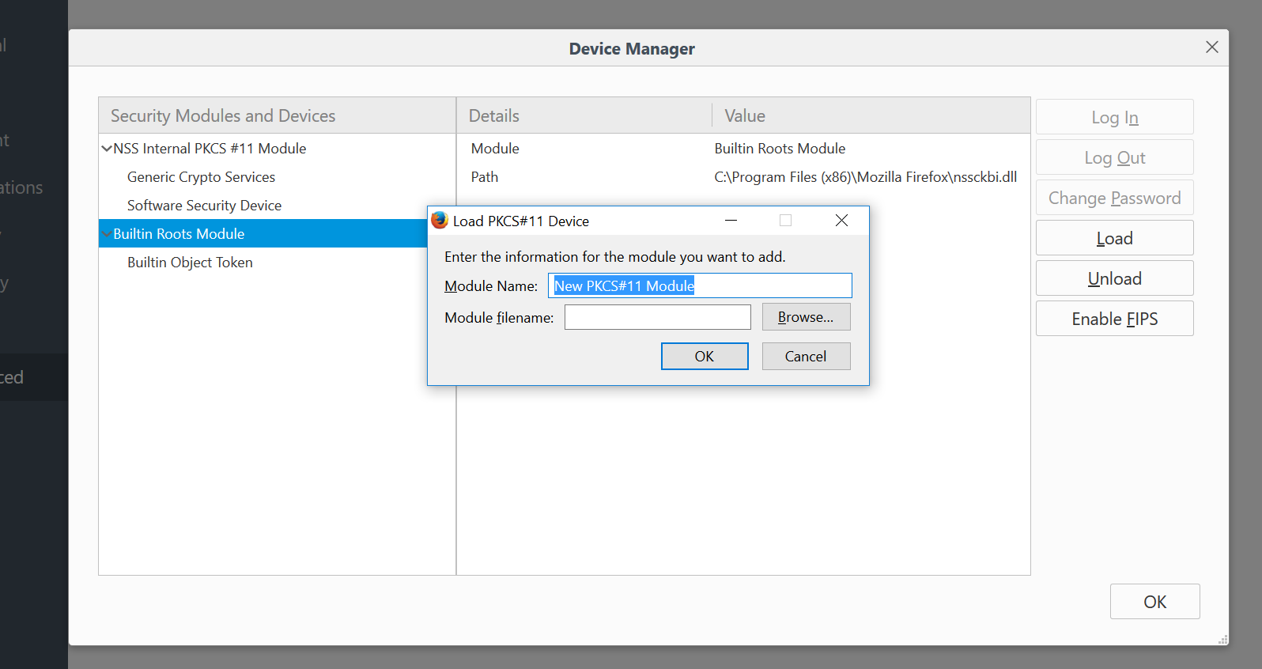
In the Module filename text box paste the following line.
C:\Program Files (x86)\HID Global\ActivClient\acpkcs211.dll

Or you can browse to the location using the browse button.
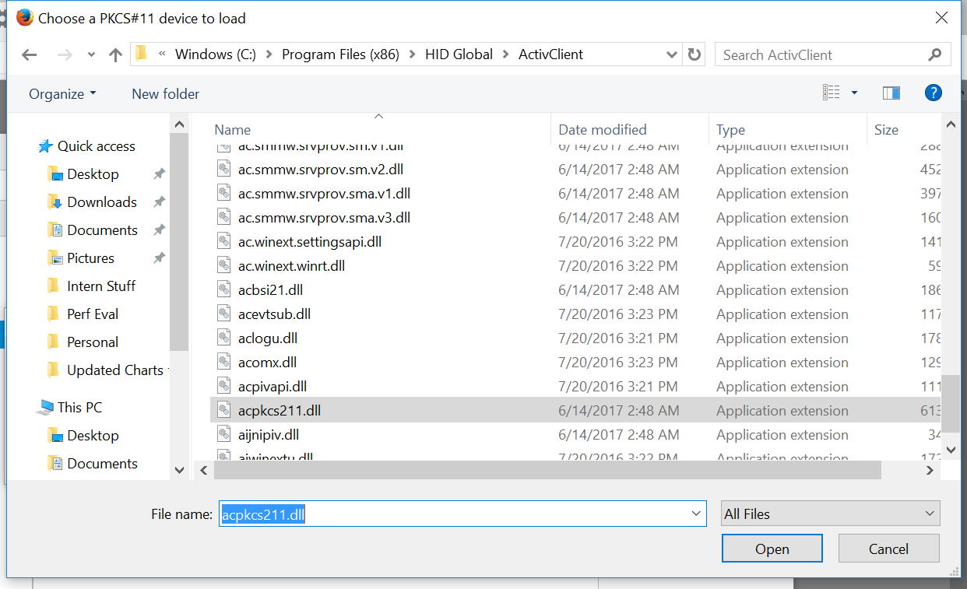

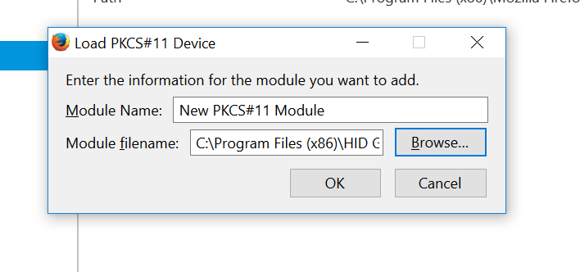
Click OK on the load dialog.
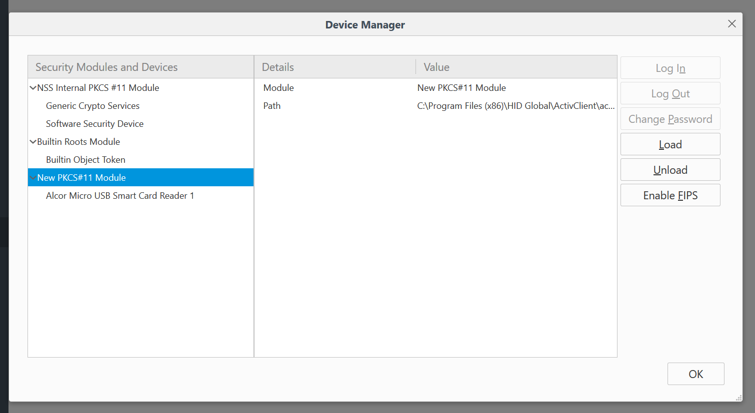
Then Click OK to close the device manager.

You should now be able to use your PIV Card with Firefox.

Instructions to Configure Firefox for PIV Authentication Using ActivClient [2018 July 18, Last Rev 2019 June 04]

