Seventh Sunday of Easter

Messiah Lutheran Church
Light in the Beartooths

Pastor Ben Cherland

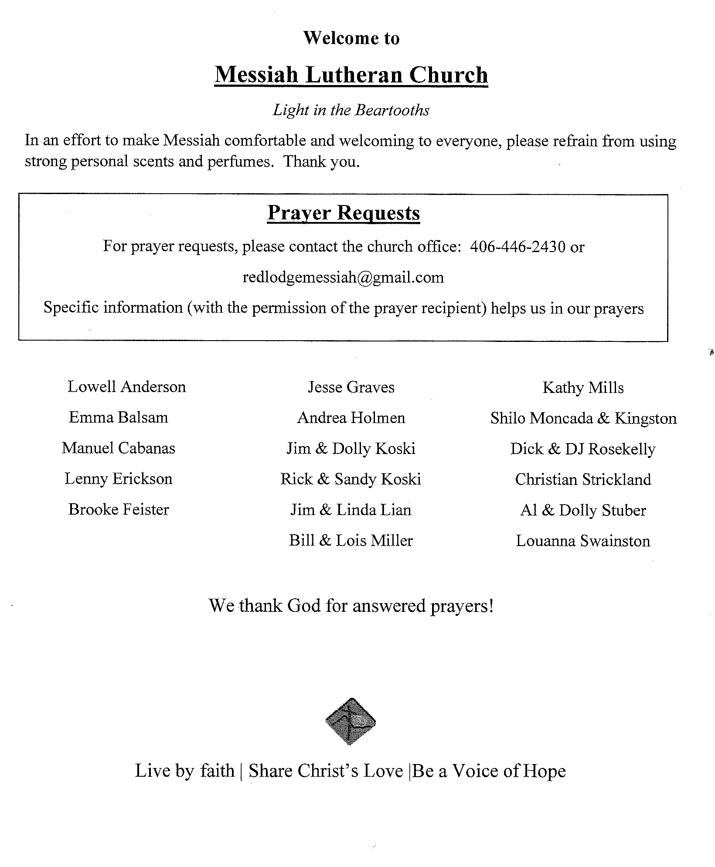
Seventh Sunday of Easter
May 21, 2023

Gathering

Greeting

Alleuia! Christ is Risen.
Christ is risen indeed. Alleluia!

Thanksgiving for Baptism

Refreshed by the resurrection life we share in Christ,
let us give thanks for the gift of baptism.
We thank you, risen Christ, for these waters
where you make us new,
leading us from death to life,
from tears to joy.
We bless you, risen Christ, that your Spirit comes to us
in the grace-filled waters of rebirth.
like rain to our thirsting earth,
like streams that revive our souls,
like cups of cool water shared with strangers.
Breathe your peace on your church when we hide in fear.
Clothe us with your mercy and forgiveness,
Send us companions on our journey as we share your life.
Make us one, risen Christ, in love and mission.
Cleanse our hearts of all division.
Shower us with the life we have in you.
To you be given all praise, with the Holy Spirit,
in the glory of God, now and forever. AMEN
GATHERING HYMN | ELW 657

. 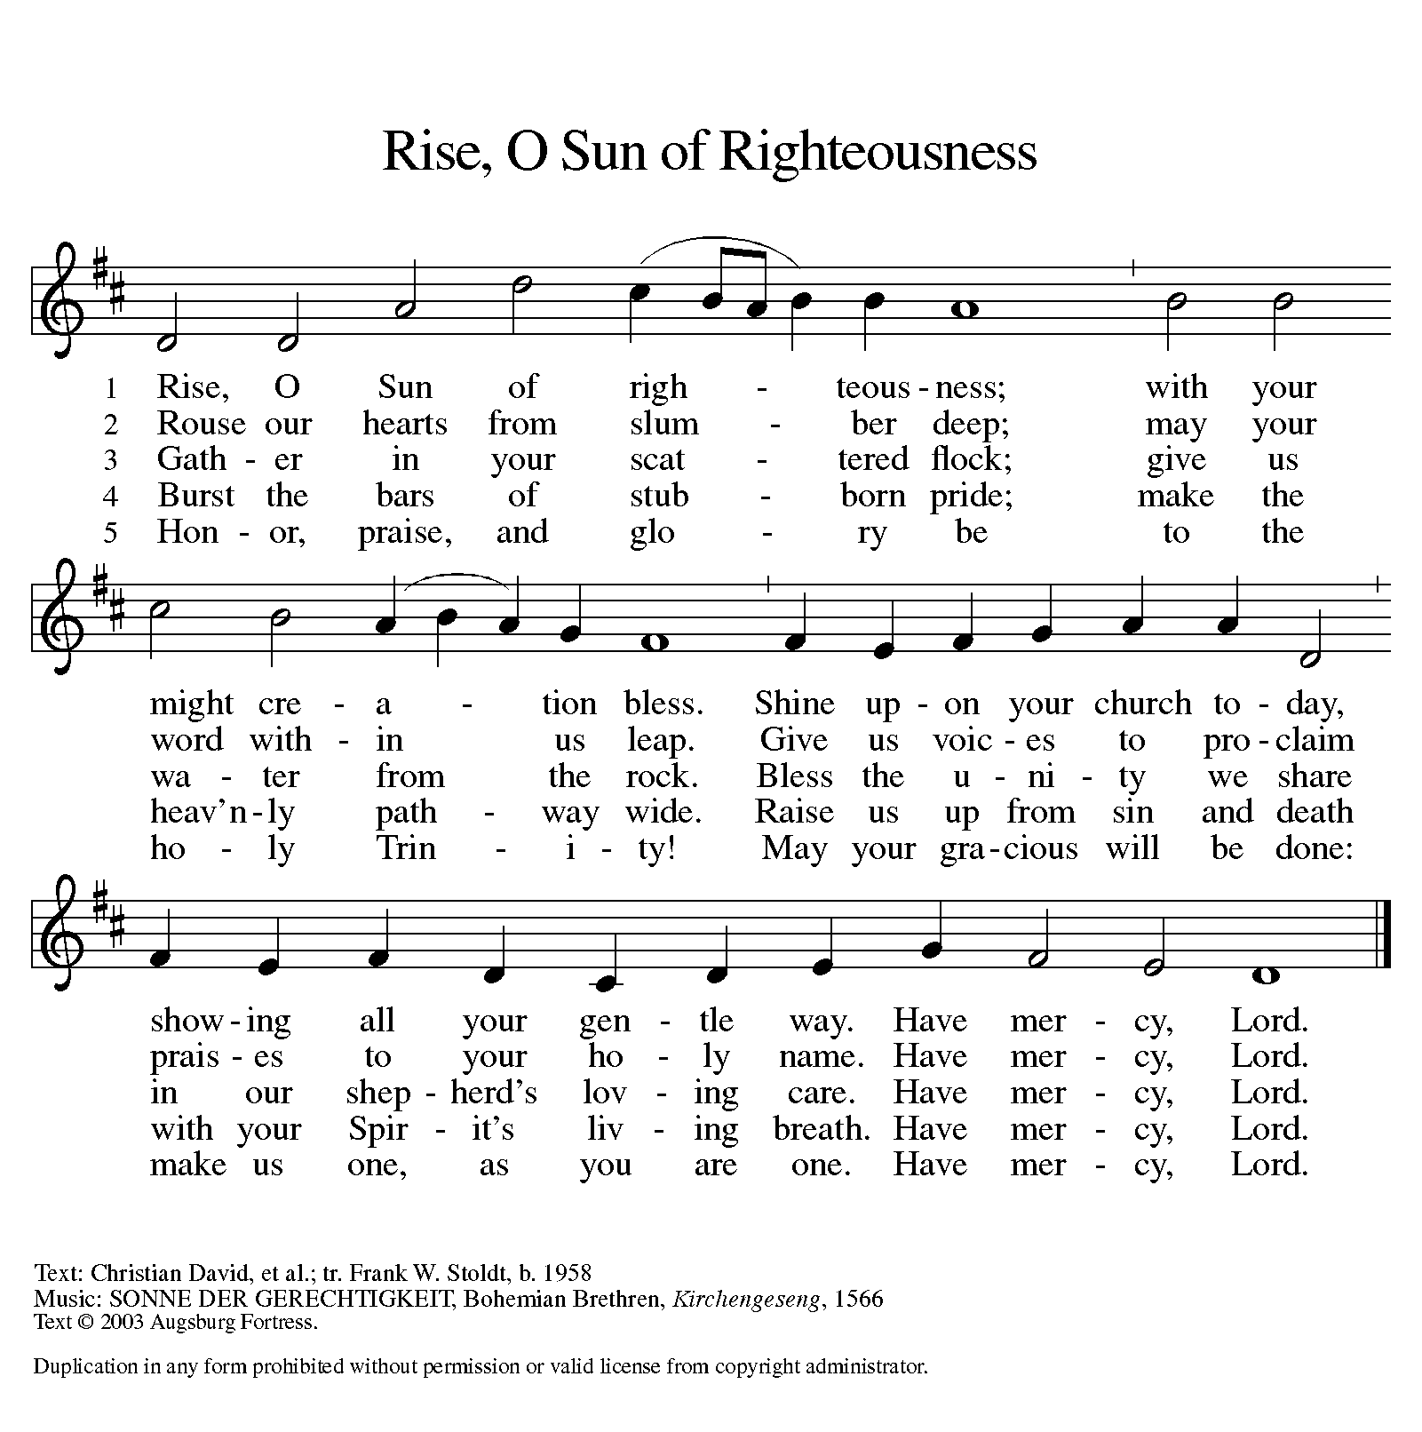

Greeting

The grace of our Lord Jesus Christ, the love of God,
and the communion of the Holy Spirit be with you all.
And also with you.

hymn of Praise

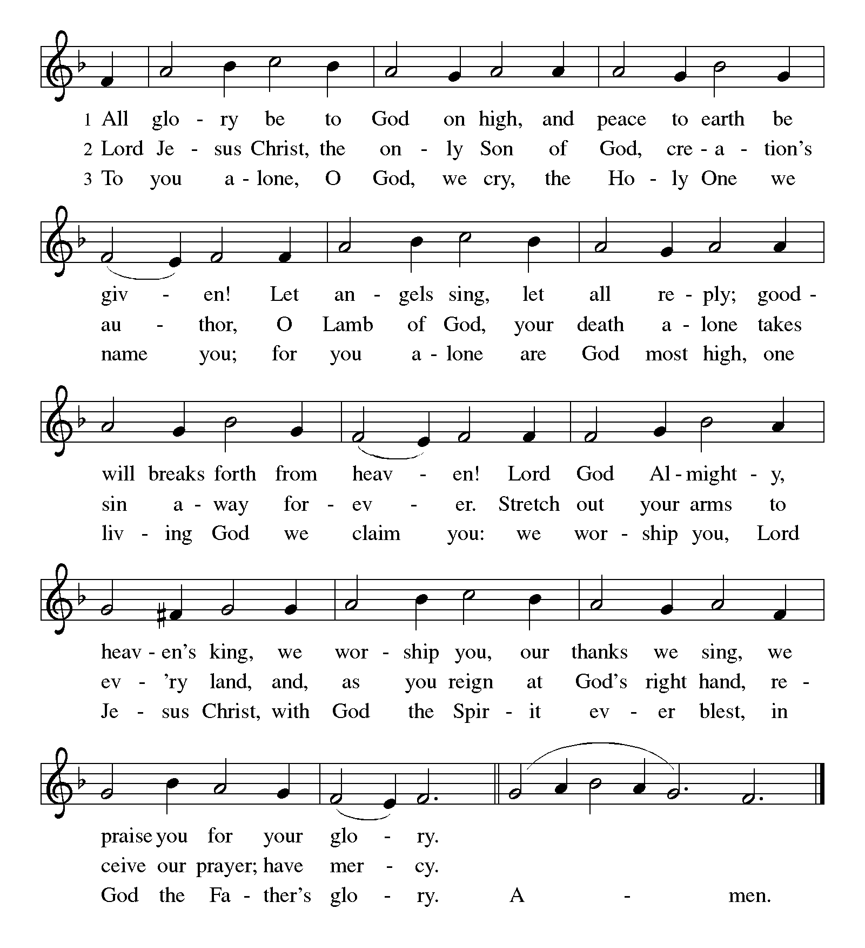

Prayer of the Day

O God of glory, your Son Jesus Christ suffered for us and ascended to your right hand. Unite us with Christ and each other in suffering and in joy, that all the world may be drawn into your bountiful presence, through Jesus Christ, our Savior and Lord, who lives and reigns with you and the Holy Spirit, one God, now and forever.
Amen.

Word

children’s sermon

Acts 1:6-14

⁶When [the apostles] had come together, they asked [Jesus], “Lord, is this the time when you will restore the kingdom to Israel?” ⁷He replied, “It is not for you to know the times or periods that the Father has set by his own authority. ⁸But you will receive power when the Holy Spirit has come upon you; and you will be my witnesses in Jerusalem, in all Judea and Samaria, and to the ends of the earth.” ⁹When he had said this, as they were watching, he was lifted up, and a cloud took him out of their sight. ¹⁰While he was going and they were gazing up toward heaven, suddenly two men in white robes stood by them. ¹¹They said, “Men of Galilee, why do you stand looking up toward heaven? This Jesus, who has been taken up from you into heaven, will come in the same way as you saw him go into heaven.”
¹²Then they returned to Jerusalem from the mount called Olivet, which is near Jerusalem, a sabbath day’s journey away. ¹³When they had entered the city, they went to the room upstairs where they were staying, Peter, and John, and James, and Andrew, Philip and Thomas, Bartholomew and Matthew, James son of Alphaeus, and Simon the Zealot, and Judas son of James. ¹⁴All these were constantly devoting themselves to prayer, together with certain women, including Mary the mother of Jesus, as well as his brothers.

Word of God, word of life. Thanks be to God.

Psalm 68:1-10, 32-35

¹Let God arise, and let God’s enemies be scattered;
let those who hate God flee.
²As smoke is driven away, so you should drive them away;
as the wax melts before the fire, so let the wicked perish at the presence of God.
³But let the righteous be glad and rejoice before God;
let them also be merry and joyful.
⁴Sing to God, sing praises to God’s name; exalt the one who rides the clouds;
I Am is that name, rejoice before God!
⁵In your holy habitation, O God,
you are a father to orphans, defender of widows;
⁶you give the solitary a home and bring forth prisoners into freedom;
but the rebels shall live in desert places.
⁷O God, when you went forth before your people,
when you marched through the wilderness,
⁸the earth quaked, and the skies poured down rain, at the presence of God, the God of Sinai,
at the presence of God, the God of Israel.
⁹You sent a bountiful rain, O God;
you restored your inheritance when it languished.
¹⁰Your people found their home in it;
in your goodness, O God, you have made provision for the poor.
³²Sing to God, O kingdoms of the earth;
sing praises to the Lord.
³³You ride in the heavens, O God, in the ancient heavens;
you send forth your voice, your mighty voice.
³⁴Ascribe power to God,
whose majesty is over Israel; whose strength is in the skies.
³⁵How wonderful you are in your holy places, O God of Israel,
giving strength and power to your people! Blessed be God!

1 Peter 4:12-14; 5:6-11

¹²Beloved, do not be surprised at the fiery ordeal that is taking place among you to test you, as though something strange were happening to you. ¹³But rejoice insofar as you are sharing Christ’s sufferings, so that you may also be glad and shout for joy when his glory is revealed. ¹⁴If you are reviled for the name of Christ, you are blessed, because the spirit of glory, which is the Spirit of God, is resting on you.
^{5:6}Humble yourselves therefore under the mighty hand of God, so that he may exalt you in due time. ⁷Cast all your anxiety on him, because he cares for you. ⁸Discipline yourselves, keep alert. Like a roaring lion your adversary the devil prowls around, looking for someone to devour. ⁹Resist him, steadfast in your faith, for you know that your brothers and sisters in all the world are undergoing the same kinds of suffering. ¹⁰And after you have suffered for a little while, the God of all grace, who has called you to his eternal glory in Christ, will himself restore, support, strengthen, and establish you. ¹¹To him be the power forever and ever. Amen.

Word of God, word of life. Thanks be to God.

Gospel Acclamation
The assembly stands to welcome the gospel.
Pastor Sings, then sing together
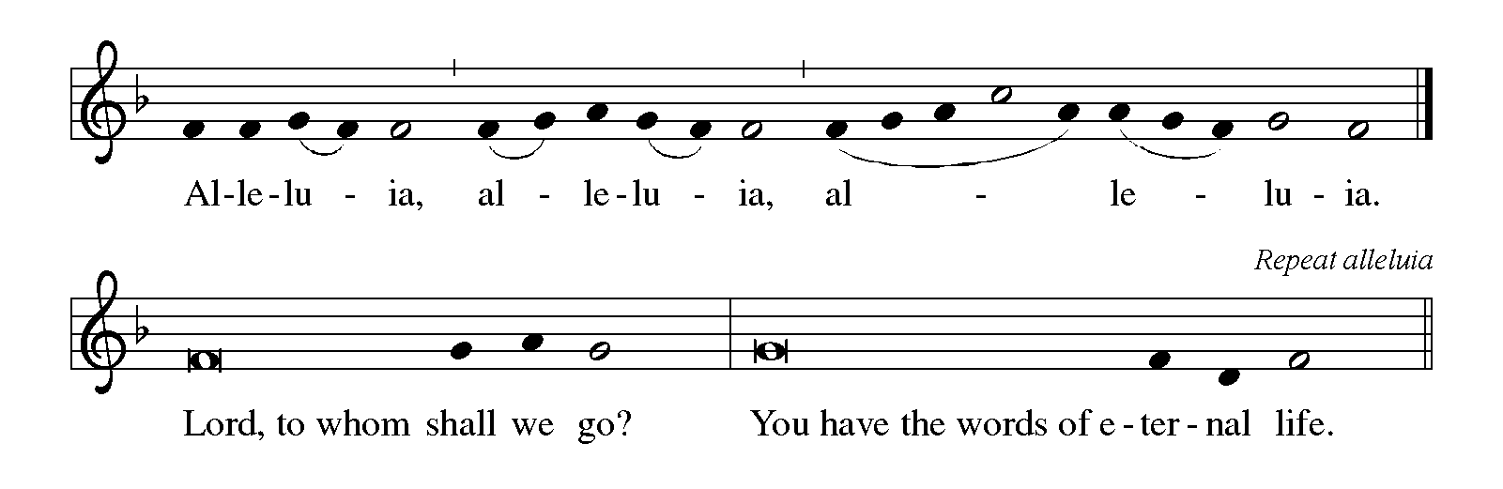
Pastor Sings

JOHN 17:1-11

The holy gospel according to John.

Glory to you, O Lord.

¹After Jesus had spoken these words [to his disciples], he looked up to heaven and said, “Father, the hour has come; glorify your Son so that the Son may glorify you, ²since you have given him authority over all people, to give eternal life to all whom you have given him. ³And this is eternal life, that they may know you, the only true God, and Jesus Christ whom you have sent. ⁴I glorified you on earth by finishing the work that you gave me to do. ⁵So now, Father, glorify me in your own presence with the glory that I had in your presence before the world existed.
⁶“I have made your name known to those whom you gave me from the world. They were yours, and you gave them to me, and they have kept your word. ⁷Now they know that everything you have given me is from you; ⁸for the words that you gave to me I have given to them, and they have received them and know in truth that I came from you; and they have believed that you sent me. ⁹I am asking on their behalf; I am not asking on behalf of the world, but on behalf of those whom you gave me, because they are yours. ¹⁰All mine are yours, and yours are mine; and I have been glorified in them. ¹¹And now I am no longer in the world, but they are in the world, and I am coming to you. Holy Father, protect them in your name that you have given me, so that they may be one, as we are one.”

The gospel of the Lord.
Praise to you, O Christ.

Sermon
Hymn of the Day | ELW 482

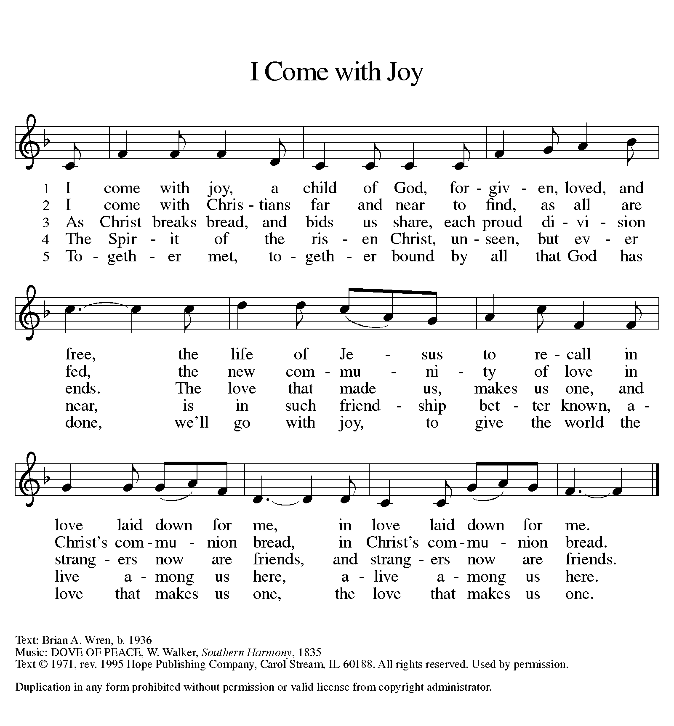

nicene Creed

We believe in one God,
the Father, the Almighty,
maker of heaven and earth,
of all that is, seen and unseen.
We believe in one Lord, Jesus Christ,
the only Son of God,
eternally begotten of the Father,
God from God, Light from Light,
true God from true God,
begotten, not made,
of one Being with the Father;
through him all things were made.
For us and for our salvation
he came down from heaven,
was incarnate of the Holy Spirit and the virgin Mary
and became truly human.
For our sake he was crucified under Pontius Pilate;
he suffered death and was buried.
On the third day he rose again
in accordance with the scriptures;
he ascended into heaven
and is seated at the right hand of the Father.
He will come again in glory to judge the living and the dead,
and his kingdom will have no end.
We believe in the Holy Spirit, the Lord, the giver of life,
who proceeds from the Father and the Son,*
who with the Father and the Son is worshiped and glorified,
who has spoken through the prophets.
We believe in one holy catholic and apostolic church.
We acknowledge one baptism for the forgiveness of sins.
We look for the resurrection of the dead,
and the life of the world to come. Amen.

Prayers of Intercession

With the whole people of God in Christ Jesus, let us pray for the church, those in need, and all of God's creation.
...Lord in your mercy, hear our prayer.
Into your hands, gracious God, we commend all for whom we pray, trusting in your mercy, through Jesus Christ, our Savior. Amen

sharing of the Peace

The peace of Christ be with you always.
And also with you.
Meal

Offering

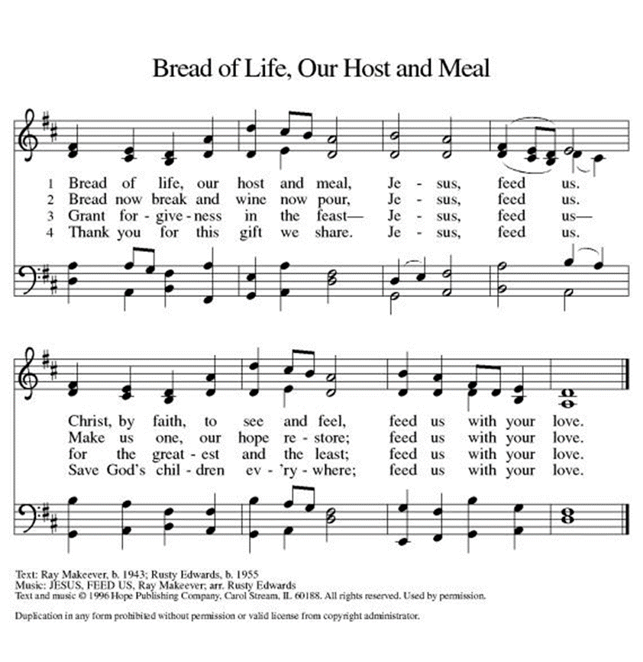

Offering Prayer

Blessed are you, O God, ruler of heaven and earth. Day by day you shower us with blessings. As you have raised us to new life in Christ, give us glad and generous hearts, ready to praise you and to respond to those in need, through Jesus Christ, our Savior and Lord.
Amen.

Great Thanksgiving

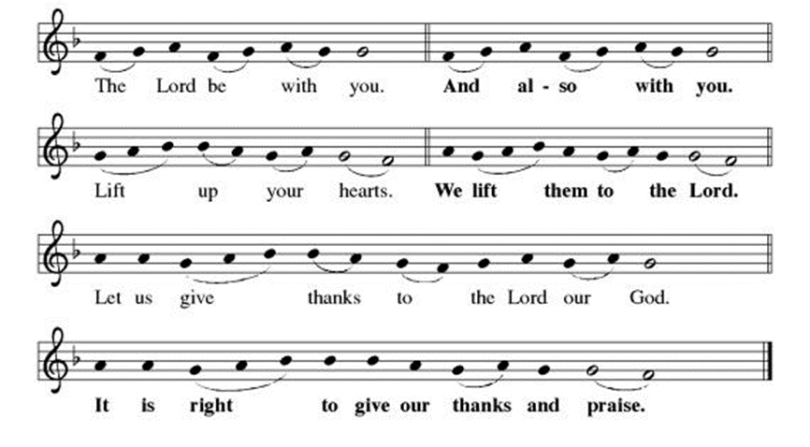
Preface

holy, holy, holy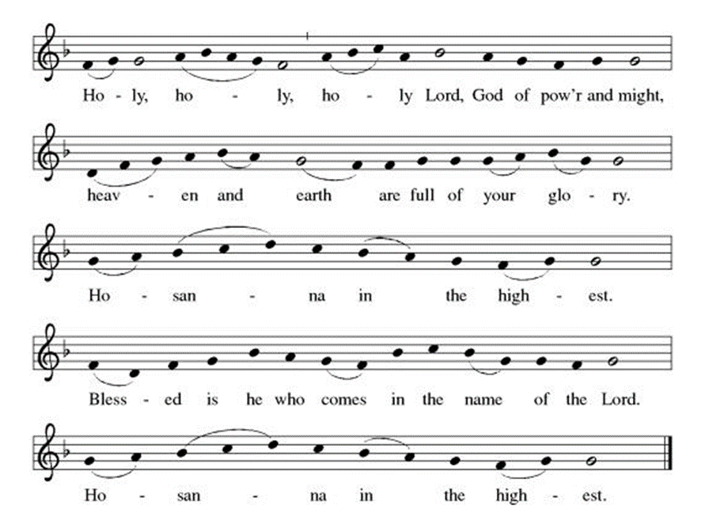
EUCHARISTIC PRAYER | WORDS OF INSTITUTION

THE Lord’s Prayer

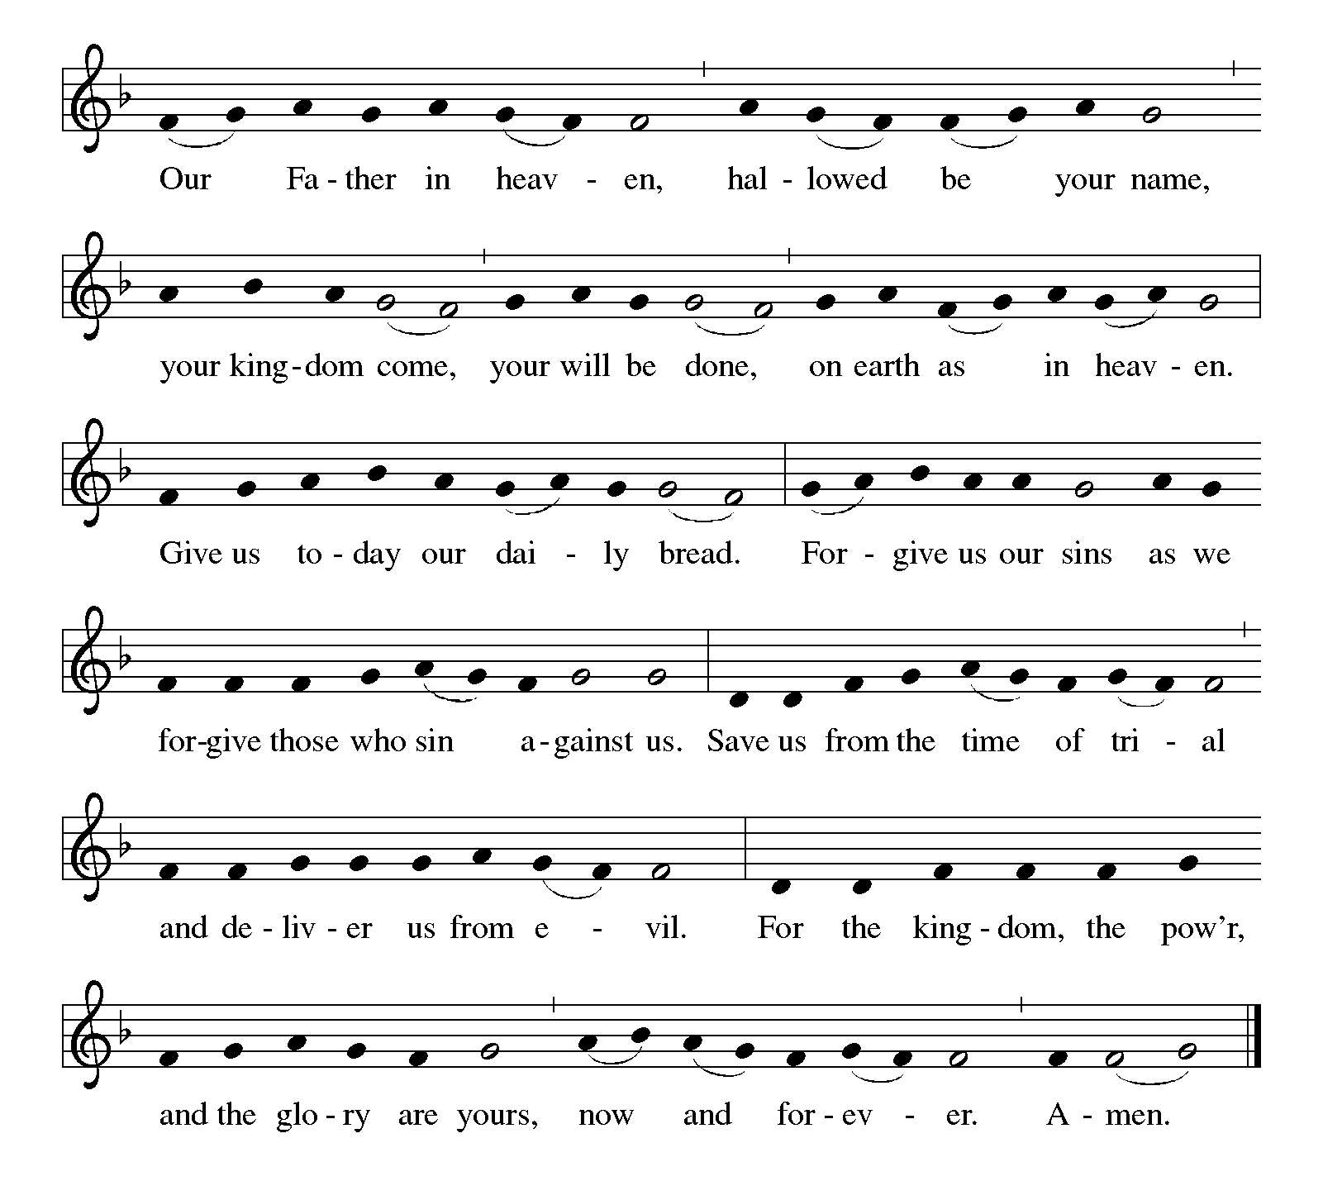

Communion

Communion Song | What a Friend We Have in Jesus
ELW 742
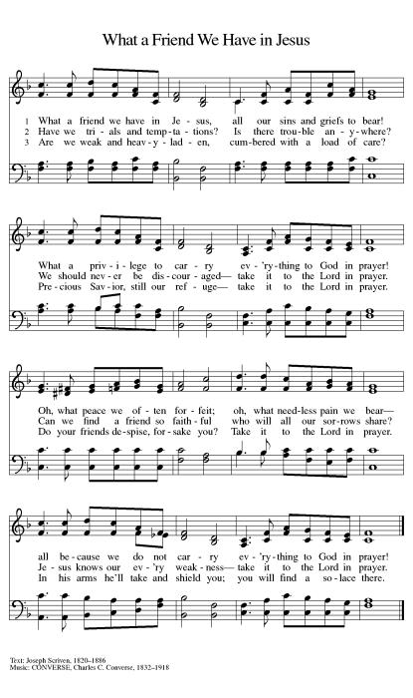

PRAYER AFTER COMMUNION

Life-giving God, in the mystery of Christ’s resurrection you send light to conquer darkness, water to give new life, and the bread of life to nourish your people. Send us forth as witnesses to your Son’s resurrection, that we may show your glory to all the world, through Jesus Christ, our risen Lord.
Amen.

Sending

Blessing

May our glorious God grant you a spirit of wisdom to know and to love the risen Lord Jesus. The God of life, Father, +Son, and Holy Spirit, bless you now and forever. Amen

Sending HYMN |ELW 855 (See next page)

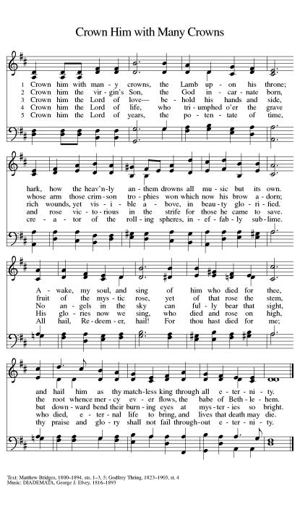

Dismissal

Alleluia! Christ is risen! Christ is risen indeed! Alleluia!
Our worship has ended. Now our service begins.
Go in peace, share the good news. Thanks be to God. Alleluia!

Announcements

As we are working on completing this building, we are conscious of the ways it marks a new chapter in the life of this faith community. The path we now take in serving Red Lodge, Carbon County and everyone who passes through these doors is the subject of conversation and deliberate reflection for us. Some things will look familiar (The Christmas Kids Shoppe, for instance) and some will be new for us (incorporating a new childcare center, set to open this summer). We invite you to join this conversation in discerning the direction in which Christ is calling us. You may be surprised at the life waiting for you in this place, among these people—a life blessed with healing, wholeness, belonging, community and great joy. Your voice is needed and your presence eagerly awaited and welcomed.

Sincerely,
Pastor Ben

Safari book club meets at 3:00 pm May 18th at the home of Donna Downing. Please contact Marla Ebel (406-664-3178) for more information.

(Communion) Wine tasting May 23 at 6:30

Volunteers are needed to serve on the Altar Guild. Duties include changing the paraments with the church seasons, helping with communion set up, and providing flowers and greenery for the sanctuary. Please talk to Marla Ebel (406-664-3178) if you are interested in serving in this way.

Sign up for the Ushers Guild. Our first meeting will be June 4 at 11:15 in the sanctuary.

I hereby certify that Allen Hansen is licensed to preach and preside for the Messiah Lutheran Church, Red Lodge, MT, May 21, 2023.
Laurie Jungling, Bishop of the Montana Synod. 5/12/2023

from sundaysandseasons.com.Copyright © 2023 Augsburg Fortress. All rights reserved.

