& “Keep Kids Safe Fair”
20th Annual
“Cruisin' Into Summer Festival!”
Tri-County Family Care Center
Saturday, June 6, 2026
South Main Street from Railroad Park to Sycamore St.
Rocky Ford, CO 81067 @ 10:00 am-5:00 pm

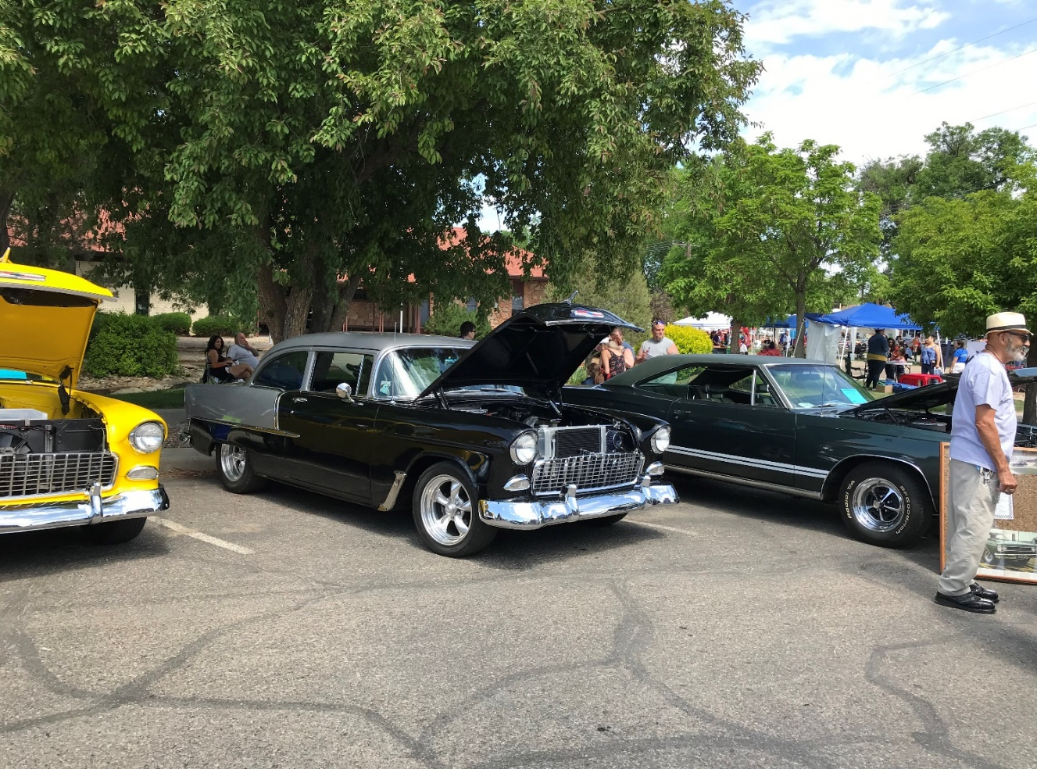
MUSIC, KIDS GAMES, ENTERTAINMENT,
WILD WEST SHOW, UC LIFELINE HELICOPTER, VENDORS,
FREE POPCORN @ the GRAND, PIE EATING CONTEST, AXE THROW, ARCHERY CONTEST, TREBUCHET LAUNCH & SAFETY BOOTHS.

DJ
Trent Ryan
Ark Valley Entertainment

MC
Kenny Ray Arguello
Beer Garden & Cornhole
Sponsored by
The Main Lounge
“Got Wheels?” &
Bike Show

Tri-County Family Care Center and Sarah Dillon, Founder and Executive Director
will complete 31 years as of May 5, 2026!

86 inch TV Raffle
Cruise safely by visiting the SAFETY BOOTHS!
This is a fundraiser for Tri-County Family Care Center
For more information, or to register for events, contact
TCFCC at 512 ½ N Main Street, Rocky Ford, 719.254.7776
info.tricountyfcc@gmail.com

