The Bright By Three program provides a visitor to help you establish a long-term nurturing and support system.
Each visit includes helpful information about baby care, child development and support services available for you and your family..

What You Will receive

- Resource and referrals
- Information on Bright By Three
Programs A, B & C
Program A: 0 to 12 months
Program B: 12-24 months
Program C: 24-36 months
- Parent education
Brain development
Growth & development
Safety for the car
Second-hand smoke
- “Giving Your Child” a Bright Beginnings handbook
- “Learning Games” Booklet
- “A Family Guide to Early Childhood Brain Development”
- Baby’s first reading book
- Small gifts

*Mission
To provide a bright beginning for all Colorado children by helping families support their children’s physical, emotional, and intellectual development during the critical first three years of life.

*Vision
Every child in Colorado will be healthy, valued, and ready to learn.

*Funding
We gratefully accept donations from a variety of private foundations, corporations, and individuals and others.

*Programs are free
Yes. Our programs are offered absolutely free-of-charge to all Colorado families of children prenatal to age three.

*Evidence -based programs
Yes. Aside from ongoing internal measures, Bright by Three has engaged quite a few studies to measure how significantly our programs impact the desired outcomes of early literacy and school readiness. These findings clearly show our program to be effective!

Why?

- Celebrating every birth and welcoming each child to the world and the community
- Helping parents raise healthy kids
- Promoting early childhood brain development
- Enhancing school readiness
- During the first three years, your baby will grow and develop more dramatically than any other stage in life
- Support and information
- Offered at no cost to families

Sponsored by
Tri-County Family
Care Center,
Colorado Bright By Three

Learning doesn’t begin when a
child starts school. Amazingly,
85% of a baby’s intellect,
personality, and social skills
are developed in the first three
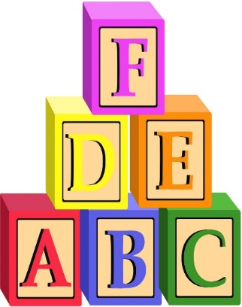
years of life.

Because babies don’t come with instructions, all parents need a
little guidance on how to make the most of this critical period.
That’s where Bright by Three comes in! Bright by Three visits with parents provide a three-step program to make sure their little ones get the best start at life. And it’s free for the families!

Bright
By
Three
Program
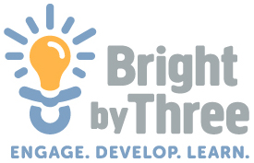

Tri-County Family Care Center
512 ½ N. Main St.
Rocky Ford, CO 81067
719.254.7776
marcellia.tricountyfcc@gmail.com
Tricountyfamilycenter.org

