COVID-19 (CORONAVIRUS) RESOURCE LIST
Free Coloring books!
http://www.openculture.com/2019/02/download-free-coloring-books-from-113-museums.html?fbclid=IwAR3p8ilHsXUQYzZHqW6SYoKbXh6vDBqQmueLFWeyu37qLGQcE4gRzvUo6G8
- New Add Wk. 3/30/20
Astronauts reading books to kids from outer space:
https://www.scarymommy.com/astronauts-story-time-in-space-kids-books/?fbclid=IwAR0c7pqNdrfKRXhL8LsF3hoZwNN2UVLDL6HH9JJFQzNVj3C_TYNGgejaJeA

Lunch doodles: Step by step drawing for kids:
https://www.youtube.com/watch?v=RmzjCPQv3y8

Virtual field trips! How cool:
https://adventuresinfamilyhood.com/20-virtual-field-trips-to-take-with-your-kids.html?fbclid=IwAR1-h9D4_xzXl6e7EsQ0wLgG3QFqFBhFL_VyOkjy75y1IW6zDQyBNw6S8I0
https://www.travelandleisure.com/attractions/museums-galleries/museums-with-virtual-tours?fbclid=IwAR05j1cF-WWcA0rAjb69wY-ki_c5u-P9W-dba1v89xiSnIymdyoc_yatyqk
https://www.deseret.com/entertainment/2020/3/17/21181994/coronavirus-art-museums-concerts-met-opera-louvre-smithsonian-virtual-tours-online-live-stream
https://crafty.diply.com/121060/you-can-virtually-tour-a-whole-bunch-of-national-parks-from-your?utm_source=facebook&utm_medium=crafty&utm_content=dav001658&fbclid=IwAR0t6TThGhrKl_QQwSg0gAqXNYK370xd9AKpJ5H7tfsjUKdny-5Jh8Ndpag
Educational show list on Netflix:
https://homeschoolhideout.com/educational-shows-on-netflix/?fbclid=IwAR29DgH3EEEvA__GOqBUEtoTtNZsiAvr7KXD-VNlU9o5oKZKGKIrhIZ63Jc

Learn at home activities/resources via Scholastic:
https://classroommagazines.scholastic.com/support/learnathome.html

For kids and parents-to destress:
https://www.pbs.org/parents/thrive/how-you-and-your-kids-can-de-stress-during-coronavirus

Other educational websites:
https://biglifejournal.com/
https://www.whatdowedoallday.com/
Added 4/2/2020
http://pblproject.com/page.aspx?pageid=Remote-Learning_STEM-Challenges

ONE STOP SHOP FOR EDUCATORS, PARENTS AND STUDENTS!
https://sites.google.com/view/resourcesremotelearning/home

How to talk to your kids about Corona Virus:
https://childmind.org/article/talking-to-kids-about-the-coronavirus/
https://www.nasponline.org/resources-and-publications/resources-and-podcasts/school-climate-safety-and-crisis/health-crisis-resources/talking-to-children-about-covid-19-(coronavirus)-a-parent-resource
https://www.additudemag.com/explain-coronavirus-covid-19-anxiety-adhd-child/?fbclid=IwAR2UPf4HkZ9bQ1CdR1-IcThLZ1u2F5yhLb3X-YZ4pQxLlkpKd8tXz0-0klM

Resources for parents:
https://www.cdc.gov/coronavirus/2019-ncov/community/schools-childcare/talking-with-children.html
https://www.zerotothree.org/resources/3210-tips-for-families-coronavirus
https://adaa.org/learn-from-us/from-the-experts/blog-posts/consumer/how-talk-your-anxious-child-or-teen-about
https://www.cdc.gov/coronavirus/2019-ncov/prepare/managing-stress-anxiety.html
https://www.cdc.gov/childrenindisasters/helping-children-cope.html
https://www.health.harvard.edu/blog/coping-with-coronavirus-anxiety-2020031219183
https://www.youtube.com/watch?v=d7xXZxRDFUU&feature=youtu.be&fbclid=IwAR11aDyS5OPsbCixF2VdSR1R14OZv4fHFgU1F3dVNG_wct5iVgQYeYFHE04&app=desktop

https://www.cdc.gov/coronavirus/2019-ncov/index.html
https://www.usa.gov/coronavirus

Added 4/14/2020
Having problems with your anger, that’s to be expected. He are some tips.
https://www.crisisprevention.com/CPI/media/Media/download/PDF_Parent-Manage-Anger.pdf?code=EBIT01MAP&src=Resources
The Power of Listening to your kids.
https://www.crisisprevention.com/CPI/media/Media/download/PDF_Parent-Listening.pdf?code=EBIT01PLP&src=Resources&med=Website
https://www.youtube.com/watch?time_continue=145&v=9udRjbkBIZk&feature=emb_title
Child Care:
Obviously, with the day to day changes, what this looks like could change. I encourage any family who may need this care to complete the family survey link ASAP so it can be determined if there is a provider available. The survey can be found at the below link.
https://covidchildcarecolorado.com/provider-survey-home/.
If families can be matched with a provider in their county tuition would be free for the family through April 4th.

This has been organized very quickly and there are a lot of questions. I am trying my best to see how it works and if this will even work in our counties. I just want families to be aware there could possibly be a resource for them.

Video for kids-with questions from Colorado Children's Hospital:
https://www.youtube.com/watch?time_continue=3&v=vSsKQPqpS7A&feature=emb_logo

At home activity guides:
https://www.zerotothree.org/resources/3264-at-home-activity-guide
https://time.com/5803373/coronavirus-kids-at-home-activities/

AWESOME mindfulness on yoga to help combat anxiety and promote self-regulation:
https://www.youtube.com/results?search_query=zen+den

12 free calming apps:
https://thiswayup.org.au/12-free-apps-to-help-you-beat-stress/

Crafts to do with you kids at home:
https://thematernalhobbyist.com/blooming-puddle-paper-flowers/
https://horrorunderground.org/cute-diy-easy-paper-butterfly-origami-for-beginners/
https://blog.soohub.com/diy/144/
https://roomdestination.com/39-best-craft-paper-for-kids-tutorial/
https://iheartcraftythings.com/butterfly-template.html
https://www.ronyestech.com/experiment/grow-eggshell-geodes-crystal-crystal-science
https://everydaychaosandcalm.com/sensory-bags-for-babies/
https://www.kitchentableclassroom.com/easy-elmers-glue-slime-an-easy-four-ingredient-recipe/
https://twopineadventure.com/
https://www.blessingmanifesting.com/
Talking to your Teenagers:
https://www.twelvetalks.com/covid-19

Facebook Groups supporting you and your kids:
https://business.facebook.com/copingskillsforkids/?ref=timeline_chaining
https://www.facebook.com/groups/getsuperpowered

Free Online Learning at Home:
https://funinfirst.com/free-online-learning-at-home/?fbclid=IwAR2cZq0dTDKvaY0nZxSeEPm2YShO8mULfIDLMNQwrhgBYCFZgFYniaMvckY

List of Free education Subscriptions for kids!
https://kidsactivitiesblog.com/135609/list-of-education-companies-offering-free-subscriptions/

For Adults-We need to calm too!
1. Breathe...especially focusing on out breath as that calms the brain and triggers the parasympathetic nervous system to calm body.
2. Stay informed, but then turn off news, nonstop exposure to information. This will increase anyone's anxiety. Determine a time to engage with information and limit it.
3. Exercise-whether inside or outside, but move. The tension in the body needs an outlet. If you can ride a bike or walk (with social distancing), getting sun while the weather allows is a good idea!
4. Set some structure to your day. It can be easy to get lost in too many tasks or searching for information. This is helpful to your children as well!
4. There are several ideas out there, but I like this acronym from a psychologist: WIN-What's Important Now? We can all go too far into the future to worry about where this may end up. (Me included). Try to focus on today. Now that doesn't mean don't plan at all, and you can get your groceries, etc. BUT once you've done the necessary tasks, look for other ways to calm your body and remind yourself to
5. Try some new calming strategies, whether guided meditation, mindfulness or in the moment techniques to bring you back to the here and now. All of these have decades of research that show it helps decrease the impact of stress on the body.
https://www.helpguide.org/articles/stress/relaxation-techniques-for-stress-relief.htm
https://www.pocketmindfulness.com/6-mindfulness-exercises-you-can-try-today/
6. Reach out to others via phone/text/email.
Added 4/2/2020
COPING SKILLS SITES AND APPS

You Tube – Anything by Roberta Shapiro (Goodbye Worries, The Calming Collection, Sleep Relaxation, Goodbye Anxiety; Goodbye Fear - can work for specific phobias and fears). Other meditation and guided imagery tools you may know.

APP – MindShift CBT – Anxiety Canada – This app is free and it teaches relaxation skills, developing new thinking, and offering healthy activities for individuals with Anxiety.

Take a Break! Guided Meditations for Stress Relief

T2 Mood Tracker – Tracks symptoms of depression, anxiety, PTSD, TBI, stress and general well-being. This was developed by the Department of Defense National Center for Telehealth and Technology.

CBT Thought Record Diary – Helps people change their negative emotions by identifying negative and distorted thinking patterns. They can document emotions, analyze thinking flaws, and reevaluate thoughts. Great for many disorders

Happify – This app offers games, activity suggestions, and use of gratitude to help train the brain to become more positive and overcome negative thinking. Good with clients who have Depression.

DBT Coach – This app is very comprehensive utilizing the DBT skills. It has exercises, videos, training, allows clients to track their progress, and increases motivation. It looks awesome!

Cleaning and Health:
Cleaning products to use:
Bleach https://www.cdc.gov/disasters/bleach.html
Vinegar https://www.woodfloorscleaner.com/faq/how-do-you-disinfect-hardwood-floors/
Hydrogen Peroxide https://www.cdc.gov/infectioncontrol/guidelines/disinfection/disinfection-methods/chemical.html#Hydrogen
Lysol

I listened to a doctor from China talk about what to do when you have to go out which was super interesting.
I have read the same information in a few other places, so I think its good information. If you want to pass it along awesome if not, I understand to ;)
If you get the virus:
Drink lots of hot liquids
Take a sip of hot liquids every 20 mins. This washes any viral bacteria down.
Gargle with antiseptic like vinegar or lemon and hot water and salt every day if possible
The virus attaches itself to hair and clothes, any detergent or soap kills it, but you must take a bath when you get home and wash your clothes. Avoid sitting down anywhere first, go get clean! Sunlight neutralizes the virus, so if you can’t wash your clothes daily you can hang them up outside.
Wash metallic surfaces very carefully because the virus can remain viable up to 9 days.
Don’t smoke
Wash your hands every 20 mins for 20 seconds with a foaming soap
Animals don’t spread the virus
Added 4/2/2020
Good advice from a respiratory therapist
CORONA Common Sense
Since they are calling on Respiratory therapist to help fight the Corona virus, and I am a retired one, too old to work in a hospital setting. I'm gonna share some common sense wisdom with those that have the virus and trying to stay home. If my advice is followed as given you will improve your chances of not ending up in the hospital on a ventilator. This applies to the otherwise generally healthy population, so use discretion. 1. Only high temperatures kill a virus, so let your fever run high. Tylenol, Advil. Motrin, Ibuprofen etc. will bring your fever down allowing the virus to live longer. They are saying that ibuprophen, Advil etc. will actually exacerbate the virus. Use common sense and don't let fever go over 103 or 104 if you got the guts. If it gets higher than that take your Tylenol, not ibuprophen or Advil to keep it regulated. It helps to keep house warm and cover up with blankets so body does not have to work so hard to generate the heat. It usually takes about 3 days of this to break the fever. 2. The body is going to dehydrate with the elevated temperature so you must rehydrate yourself regularly, whether you like it or not. Gatorade with real sugar, or pedialyte with real sugar for kids, works well. Why the sugar? Sugar will give your body back the energy it is using up to create the fever. The electrolytes and fluid you are losing will also be replenished by the Gatorade. If you don't do this and end up in the hospital they will start an IV and give you D5W (sugar water) and Normal Saline to replenish electrolytes. Gatorade is much cheaper, pain free, and comes in an assortment of flavors 3. You must keep your lungs moist. Best done by taking long steamy showers on a regular basis, if you’re wheezing or congested use a real minty toothpaste and brush your teeth while taking the steamy shower and deep breathe through your mouth. This will provide some bronchial dilation and help loosen the phlegm. Force yourself to cough into a wet wash cloth pressed firmly over your mouth and nose, which will cause greater pressure in your lungs forcing them to expand more and break loose more of the congestion. 4. Eat healthy and regularly. Gotta keep your strength up. 5. Once the fever breaks, start moving around to get the body back in shape and blood circulating. 6. Deep breathe on a regular basis, even when it hurts. If you don't it becomes easy to develop pneumonia. Pursed lip breathing really helps. That's breathing in deep and slow then exhaling through tight lips as if your blowing out a candle, blow until you have completely emptied your lungs and you will be able to breath in an even deeper breath. This helps keep lungs expanded as well as increase your oxygen level. 7. Remember that every medication you take is merely relieving the symptoms, not making you well. 8. If your still dying go to ER.

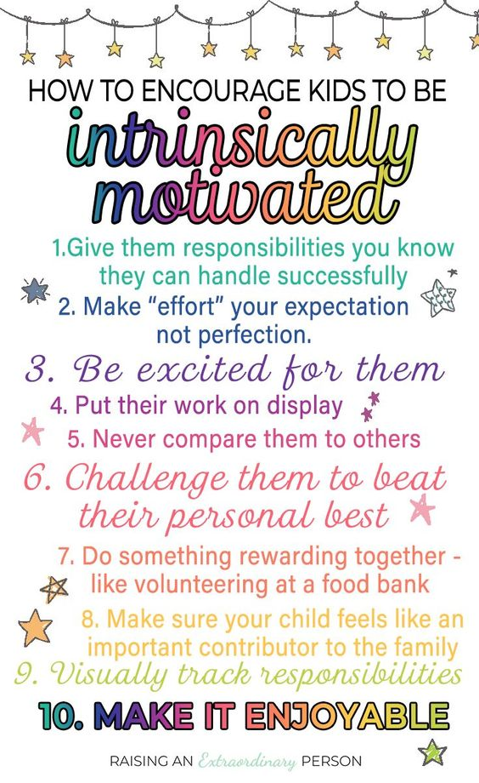
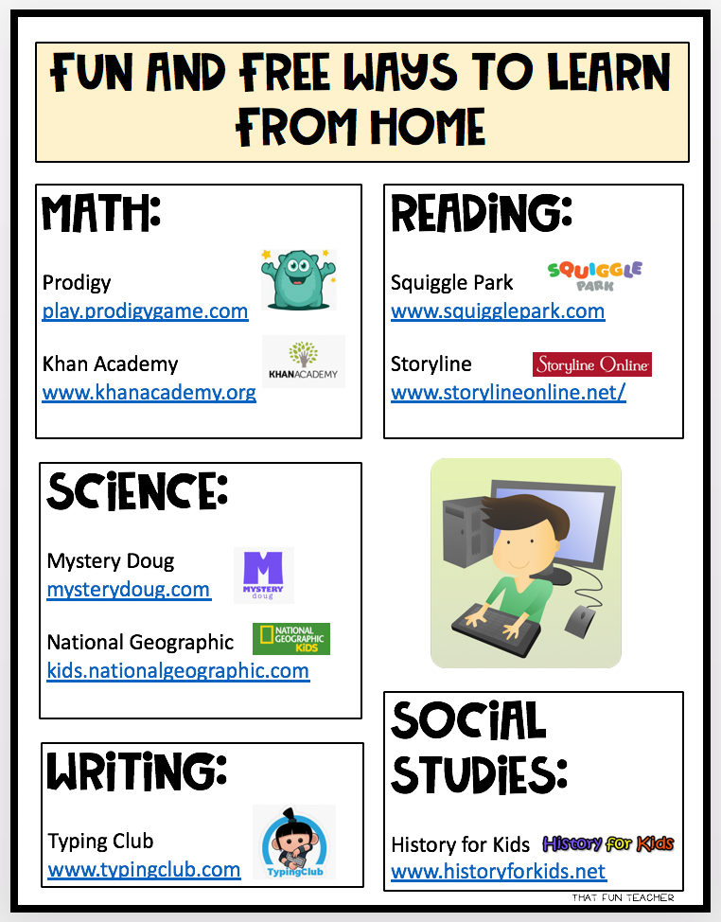
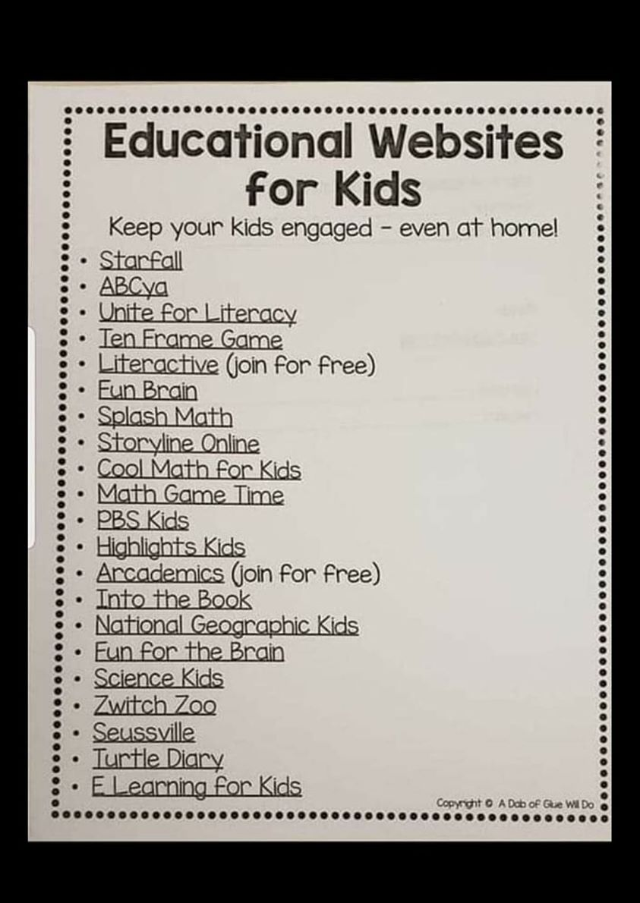
Health tips and tricks:
https://ncov2019.live/data
From a friend of a friend who is an RN: (copied and pasted - feel free to do the like)
Just saw on a friend's page who is also a nurse...
I know we’re all tired of hearing/talking about it, but one thing I HAVEN’T really seen going around is advice for what happens if you DO get coronavirus (many of us will), we're only seeing advice for how to try to AVOID it. So as your friendly neighborhood RN, here we go:
Things you should *actually* buy ahead of time (Um, not sure what the obsession with toilet paper is?): Kleenex, Acetaminophen (Tylenol) in 325 mg tablets, Ibuprofen (Advil) in 200 mg tablets, Mucinex, Robitussin or DayQuil/NyQuil, whatever your cough medicine of choice is.
If you don’t have a humidifier, that would also be a good thing to get. (You can also just turn the shower on hot and sit in the bathroom breathing in the steam). Also a good time to make a big batch of your favorite soup to freeze and have on hand.
If you have a history of asthma and you have a prescription inhaler, make sure the one you have isn’t expired and refill it/get a new one if it is.
You basically just want to prepare as though you know you’re going to get a nasty respiratory bug like bronchitis or pneumonia. You just have the foresight to know it’s coming.
For symptom management, use the meds I mentioned. For a fever over 101, alternate Tylenol and Advil so you’re taking a dose of one or the other every 3 hours. Use both cough suppressants and expectorants (most cough meds have both). Drink a ton, hydrate hydrate. Rest lots.
If you're sick, you should not be leaving your house except to go to the doctor, and if you do, wear a mask (regular is fine, you don’t need an N95). You DO NOT NEED TO GO TO THE ER unless you are having trouble breathing or your fever is very high and unmanaged with meds.
90% of healthy adult cases thus far have been managed at home with basic rest/hydration/over-the-counter meds. We don’t want to clog the ERs unless you’re actually in distress. The hospital beds will be used for people who actively need oxygen/breathing treatments/IV fluids.
If you have a pre-existing lung condition (COPD, emphysema, lung cancer) or are on immunosuppressants, now is a great time to talk to your PCP or specialist about what they would like you to do if you get sick. They might have plans to get you admitted and bypass the ER entirely.
One major relief to you parents is that kids do VERY well with coronavirus— they usually bounce back in a few days, no one under 18 has died, and almost no kids have required hospitalization (unless they have a lung disease like CF).
Just use pediatric dosing of the same meds.
(If you want to share, copy and paste.)

