& “Keep Kids Safe Fair”
15th Annual
“Cruisin' Into Summer" Festival!
Sponsored By
Tri-County Family Care Center
Saturday, June 6, 2020

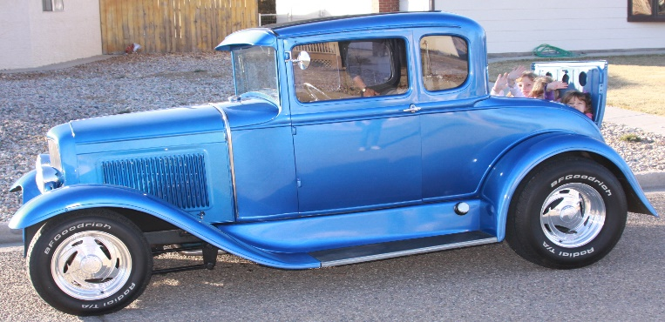
“Dj Rivas” 719.469.3697
Djrivas719@gmail.com

South Main St. from
Railroad Park to Maple St,
Rocky Ford 10:00 am-5:00 pm

Motorcycles Lowrider Peddle Bikes“Got Wheels?”Show
Cars, Trucks, Art & Unusual Vehicles

Care Connect Helicopter will be here!

MUSIC! KIDS GAMES, ENTERTAINMENT Elvis is coming!!

RF Chamber Breakfast 7-10 am @ the Depot
Rocky Ford Fire Dept Open House 10 - 12 pm

BEER GARDEN, HORSESHOE & DISC GOLF TOURNEYS
VILLAGE INN PIE EATING CONTEST
50/50 CA$H POT Raffle

Cruise into summer safely by visiting the SAFETY BOOTHS!
This is a fundraiser for Tri-County Family Care Center
For more information, or to register for events, contact
TCFCC at 512 ½ N Main Street Rocky Ford 719.254.7776 sarah.tricountyfcc@gmail.com

