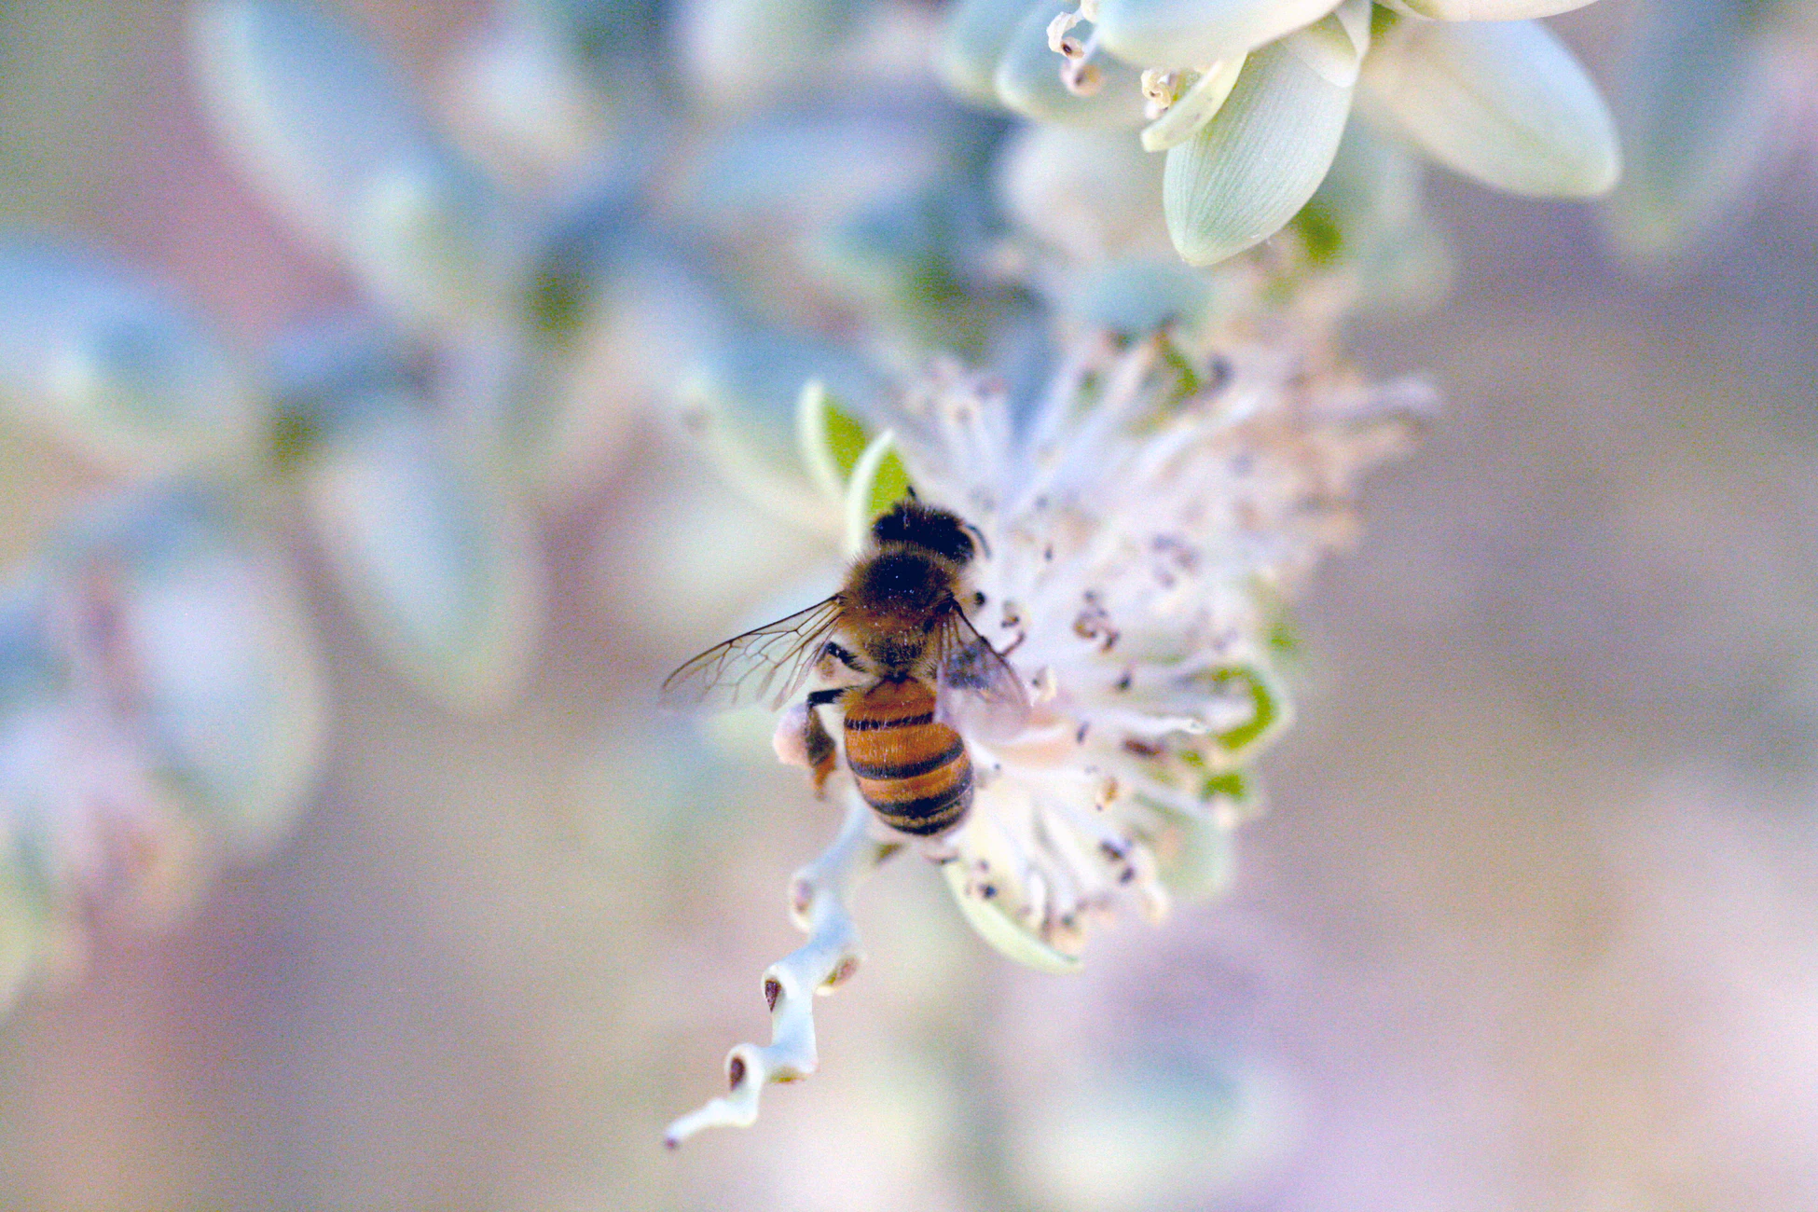
How to Make a Difference in Your Community

Powerlessness is an awful feeling. Unfortunately, it’s one that’s all too easy to succumb to in this day and age. The issues facing our world can feel insurmountable. We know we must stay aware, but that awareness can erode us if it’s left unchecked.
The antidote to powerlessness is action. When we become the change we want to see, we prove to ourselves just how powerful we really are. Everyone has the ability to make a difference. Here are some ways you, your loved one, and your community can rise to the challenge and create a better world.

Working with Children
Invest in the next generation, and invest in the future.

- Advocate for strong public education, especially for underserved populations.
- Consider volunteering as an afterschool tutor to help kids who are struggling.
- Encourage your own children to volunteer to teach them compassion and awareness.
- Consider fighting for out-of-the-box approaches to education outcomes, such as in-school laundry programs.
- Support organizations that make a difference for at-risk families.

Fighting for Major Changes
You can make a difference for those who are struggling today.

- Volunteer to help the homeless in your area.
- Get involved in local politics to fight for institutional changes.
- Contact your national representatives about issues that matter to you.

Connecting and Caring for Nature
Working with nature is a great way to destress and make a difference at once:

- Fight to create as little waste as possible by recycling, reusing, and composting.
- Join a local hiking trail clean-up effort to exercise and volunteer all at once.
- Put out small shelters for homeless pets in your neighborhood.
- Plant pollinator-friendly plants in your yard.

Fighting for what you believe in isn’t easy, but it’s necessary. Without action, our grief does nothing but weigh us down. Counterintuitively, taking on the work lightens our load substantially. Transform yourself into a beacon of hope, and see how the world glows.

Photo Credit: Unsplash

