**T**ri**-C**ounty **F**amily **C**are **C**enter

“Melon Chunkin’ Contest!”

**Saturday, September 13, 2025**

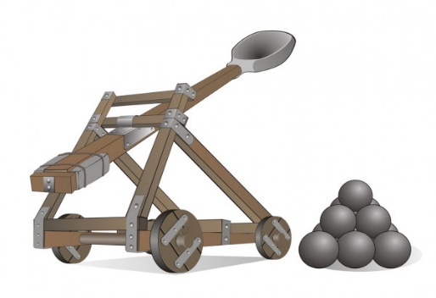

***EVENTS***

8:00-10:00 am Vendors Sign In/Setup

10:00am-12:00pm UC Lifeline Helicopter in West field

10:00 – 5:00 pm Kids Zone by South wall

10:00 – 3:00 pm Pumpkin Patch by South wall

Nerf Battle Zone by South wall

10:00 – 2:00 Archery Contest

12:30 pm Parade Led by Knights in Armor

1:30 pm Bike and Costumes Judged

2:00 pm Watermelon eating contest

3:00 pm Judging of the Pumpkin Patch Artwork

3:45 pm – 4:00 pm Announcing of all the Event winners

***SCHEDULE OF COMPETITION***

8:00 am – 9:00 am Set up of Trebuchet

9:00 am – 10:00 am Orientation of teams

10:00 am – 11:00 pm Team Launching

11:00 am – 11:15 pm Knights in Armor Sword Fights

11:15 am – 1:00 pm Team Launching cont’d Top 3 teams

win prizes with a Trophy for 1st place.

1:00 pm – 1:15 pm Knights in Armor Sword Fights

1:15 pm – 2:30 pm Cantaloupe Catapult Contest

Hit the Watermelon in the bullseye

3:00 pm – 3:30 pm Last Sword Fight

5:00 pm Festival ends

This is a fundraiser for Tri-County Family Care Center

**For more information, or to register for events, contact**

**TCFCC at 512 ½ N Main Street, Rocky Ford. 719.254.7776**  info.tricountyfcc@gmail.com