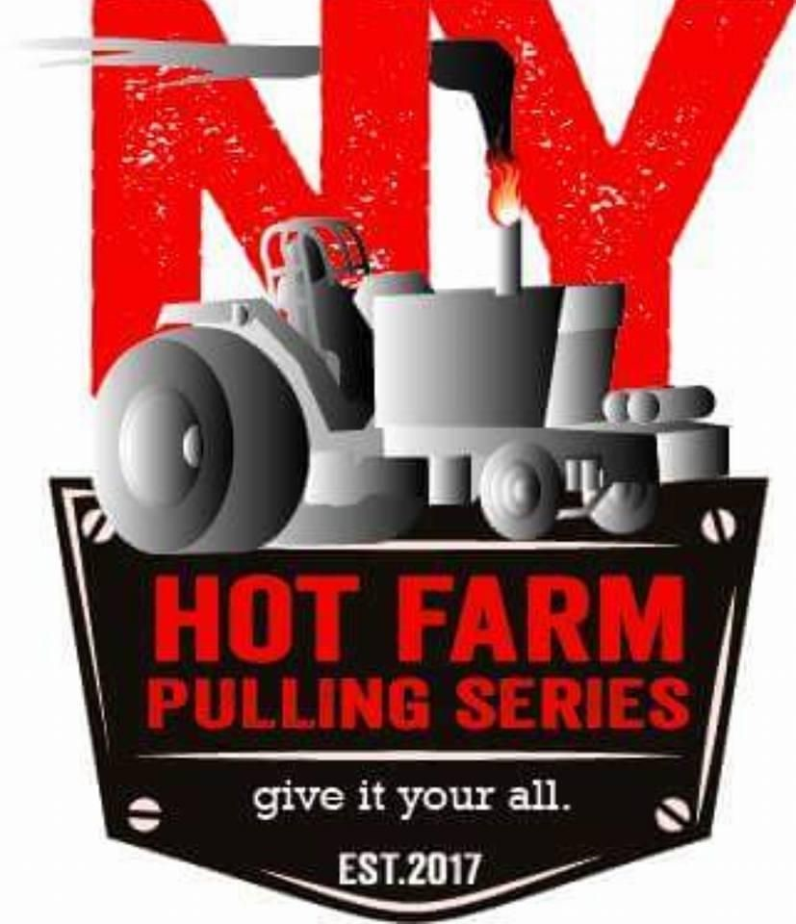
10500 LB 466 Hot Farm Rules
- Safety first, always!!!
- Follow the general rules at all times.
- Maximum 480 cubic inches.
- Maximum 3”x3” turbo. No reducers.
- 20.8 max tire.
- Roll bar/roll cage and seat belts are MANDATORY.
- NO intercoolers are allowed.
- Water injection is allowed.
- Any pump up to p7100.
- Driver MUST wear at least a fire jacket, gloves, helmet and leather boots. ALL tractors must be equipped with a WORKING fire extinguisher.

