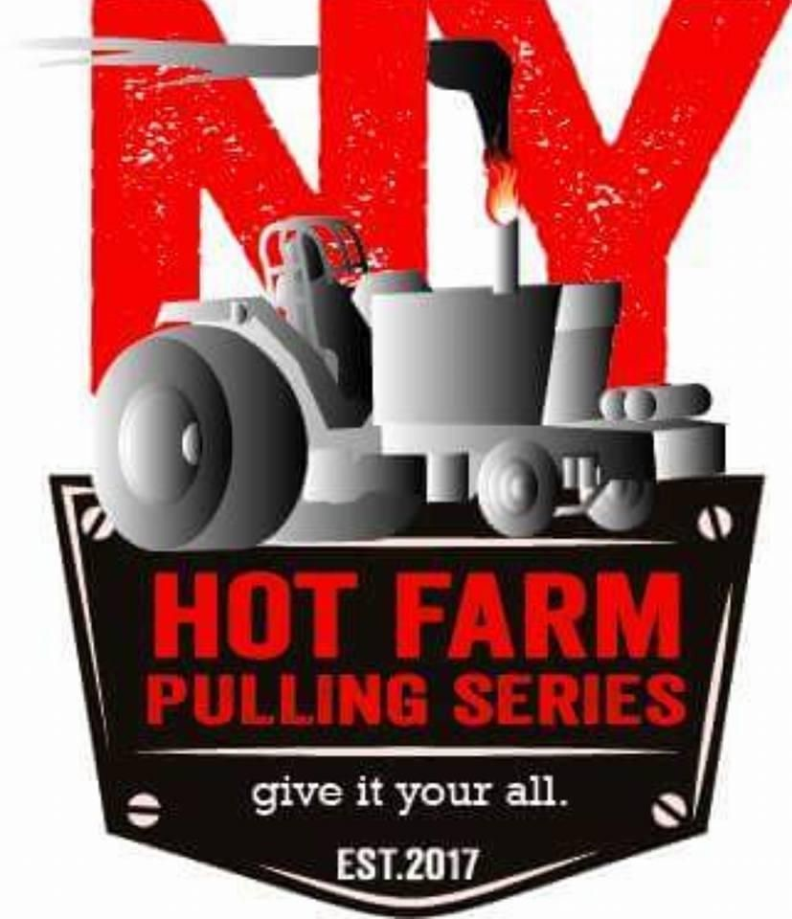

6700 LB LIGHT HOT FARM

- All general safety and chassis rules apply
- Diesel tractor with turbo maximum 401 cid, open rpms
- Turbo should be a maximum of 3 x 3 for diesel engine only.
- N/A automotive style engine maximum 410 cid, open rpms
- N/A agricultural or industrial style engine max 800 cid, open rpms
- Tire size is 20.8x34 or 18.4x38 any cuts
- N/A engine &turbo diesel engines up to 360cid may run 20” drawbar, 360-401cid turbo diesel engine may run max of 19”.
- No intercoolers of any kind allowed, water injection is allowed
- Diesel engine to use any pump up to maximum of a p7100
- No electronic fuel injection, All spark ignition will be carbureted
- All tractors will have an ignition kill switch for spark ignition engines and an air shut off for diesel tractors
- Roll Bar with lap belt, or Roll Cage with five point harness
- Must wear fire coat, gloves, helmet & leather boots.

