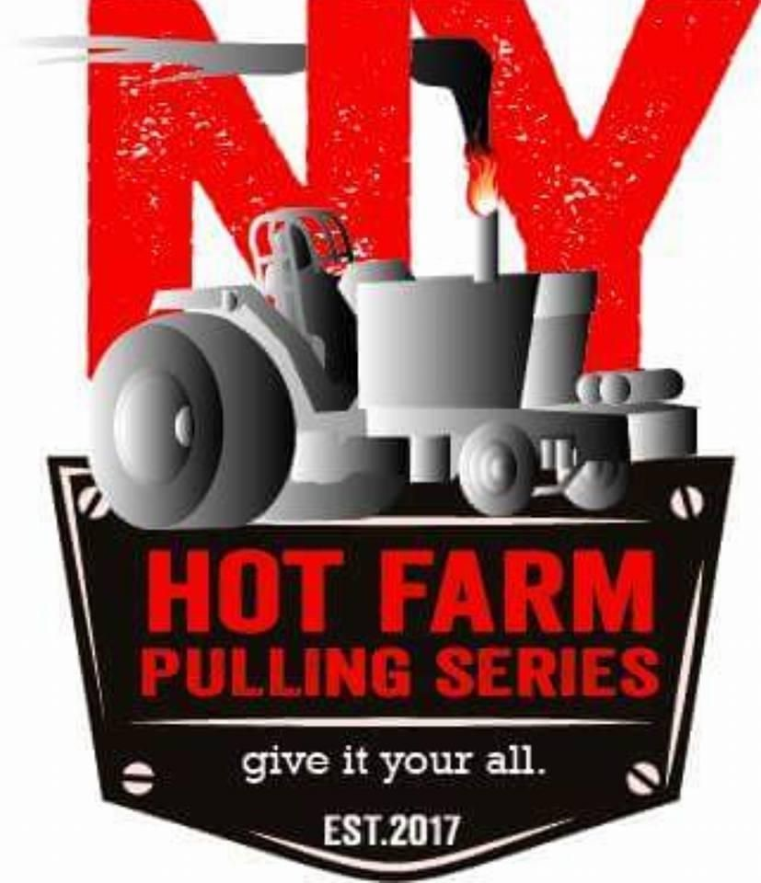

9500 LB LIMITED HOT FARM

- Safety first!!!
- Follow the general rules at all times.
- 619 cubic inch max!
- 3” X 3” turbo max. No reducers.
- Up to 24.5 double cut tires.
- Roll cage is mandatory.
- Intercoolers are allowed.
- Water injection is allowed.
- Any pump up to p8600.
- Driver must wear full fire suit, helmet, gloves and fire shoes.
- All tractors must be equipped with a working fire extinguisher within reach of the driver.
- Neutral safety light must be present on rear of tractor.
For any questions regarding this class, contact class representative
Karl Durant-
315-368-7708

