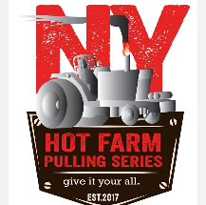
President – Matt Loucks | 315-264-4816
NYHOTFARMPULLERS@GMAIL.COM
NYHOTFARM.COM
The NY Hot Farm Pulling Series Club has been established since 2017 and operates as a nonprofit 501(c)(7) organization. As a tractor pulling club, we average approximately 10 sanctioned pulling events per year.
Our events feature the following tractor classes:
⦁ 8,500 lb Farm Stock
⦁ 14,200 lb Farm Stock
⦁ 12,500 lb Farm Stock 12MPH
⦁ 7,700 lb Light Hot Farm
⦁ 10,500 lb - 466 Hot Farm
⦁ Limited Pro Diesel 4X4 (3.0 class) Truck
⦁ Wild Street Diesel 4X4 Truck
⦁ Enhanced Gas 6,500 lb Truck
The NY Hot Farm Pulling Series continues to grow each season by adding new events and locations. Our pulling events draw over 1,000 spectators on average, with attendance continuing to increase each year.
Our primary advertising platforms include social media and our website:
- Facebook Group with over 3,700 followers
- Average 2,900 views per post
- Average 654 reactions, comments, and shares per post
We ask you to consider supporting our club during the 2026 season to help us create a better experience for pullers and spectators alike.

Any questions please reach out to President, Matt Loucks, 315-264-4816.

Sponsorship Levels – 2026
Level 1 – $250
- Announcement at the pulling events
- Website recognition
Level 2 – $450
- Announcement at the pulling events
- Website recognition
- Facebook & Instagram recognition
Level 3 – $1,000+
- Announcement at the pulling events
- Website recognition
- Facebook & Instagram recognition
- Personal banner displayed at events
- Two (2) tickets to the end-of-year banquet

Mailing / Payment Options
Mail:
NYHFPS
P.O. Box 122
South Otselic, NY 13155
OR
Venmo (NY Hot Farm Pulling Series)
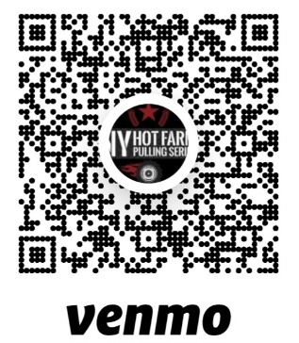
Business Name : ________________________________________________________________
Address : _______________________________________________________________________
Email : _________________________________________________________________________
Phone : ________________________________
Amount Enclosed : $ ___________________________________

** We are a 501c7 Non-Profit organization, so any donations would be greatly appreciated.**
** Please return by May 1st 2026 to ensure banners are made in time for our first pull of the year! **
Please let us know what you would like us to announce at the pulls below:
___________________________________________________________________________________________________________________________________________________________________________________________________________________________________________________________________________________________________________________________________________________________________________________________________________________________________________________________________________________________________________________________________________________________________________________________________________________________________________________________________________________________________________________________________________________________________________________
Please enclose your business card below:

Thank you,
NY Hot Farm Pulling Series

