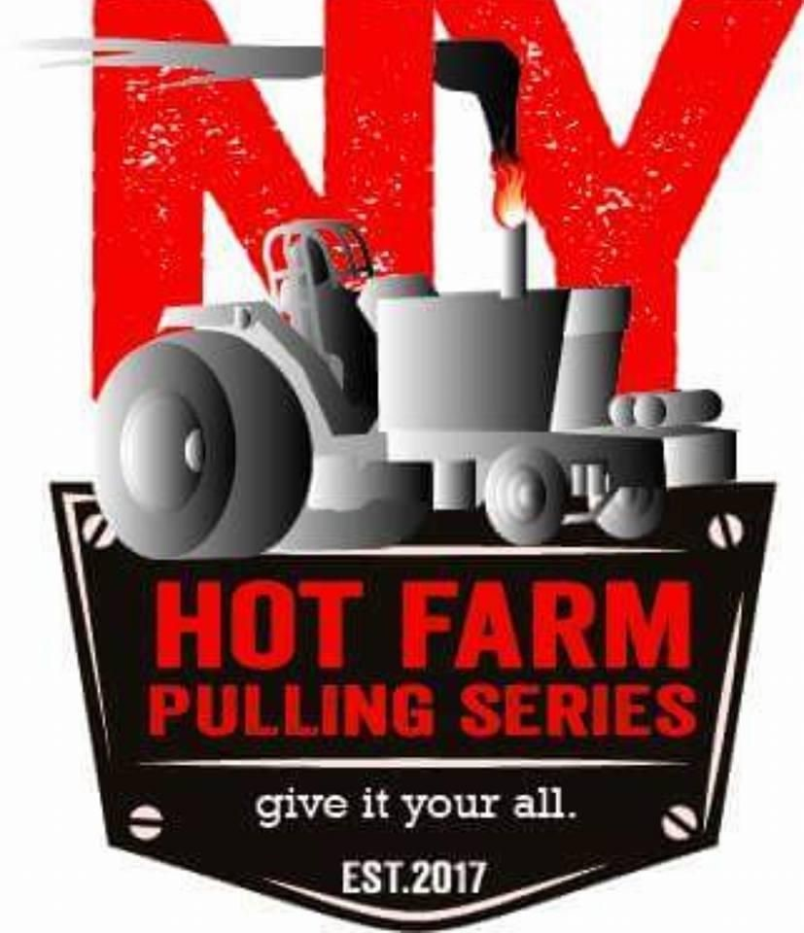

**14,200lb Field Ready Farm Stock Rules**

1. Max weight 14,200lb
2. 8 MPH limit
3. Factory front end
4. Factory seat mounts
5. Factory air system
6. Factory draw bar with 1 inch plate with 3.5 inch hole or a clevis with a 1 inch pin
7. NO cut tires