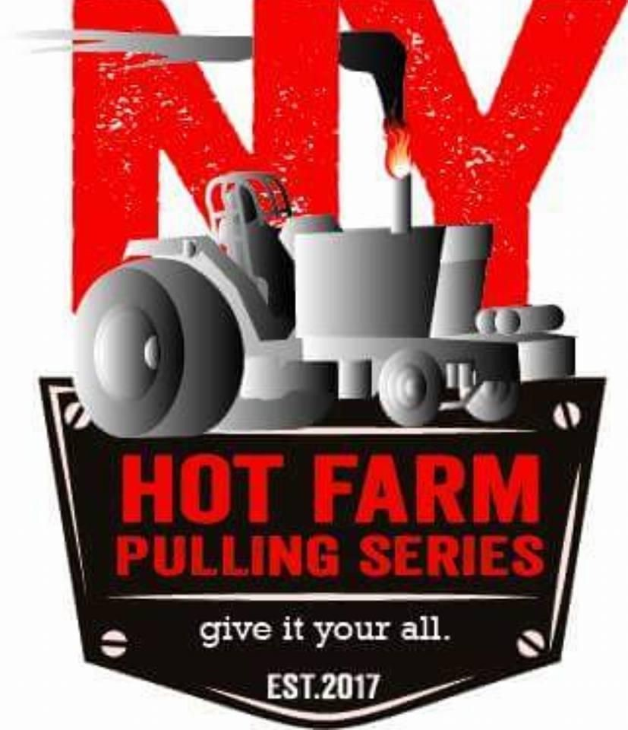

General Rules

- Safety is always first! Good sportsmanship is expected at ALL times.
- Operate in a safe manner at all times.
- NO alcohol before pulling or driving equipment.
- No riders - drivers only.
- Drivers have to shut down before 100ft. mark in order to restart (breakage must drop to last).
- First puller in class has the option to come back in third, only if the sled is reset.
- Drivers must remain in their seats during pull, if you lose control you will be flagged.
- DRAW BARS:
  - Minimum of 18 inches from center of the rear axle to hitch point.
  - Maximum of 20 inches to top of hitch point.
  - Minimum of ¼ inch steel plate, to a maximum of 1 inch thick at hook point. Minimum of 3x3.5 inch hole for hook.
  - Drawbar and assembly must be rigid and sturdy, must have a horizontal pin. To be checked by tech official.
- Weights:
  - All weights should be secured.
  - No weights should interfere with hooking to the sled
  - Front weights shall not extend 2’ from nose of tractor
  - Rear weights shall not extend beyond rear most part of tires
  - Rear wheel weights shall not extend beyond 2 feet of tire sidewall.
- Loss of weights or parts will result in disqualifications.
- All tractors to run one fuel only, fuels to be: gasoline (VP gas), diesel, alcohol, propane (No nitro-methane, nitrous or nitro-propane).
- Water injection is allowed. NO alcohol, windshield washer fluid,or other enhances, water pump lubricant is ok.
- Turbo Size 3X3 maximum. No reducers.
- Mandatory fire suit and shoes, gloves and helmet.
- All Tractors must have:
  - WIDE FRONT END
  - AIR SHUTOFF - Vehicle must have a cable operated engine air intake shut off device. Device cannot be a butterfly type and must be spring loaded. Cable must be located approximately 4 feet above the point of hook and within 6 inches of center of vehicle. Device must prevent the engine from building boost. The sled requires a 2 inch ring of equivalent be attached at the end of the cable. Mont cable in clear view no obstructions. One must be within the driver's reach as well when strapped in seat.
  - BRAKES - All tractors must have working rear brakes capable of
sliding each rear wheel.
  - CLUTCH - Clutch Blanket: Must have a SFI APPROVED clutch, flywheel & clutch blanket or 3/8 steel/ ½ aluminum x 6” band bolted to the frame of tractor.
  - HARMONIC BALANCER must be shielded so it cannot come out of tractor in any way.
  - COOLING FANS - All cooling fans will be electric operated. No factory metal blades on water pumps.
  - CHASSIS - Maximum of 114 inches wheelbase unless originally produced with a longer wheelbase at which point the wheelbase will remain stock. Mandatory front hitch.
  - DUMP VALVE - A 3 way fuel dump bypass valve is required ahead of the injection pump. This valve is to be operated by a cable within the driver's reach when strapped in seat. No electronically controlled engines of any configuration.
  - SEAT BELTS - Three bar roll cage protection and 5 point seat belt harness in roll cage. Roll Bar: MUST have Lap Belt and must support the weight of the tractor.
  - SHIELDS - Side panels are mandatory on both sides of the engine and cover bar the entire engine. Either aluminum or steel not less than 0.060” thick. There must be a firewall that separates the operator from the engine compartment with no hole more than ½ in diameter for controls to pass through. A 0.060” thick or 120” thick aluminum must run between frame and under the harmonic balancer to prevent loss of harmonic balancer from tractor.
  - WHEELIE BARS - Must support the weight of tractor this is
MANDATORY.
  - THROTTLE - Throttle lever must have a double spring installed such that if the throttle lever is released. The engine will return to idle.
Throttle must function such that moving the throttle lever forward, increases the engine speed.
  - TUBE FRAME AND FRONT END - Manufactured tube frames and front ends are allowed, must support the weight of tractor.
  - TURBO - 3.0 maximum diameter of the intake inlet. Map ring enhancement grooves allowed. 3.0 Exhaust housing
  - WATER INJECTION - Water injection is allowed with water and pump lubrication only. Water may contain crop oil or water soluble oil. Water must pass any test.
  - WHEEL HUBS - Must be steel weld on hubs or heavy duty clamp on hubs. No Cast Iron.
  - FRONT SKID PLATES/SKI BARS ARE MANDATORY on non factory front ends. Must be within 6 inches of the ground.
  - All tractors must have an ag rear end and stock transmission housing, no drop box transmissions.
  - A functioning, up to date fire extinguisher must be mounted on all pulling vehicles, within reach of the driver.
  - All tractors must have a cable around the motor between 1st & 2nd cylinder with four clamps.

***WARNING - Any competitor suspicious of another competitor’s vehicle on cubic inches or water injection can have a tech official witness the tear down or testing of the tractor for a fee of $1500. If the competitor is deemed legal for the class they are pulling in, they keep $1250 and the official gets $250. If not deemed legal, the person who put the money up gets his money back!!!

