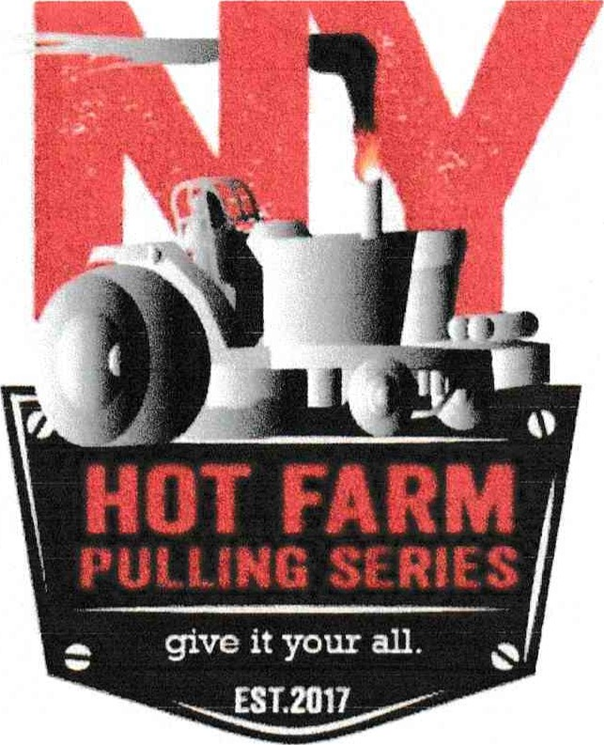

Sportsmanship Expectations

In order to ensure that 2021 is a successful and enjoyable season, it is expected that all participants act in a professional and sportsmanlike manner at ALL times. This is inclusive of, but not limited to: respecting other pullers, spectators, the facility and not leaving a mess behind. Failure to do so may result in the participant being asked to remove themselves from the event. Multiple episodes of unsportsmanlike conduct will result in participant not being permitted to participate with the club for the remainder of the season, and all membership fees, hook fees, etc. will be forfeited by the participant. I have read the above terms, and agree to comply.

I, ______________________ have read the above terms and agree to comply.

Signature: _________________________________ Date: ________________