**Matchday hints and tips for managers and parents.**

**As a manager, how to check which parents have not subscribed to the Paypal payment schedule and therefore will be missing payments.**

When in as the manager role in the matchday app, go to Payments screen

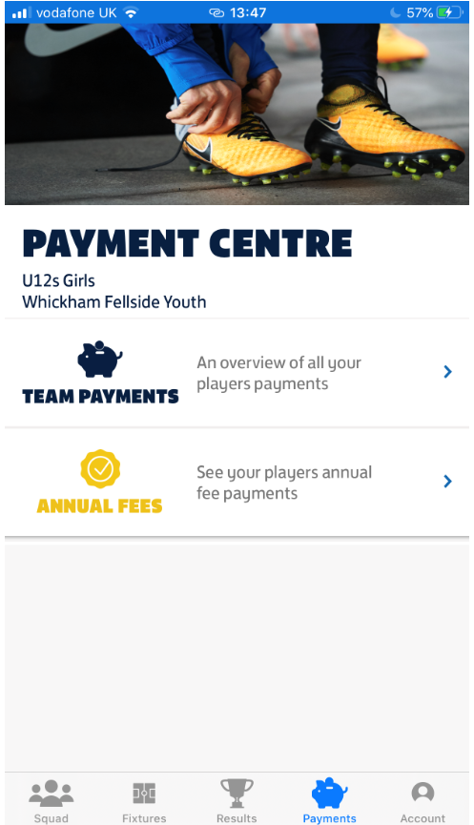

Press the “Annual fees” option

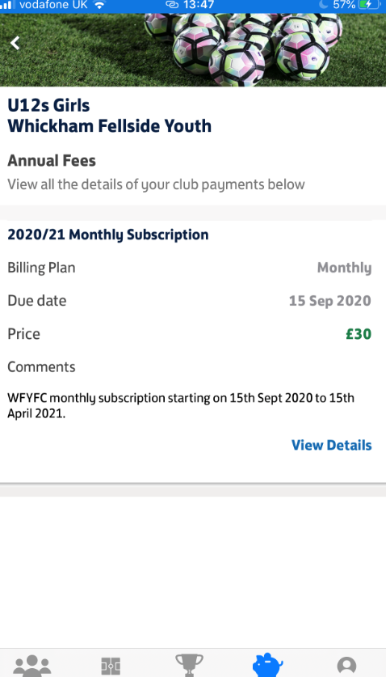

You will see the payment option setup by the club against the players - Press “View details”

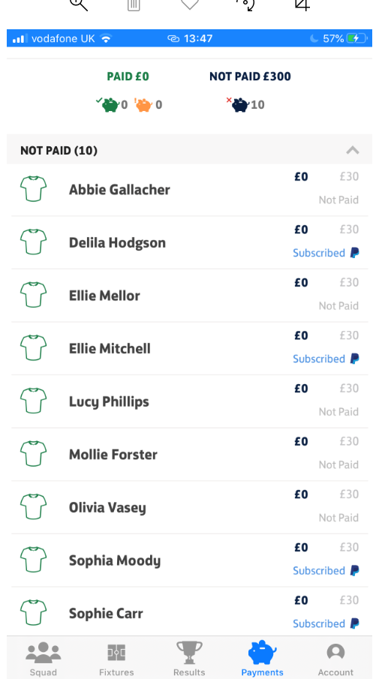

Those players subscribed via Paypal are shown with the Paypal icon. The ones not displaying the PayPal icon need to be chased up.

**How to see what actions are outstanding from Parents.**

Go to Squad screen (whilst in manager role) and you can see those that have an email in the WGS, have a linked parent and those who have signed into the Matchday app.

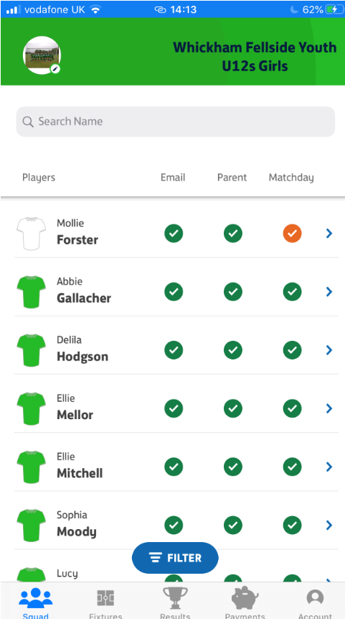

**As a parent (or manager with a child in the club) – how to subscribe to Paypal**

Please download the FA’s Matchday app from the Apple and Android stores as soon as you can. This FA App links to the Whole Game System which the club uses for all its admin functions. You may also receive an invitation from the FA’s Matchday app to download and sign in – this will have been sent to you via your team’s manager.

The Matchday app is the method that WFYFC is using for its subscription payments for 2020/21 via the FA and PayPal partnership – the WFYFC subscription cost per player has not changed for this season. The subscription options will be a one-off annual payment or 8 monthly payments – both applicable from the 15th Sept 2020. Please speak to your team’s manager about the pricing details. By default, everyone is set to monthly payments.

By registering your child, or children, to play for WFYFC for the 2020/21 season, you are agreeing to abide by the rules set out in the WFYFC Registration and subscription policy for 2020/21 document – to view the WFYFC Registrations and subscriptions policy for 2020/21 document (which also contains useful links/Frequently Asked Questions on the Matchday app) go to [https://whickhamfellsideyfc.co.uk/documents](https://whickhamfellsideyfc.co.uk/documents?fbclid=IwAR0vbgrOv3RO48g_0nsez4umwgftwWSYCI1YyWDWMzAP54Kgtx44VtTBdB8).

If you wish to pay the one-off annual fee, please email registrations@whickhamfellsideyfc.co.uk by the 1st September 2020 and this will be setup.

Login using the email address (as the username) and password details that you used if you registered yourself and your child(ren) in the Whole Game System. If you did not, login in using the email address you have provided to the club for the team manager to register your child and you will be able to create a Matchday app password.

If you are a player aged 16 and over, you may have your own email address on the Whole Game System, so use this (as the username) to log into the Matchday app. You will be able to create a password.

Via the Matchday app, managers can see who has logged in. If you are having difficulties signing in, or you do not see the correct team or your children, please speak to your team’s manager.

Parents/Carers/Managers - Once in the Matchday app, this simple FA grassroots technical team video will show you how to select and setup the payment option of monthly or annually - [https://www.youtube.com/watch?v=oOPPp-JjGsE](https://www.youtube.com/watch?v=oOPPp-JjGsE&fbclid=IwAR37DVopexpbvdLPDHXdQoLF0f_ol64I1xElTqhCwweUe6Jx3-rEgUOQi5c)

**Changing your role from manager to parent and vice versa in the matchday app.**

Go to the Account icon.

The manager view has the o/x symbol. So here you can see I’m the manager on 2 teams and a parent of a child in 2 teams.

My current view is as the Manager of the U12 Girls.

