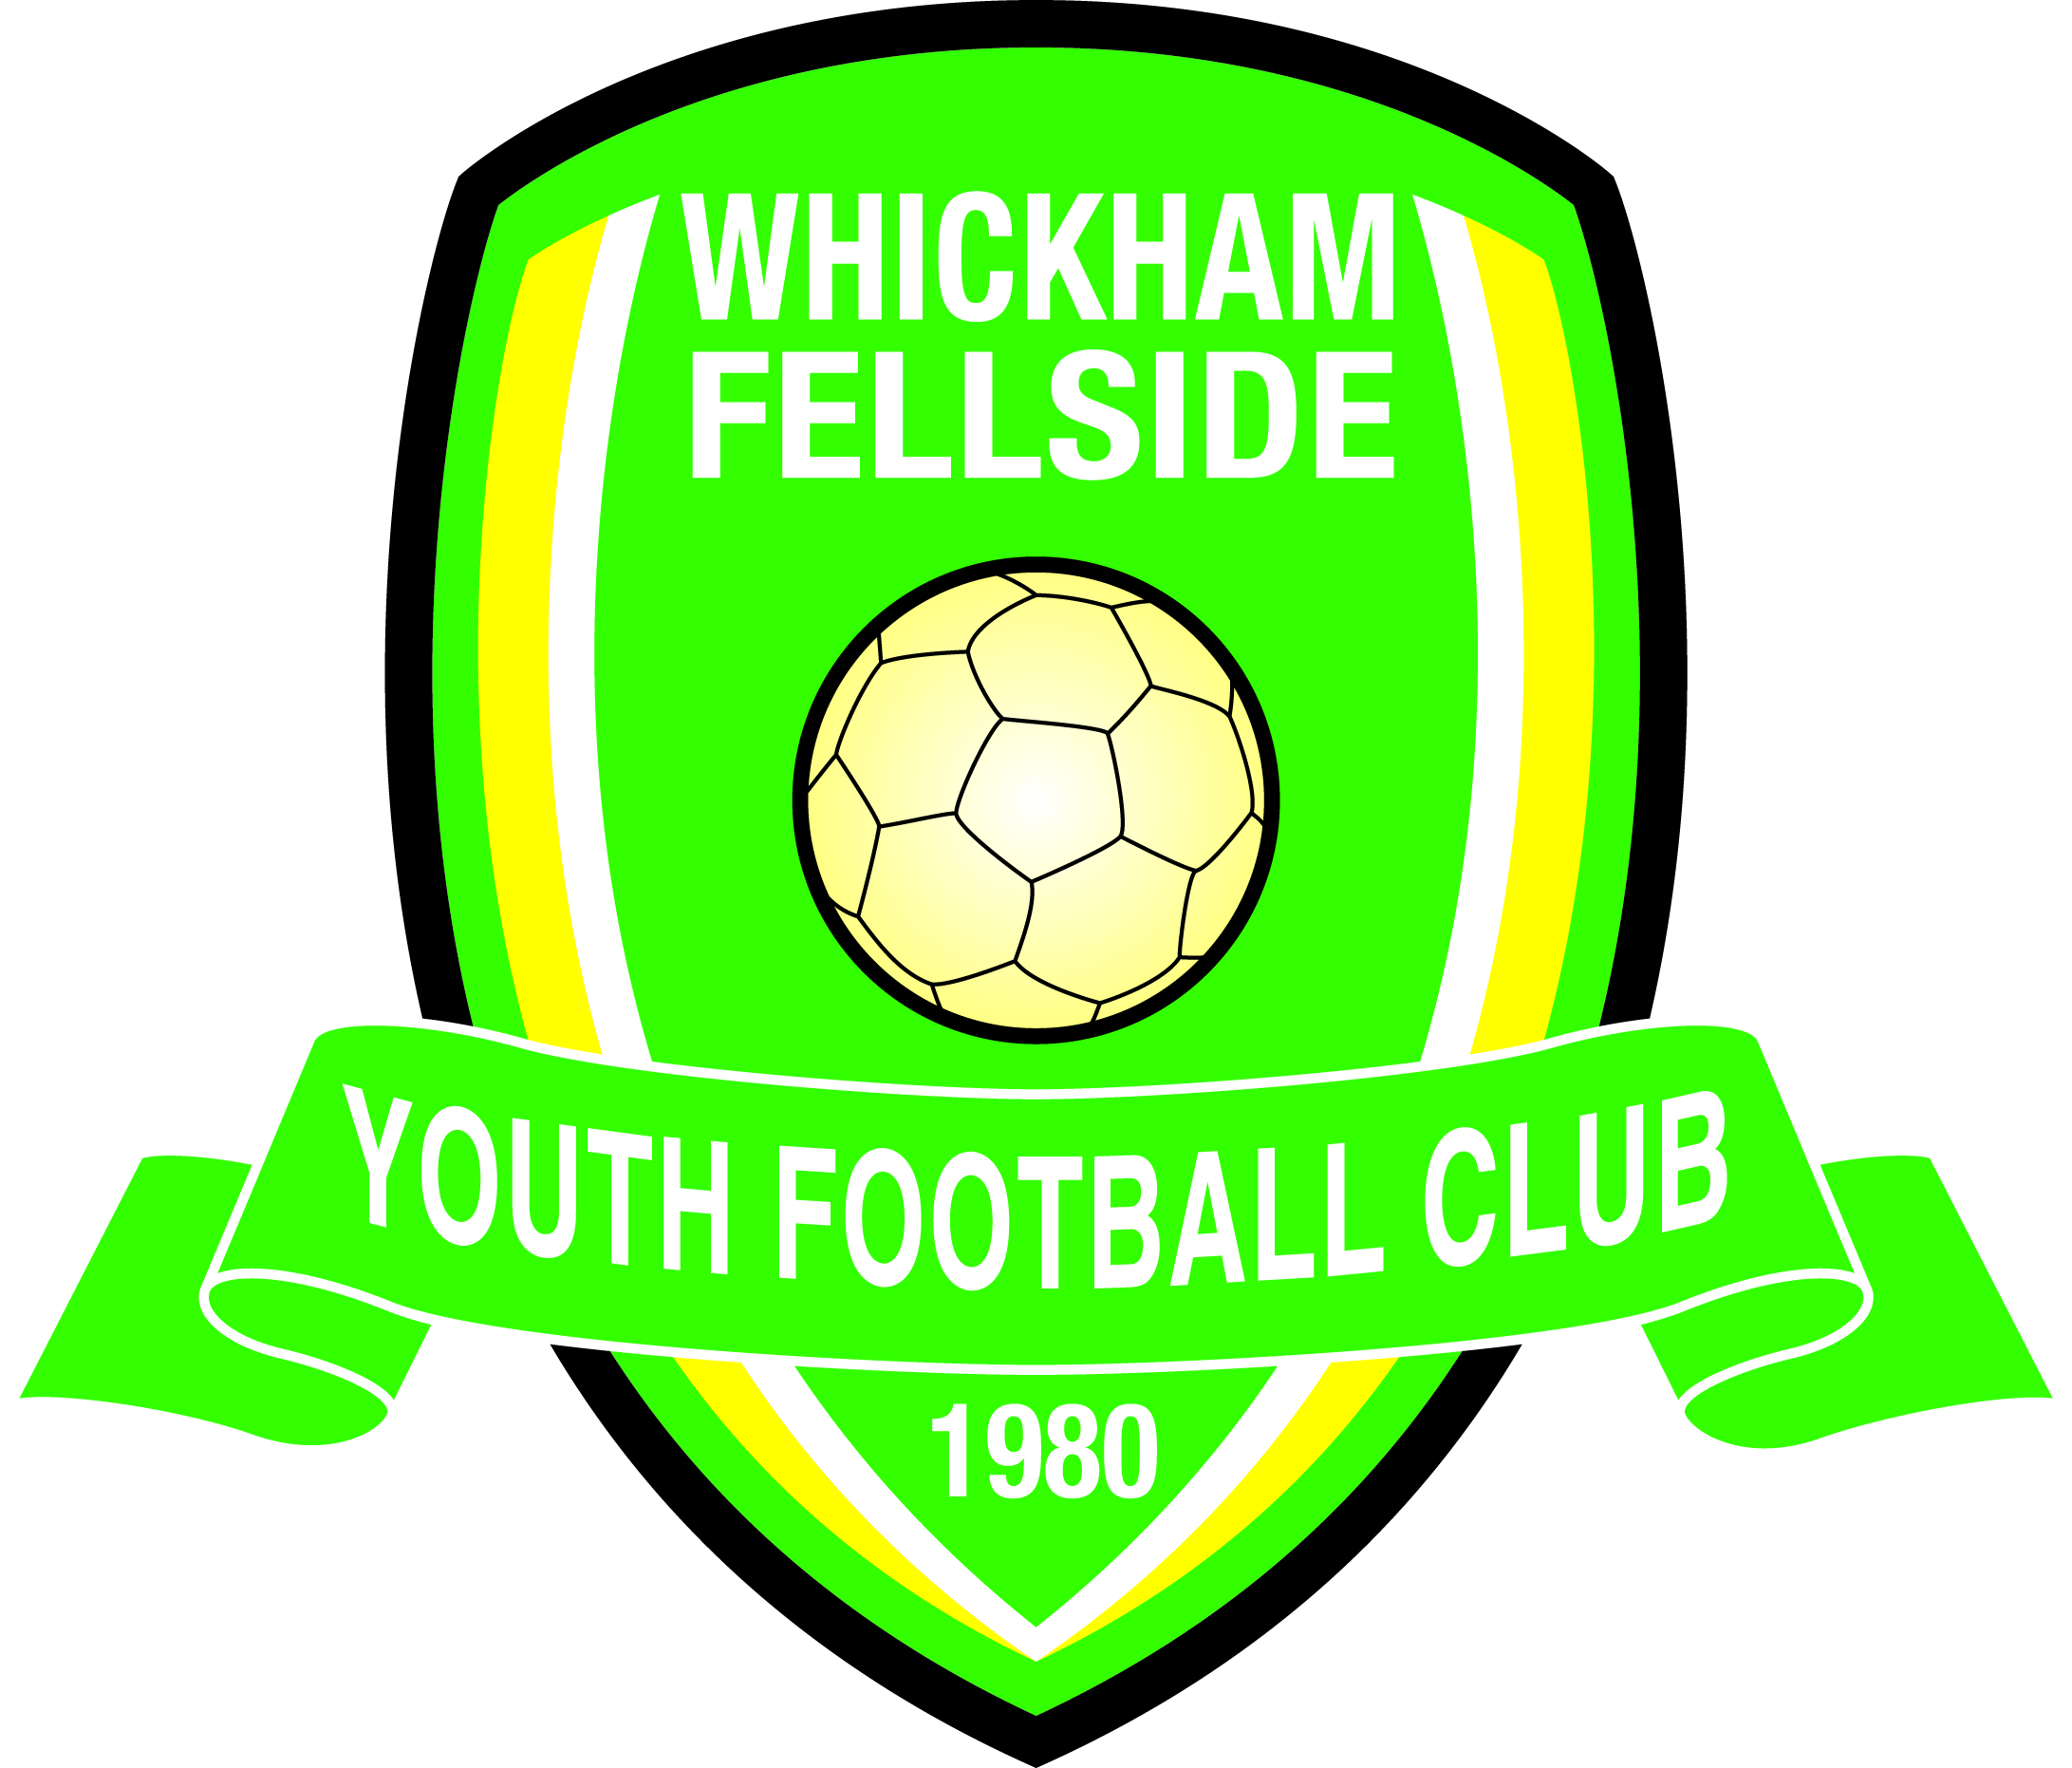

**Football Association Charter**

**Standard Community Club**





(07958 988



In partnership

# **Club Management Committee:** President – Rob Hennessey

# Chairman – Dave Nelthorpe (welfare officer) Secretary – Paul Mitchell Treasurer/Vice-Chairman – John Clark

# Football Development Officer – Peter Craddock Registration Secretary –Steve Franklin Equipment & Marketing – Tony Smith Watergate and Pitch Facilitator – Paul Kelly IT & Marketing – Paul Mitchell Welfare Officer - Sue Broadbent

# Referees and pitch allocation – Barry Wake Asst. Secretary – Sharon Johnson

# **Club General Committee** All Team Managers and Assistants DFA Affiliation No. **W-DUR4509**

ntinue with the club at the end of the season, that’s it – the team’s budget is absorbed into the club reserve account.

**Registered under the Football Association’s Child Protection Policy www.whickhamfellsideyfc.co.uk**

### CODE OF CONDUCT

WFYFC code of conduct for Oct 2020.

The club’s code of conduce is governed by the Football Association’s “Respect” campaign. All the information about this can be found at <https://www.thefa.com/get-involved/respect/play-your-part>

The FA’s Respect campaign has individual Respect codes of conduct for:

1. Young Players
2. Coaches, Team Managers and Club Officials
3. Spectators and Parents/Carers
4. Match officials

These documents and the FA’s “Respect” campaign are the framework for the club’s code of conduct. As well as the above FA codes of conduct, the club has its own rules, to sit alongside the FA’s. A player and/or a parent’s acceptance of registering with the club is acceptance of the club’s code of conduct. It is the responsibility of each club official, player, and parents to read the club’s code of conduct and refer to the FA Respect’s campaign webpage and associated codes of conduct. **Not knowing the club’s code of conduct or not being aware of it is NOT an excuse or a mitigating factor in any complaints received or disciplinary action undertaken, against an individual or individuals.**

1. All members are expected to behave in a responsible way, respecting adults, opposition officials and match officials. It is hoped that at the conclusion of a game both teams shake the hands of the opposition, club officials and match officials.
2. The Club reserves the right to implement further disciplinary action on any member or parent. This can take the form of a pitchside ban or a further financial penalty on top of any levied by the League or Durham Football Association.
3. All parents and Club officials are expected to behave in a responsible manner, respecting the decision of match officials, however contentious and acting in a courteous way towards the opposing players, officials, supporters and match officials.
4. Any official complaints should be directed through the appropriate Team Manager or Assistant and they will be submitted to the Club Executive Committee for discussion and for a decision to be reached. The Executive Committees’ decision shall be final.
5. The Club reserves the right to take the ultimate disciplinary action by ceasing the membership of an individual player or banning any parent or supporter who has carried out an action of gross misconduct, the decision lies with the Executive Committee and their decision shall be final.
6. The Fair Play Charter which covers Youth Football shall be complied with. In the main this covers many common-sense issues and is incumbent with good behaviour, respect and responsibility of members, Club officials and supporters.

### The above points will be implemented whilst members, officials and parents are on Club duty, i.e. training, friendly and competitive matches, Club trips and generally whilst representing the Club and under the supervision of Club officials.