Club Secretary:
Football Association Charter
Standard Community Club

Paul Mitchell

Registered under the Football Association’s Child Protection Policy www.whickhamfellsideyfc.co.uk

Club Management Committee: President – Rob Hennessey

Chairman – Dave Nelthorpe (welfare officer) Secretary – Paul Mitchell Treasurer/Vice-Chairman – John Clark

Football Development Officer – Peter Craddock Registration Secretary –Steve Franklin Equipment & Marketing – Tony Smith
Watergate and Pitch Facilitator – Paul Kelly IT & Marketing – Paul Mitchell Welfare Officer - Sue Broadbent

Referees and pitch allocation – Barry Wake Asst. Secretary – Sharon Johnson

Club General Committee All Team Managers and Assistants DFA Affiliation No. W-DUR4509

Club registration and subscription payments
Policy Name: Whickham Fellside Youth Football Club (WFYFC) Registrations Policy.
Policy Version Number: Final 1_0a Policy Effective Date: from 1st July 2020
Policy Owner: Registration Secretary
Policy Reviewer: WFYFC Management Committee Review Cycle: Yearly
Purpose: This policy is to ensure that the club’s subscription payment process is documented and circulated round managers and parents/carers.

For the 2020/21 season and onwards, the club is moving away from the LoveAdmin payments system that has been used for the last 2 years and onto the FA’s Matchday app for all its subscription payments. The Matchday app will allow managers to assist the club in managing payments from parents and will allow payments to pay via Paypal and other cards.

There are a few key drivers for the club moving to the FA’s Matchday app for payments:

- The Matchday app ties in with the FA’s Whole Game System which is being mandated to be used by all English Football clubs from the 2021/22 season – so we are moving a year early. The delay in leagues getting started again due to Covid-19 meant that the new Registration Secretary, Steve Franklin, has had more time to assist in establishing the Whole Game Systems and the FA’s Match day app.
- The club (and many others) and Durham FA heavily uses the Whole Game System for its affiliation process, safeguarding checks, discipline management and other club / Durham FA functions.
- The Russell Foster Youth League and The Northumberland League are using the FA’s Whole Game System for all their team and player registrations for the 2020/21 season
- LoveAdmin transactions costs were going to increase substantially, and the club could not be certain that these costs would not be passed on in the form of higher subscription costs.
The subscription process has changed as a result and relies heavily on Parents/Carers using the App to make the subscription payments. For the 2020/21 season there will be 2 payment options:

- Monthly - For predefined monthly instalments the first payment will be on 15th September 2020 for all teams – 8 payments at £30 (£240 in total) per month starting 15th Sept 2020 and last payment due on 15th April 2021,
- Annual - paying the £240 upfront in one annual payment. Whilst this is the “big hit” payment, as a club it is massively beneficial to our cashflow and planning if we already have the only source of income in one go as early as possible in the payment cycle. We appreciate that this is a large expenditure in one go, but we urge parents/carers to choose this option – thank you!
Parents/Carers can inform Steve Franklin, Registration officer by email (registrations@whickhamfellsideyfc.co.uk) if they wish to pay via the annual subscription option.

Policy:
- Players’ registration fees can be either paid up front on registration or on a club defined instalment basis by months within the playing season via the FA’s Matchday app (using Paypal).
- If the registration fee is being paid upfront a player will be ineligible to play until the fee is received.
- For predefined monthly instalments the first payment will be in September for all teams where their league starts after the Covid-19 stoppage. Due to the late start in the 2020/21 football season, there will be 2 options available – 8 payments at £30 per month starting 15th Sept 2020 and last payment due on 15th April 2021 or paying the £240 upfront in total.
- A player can player for a WFYFC Saturday and Sunday team under the payment option chosen by the parent/carer ie they won’t be paying double.
- Parents MUST register with the FA’s matchday app and accept the any app notifications for WFYFC team payment notifications for their child or children.
- Parents MUST provide the club (via the Club registration process) with a contact email address (Parents just need to be linked to their child (if under 16) in Whole Game System for them to be able to pay in the Matchday app) and a contact phone number. Managers will be responsible for ensuring that all their team payments are collected and correct in the Whole Game System. The Registration officer can also see this detail from within the Whole Game System.
- If over 16, the players can have their own email address and make their own payments or the parent linked can do this as above.
- For monthly instalments if a payment is not received, the Parent/Guardian will be notified by email by the Club’s Registration officer with having up to one month to rectify the missing payment, with a Club imposed player suspension for none receipt of payment within the following month (for example if the October 2020 payment not received by the end of November 2020).
- Where registration fees are two or more months behind the Registration Secretary will inform the manager/coach and the parent to notify them of the player suspension until all missing payments are paid.
- In the case of a family in financial difficulties, the Registration Secretary will agree a payment plan with the parent/guardian to suit their situation. These will be dealt with on a case by case basis.
- Any disputes will be passed to the Management Committee for review and final decision.
- If a player wishes to leave the club, the registrations secretary, Steve Franklin (registrations@whickhamfellsideyfc.co.uk) and club secretary, Paul Mitchell (secretary@whickhamfellsideyfc.co.uk) must be informed via email. Failure to notify the club officers will result in all remaining fees remaining outstanding and payable.
- If a player registers for a team at the club, the full subscription fee for that season is payable. The club may waive the remaining instalments/refunded part year payments based on a genuine reason for leaving the club but only if the registrations secretary, Steve Franklin (registrations@whickhamfellsideyfc.co.uk) and club secretary, Paul Mitchell (secretary@whickhamfellsideyfc.co.uk) have been informed via email that the player is leaving. This will be on a case by case basis.
Failure to comply with the policy will result in sanctions imposed by the WFYFC Executive Committee.

Aug 2020

PARENTS/CARERS - What do they need to do by 1st September 2020?

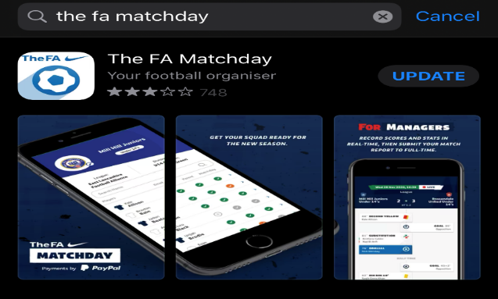 | DOWNLOAD THE FA’S MATCHDAY APP via the Apple and Google apps store.

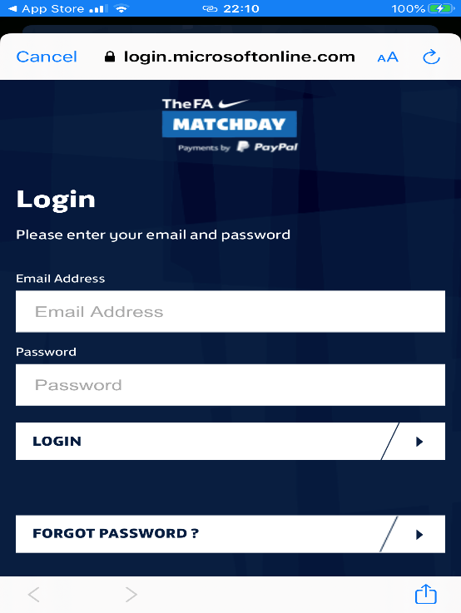 | GET LOGGED IN ASAP - If they already have registered for a FAN, the parent will be on the Whole Game System and linked to their child. Just login in to the app using the email address and password you used to get into the Whole Game System.  If you have forgotten the password, this can be reset.  If the parent/carer has not created a FAN, then a new account can be created by logging into the Matchday app. Please use the email address that you have provided to the club on any registration documents, as this will then tie you Matchday app account with your child(ren) and their team(s).  For any issues logging in, if you don’t see the correct team or if you don’t see any team, contact the Registration secretary (registration@whickhamfellsideyfc.co.uk) or the club secretary (secretary@whickhamfellsideyfc.co.uk). We will endeavour to get back to you as soon as possible, day to day personal commitments withstanding.  Also try this link for loads of useful frequently asked questions about matchday for managers and parents - http://www.thefa.com/get-involved/matchday/faqs  For all other issues, parents/carers should speak to their manager first as the mnager will be able to see what payments are outstanding via the manager’s matchday app. If the manager cannot resolve the issues, then the managers should contact the club’s registration secretary, Steve Franklin (registrations@whickhamfellsideyfc.co.uk)

Matchday offers multiple ways to collect and pay match fees - http://www.thefa.com/get-involved/matchday/payments/payment-methods

Monthly or annual autocollect and autopay - Simply activate PayPal’s new subscription service, and every month PayPal transfers a flat fee from your players (option if 16+) or a parent/carer. It’s a direct debit system in effect. Follow the link to watch a simple FA video showing how to set this up: https://www.youtube.com/watch?v=oOPPp-JjGsE

That’s it!

Managers – What do they need to do?

DOWNLOAD THE FA’S MATCHDAY APP via the Apple and Google apps store.

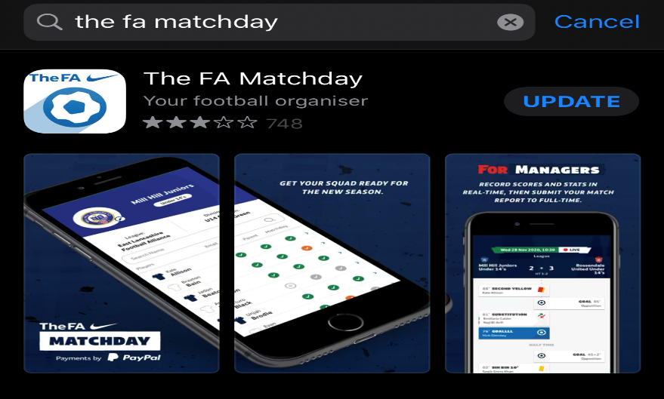

GET LOGGED IN ASAP - If they already have registered for a FAN, the parent will be on the Whole Game System and linked to their child. Just login in to the app using the email address and password you used to get into the Whole Game System.

If you have forgotten the password, this can be reset.

Managers can see all their players on their team(s).

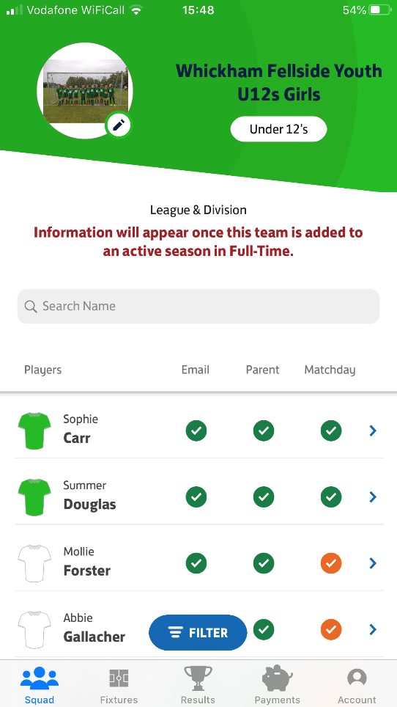

By “Payments”, Managers can see what payments are due or have been paid by their players (1 month before the first payment date).

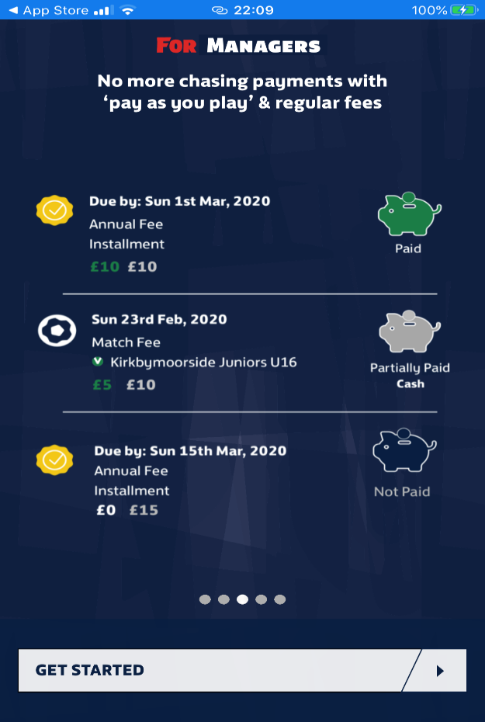

This policy clearly sets out the financial and playing eligibility punishments if player’s subscriptions are not up to date. This policy is available on the documents page of the club’s website.

IT IS THE MANAGER’S RESPONSIBILITY TO ENSURE THAT EACH PARENT/CARER IS AWARE OF THE CONSEQUENCES OF FAILING TO PAY THE SUBSCRIPTION COSTS. MANAGERS TO CIRCULATE THIS DOCUMENT VIA EMAIL AROUND THEIR PARENTS/CARERS ASAP

Managers must read the policy on the management of Team budgets – available on the documents page of the club’s website.

Appendix 1 - Matchday FAQs links and useful documents

About Matchday payments and Paypal - http://www.thefa.com/get-involved/matchday/payments/about-paypal

Payment FAQ main page http://www.thefa.com/get-involved/matchday/payments

Frequently asked questions about matchday for managers and parents - http://www.thefa.com/get-involved/matchday/faqs

Getting the team ready for a new season - http://www.thefa.com/get-involved/matchday/how-to-get-a-squad-ready?sc_src=email_804298&sc_lid=52752744&sc_uid=UQRy9pVKg3&sc_llid=36191&sc_eh=7139a9f9d54663431

